an Working Group | IEEE DYSPAN-SC 1900.5
Title | Meeting minutes 0210 for P1900.5 Monthly Meeting – May 2, 2017
DCN | 5-17-0016-00-mins
Date Submitted | 6/5/2017
Source(s) | Carlos Caicedo (Syracuse University)  email: ccaicedo@syr.edu
Abstract | Minutes for IEEE 1900.5 meeting (electronic) held on May 2 / 2017
Notice | This document has been prepared to assist the IEEE DYSPAN-SC. It is offered as a basis for discussion and is not binding on the contributing individual(s) or organization(s). The material in this document is subject to change in form and content after further study. The contributor(s) reserve(s) the right to add, amend or withdraw material contained herein.
Release | The contributor grants a free, irrevocable license to the IEEE to incorporate material contained in this contribution, and any modifications thereof, in the creation of an IEEE Standards publication; to copyright in the IEEE’s name any IEEE Standards publication even though it may include portions of this contribution; and at the IEEE’s sole discretion to permit others to reproduce in whole or in part the resulting IEEE Standards publication. The contributor also acknowledges and accepts that IEEE DYSPAN SC may make this contribution public.
Patent Policy | The contributor is familiar with IEEE patent policy, as outlined in Section 6.3 of the IEEE-SA Standards Board Operations Manual <http://standards.ieee.org/guides/opman/sect6.html#6.3> and in Understanding Patent Issues During IEEE Standards Development <http://standards.ieee.org/board/pat/guide.html>.
>.

1. Administrivia

1.a Roll Call
Meeting starts at 2:35 p.m. EDT. The participants identified in table 1 were noted.
Quorum was achieved.

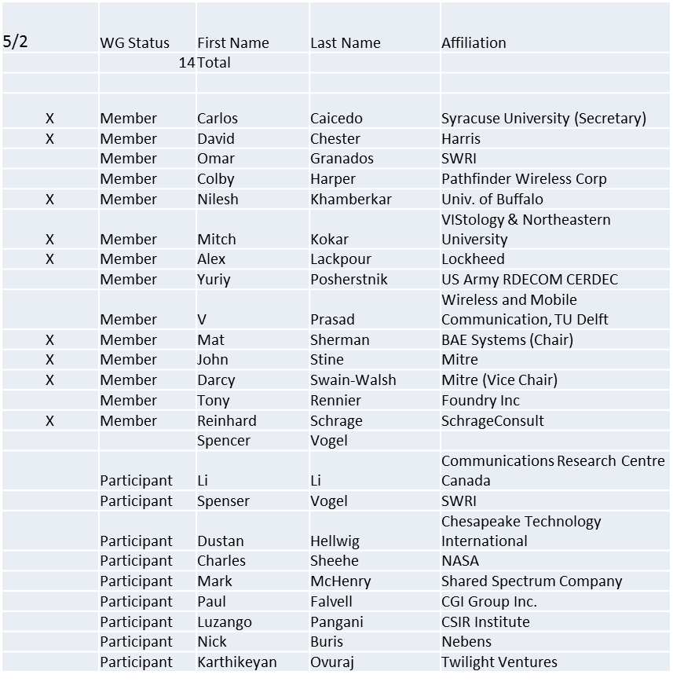
Table 1

1.b. Approval of Agenda
Motion to approve Agenda from 5-17-0013-00
Mover: Carlos
Second: Dave
Adopted by unanimous consent

1.c. Patent slides / Notes on status
Patents related slides were presented, no issues came forward

1.d. Approval of recent minutes
Motion to approve WG minutes contained in 5-17-0014-00

Deferred to next meeting

2. Status on 1900.5.1

- Python based tools to interact with the policy language are being studied by Reinhard
- Policy language needs to be incorporated and/or be able to interact with a general purpose language (i.e. python, java)
- Move schedule by 2 months
- Will need to extend the PAR deadline

3. Status of 1900.5.2

- 2nd Recirculation Complete
- One comment received, to be treated mainly as an editorial comment.

- Motion to forward 1900.5.2 to standards board (RevCom) for approval was presented
Mover: John
Second: Dave

approved by unanimous consent

- PAR to add Schema to 1900.5.2 is ready (written) but will wait for Revcom approval of 1900.5.2 first

4. Review of other 1900 activities (1900.1, Leadership meeting etc)

None

5. 1900.5 marketing inputs

- NSC
  - Several projects appear to be leveraging 1900.5
- Standards paper in process
  - Communications Magazine
    - 2 papers – 1900.5.1 and 1900.5.2
- Looking also into the new Communication Standards Magazine

6. 1900.5 meeting planning and review

- June 6 / 2017
  - Schedule 1900.5.1 review

7. AoB
- None

8. Adjourn
Meeting ends at 3:25 p.m. EDT

