an Working Group | IEEE DYSPAN-SC 1900.5
Title | Meeting minutes 0209 for P1900.5 Monthly Meeting – April 4, 2017
DCN | 5-17-0014-00-mins
Date Submitted | 5/1/2017
Source(s) | Carlos Caicedo (Syracuse University)  email: ccaicedo@syr.edu
Abstract | Minutes for IEEE 1900.5 meeting (electronic) held on April 4 / 2017
Notice | This document has been prepared to assist the IEEE DYSPAN-SC. It is offered as a basis for discussion and is not binding on the contributing individual(s) or organization(s). The material in this document is subject to change in form and content after further study. The contributor(s) reserve(s) the right to add, amend or withdraw material contained herein.
Release | The contributor grants a free, irrevocable license to the IEEE to incorporate material contained in this contribution, and any modifications thereof, in the creation of an IEEE Standards publication; to copyright in the IEEE’s name any IEEE Standards publication even though it may include portions of this contribution; and at the IEEE’s sole discretion to permit others to reproduce in whole or in part the resulting IEEE Standards publication. The contributor also acknowledges and accepts that IEEE DYSPAN SC may make this contribution public.
Patent Policy | The contributor is familiar with IEEE patent policy, as outlined in Section 6.3 of the IEEE-SA Standards Board Operations Manual <http://standards.ieee.org/guides/opman/sect6.html#6.3> and in Understanding Patent Issues During IEEE Standards Development <http://standards.ieee.org/board/pat/guide.html>.
>.

1. Administrivia

1.a Roll Call
Meeting starts at 2:35 p.m. EDT. The participants identified in table 1 were noted.
Quorum was achieved.

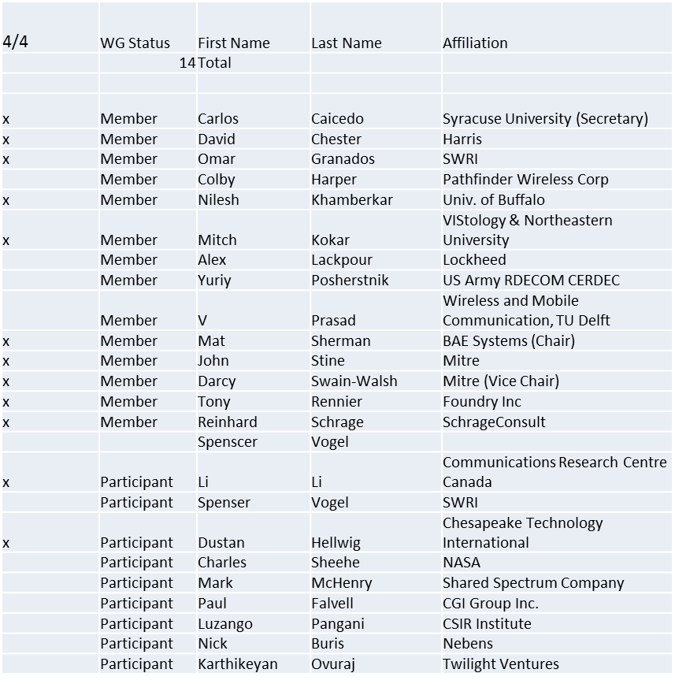

1.b. Approval of Agenda
Motion to approve Agenda from 5-17-0011-00
Mover: Dave
Second: Tony
Adopted by unanimous consent

1.c. Patent slides / Notes on status
Patents related slides were presented, no issues came forward

1.d. Approval of recent minutes
Motion to approve WG minutes contained in 5-17-0012-00
Mover: John
Second: Dave
Adopted by unanimous consent

2. Status on 1900.5.1

Document moving forward
- Ad Hocs for review? Yes
- Clause 5 amended for semantic interpretations
- Hit wall with FUXI RIF Core in Clause 6
  - Python 2.6.1 not supported
    - Needed to install manually
  - Implementation should be portable into JAVA
  - Python has less strict semantics and Java more portable but slower
- Clause 7 needs some more examples

3. Status of 1900.5.2

- Started 2nd Recirculation
  - Ends April 8
- Then vote to send to standards board
- Draft PAR to add Schema will be elaborated after base 1900.5.2 standard approval process is complete based on preliminary work done in the March meeting (Baltimore)

4. Review of other 1900 activities (1900.1, Leadership meeting etc)

Leadership meetings
- Face to face meetings – possibly reduce to once per year
- 1900.5 only face to face?
  - Probably yes
  - Piggy back or plan around Virginia Tech conference or WIN-F?

5. 1900.5 marketing inputs
- NSC
  - Nothing to report
- Standards paper in process
  - 2 papers – 1900.5.1 and 1900.5.2
- Spectrum Challenge
  - No new news
  - Some general interest for 3 DARPA projects

6. 1900.5 meeting planning and review

02 May monthly electronic meeting
- No conflict
- Schedule 1900.5.1 review

7. AoB
- None

8. Adjourn
Meeting ends at 3:25 p.m. EST

