an Working Group | IEEE DYSPAN-SC 1900.5
Title | Meeting minutes 0207 for P1900.5 Monthly Meeting – February 7, 2017
DCN | 5-17-0007-01-mins
Date Submitted | 5/1/2017
Source(s) | Carlos Caicedo (Syracuse University)  email: ccaicedo@syr.edu
Abstract | Minutes for IEEE 1900.5 meeting (electronic) held on February 7 / 2017
Notice | This document has been prepared to assist the IEEE DYSPAN-SC. It is offered as a basis for discussion and is not binding on the contributing individual(s) or organization(s). The material in this document is subject to change in form and content after further study. The contributor(s) reserve(s) the right to add, amend or withdraw material contained herein.
Release | The contributor grants a free, irrevocable license to the IEEE to incorporate material contained in this contribution, and any modifications thereof, in the creation of an IEEE Standards publication; to copyright in the IEEE’s name any IEEE Standards publication even though it may include portions of this contribution; and at the IEEE’s sole discretion to permit others to reproduce in whole or in part the resulting IEEE Standards publication. The contributor also acknowledges and accepts that IEEE DYSPAN SC may make this contribution public.
Patent Policy | The contributor is familiar with IEEE patent policy, as outlined in Section 6.3 of the IEEE-SA Standards Board Operations Manual <http://standards.ieee.org/guides/opman/sect6.html#6.3> and in Understanding Patent Issues During IEEE Standards Development <http://standards.ieee.org/board/pat/guide.html>.
>.

1. Administrivia

1.a Roll Call
Meeting starts at 2:35 p.m. EDT. The participants identified in table 1 were noted.
Quorum was achieved.

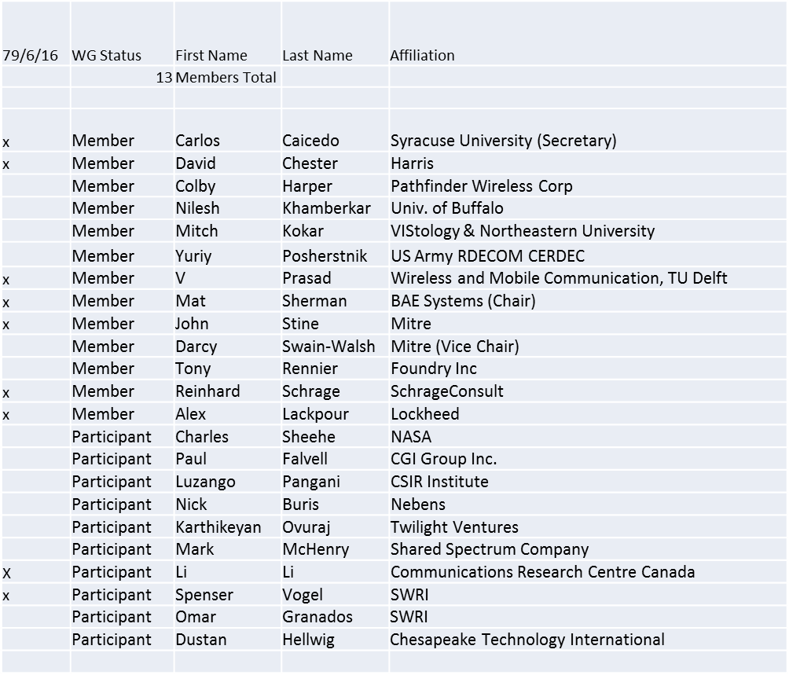

1.b. Approval of Agenda
Motion to approve Agenda from 5-17-0004-02
Mover: John
Second: Carlos
Adopted by unanimous consent

1.c. Patent slides / Notes on status
Patents related slides were presented, no issues came forward

1.d. Approval of recent minutes

Motion to approve WG minutes contained in 5-17-0001-00 & 5-17-0005-00
Mover: Carlos
Second: Dave
Adopted by unanimous consent

2. Status on 1900.5.1

Document moving forward
Ad Hocs for review? Not needed
Plan to review final version in Baltimore. Will have at least one full day for review.

3. Status of 1900.5.2

Review of comments was completed

Motion to adopt document #5-15-0064-12 as the new 1900.5.2 draft and document #5-16-0011-02 as resolutions to the comments in the 1900.5.2 sponsor ballot and instruct the IEEE 1900.5 Chair to take actions as required to conduct a sponsor recirculation ballot on that draft / comment resolutions and make editorial changes as required for the ballot.
Mover: John
Second: Reinhard
Vote: 7 Approve, 0 Disapprove, 0 Abstention

4. Review of other 1900 activities (1900.1, Leadership meeting etc)

Nothing to report

5. 1900.5 marketing inputs
- NSC
  - On hold till CY17
- Standards paper in process
  - DySPAN – Poster on 1900.5.2 approved
    - Carlos will present. John likely. Alex, Reinhard and Mat likely.
- Vita 49 interactions
  - Done for now
- Spectrum Challenge
  - 1900.5.2 will not be used in phase I of the challenge.

6. 1900.5 meeting planning and review

- Ad Hocs? No
- Face to Face in March adjacent to DySPAN Conference in Baltimore March 9-11, 2017
  - DySPAN Conference is March 6-9
  - Mat, John, Reinhard (likely), Carlos (likely)
- Tentative Meeting times (9-5:30 daily)
  - Day 1 (start 11 AM): 1900.5 WG / 1900.5.2 Ad Hoc
  - Day 2 (start 9 AM): 1900.5.1 Ad Hoc
  - Day 3 (end 3:30 PM) : 1900.5.1 Ad Hoc / 1900.5 WG
- No March 7 monthly electronic meeting

7. AoB
- None

8. Adjourn
Meeting ends at 3:40 p.m. EST

