Working Group | IEEE DYSPAN-SC 1900.5
Title | Meeting minutes 0195 for P1900.5 F2F meeting – March 22-24, 2016
DCN | 5-16-0019-00-mins
Date Submitted | 6/06/2016
Source(s) | Carlos Caicedo (Syracuse University)  email: ccaicedo@syr.edu
Abstract | Minutes for IEEE 1900.5 F2F meeting held on March 22-24/2016 in Piscataway, NJ
Notice | This document has been prepared to assist the IEEE DYSPAN-SC. It is offered as a basis for discussion and is not binding on the contributing individual(s) or organization(s). The material in this document is subject to change in form and content after further study. The contributor(s) reserve(s) the right to add, amend or withdraw material contained herein.
Release | The contributor grants a free, irrevocable license to the IEEE to incorporate material contained in this contribution, and any modifications thereof, in the creation of an IEEE Standards publication; to copyright in the IEEE’s name any IEEE Standards publication even though it may include portions of this contribution; and at the IEEE’s sole discretion to permit others to reproduce in whole or in part the resulting IEEE Standards publication. The contributor also acknowledges and accepts that IEEE DYSPAN SC may make this contribution public.
Patent Policy | The contributor is familiar with IEEE patent policy, as outlined in Section 6.3 of the IEEE-SA Standards Board Operations Manual <http://standards.ieee.org/guides/opman/sect6.html#6.3> and in Understanding Patent Issues During IEEE Standards Development <http://standards.ieee.org/board/pat/guide.html>.
>.

Table 1 IEEE 1900.5 March 22-24, 2016 WG Meeting
Summary of Participants

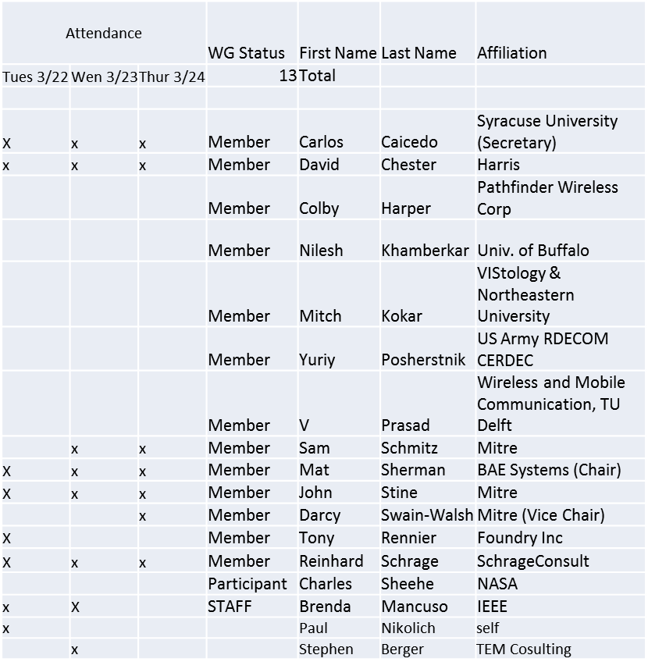

Minutes

DAY 1 – 3/22/16

- Administrivia
    - Roll Call / Quorum Check
Meeting starts at 9:05 a.m.

    - Approve Agenda
Agenda adopted by unanimous consent

    - Patent slides / Notes on status

No comments

    - Approval of recent minutes

- Motion to approve WG minutes contained in 5-16-0013-00
- Mover: Carlos
- Second: Dave
- Vote: UC

2. 1900.5.1 Review

Some changes made to clauses 4 & 5 and introduction section

Next update to be discussed at the end of April – clauses 5 and 6
Clause 7 potentially to be discussed in May

3. 1900.5.2 Ballot Review

102 Balloters called to or registered to participate in the 1900.5.2 ballot
Response rate was 76%
Approval rate was 93%
Abstain rate 5%
# of comments received: 54

4. 1900.5.2 Comment Resolution

- Proceeded to resolve comments

DAY 2 – 3/23/16

1900.5.2 Comment Resolution

- 6 comments remain – they are more difficult to resolve
- John Stine will continue to work and provide recommended resolutions for May WG meeting

- Carlos will provide exemplary schema for 1900.5.2 in the following days
  - Ad Hoc for Mid April

Met with ANSI C63
  - Reviewed activities in 1900.5 for possible collaboration

DAY 3 – 3/24/16

1900.5 marketing

- WInnForum 3.6GHz stakeholders requirements and positioning

- National Spectrum Consortium requirements and positioning

- Internet Research Task Force (IRTF)
  - NFV (Network Function Virtualization)
  - Looking at declarative Policy

- DySPAN Core Standards paper?

Paper still on hold. Carlos suggests that 1900.5 WG should write its own paper.

1900.5 meeting planning and review

April meeting will not be necessary
Schedule Ad Hoc for Mid May to review work with Carlos

Normal May meeting would cover:
- Review 1900.5.1 progress
- Another ad hoc in May to review comment resolution on 1900.5.2

AoB
None

Adjourn

Adjourned at 12:30 p.m.

