|  |  |  |  |
| --- | --- | --- | --- |
| P802.1CF/D2.2 CID-32 comment resolution proposal | | | |
| Date: 2018-09-24 | | | |
| **Authors:** | | | |
| Name | Affiliation | Phone | Email |
| Max Riegel | Nokia |  | Maximilian.riegel@nokia.com |
|  |  |  |  |
|  |  |  |  |
| **Notice:**  This document does not represent the agreed view of the OmniRAN TG It represents only the views of the participants listed in the ‘Authors:’ field above. It is offered as a basis for discussion. It is not binding on the contributor, who reserve the right to add, amend or withdraw material contained herein. | | | |
| **Copyright policy:**  The contributor is familiar with the IEEE-SA Copyright Policy <<http://standards.ieee.org/IPR/copyrightpolicy.html>>. | | | |
| **Patent policy:**  The contributor is familiar with the IEEE-SA Patent Policy and Procedures:  <[http://standards.ieee.org/guides/bylaws/sect6-7.html#6](http://standards.ieee.org/guides/bylaws/sect6-7.html)> and <[http://standards.ieee.org/guides/opman/sect6.html#6.3](http://standards.ieee.org/guides/opman/sect6.html)>. | | | |

# Abstract

This document provides text amendment proposals to address comment i-32 of the initial sponsor ballot on P802.1CF-D2.2

# Text amendment to address i-32 (Brian):

* Enterprise network

Enterprise networks are privately operated network infrastructures within enterprises, organizations, or corporations. They encompass a huge variety of implementations and sizes. Enterprise networks can vary in complexity, from a completely isolated network with a few PCs connected through a single Ethernet bridge, up to a global network of many privately interconnected sites each having its comprehensive LAN with wired and wireless IEEE 802 connectivity of hundreds to thousands of terminals, devices, and servers. The commonality of all such enterprise networks is the deployment of IEEE 802 bridging among all connected terminals in the local area network. The Internet Protocol is used for delivering services within enterprise networks. It implies that at least one access router exists, which is often embedded in the WAN router with the firewall to the Internet and the VPN gateway to the other remote sites of the same enterprise network.

* Enterprise network scenario

Figure 17 shows a typical enterprise network scenario providing wireless access to portable devices through a number of access points connected to an aggregation bridge. Often, the aggregation bridge is complemented by a WLAN controller to accomplish a more seamless wireless network by facilitating central coordination of higher layer IEEE 802.11 functions. Another aggregation bridge provides wired IEEE 802.3 connectivity to a number of workstations or PCs, and potentially also to special devices like printers. The bridges build the backhaul of the wireless access points and the wired terminal interfaces toward the access router. The access router coordinates the configuration of the IP protocol inside the enterprise and provides outside connectivity toward the Internet and other sites of the enterprise.

A directory service enables the central storage and maintenance of user-specific subscription information. It allows user-specific access rights to the network and services to be centrally configured.

Due to the distributed nature of the network with its devices spread over the whole campus, enterprise networks usually have a dedicated network management station for configuration, administration, monitoring, and maintenance of the whole network.

The components of an enterprise network can be easily mapped to the NRM. The bridging infrastructure builds the backhaul of the network, with terminal Ethernet ports and WLAN access points resembling the nodes of attachment. The functions of the WLAN controller fit well to the role of the ANC, and network management station and directory are typical realizations of the NMS and SS, respectively.



* Mapping of enterprise network to the NRM

The implementation of a real enterprise network may not exactly resemble the functional decomposition of the NRM, but it is clearly visible in Figure 18 that the components of an enterprise network are well matched with the functional entities of the NRM. All reference points toward terminals are supported. Many of the reference points of the AN directly exist as interfaces in the enterprise networks. R6 is exposed on the interface between the bridge and the access point, and R3 maps to the LAN cable between the core bridge and the WAN router. Even control interfaces of the access network may be exposed in enterprise networks. R5 could be mapped to the communication between the WLAN controller and the WLAN access points, and R4 and R11 denote the protocol connections between the WLAN controller and the directory server and network management station, respectively. The information exchange between WAN router and directory server can be mapped to R12. However, not all reference points are such clearly exposed in enterprise networks. R7 and R9 may exist, but the related ANC functions may be distributed across the Ethernet bridges in the backhaul.

Even when a typical implementation of an enterprise network widely follows the decomposition of functions represented by the NRM, equipment exists that integrates and combines functions into a single device for functional or economic reasons. E.g., many WLAN controllers do not only act as controller for the WLAN access points but also as Ethernet bridge for the aggregation of the user data. Enterprise networks may deploy virtualized instances of WLAN controllers, network management systems, and directories, either hosted in the Cloud, or in local data centers, when higher security requirements exist.

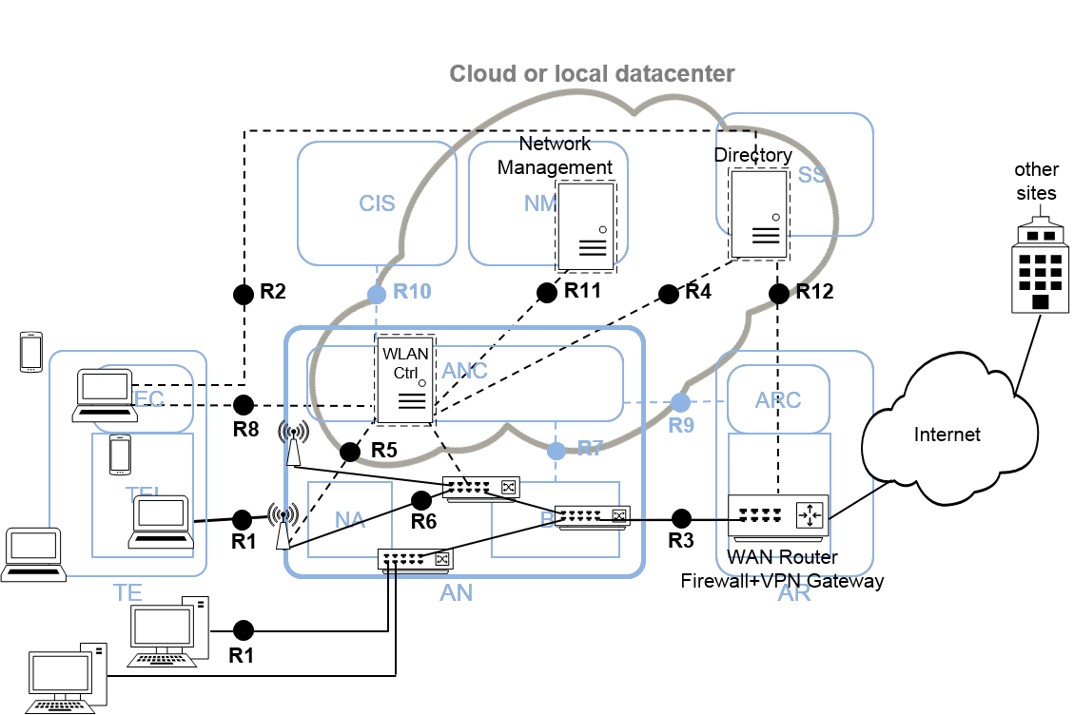

Figure 18+1 – Cloud-managed enterprise network

The figure 18+1 illustrates that also cloud-managed network realizations well fit to the NRM. As the NRM only defines the information carried over control interfaces, but not the protocol or physical transport, all or part of ANC, NMS, SS, and CIS may be realized as virtual instance and be operated in the Cloud or a local data center.