P802.1CF-D1.0 Comment resolution proposal
Date: 2018-03-06
Authors:
Name | Affiliation | Phone | Email
Max Riegel | Nokia Bell Labs |  | maximilian.riegel@nokia.com
Notice:
This document does not represent the agreed view of the OmniRAN TG It represents only the views of the participants listed in the ‘Authors:’ field above. It is offered as a basis for discussion. It is not binding on the contributor, who reserve the right to add, amend or withdraw material contained herein.
Copyright policy:
The contributor is familiar with the IEEE-SA Copyright Policy <http://standards.ieee.org/IPR/copyrightpolicy.html>.
Patent policy:
The contributor is familiar with the IEEE-SA Patent Policy and Procedures:
<http://standards.ieee.org/guides/bylaws/sect6-7.html#6> and <http://standards.ieee.org/guides/opman/sect6.html#6.3>.

Abstract
This document provides initial text and figure proposals to address the comments #7, #152, and #12 of 802.1CF-D1.0

7 | Tl | 15 | 3 | 423 | Definition of access network is vague and does not clearly identify what makes an access network different than any 802 LAN/MAN with a router. It seems the access provided by the access network is to a service provider facility through an access router, however this does not appear to be a requirement of the definition. Since the only 802 LAN/MANs that don't provide L2 access between terminals and hosts are those which interconnect only routes or other higher layer non-terminating interworking devices. | Clarify the definition by defining what is meant by terminal and host. For instance: Access network denotes an 802 LAN/MAN providing layer 2 connectivity between terminals(hosts) and service provider access routers. | Yes | Paul B. | input needed | Provide text proposal for discussion
152 | T | 29 | 6.3.1.1 | 726 | Are you saying ANC is Element Manager that is used to manage node? this is contract to central control. An Element Manager does not need to have network view and only used to manage node (NE), but central controller for AN need to have network view of the access network, so what exact ANC is intent to do? | Clarfy what ANC is intended to control | No | Weiying C. | agreed, but text proposal needed for amendment. Avoid the term 'element manager' as it is too restrictive and misleading. | Initial text proposal for conclusion in F2F
12 | T | 33 | 6.6 | 836 | Here is the first reference to OSS/BSS however it's use is not illustrated in the diagram (though later diagrams illustrate it) | Add OSS/BSS to diagram | No | Paul B. | Agreed. Max to provide a proposal for acceptance | Update figure

Comment #7 (Paul B.) – line 423

Original text

3. Definitions
For the purposes of this document, the following terms and definitions apply. The IEEE Standards Dictionary Online should be consulted for terms not defined in this clause.1
Access network: Access network denotes the network providing the layer 2 link between the terminal and its corresponding host, including other terminals or the access router.
Access router: The access router terminates the layer 2 link from the terminal and forwards user traffic toward information servers according to IP addresses carried in the payload of the layer 2 data frames.

Proposed by Paul
Access network: Access network denotes an 802 LAN/MAN providing layer 2 connectivity between terminals(hosts) and service provider access routers.

Proposed remedy:
Access network: Access network denotes an IEEE 802 LAN/MAN providing layer 2 connectivity between end-stations terminating layer 2 connectivity either into a host or an access router to higher layer services.

Comment #152 (Weiying C.) – Line 726

Original text
6.3.1.2 Access network (AN)
The access network consists of the nodes of attachment providing the physical ports toward the terminals and the backhaul for connecting the nodes of attachment toward the access router. The access network may deploy a dedicated access network control for configuration and management of the elements inside the access network as well as exchange of control and management information with both the terminal and access router. As a central controller, ANC acts as an element manager providing management on network elements that connect to it, namely access network elements, terminal, and access router.

Proposed remedy:
The access network consists of the nodes of attachment providing the physical ports toward the terminals and the backhaul for connecting the nodes of attachment toward the access router. The access network deploys a access network control (ANC) for configuration and management of the elements inside the access network as well as exchange of control and management information with both the terminal and access router. The ANC also provides the interface towards the Network Management Service for propagating network management information on behalf of the network elements of the access network.

Comment #12 (Paul B.) – Line 836
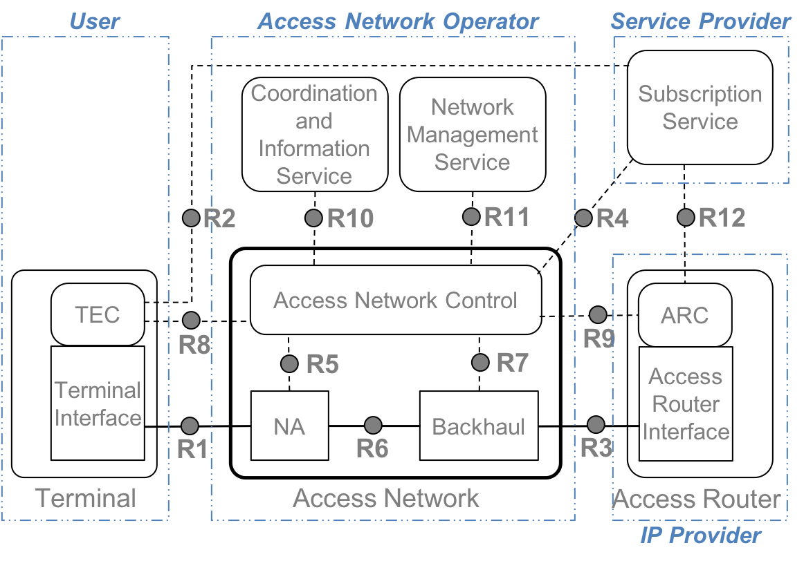
Proposed remedy:
