**IEEE P802.24**

**Vertical Applications Technical Advisory Group**

|  |  |  |
| --- | --- | --- |
| Project | IEEE P802.24 Vertical Applications Technical Advisory Group | |
| Title | **IEEE 802 Networks for Alternative Fuel Vehicle (AFV) Fueling Infrastructure White Paper** | |
| Date Submitted | 2023-07-10 | |
| Source | Craig Rodine, lead author and editor |  |
| Re: | Incorporating content from Jin Seek Choi, Hyeong Ho Lee, and Young Kyu Ko on Smart Home and Cooperative Energy Management | |
| Abstract | < to be merged in from April, 2023 draft > | |
| Purpose | < to be merged in from April, 2023 draft > | |
| Notice | This document has been prepared to assist the IEEE P802.24. It is offered as a basis for discussion and is not binding on the contributing individual(s) or organization(s). The material in this document is subject to change in form and content after further study. The contributor(s) reserve(s) the right to add, amend or withdraw material contained herein. | |
| Release | The contributor acknowledges and accepts that this contribution becomes the property of IEEE and may be made publicly available by P802.24. | |

# Introduction

The growing adoption of vehicles powered by electricity and hydrogen, instead of traditional fossil fuels like gasoline and diesel, creates the opportunity and need to re-consider fueling processes and infrastructure. The ‘user experience’ of fueling a traditional Internal Combustion Engine (ICE) powered vehicle is very familiar throughout the world. Everything from station locations and hours of operation, to safety precautions and ergonomics; the resources (time and money) required; how to use the dispenser; the units of measure and method of sale, including financial transaction and receipt; are well-known and effectively taken for granted by the driving public. However, many aspects of the fueling experience can and will likely be quite different for the new, non-ICE vehicles.

Throughout this report, the term Alternative Fuel Vehicle (abbreviated AFV) designates Electric Vehicles (EVs) and Hydrogen Surface Vehicles (HSVs), the two leading types of AFVs coming into use.

One significant difference is that AFV vehicles connect to their fueling infrastructure via a coupler that enables analog signaling and/or digital communication between the devices. (Taking the form of one or more electrical conductors for EV charging and a point-to-point infrared link for HSV fueling.) This capability currently supports control protocols that manage the transfer of electrical energy or gaseous hydrogen; in principle, it could be used for other purposes as well.

This whitepaper presents some use cases, requirements, and integration oppor­tunities for AFV fueling that take advantage of mainstream communications capabilities and networking standards, across a range of scenarios and sites.

# Overview of AFV Fueling

This section describes common aspects and characteristics of AFV fueling processes, which may provide orientation to the AFV application domain and enhance understanding of the use cases presented in Section N.

## AFV – fuel dispenser mechanical connection

Every fueling process requires a means for fuel (liquid gas/petrol, electricity, liquid or gaseous hydrogen) to flow between the dispenser and a vehicle. It’s helpful to refer to this mechanism as a *coupler* with two mating components, an *inlet* (on the vehicle) and a *connector* or *nozzle* (on the dispenser).

The familiar “gas pump handle” used to fuel an ICE can be understood as a simple coupler, with the critical mating feature being the diameter of the nozzle spout and fuel filler neck. (This prevents a diesel fuel nozzle from being inserted into a petrol inlet.) Its control and safety features are mechanical: fuel-tank shutoff, attitude shut-off, a no-pressure-no-flow device, etc. There is no communication – not even a mechanical linkage – between fueling infrastructure and vehicle.

A gaseous hydrogen fuel coupler is similar to the ICE design but more complex, requiring a mating collar with magnet for dispenser activation and a sealing/locking feature for safety, since the gas is under pressure. The HSV specifies its fueling pressure (H35 or H70 service) via one-way infrared communication and can send an ‘emergency stop’ message if the vehicle detects an unsafe condition. (The dispenser can also detect an anomaly and shut down, but it can’t communicate this to the vehicle.)

For *conductive* charging of EVs, there are multiple standards-based couplers designed for manual, ergonomic insertion; almost all use mating pin-and-sleeve (or pin and contact-tube) electrical contacts following the practice and standards for high-voltage electrical plugs and sockets. All DC couplers support mechanical or magnetic locking to prevent arc flash on separation of connector from inlet with high voltage on the contacts. Some AC coupler designs include a locking feature, primarily for physical security (to prevent a charging cord from being stolen) not electrical safety.

There are some additional means of connecting EVs to the charging infrastructure.

For *inductive* (also known as ‘wireless’) charging, electrical energy is passed over an air gap between coils in the infrastructure and the vehicle. In a typical prototype implementation, the dispenser coil is embedded in the floor or a in moveable pad or platform, and the mating coil is mounted on the underside of the EV. Mating is done by positioning the vehicle over the pad for optimal energy flow between the coils; this positioning could use automatic vehicle control (e.g. EV autonomous driving capabilities). Naturally the communications used to control inductive charging is also wireless. One system sends control signals on the energy transfer frequency (~25 kHz or 85 kHz), while one prototype used JSON messages over IEEE 802.11/Wi-Fi® for coil geometry compatibility and positioning.

There are standards and technologies for robotic control of EV-infrastructure charging using pantograph mechanisms to connect rails or other, multi-pole contact systems to charge e.g. electrific buses. Such a system can deliver power at high levels, up to 1 MW for 30 seconds or 400 kW for 15 minutes. As for wireless charging, the communications used to engage and disengage the pantograph, do electrical connectivity safety checks, and control the energy flow is some form of wireless, including IEEE 802.11n.

## Energy Requirements and Supply

AC charging: uses ubiquitous utility service to power conversion devices (AC-DC converters) on board the EV. In North America, utility service is 117 VAC or 208-240 VAC, both single phase; these are called Level 1 (L1) and Level 2 (L2) AC charging levels, respectively. In Europe the coupler has five pins for power, enabling it to support both single-phase and three-phase AC charging; nominal service voltage is 230 VAC and most homes and commercial buildings have single-phase service.

DC charging: < explain power conversion in charging stations using 400-480 VAC three-phase service as input, to delivery up to 400 kW (800 VDC, 500 A) at the connector. Liquid cooling of cable and connector pins required above 200 kW, etc. Higher voltage and power levels are being supported in emerging standards, e.g. up to 1250 VDC AND 3000 A per CharIn per the so-called CharIn Megawatt Charging System (MCS): IEC 63379, SAE 3271>

Future: < explain that there is interest in using DC as EV charging system input voltage. This would improve system efficiency by avoiding AC-DC conversion losses. The most likely sites for this development would be those with DC voltage sources like PV arrays, stationary fuel cells, and batter energy storage systems. In such an environment, IEEE 802 communications would offer a communications fabric for the integration, coordination, and control of energy and AFV fueling systems. >

## Fueling Session Frequency and Duration

< Describe short dwell high power, longer dwell lower power, etc. Some EV chargig equipment is lightly used, delivering one or two charging sessions per day, e.g. 3.5-11 kW AC charging in a residence or workplace. Others will be used with higher frequency, up to 24-30 sessions per day. (Strawman: one 30 minute session every 45 minutes for 18 hours, e.g. 66% duty cycle when the station is publicly accessible with six hours down time per 24-hour period). Extremes of activity would be seen in medium-and heavy-duty vehicle charging sites, with large numbers of stations/dispensers used at high duty cycles and/or energy levels. >

## Deployment geographies (environments? sites?)

< Describe the sites where AFV Fueling is taking place. Attention will be paid to physical site characteristics that matter for network design, e.g. size and span (horizontal and vertical); connectivity to power systems and power density; physical security; brownfield vs. greenfield; etc.

Examples include

* residences (single- and multi-family): one to ten(?) AC stations, power level 3-11 kW each; typical cable length 5 ± 2 m; medium physical security; mostly retrofit, some greenfield; spans would be covered by a single Wi-Fi AP.
* workplaces and other long-dwell, high-user-density sites; tens to a thousand AC stations, power level 6-22 kW each, currently almost all 6.6 kW AC; typical cable length 5 ± 1 m; more DC stations to come (same input voltage as AC but higher power level e.g. 11 kW); spans would require one to many Wi-Fi Aps; some workplace sites will resemble large public parking facilities, e.g. municipal or airport parking lots.
* publicly accessible facilities for short-dwell, high-power-delivery “fast charging”, such as urban and suburban dedicated fueling stations, parking structures, and highway rest stops;
* fleet vehicle depots, including privately owned (goods delivery, taxi pools) and publicly owned facilities (school districts, postal services, etc.)
* highway-side fueling facilities for extremely-high-power-delivery long-haul truck re-fueling (“truck stops”) >

< to be reconciled with content from the April, 2023 draft >

## EV – charging infrastructure communications

< Describe the range of communications standards and technologies used in AFV fueling systems, focusing on EV charging. Include SWCAN, CAN, PWM, PLC, TCP/IP for EV charging, and IrDA for HSV fueling. >

< Observe here that the EV charging communications methods described are all ad-hoc ‘point’ solutions created by auto and electrical infrastructure/safety engineers without knowledge of or regard for communications/network orientation or expertise. That EV-EVSE interactions are not demanding and could remain fairly isolated, but could also be one among multiple e-mobility services that infrastructure offers to vehicles. This will set up our discussion of next-generation communications and networking requirements in Section 4. >

# AFV Fueling Use Cases

CR: Since we’ve covered the status quo in Section 2, I recommend that we present use cases for new or extended functionality that will motivate extensive use of IEEE 802 standards. So far, all contributions regarding use cases meet this criterion.

< Note: order and numbering of the Use Case sub-sections might change. >

## Public Parking with Advanced Charging Services

< Describe the use case ref. 24-22-0020-01-0000-afv-fueling-vertical-update.pptx, #5 >

## Low-power Fleet Charging

< Describe the use case ref. 24-22-0020-01-0000-afv-fueling-vertical-update.pptx, #4 >

## High-power Medium/Heavy-duty Vehicle Charging

< Describe the use case ref. 24-22-0016-01-0000-ev-charging-vertical-overview.pptx, #8 >

## < Additional Use Cases >

…

## Smart Home and Cooperative Energy Management

This Use Case focuses on EV charging in residential and small building (perhaps, multi-family residential and small-to-medium sized business office) sites.

### Electrical characteristics of residential/small building charging

Currently, the most common type of EV charging used in these sites is a so-called “Level 2” (L2) AC charging device. Level 2 designates the capability to deliver 3-20 kW of power to recharge the EV battery; this is done by a control unit (in a “cordset” that plugs into a standard electrical socket, or a fixed-in-place “wallbox” with a receptacle or cable and connector) that manages energy flow to the on-vehicle converter and battery management system. The voltage level of L2 charging is 200-250 VAC; and the current level typically ranges from 12-80 Amps. L2 charging service is defined in three standards: SAE J1772 (used in North America and Japan); GB/T-XXXX (used in China); and IEC 68151-1 (used in Europe). While there are substantive difference between the three, they have much in common.

The SAE J1772 standard defines charging using a single-phase electrical connection; the connector it defines has three pins to support power transfer: two for power delivery and one for earth (ground). Two additional, smaller pins are used for control pilot (signaling) and proximity sensing (optional).

SAE J1772 also defines “Level 1” charging, which uses 100-120 VAC. [need to check L1 current range] Most legacy North American EVs support L1 charging over a cable with a three-prong (grounded) household appliance plug on one end and a J1772-compliant connector on the other. Newer EVs, especially those with battery capacity of 30 kWh or more, might not support L1 charging due to long charging times at L1 power levels (see below).

The IEC 61851-1 standard defines charging using both single- and three-phase electrical connections; consequently, the associated connector (per IEC 62196-2) has five pins for power transfer: three for power delivery (one per phase; single-phase charging is supported on two designated pins) and one for earth (ground). Like the SAE standard, two additional pins are used for control pilot and proximity sensing / resistive coding.

The advantage of L2 charging over L1 is shorter EV charging times. For example, fully charging an EV with 30 kWh battery capacity would take more than 15.5 hours to charge at L1 (~2 kW: 120 VAC x 16 A) and fewer than 4 hours at a typical L2 level (~7.6 kW: 240 VAC x 32 A). Using four times the power, the EV can charge in 1/4 the time.

The amperage values above align with common circuit breaker values, and the North American electrical code requirement that installed breakers be rated to trip at 125% of the maximum expected current draw (appliance maximum current rating) on the circuit. If it is the only appliance being protected on the circuit, a charging device drawing up to16 A requires a 20 A circuit breaker; a 32 A device must be protected by a 40A breaker.

The main deterent to L2 charging is the potentially high cost of providing the electrical wiring and protection needed. The worst case is when the capacity of the site’s electrical service would be exceeded by the addition of an EV charging station; the cost of a utility service upgrade (say, from 100 to 200 A) can be prohibitive. Another consideration is whether existing wiring from the service delivery point (the circuit breaker box) to the installation location is adequate; if not, new wiring might need to be installed. Finally, the cost of the EV charging device adds to the overall impact, but this is often the least costly part of a project.

### Communications aspects of residential/small building charging

Since L2 AC charging is controlled by analog circuits in the charging device and the EV, which are connected by the charging cable, there has been no need for communications interfaces on either to support the charging function. Nevertheless, some vendors have included wireless communications capabilities in their wallbox products to provide user access and some services. Examples include Bluetooth™ for charging station configuration using a vendor-provided app on the user’s smartphone; and Wi-Fi® for communication between the charging station and the vendor’s cloud-based charging network (and device) management system, via the user’s home Wi-Fi AP/router and Internet access (e.g. via cable or DSL modem).

An example of a service delivered to the charging device via Wi-Fi and the vendor’s cloud, is to allow the user to select their electricity pricing rate program from a list provided by the utility or utilities serving their location. Some utilities offer discounted rates for overnight consumption, encouraging EV charging at lower cost when electricity is not in high demand. If the user enrolls in such a program and selects that rate, their wallbox might be configured to block charging, or post a warning, if the EV is plugged in when rates are higher (e.g., during daytime). Given the rate program, the wallbox could calculate and display the cost of charging the EV. (Only after energy has been delivered, unless the EV’s battery capacity was set on the station and the EV sent its state of charge before charging, which is not currently possible using SAE and IEC L2 AC charging protocols).

A similar service that could be provided to EV drivers via the vendor cloud and Wi-Fi include charging power level regulation and/or incentive based on energy pricing or utility capacity constraints. Thus, an attempt to charge an SUV or pick-up truck with a 120 kWh battery pack at 14.4 kW (60 A) during hours of peak energy demand might result in the charging station being limited to delivering only 7.2 kW (30 A) and perhaps incentives – a price discount or confirmed reservation – to charge at a nearby public fast charging station that gets its energy from solar panels and energy storage, rather than the grid.

< an example in multi-family dwellings: ‘waitlist’ queueing with notifications when charging stations become available; note: this uses NFC/M2M/cloud/app but not 802 comms, in a non-trivial way >

Such EV charging services use IEEE 802 communications (Wi-Fi) in a limited way, and depend on the device vendor (or service provider) and utility to partner on providing service offerings. Developments in Smart Home promise to expand opportunities for EV charging to participate in comprehensive, dynamic *cooperative energy management*.

### Smart Home platforms for Cooperative Energy Management

The term ‘Smart Home’ designates a system that coordinates and controls services in a single- or multi-family dwelling, such as HVAC, lighting, media and information, security, water, and distributed energy resources (DERs) including rooftop solar, fixed energy storage, and electric vehicle charging/discharging. The goals of such a Smart Home system are to enable constituent devices and systems to respond to user requirements and desires, while also optimizing as much as possible the use of resources, in particular electrical energy.

In order to meet these goals, the devices and systems in a home need to have some degree or information processing and communication capability. Modern media devices, which are highly configurable and connected, provide a good example of how any subsystem within the home can be automated and integrated with others. For example, meshed Wi-Fi nodes – originally meant primarily to provide consumer devices with wireless access to the Internet –now incorporate microphones and speakers, allowing for natural-language interaction from almost anywhere in the home; can retrieve or relay data such as music playlists or television viewing preferences and activate services accordingly; and can report the status or change the settings of environmental controllers such as thermostats, skylights, and window shades. One can imagine such nodes soon incorporating sensors to gauge environmental factors (e.g. air quality, human/pet motion/activity, light or noise levels) as well.

A vital area of research and development is home energy management. As home energy becomes more electrified (due primarily to environmental benefits), there will be opportunities to balance convenience and environmental preferences with energy efficiency. And as users’ expectation for convenience – the ability to view and change settings from anywhere – grows, appliance vendors will likely need to expose more and better communications and control interfaces that can be leveraged for integrated smart home management.

Examples of this evolution include the Matter protocol, which has emerged as a foundation for a comprehensive Smart Home ecosystem. EMAP, another vision for next-generation Smart Home integration, is provided in the ISO/IEC 15067-3 series of standards. IEEE 2030.5, the successor of the ZigBee Alliance’s Smart Energy Profile 2.0, is a “standard for communications between the smart grid and consumers … built using Internet of Things concepts”. All of these can be deployed on IEEE 802 (Wi-Fi, Ethernet, 805.12) networks.

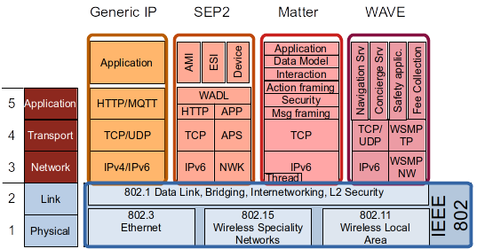

*Figure N: Examples of Smart Home platforms that can be deployed on IEEE 802 networks*

IPv4/IPv6

UDP

CoAP

EMAP

Applications

### Integrating EV charging in an EMAP network

#### Energy management for Smart home integrated with EV charging

Smart Home can implement a system that attempts to coordinate and control when the house needs smart services for heating, air conditioning, distributed energy resources (DERs) and Electric vehicles (EVs) to increase energy efficiency (e.g., power balance, power-sharing, energy management, and optimizing) [6]. DER energy sources (such as solar energy and wind energy) have become important alternative sources of energy in the smart home. EVs are also becoming popular, because of their fuel efficiency and economic benefit, as compared to the conventional fuel-based vehicles. Energy management is an early target for similar verticals such as healthcare, agriculture, manufacturing, automotive, public transportation, utilities and energy, environmental, smart cities, and more. In energy vertical, it is crucial to find solutions to manage the peak demand while supporting substation automation of renewable energy systems such as DERs and EVs. The smart home energy management framework, i.e., EMA framework, must extend high-level communication that allow a bidirectional energy flow among energy systems including DERs and EVs [1]. In this context, control of the energy systems will allow the management of energy flow generated from DERs and EVs for consumption or for storage in the collective EVs.



ISO/IEC JTC1 SC25 standardized EMA that plays an important role to optimize the energy use of home appliances in smart homes by utilizing standardized two-way communication in home area networks (HAN). EMA is a self contained autonomous software agent for energy management by allocating/scheduling limited energy resources (e.g., thermostat) within residential and small buildings [2]. An EMA can be embedded in devices such as a thermostat, a smart appliance, or other consumer products such as EV charging system and distributed energy resources (DERs) [3]. EMA allocates energy among houses efficiently in a community and among appliances within houses, and to accommodate a choice of external or local or both energy sources linked to DERs or EVs [4]. External sources can be public utilities or DERs in other homes, possibly purchased using transactive energy. Local sources can include electric vehicles, renewable power generators and storage devices at the customer premises linked to its own EMA. Consumer devices linked to an EMA can interconnect logically via an EMA with local DER equipment such as generators (wind and solar) and energy storage devices (electric vehicle). In this system, EMA automatically react to DR events, while EVs are charged and discharged (i.e., V2G) in appropriate time slots by taking into account DR events, time-of-use rate information, and users’ vehicle usage plan. For realizing different levels of coordination, EMA is useful to optimize the energy use in smart homes by using EV as an emergency backup power when power outage occurs, and also it is beneficial for peak shift by charging EV in off-peak periods and discharging it in peak periods.

Each EMA enables the allocation of energy among appliances and switching energy sources from grid to local generation or storage according to consumer preferences [1]. EMA also enables automated demand-response (DR) services in a house, a residential community or a building consisting of multiple apartments for coordinating and allocating energy consumption and generation among multiple EMAs in different locations [6]. DR programs are being offered to residential consumers for energy conservation and for energy management to align demand for power with available supplies for appliance usage and budget constraints. The co-ordination among EMAs offers improved energy management and overall efficiency according to customer preferences.

Typical smart energy services can include integrated energy management for efficient energy usage. The coordinative energy management is a combination of DR services and distributed energy sharing and trading within the community, energy information sharing among multiple energy systems for more efficient energy usage, etc. These cooperative energy services offer benefits in electrical energy management in a house, a residential community or a building consisting of multiple apartments by energy sharing and trading among EMAs, EVs, DERs and home appliances [6].

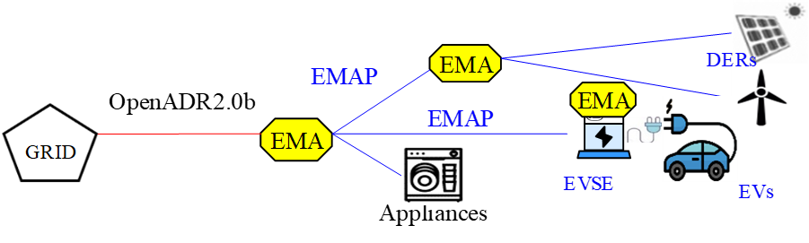

*Figure N: EMAs for Cooperative Energy Management*

#### EMA Protocol (EMAP) in Smart home integrated with EV charging

For Smart home integrated with EV charging, various standard communication protocols have been developed. For sending DR signals between grid and the home, OpenADR is often used as an application layer protocol. SEP 2.0 and ECHONET are application layer protocols for use in smart home. SAE J2836/J2847/J2931 and ISO/IEC 15118 are suites of standards of two-way digital communication between EV and EV supply equipment (EVSE) for smart charging and discharging control [7]. IEEE's standard 1547 is intended to mitigate many of these DER impacts by defining how DER devices are designed and tested, and how DER will be integrated into the power system.

EMA Protocol is a protocol to facilitate high-level communications among EMAs, EVs and DERs for cooperative energy management applications [5]. In this context, control of the energy systems will allow the management of energy flow generated from DERs and EVs for consumption or for storage in the collective EVs. The intent of EMAP is to accommodate flexible and efficient energy management systems according to the customer’s budget over a broad range of EMA deployments.

EMAP specifies message formats for energy related information including DERs, pricing, and DR commands to manage customer energy resources, including load, generation, and storage in a home, building and apartment complex. The message sets support direct load control, time-of-use (TOU), critical-peak-pricing (CPP), real-time pricing (RTP), peak time rebates, various types of block rates, transactive energy, charging, discharging and a range of opt-in, opt-out and service modifications. EMAP must support bi-directional exchange of DR event between EMAs for co-operative energy management by using the opt commands in a hierarchical or point-to-point architecture.

EMAP is an IEC-ISO application layer protocol among EMAs for cooperative energy management in smart home environment [5]. EMAP specifies interacting procedures and message formats to ensure interoperability over a broad range of EMA deployments. It also specifies a communication mechanism through which application layer messages based on UML based data modeling may be passed across EMAs.

EMAP gives a set of the message interactions for performing various functions and operations. The transport mechanisms rely upon standard-based IP communications, such as Constrained Application Protocol (CoAP) and JavaScript object notation (JSON) messaging: CoAP is a specialized Internet Application Protocol for devices with limited processing capability, as defined in RFC 7252[8]. It enables EMA devices to communicate with the Internet using similar protocols. CoAP is designed for use between devices on the same constrained network (e.g., low-power wireless home networks), between devices and general nodes on the Internet, and between devices on different constrained networks both joined by an internet. JSON is a public file format as defined in RFC 7159 that uses human-readable text to transmit data objects consisting of attribute–value pairs and array data types (or any other serializable value) [9]. It is a very common data format used for asynchronous browser–server communication.



*Figure N: High-level protocol architecture of EMAP*

#### IEEE 802 Requirement for Integrating EV charging in an EMAP network

EMAP network requires the Development of an IEEE 802.11/TSN integrating smart home, DERs and EV charging system for cooperative energy management and control.

* Bidirectional data flow among Storages, DERs and EVs to support coordinated Energy Management and automation control (e.g., active and reactive power balance) in home microgrid.
* Regulation of power demand for the continuous balancing of generation, load, and interchange at a very granular level.
* Metering and sensing measurement for real-time control of power systems or microgrids

EMAP network requires evolution of IEEE 802.11/TSN for Electric Vehicle and Smart home Integration.

* To take advantage of the charging system and allow for a scalable approach while improving reliability and resilience in smart home with renewable energy sources.
* To take advantage of Collaboration and Coordination among smart home, DERs and EVs
* to compute charging schedules and to implement demand response and ancillary services [Collaborative Autonomy]

IEEE 802 provides a high number of wired and wireless solutions for the Physical and Link layer functions of communication links to serve a very wide range of interconnecting requirements of applications. Often the Generic IP protocol stack is used for realizing vertical applications, like HTTP, CoAP, or MQTT in the Application layer. IEEE 802 technologies allow for more specific network solutions when particular requirements or conditions arise. IEEE 802 standards allow the transmission of critical data in real time with a conventional Ethernet infrastructure in integrating smart home, DERs and EV charging system for cooperative energy management.



*Figure N: High-level protocol architecture of IEEE 802 based EMAP*

#### Future IEEE 802 communication design (802.11 series vs. Ethernet vs. TSN) enables near real-time communications for Integrating EV charging in an EMAP network

IEEE 802.11p technology is the popular standard for vehicular networks, offering a coverage area of up to 1km, data rates of up to 54 Mbps and latency as low as 50 ms. IEEE 1609 “Wireless Access in Vehicular Environments (WAVE)" is a higher layer standard based on the IEEE 802.11p. This includes data exchange between high-speed vehicles and between the vehicles and the roadside infrastructure, so called V2X communication, in the licensed ITS band of 5.9 GHz (5.85–5.925 GHz).

IEEE 802.11 is less expensive, supports mobility of devices, and its widespread prior adoption compared with other communication technologies is useful to equip the locations, such as parking areas, with wireless communication between EVs and CSs.

The significant advancement has been accomplished for the communication infrastructure with the special technologies that include the IEEE 1588 v2 or Precision Time Protocol (PTP) and Time-Sensitive Networking (TSN) standards to this area. These technologies are a clear evolution of the real-time control and allow synchronization levels of over few ms to be achieved.

TSN based LAN networks allow for higher levels of bandwidth utilization (75%) with lower latencies. TSNs were able to reduce this latency. With IEEE TSN’s ability to both synchronize timing for measurements as well as quickly move this data through a network, the feasibility of a large distributed state estimation system becomes more practical. It enables near real-time communications to request immediate energy consumption at the moment of generation or for use of the reserved energy to switch the energy systems from charging mode to power supply mode.

# Distributed Energy System support for EV Charging

Introduce and expand on the concept of ‘energy edge’ and its convergence with LAN/MAN (the Internet and content edge) and edge computing (the data/ML edge).

# Communications and Networks supporting AFV Fueling

The culmination of our whitepaper, providing details on the topics in the subsections below.

## Communications requirements

Speeds and feeds, both minimal and aspirational.

## Network architecture

Expanding on the diagrams below from 24-23-0007-00-0000-draft-afv-whitepaper.docx

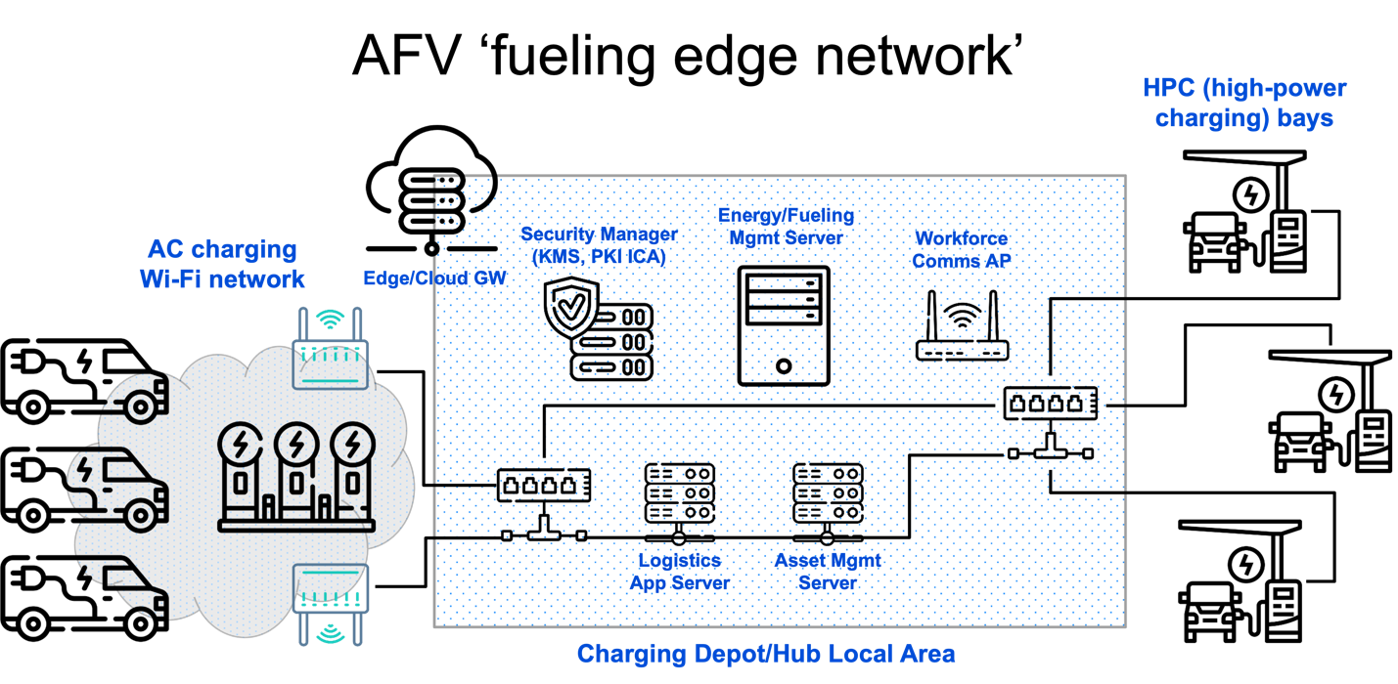

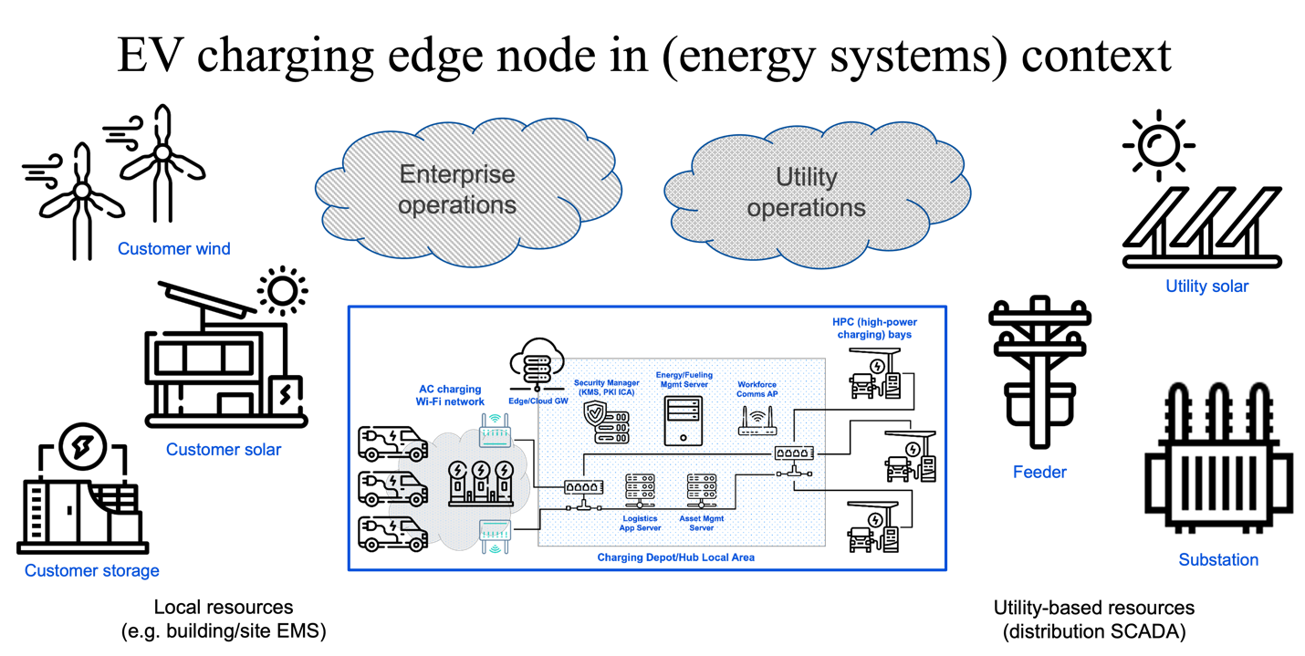

## Device and network cybersecurity and management

Survey the applicable IEEE 802 standards relevant and applicable to this concern.

# IEEE 802 Standards and Technologies supporting AFV Fueling and the Energy Edge

A survey of specific IEEE 802 Standards/Clauses and Amendments that would comprise a secure communications fabric/foundation for the ‘energy edge’.

# Conclusions and Recommendations

# References

1. J. S. Choi, "Energy management agent frameworks: Scalable, flexible, and efficient architectures for 5G vertical industries," IEEE Industrial Electronics Magazine, vol. 15, no. 1, pp. 62-73, March 2021
2. ISO/IEC 15067-3:2012, Information technology – Home Electronic System (HES) application model – Part 3: Model of a demand-response energy management system for HES
3. ISO/IEC 15067-3-3:2019, Information technology – Home Electronic System (HES) application model – Part 3-3: Model of a system of interacting energy management agents (EMAs) for demand response energy management
4. ISO/IEC 15067-30:FIDS, Information technology – Home Electronic System (HES) application model – Part 30: EMA functional requirements and interfaces
5. ISO/IEC 15067-3-31:FDIS, Information technology – Home Electronic System (HES) application model – Part 3-31: Protocol of energy management agents for demand response energy management and interactions among these agents
6. J. S. Choi, "A hierarchical distributed energy management agent framework for smart homes, grids, and cities," IEEE Communications Magazine, Vol. 57, No. 7, pp. 113-119, 2019
7. T. Shimizu, T. Ono, W. Hirohashi, K. Kumita, and Y. Hayashi, “Experimental demonstration of smart charging and vehicle-to-home technologies for plugin electric vehicles coordinated with home energy management systems for automated demand response,” SAE International Journal of Passenger Cars-Electronic and Electrical Systems, vol. 9, no. 2016-01-0160, pp. 286–293, 2016.
8. IETF RFC 7252, The Constrained Application Protocol (CoAP), edited by Z. Shelby et al., June 2014, available at: <https://tools.ietf.org/rfc/rfc7252.txt> [viewed 2023-05-31]
9. IETF RFC 7159, The JavaScript Object Notation (JSON) Data Interchange Format, edited by T. Bray, March 2014, available at: https://tools.ietf.org/rfc/rfc7159.txt [viewed 2023-05-31]