IEEE P802.24
Vertical Applications TAG

Project | IEEE P802.24 Smart Grid Technical Advisory Group
Title | TAG Minutes March 2021
Date Submitted | May 12, 2021
Source | Benjamin A. Rolfe  (Blind Creek Associates) | Voice: +1 408 395 7207  Fax: Deprecated  E-mail: ben.rolfe @ ieee.org
Re: | 802.24 TAG minutes
Abstract | Meeting minutes for 802.24 TAG and TGs.
Purpose | Document meeting and action items.
Notice | This document has been prepared to assist the IEEE P802.24. It is offered as a basis for discussion and is not binding on the contributing individual(s) or organization(s). The material in this document is subject to change in form and content after further study. The contributor(s) reserve(s) the right to add, amend or withdraw material contained herein.
Release | The contributor acknowledges and accepts that this contribution becomes the property of IEEE and may be made publicly available by P802.24.

Minutes TAG 24
  - May 2021 Virtual Interim
802.24 TAG
TAG and TG1 Chair: | Tim Godfrey (EPRI)
Vice Chair and Recording Secretary: | Benjamin Rolfe (Blind Creek Associates)
TG2 Chair: | Chris DiMinico (MC Communications)
Table of Contents
Wednesday, March 17, 2021 2
Opening 2
Low Latency White Paper 3
TG2 IoT White paper 3
IEEE 802 Solutions for Vertical Applications 3
IETF Reliable and Available Wireless 3
Vertical Applications – Industry Standards 3
Tech Talk Discussion 4
2020 Future TAG Activity Planning 4
Next meetings 4
AoB 4
Adjourn 4
Gratuitous Squirrel Picture 5

Wednesday, May 12, 2021

Opening
Meeting called to order at 10:30 ET by TAG Chair Tim Godfrey.
Chair presents meeting slides document # 24-21-0006r00.

The chair presents the Guidelines for IEEE-SA Meetings and Participation in IEEE 802 Meetings, including the copyright slides provided by IEEE. An opportunity is provided for attendees to respond. No responses nor questions heard.

Agenda given document # 24-21-0006r00. Following neither discussion nor objection, agenda approved by unanimous consent.

Approval of Minutes of March meeting, document # 24-21-0003r0: Following neither discussion nor objection, minutes approved by unanimous consent.

Liaison Updates
Chair reviews liaisons. Noted that the Zigbee Aliance has a new name, now Connected Standards Alliance (CSA).

802.18 RRTAG Update
Nothing to report (RRTAG chair not present).

Low Latency White Paper
Latest draft is in document #24-19-0003r09. Following the last meeting, results of the work have been applied to create revision 09. Chair reviews changes from previous version.

Discussion:
- Further input on use of n802.15.4 UWB for low latency applications (Ben)
- Further input on security issues related to low latency networks (Allan)

TG2 IoT White paper
TG2 Chair presents status (doc # 24-15-0036r02).
Chair briefs on the results of outreach efforts.

IEEE 802 Solutions for Vertical Applications
The effort formerly known as “Network Integration” (document #24-19-17r05). Request from Max R. (via email to chair) to identify stakeholders and interested parties to help complete.

Tech Talk Discussion
Chair did a “Tech talk” with 802 chair Paul N.
[add link]

2020 Future TAG Activity Planning

AoB
None

Next meetings
Will meet virtually in July. Details to follow via the email reflector.

Adjourn
Adjourned at 11:01 EDT.

Gratuitous Squirrel Picture

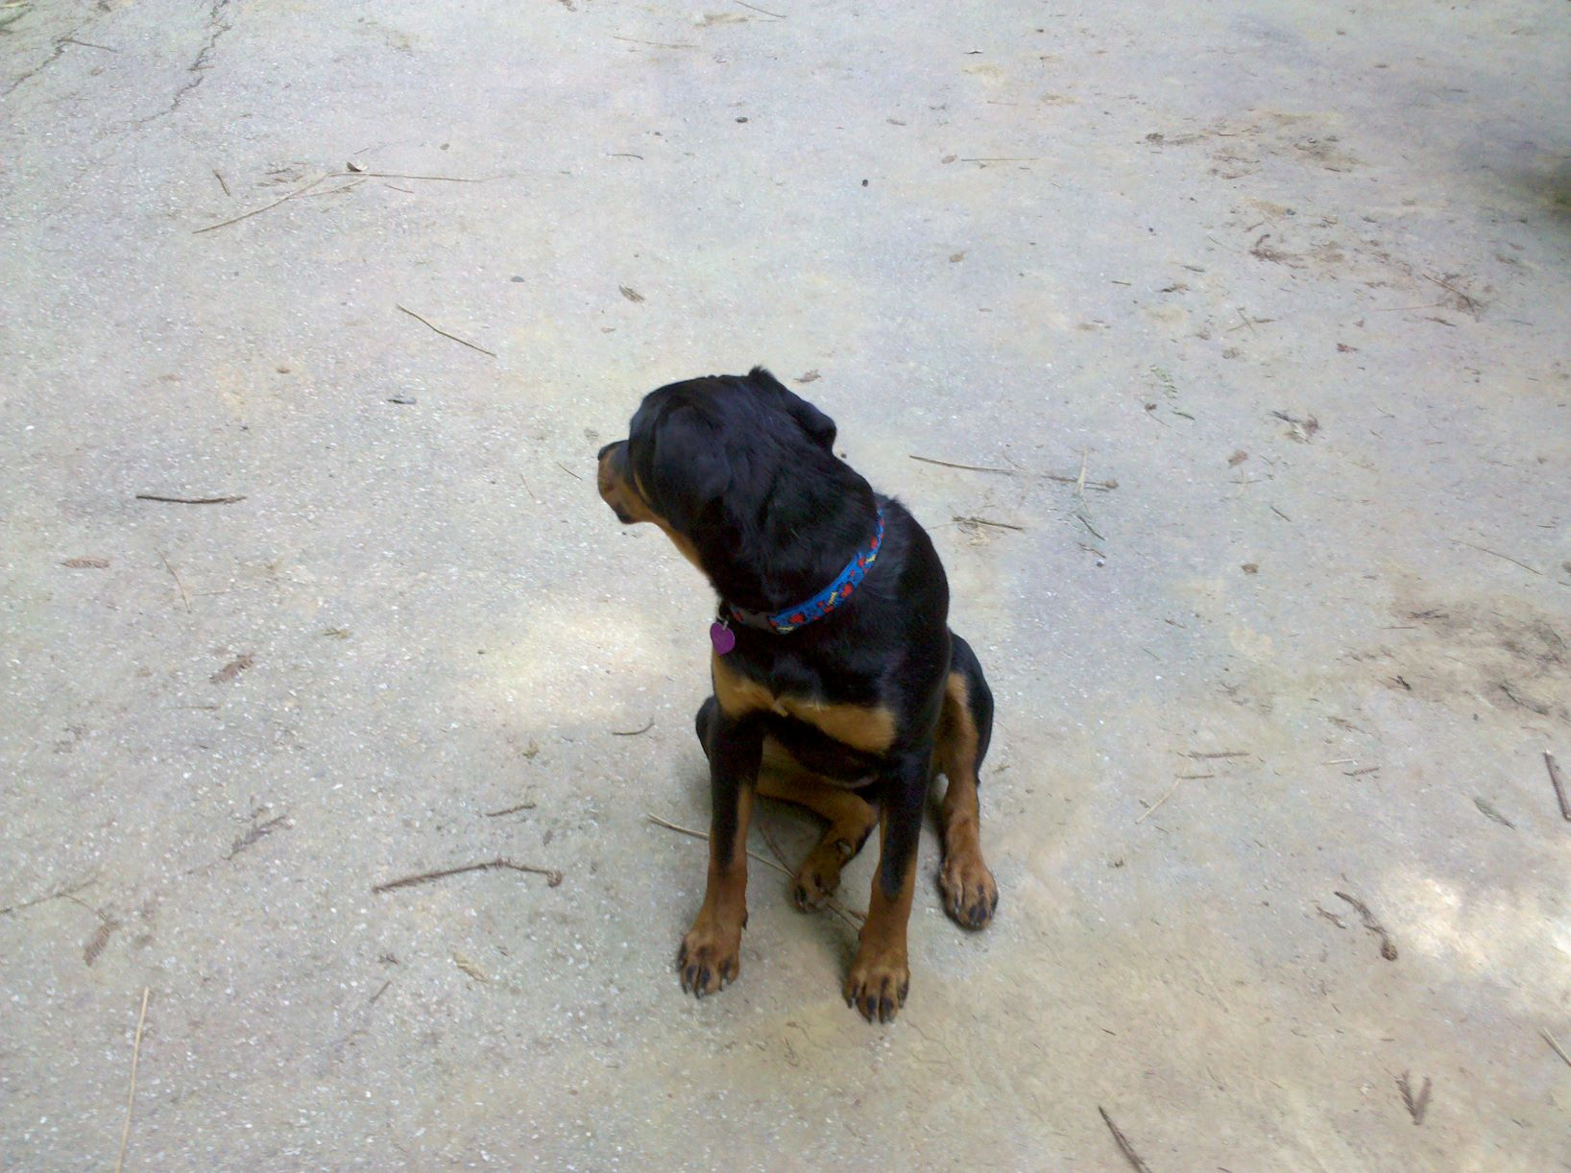

Did someone say “squirrel?”

