IEEE P802.24
Vertical Applications Technical Advisory Group

Project | IEEE P802.24 Vertical Applications Technical Advisory Group
Title | IEEE 802 Solutions for Vertical Applications White Paper
Date Submitted | 11 November 2019
Source | Max Riegel (Nokia)
Re: | IEEE P802.24-19-0017-03
Abstract | Addition of description of IEEE Std 802.1CF (OmniRAN)
Purpose
Notice | This document has been prepared to assist the IEEE P802.24. It is offered as a basis for discussion and is not binding on the contributing individual(s) or organization(s). The material in this document is subject to change in form and content after further study. The contributor(s) reserve(s) the right to add, amend or withdraw material contained herein.
Release | The contributor acknowledges and accepts that this contribution becomes the property of IEEE and may be made publicly available by P802.24.

Background and Introduction
What is the value and differentiation of the IEEE 802 architecture in the context of vertical markets? How is IEEE 802 better suited to deployment in the communication infrastructure of private enterprise, industry, and the individual user?
How does IEEE 802 compare to network architectures oriented towards service providers?
The IEEE 802 architecture enables networks that are like Ethernet: Well understood, mature, predictable. It offers a “cleaner” integration of disparate technologies under the common architecture and addressing.

Requirements of Vertical Applications

Define Vertical Applications – various systems including network connectivity that preform specific tasks or enable use cases for their industry.

Defining “Vertical”
In the context of this white paper, Vertical Applications refers to networks that serve specific use cases in specific market segments. The network is used by the entity to enable its business processes. This is in contrast to an access network, where the network services are the product.

Vertical markets involved specific usage models:
- Industrial automation
- Building Automation
- Smart Cities
- Smart Grid / Utility
- Automotive / transportation
- Agriculture
- Connected Supply Chain
- Critical infrastructure protection and control
- Wide area gaming (including AR/VR)

There are other ways of looking at vertical. Vertical integration is really a competition/anti-trust term, rather than a technical term. In that context it describes a technical situation that some set of functionalities that may be provided by the same company could actually in practise also be provided by different companies. So, for instance, "5G" is "vertically integrated" because it actually assumes - from the technical spec - that a single commercial provider will be responsible for a whole range of different features that are not really separable. But IEEE 802 is not "vertically integrated" in that sense because you could just as well have different operators of
different networks (one does wired, someone else wireless, etc).

Define some reference specifications for vertical markets
Unique requirements, may be specific to the vertical markets

Vertical markets often required highly-engineered networks. Not commodity service.
Vertical markets operate on a different lifecycle – the vertical network is expected to remain in service for a longer time than a service-provider network.
Vertical markets may have different cost models. Some are opex averse, others are capex averse.

Key Aspects of the IEEE 802 Network Model

Layering
- IEEE 802 is a transport network
- IEEE 802 is Layer 2
- 3GPP RAN is layer 3 only, Layer 2 is not available
- IEEE 802 provides direct and simultaneous support of IPv4 and IPv6 or pure layer 2 protocols
- IEEE 802 offers trade-off and optimizations between flexibility (L2) and scalability (L3)

Routing and Bridging
- IEEE 802 enables networks to scale with routing and bridging.
- IEEE 802 supports layer 3 protocols such as IP, which enables routing to enable IEEE 802 networks to expand to higher scale
- IEEE 802 networks can be built at smaller scale to provide more flexibility
- Smaller scale provides opportunity for real-time
- IEEE 802 standards can emulate a point to point network over a wireless point to multipoint network to enable bridging over the wireless link.
- IEEE 802 can route via L3 when needed. 3GPP cannot offer L2
- IEEE 802 can also offer L2 routing when appropriate (e.g. 802.15.10)
  - Note: Not an alternative to L3 routing, but there to address a different problem

Management and Control
- IEEE 802 does not provide as many means of control for a specific end device and its traffic on a path.
- There are some management facilities in some standards
- It is easier for IEEE 802 to support an “unmanaged” network, such as consumer Wi-Fi.
- 3GPP networks provide more tools for subscriber management, and assume that active management.
- 802 provides local networks that may be (but don’t have to be) connected into theInternet or other networks.
- Operator networks are focused on services for single devices, while IEEE 802 networks support and include multiple devices (networks of networks) – devices can communicate with each other as well as with other networks

IEEE 802 compared to other wireless IoT Networks
- Commercial, proprietary IoT LPWAN services
  - They don’t have an “Ethernet-like” L2. The system does not have the concept of a LAN. It is terminal to central “gateway” only. Star topology only.
  - Similar to LTE UE to UE traffic that must route through core. (DTD Proximity services have addressed that to some extent in LTE)
- 5G URLLC, and MMTC.
  - IEEE 802 has already developed TSN in wired standards (802.1 and 802.3),
  - IEEE 802.16 and 802.22 standards operate in licensed spectrum and offer scheduled MAC operation and services for bounded low latency

  - Latency is impossible to guarantee in unlicensed, shared spectrum. However, it can be highly optimized by the MAC layer. Low latency capabilities are part of the scope IEEE 802.11be amendment.

  - IEEE 802 has a history and internal coordination of coexistence between different standards operating in unlicensed spectrum. 3GPP is oriented towards exclusively licensed spectrum, “sharing” has been a foreign concept. More recently 3GPP has shown some willingness to coexist with 802.11 in 5 GHz and 6 GHz bands.
- 3GPP has a common strategy for the three primary use cases identified for 5G (eMBB, mMTC, URLLC). IEEE 802 has a common architecture, but not a common business strategy.
- License exempt can provide higher economic value per MHz of spectrum.
  - See Wi-Fi Alliance 2018 study on economic value of WI-Fi.
  - See Cisco Visual Networking Index. Wi-Fi carries more data than all cellular spectrum
- Wi-Fi created the expectation of broadband wireless that led to the development of LTE
- What would it look like to combine multiple IEEE 802 standards into a single offering?
  - Some vendors already do that – integrating 802 technologies into systems.
  - The “Package” offered by the “5G” ecosystem is clearly articulated.
  - What is the comparable offering from IEEE 802?

IEEE Std 802.1CF “OmniRAN” in vertical application networks

A common foundation of the network architecture for a variety of vertical applications is provided by the IEEE Std 802.1CF-2019 IEEE Recommended Practice for Network Reference Model and Functional Description of IEEE 802 Access Network.
All communication networks providing the means to connect various communication endpoints (terminals) to the same or different information servers over a shared infrastructure follow the same architectural principles. IEEE 802 technologies well support the realization of an access network, that establishes the shared infrastructure allowing to manage the connections of a wide variety of terminals through wired or wireless interfaces to their communication peers, either through bridging in the local area, or through routing by an access router in more widespread networks.
Figure 1 below shows the mapping of the IEEE 802 Network Reference Model (NRM) to usual communicaton network topologies. Core of the NRM is the Access Network that connects terminaly either directly through bridging or forwards traffic to the access router when the communication peer is behind the same Layer 2 domain. Various control entities support the access network to provide secured and managed connectivity.

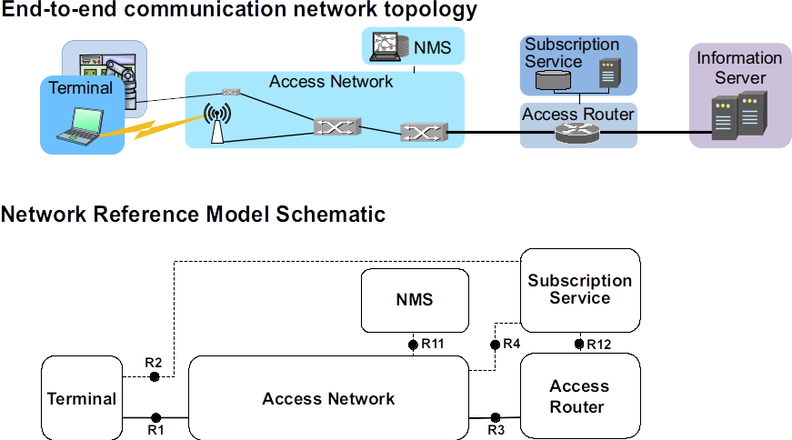Figure 1: Network reference model design

NMS denotes the network management system that provides the functions to configure and to monitor the correct operation of the access network infrastructure. The subscription service is the control entity that deals with the communication demand of the individual terminals. It provides authentication to restrict the usage of the access network to only known terminals and provides to the access network the configuration parameters that each of the terminal expects for proper operation.
Figure 2 below further details the network reference model through exposing the internal structure of the access network as well as the terminal and access router, and through the definition of reference points labeled R1 to R12 to denote control and user data interfaces of the access network. Solid lines indicate the path of the user data, while dotted lines indicate the flow of control information. The figure also shows an additional control entity called Coordination and Information Service, which is only needed when multiple access networks dynamically share the same communication resources, like in the case of dynamic spectrum management or dynamic resource sharing of virtual and virtualized access networks.
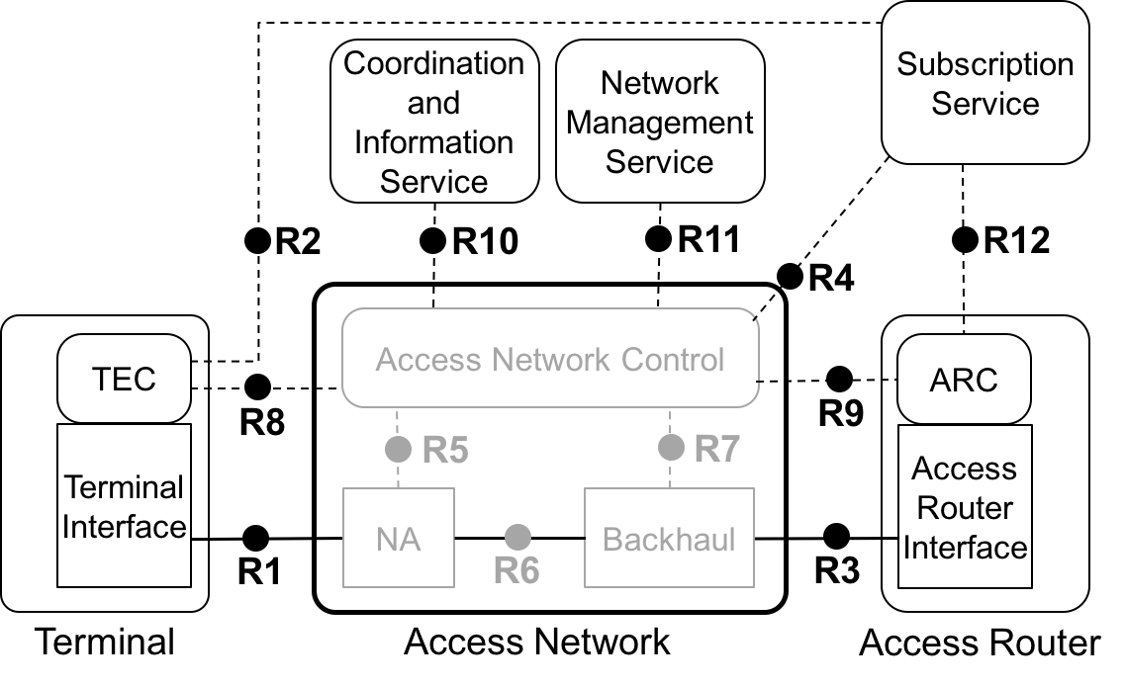Figure 2: IEEE 802 Network Reference Model
The IEEE 802 NRM is a conceptual model allowing many different implementations to leverage the same foundation and network functions, but it is not not intended as exact blueprint for the installation of a real network. Vertical applications have very specific networking requirements. To accommodate the variety of the requirements, the IEEE 802.1CF provides guidance and a common structure to build powerful networks out of the universal IEEE 802 technology building blocks.
The applicability and flexibility of the approach is demonstrated in IEEE Std 802.1CF through the mapping of the NRM to a number of deployment scenarios from a simple WLAN router, home networks, simple and more complex enterprise networks, industrial networks, public WLAN hotspots to virtualized WLAN access networks for in-building IoT services and networks for fog computing.

In addition to a common network reference model introduced above, the specification also provides generic functional description of the operation of an access network build through IEEE 802 technologies. Figure 3 below shows the funtional phases of an access network during a session of an IEEE 802 terminal. The session begins with the terminal searching for potential access to an network and ends with either terminal or network tearing down the connectivity.

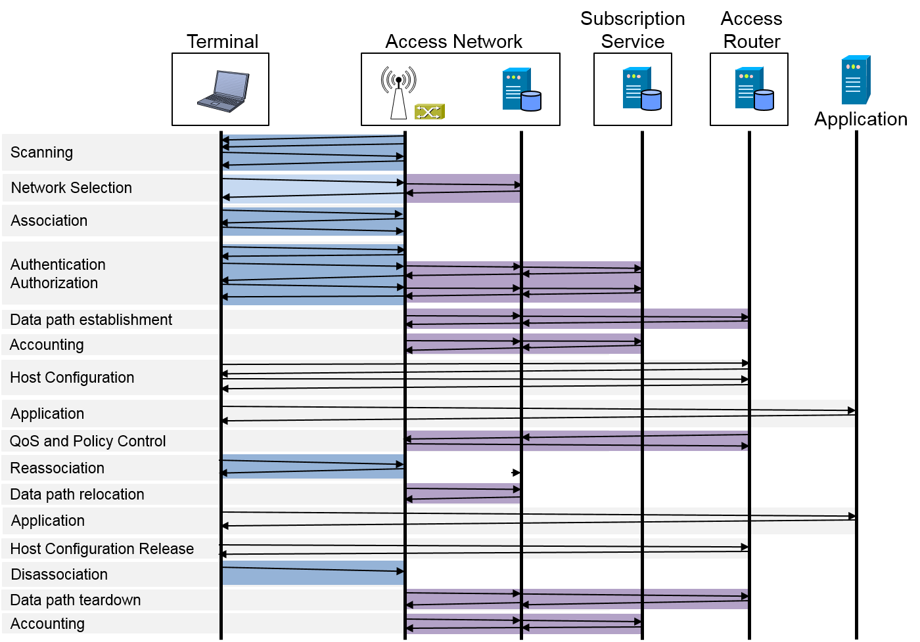Figure 3: Lifecycle of a user session
There are many network functions invoked between the begin and the end of a session, and the figure 3 above shows a typical example mainly aligned to the IEEE 802.11 air interface. The functional description provides a comprehensive reference of the management and control information conveyed over the reference points between the access network and external control and management entities. Such reference is not only helpful for educational purposes but also fosters commonalities in the design of the control gear of IEEE 802 access network and provides a development base towards virtualization of IEEE 802 access networks.

While well-known models like VLANs in IEEE 802 or the network slicing solution of 3GPP provide several isolated user data planes in a common infrastructure, which can be either assigned to different services or to different tenants of the network, the network functional modeling provides the prerequisites for setting up multiple instances not only for the user data path, but also for all the control associated with a user data path. Separating not only the data paths of multiple tenants, but also all the control associated with a data path allows to address one of the main prerequisites of deployment of vertical application networks, the need for independent operational domains for each of the verticals. Virtualized IEEE 802 access networks behave exactly the same way as dedicated access networks but have the cost and scalability benefits of making use of a common infrastructure. It is the same approach that was taken through Virtual Machines (VMs) leading to the establishment of cloud computing.
Figure 4 below sketches the concept of virtualization of IEEE 802 access network. Three instances are shown based on a common infrastructure, each with its own control entitites and interfaces towards terminals and application servers reachable through the access router. As infrastructure resources can be dynamically shared among the virtualized networks, the CIS acts as control entity managing the dynamic assignment of infrastructure rescources.

The virtualized access network example shown above is directing into potential network evolution beyond the current understanding of network slicing. However, the IEEE 802.1CF specification already provides the model and concepts of virtualized access networks, that can be fully build based on existing IEEE 802 protocol specifications. It is shown that realization of such powerful networking concepts with IEEE 802 technologies is a matter of implementation without the need for lengthy standardization activities. Just, let’s do it.
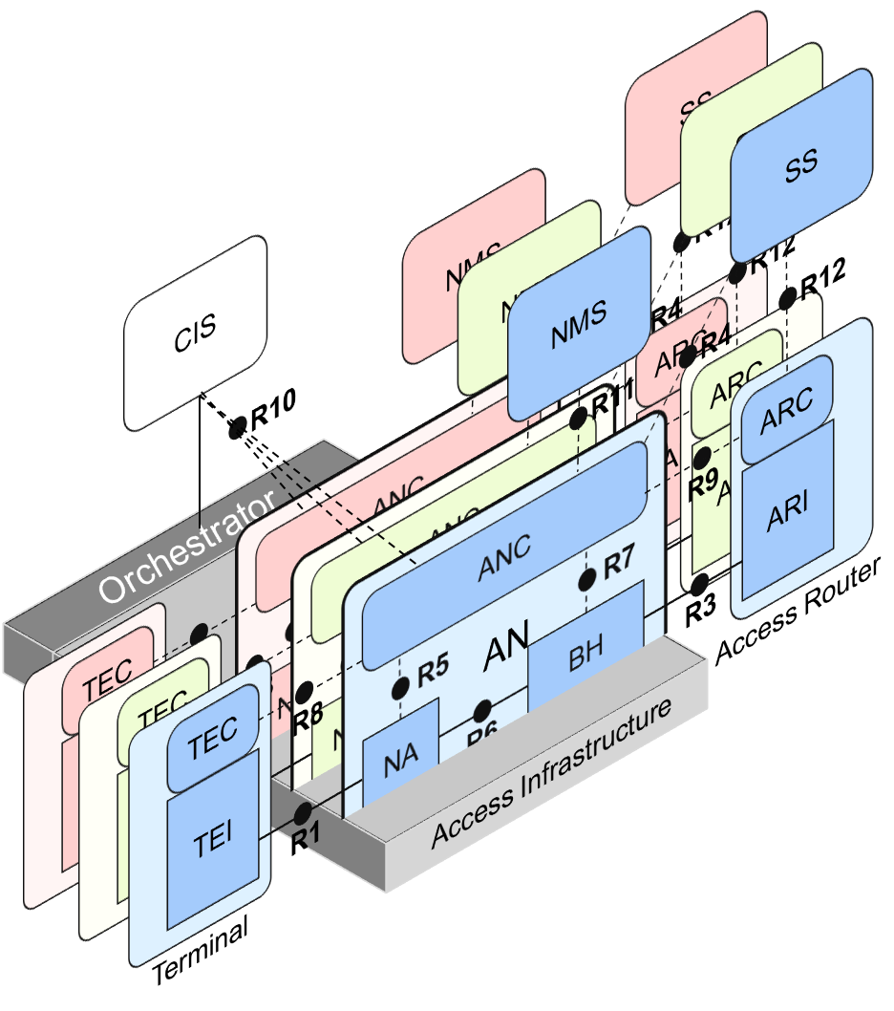Figure 4: Multiple instances of virtualized IEEE 802 access network
IEEE’s (Advanced Access Network Interface) AANI standing committee is about integrating 802.11 into the 5G domain. There is nothing corresponding in 3GPP for integrating into 802.
Industry connections – NENDICA: Flexible Factory IoT, Data Center Bridging

What’s missing – a picture of 802 as a peer to 5G. 5G promises they will do “everything”.
But, they don’t define any wired standards, but they support them.
5G requires an extensive PLMN to support it.
It is designed to help the cellular operator grow their market.
Verticals might not want an operator in the middle of their network.
However, private 4G or 5G networks are possible.
Value proposition: 802 networks are customer-owned.
Example – Santa Clara Emergency services issues

Provisioning and service discovery in vertical application networks
Is there a need for an IEEE 802 activity for improving provisioning? Can IEEE 802 offer a provisioning solution as flexible as the SIM? Can the SIM be adopted into IEEE 802?
Security, Network Health, Better sharing and coexistence in spectrum
What can IEEE 802 do to enable “SD-WAN” types of services for the heterogeneous network in a vertical?
- Application-sensitive provisioning?
- What is the role of edge computing?
- What is the IEEE 802 analogy for 5G Network Slices?
  - OmniRAN has done this with Virtual LANs. OmniRAN took it one step further. A Network Slice is a separated user plane, with a common control plane. Traffic classes are separated by tags.
  - The VLAN as defined today provides the network slice capability. It can provide service differentiation, and forwarding differentiation.
  - There is nothing in 5G network slicing that is not covered by a VLAN.
  - OmniRAN went further to virtualize and separate control planes. This capability is not available in 3GPP – the operator is assumed to control everything.
Slices to be adapted to the set of application requirements

Business Models for Vertical Application Networks
The network “enables creating/delivering a product” vs “the network is the product”

- IEEE needs to think about how to create that package without a “subscription model”
  - IEEE 802 is often free to use
- IEEE 802 is deployed in vertical markets, where the network is owned and operated by the user of the services.
- Are there other models for IEEE 802 other than subscription that can provide ancillary economic value?
  - Is management of shared spectrum a candidate?
  - An economy of scale can be accomplished by creating a network that can be leveraged by multiple entities. This is similar to the cloud thinking – the model of sharing the infrastructure (network) without the need for them to be independently installed and managed. A similar concept to a data center just providing computing resources, but not dealing with installing and running software for all the needed services.
  - The trend toward more virtualization is a strength of IEEE 802 because it allows the network to be better prepared for that virtualization. It provides the clean separation between the infrastructure and the service running on the infrastructure. In the IEEE 802 case, this is the layer 2 to layer 3 boundary.
  - The IEEE 802.3 Ethernet transport is the most well understood transport in existence. This is analogous to the X86 computer architecture that became the basis for the computing resources of data centers.
- IEEE 802 and unlicensed spectrum enables faster innovation
  - Many of the breakthrough innovations were not as planned
  - The story of why IEEE 802 complements everything else, and everything else (alone) is not sufficient.
- IoT is built around many specialized niches. The challenge is meeting the diverse requirements. No single standard can address all of them well. IEEE 802 provides multiple standards to address multiple IoT applications.

Modularity and Interchangeability, competition economics
A user of a vertical application may want to be able to replace parts of their vertical application network with a better, newer product when one arrives (for instance, installing a new AP when a better one is available from a different vendor). IEEE 802 products lend themselves to this form of user-empowered modularity.
Building blocks with smaller functional content and broader variation offer this flexibility to the vertical application. 3GPP 5G (or cellular networks in general) does not have this modular feature. Although many vendors of UEs can be certified to the specifications, it is much harder for the network owner to mix multiple vendors in the RAN and Core of the network.

Possibility of small business entities deploying small scale networks
It would be possible for a small utility or municipality with only a few employees to set up a reasonably secure Wi-Fi network at their workplace, perhaps with temporary help from a consultant if they were making sure it was really secure. But they would find it much more difficult to acquire a municipal spectrum license for LTE technologies, and install, configure, and maintain a 3GPP private network infrastructure.
IEEE 802 also enables a greater degree of scalability. A network that starts small can easily be scaled to more complexity and users as the business grows. A 3GPP access network is designed from the start for large scale, and is more difficult to apply at a small scale.

Conclusion
Future perspectives – how can IEEE 802 evolve to better serve vertical markets?

References

http://grouper.ieee.org/groups/802/11/Workshops/2019-July-Coex/workshop.htm
https://www.wi-fi.org/news-events/newsroom/wi-fi-global-economic-value-reaches-196-trillion-in-2018
https://www.cisco.com/c/en/us/solutions/service-provider/visual-networking-index-vni/index.html

