IEEE P802.24
Vertical Applications Technical Advisory Group

Project | IEEE P802.24 Vertical Applications Technical Advisory Group
Title | Low Latency Communication White Paper
Date Submitted | 2019-09-18
Source | Oliver Holland  Advanced Wireless Technology Group, Ltd.  London, UK | Voice: +1 407 773 6211; +44 7916 311973  E-mail: oliver.holland@awtg.co.uk
Re: | N/A
Abstract | This contribution provides a first version of the Table of Contents of the Low Latency Communication White Paper. It will be updated (along with this Abstract) as the content materializes and is included.
Purpose | Assist in the development of the Low Latency Communication White Paper
Notice | This document has been prepared to assist the IEEE P802.24. It is offered as a basis for discussion and is not binding on the contributing individual(s) or organization(s). The material in this document is subject to change in form and content after further study. The contributor(s) reserve(s) the right to add, amend or withdraw material contained herein.
Release | The contributor acknowledges and accepts that this contribution becomes the property of IEEE and may be made publicly available by P802.24.

Background and Introduction
General information on low latency communication, background and the drive for it (e.g., linked to “5G” and IMT-2020 requirements), possibilities that are created (in a general sense), challenges that are encountered, etc.
The purpose of the white paper is to inform users and IEEE 802 working groups on the applications and requirements for low latency communications.

Low Latency Communications Applications
Some detail about the possible applications for low latency communications. E.g., Haptic Communication expanding the human senses and interactions that can be conveyed over communication links, expanding machine “senses” and interactions that can be conveyed over communication links, the “Tactile Internet” and Industry 4.0, investment/trading(?), etc. It will be noted that many of the applications also link to high reliability, profoundly affecting the low latency solutions that might be used.

Different application categories / markets
Unique low latency requirements specific to applications and markets

Consider dividing applications and use cases into human interaction and machine-only.
Haptic applications include a human – tactile and kinesthetic. (Oliver Holland)
Haptic and VR environments are the most challenging for low latency since the user is engaged with more senses, and more sensitive? Latency has a bigger effect.

Remote Surgery and Tele-medicine

Many critical infrastructure applications are machine only, but still latency-critical.
E.G. electric utility grid protection

Add content from TSN white paper on grid protection

Implications of low latency networks on cyber-security. How is the threat surface changed in a low latency network?

Crisis management – ensuring that applications that require low response times are not affected by crisis events. More related to ultra-reliable than low-latency communications.

Use Case Applications from 802.11 RTA TIG (11-18-2009r6

Real-time Mobile Gaming

Real-time mobile gaming is a fast-developing application category. Different from traditional games, real time mobile gaming is very sensitive to network latency and stability.

The mobile game can connect multiple players together in a single game session and exchange data messages between game server and connected players. Real-time means the feedback should present on screen as users operate in game. For good game experience, the end to end latency plus game servers processing time should not be noticed by users as they play the game.
The challenges that real-time mobile gaming encounter is the worst-case latency. Since the high latency spike is highly likely to cause packet loss and packet disorder, hence impact quality of experience.

Wireless Console Gaming

Console gaming which is also known as the video game is played on devices made especially for gaming. Starting with the Arcade games, it transformed to console games which began with cartridge storages which has changed to disks and inbuilt hard-drive storages. These advancements have now optimized the consoles to play online multiplayer gaming which involves instant response for your actions in the game and enables interactive gameplay.

Console gaming involves various genres of games, but the main genre we are focusing on is latency sensitive online FPS (First Person Shooter) games. This is an interactive gaming experience with real-time feedback and response. A Synchronized game state is established among players in the same match to get the best performance. FPS gaming is centered around guns and other weapon combats in the first-person point of view with which the player sees the action through the eyes of the player character.

In multiplayer FPS game, more than one person can play in the same game environment at the same time either locally or over the internet. Multiplayer games allow players interact with other individuals in partnership, competition or rivalry, providing them with social communication absent from single-player games. In multiplayer games, players may compete against two or more human contestants, work cooperatively with a human partner to achieve a common goal, supervise other players' activity, co-op. Multiplayer games typically require players to share the resources of a single game system or use networking technology to play together over a greater distance.

Playing online on a console has 2 types of internet connectivity, which is either wired or Wi-Fi. Most of the gaming consoles today support Wi-Fi 5. But Wi-Fi has an especially bad reputation among the gaming community. The main reasons are high latency, lag spikes and jitter. According to a top-selling online console game in the US up to 79% of FPS players are using Wi-Fi connected consoles.

Cloud Gaming

Cloud gaming is another type of video game potentially played on light-weight devices at users premise. Unlike other gaming hardware, user devices do not need to render pictures or video. Instead, they are rendered at the cloud server. The picture/video generated at the cloud server are streamed to the user devices, and the user devices just display the received picture/video on its display. The cloud game can accommodate and connect multiple players in a single game session just as mobile gaming scenario.
The cloud gaming requires low latency capability as the user commands in a game session need to be sent back to the cloud server, the cloud server would update game context depending on the received commands, and the cloud server would render the picture/video to be displayed at user devices and stream the picture/video content to the user devices. This cycle needs to be short enough so users do not feel lagging responses.
With cloud gaming experience, users can play large amount of game titles as they will be provided and hosted by the cloud server. Users can pick up game title from the library on the cloud server. Another benefit of the cloud gaming is that the user device could be light-weight in terms of hardware footprint. The user devices only need to decode and display received picture/video content. This way, users can enjoy realistic and immersive game experience without requiring heavy computation at user devices. The light-weight user device leads to lower cost and longer battery life, which could motivate gamers to play on the games more.

Industrial Systems

Industrial systems include a wide range of applications: process monitoring, automation, control systems, human-machine-interfaces (HMI), Automated Guided Vehicles (AGVs), robotics and AR/VR. Recently, several standard developing organizations have published detailed description of industrial application and their requirements, such as:
- IEEE 802.1 NENDICA Report Wired/Wireless Use Cases and Communication Requirements for Flexible Factories IoT Bridged Network (802.1-18-0025-06-ICne);
- IEC/IEEE 60802 Use Cases for Industrial Automation (TSN-IA Profile for Industrial Automation);
- 3GPP TR 22.804 Technical Specification Group Services and System Aspects; Study on Communication for Automation in Vertical Domains.

The purpose of this document is not to repeat the detailed application descriptions, which can be found in above references. Instead, the focus is to summarize the challenges and requirements of real-time and time-sensitive applications that are most relevant to 802.11.

Many industrial applications can be considered delay-tolerant (e.g. process monitoring, industrial sensor networks, etc.) with latency requirements in the order of 100msec or more. Such applications may be served by existing wireless standards and are not considered in this report. This report focuses only on time-sensitive and real-time applications.

Real-time video

Today, many devices handle video streaming via 802.11 wireless LAN. Most of them are not latency sensitive. However, some video applications require low latency capability, when the application provides interactive play. Example of such applications includes VR/AR, and video cable replacement [3].
In many of these cases, the latency requirements are derived from the video frame rate. As of today, 60Hz framerate is commonly used, i.e., 16.7msec per frame. However, it is possible that the video rendering system would migrate to high frame rate solution, i.e., 120Hz which resulting in 8.33 msec per frame, etc., in the future.
To accommodate end-end signal processing in a video frame, the signal processing delay plus transmission latency need to be less than 16.7 msec. For these applications, ideally, 10[msec] one-way or roundtrip delay should be considered as a targeted specification for the radio link transmission, allowing 6.7msec for other signal processing including, but not limited to, video signal encoding (compression), in-device frame forwarding, video signal decoding (decompression), etc.
When the video frame rate of 120 Hz (8.33msec per frame) is used, ideally, 3 msec delay should be considered as a target for the radio link transmission, allowing 5.33 msec for other signal processing.

The following figure depicts the difference between a video application which does not require low latency capability and a video application which requires low latency capability. In general, low latency requirements arise when there is a control loop in the system.

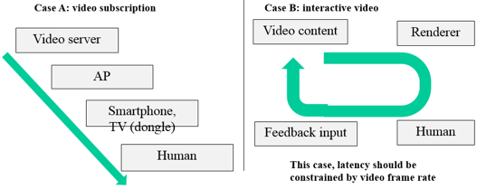
Figure 4-14 Difference between buffered video and live video

Drone Control

Drone is an aircraft without a human pilot aboard. Drones are rapidly popularized and utilized for a wide array of uses. Gartner mentions that worldwide production of drones neared 3 million units in 2017 [8]. Wi-Fi has an important role to control drones by providing following functions.

- Tele control
Controlling motions and functions of the drone. A few Kbps of data rate is required.

- Data transmission
Monitoring information from sensors in a drone or information of the status of the drone itself. A few Kbps~Mbps of data rate is required.

- Picture / video transfer
Transferring recorded pictures or videos by the drone. More than tens of Mbps of data rate is required.

Use Case Applications from 802.21 AR/VR enablers. (Subir, Dillon Seo)

  - Case 1: A Single VR System Connected via a LAN
In the picture below, a user is playing a VR game using a VR HMD connected to a game console system known as PlayStation 4 with HDMI (High Definition Multimedia Interface) and USB (Universal Serial Bus) cables. The HDMI cable is delivering both video and audio for the VR game that are rendered in real time by the game console (shown in figure) to the VR HMD. The USB cable is delivering the head tracking data from the VR HMD to the game console to reflect the user’s head position so that the game console can render both the video and the audio of the VR game accordingly in real time.
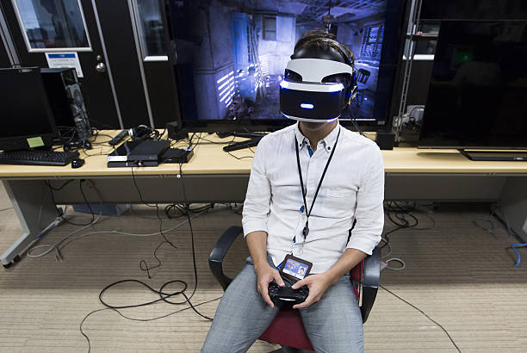

A Single VR System Connected via LAN
The following is a simplified logical network connectivity diagram of the above use case scenario in which the VR HMD is communicating to a local content server (e.g., a PC or a gaming console) via a local area wired network (LAN). The VR content service is rendered or decoded in the local content server.
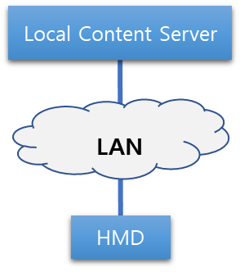

    - Issues/Limitations
The user mobility is limited due to the HDMI and the USB cables connecting to the VR HMD and to the local content server.
    - Recommendation
To increase the user mobility while playing a VR game, the wired LAN needs to be replaced with a wireless LAN. Since HDMI 2.0 cable is a fully dedicated and stable wire that can transfer 18 Gbps with less than 1 ms of latency, the wireless LAN that replaces the HDMI cable should be able to match the same conditions to support this use case scenario.

  - Case 2: A Single VR System Connected via a WAN
In the following picture, a user is watching a baseball game in a virtual reality environment using a mobile phone-based VR HMD system. The baseball game in this scenario is being captured with a 360-degree camera and it is being streamed to the VR HMD in real time. The head tracking data is also transferred to the camera via a mobile network to display the view where the user is looking at.
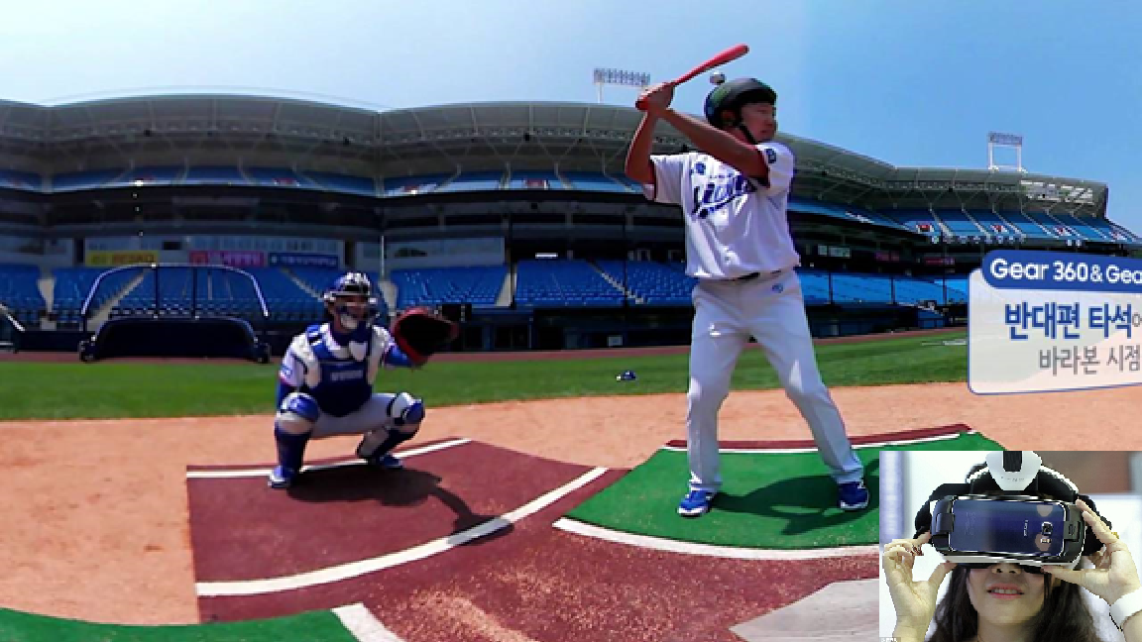
A Single VR System Connected via WAN
The following is a simplified logical network connectivity diagram of the above use case scenario in which the VR HMD is communicating to a remote content server (such as to a cloud service provider) and receiving the VR content service via a wide area mobile network. In this scenario, the VR content service is rendered or decoded in the remote content server. It is important to note that the remote content server is located outside the local network and wide area network (WAN) consists of both wired and wireless networks.
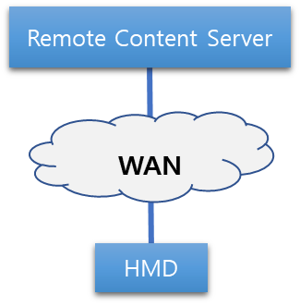

    - Issues/Limitations
Since the content server is located outside of the local area and the content data is traversing through multiple networks, the network latency is an important factor that will vary depending upon the network conditions. The increased latency may cause the poor video resolution quality and reduce the frame rate (e.g., due to network congestion). This drop of video quality results to VR sickness.
    - Recommendation
In order to maintain the optimal VR user experience, it is recommended that the video resolution quality should be remained as high as possible with a constant data transmission rate of 90 FPS. As the current commercial VR HMD supports the display resolution up to QHD (2,560 x 1,440) resolution and frame rate up to 90 FPS, the data transmission rate, which is calculated using the following equation,
$$Data Transmission Rate=Resolution x 24 bit \left(color\right) x Frame Rate$$
is roughly 8 Gbps uncompressed. Hence, the end-to-end network (Wired backbone and Wireless access) should be capable of transferring 8 Gbps of uncompressed data to support the use case scenario.

  - Case 3: Multiple VR Systems Connected via a LAN
In the following picture, a user is playing a virtual reality game and competing against other remote players using a VR HMD system that is connected to local server (e.g., a PC or a Laptop). The HDMI cable connecting the VR HMD system and the local server is used to receive the video and the audio data of the VR game content, the service of which is being rendered real time in the local server. The USB cable connecting the VR HMD and the local server is used to exchange the head tracking data so the server can render the video and the audio data accordingly. The remote content server is calculating the scores and the consequential data caused by the remote users’ input. These data are sent to the local content server so it can render the video and the audio of the VR game content accordingly.
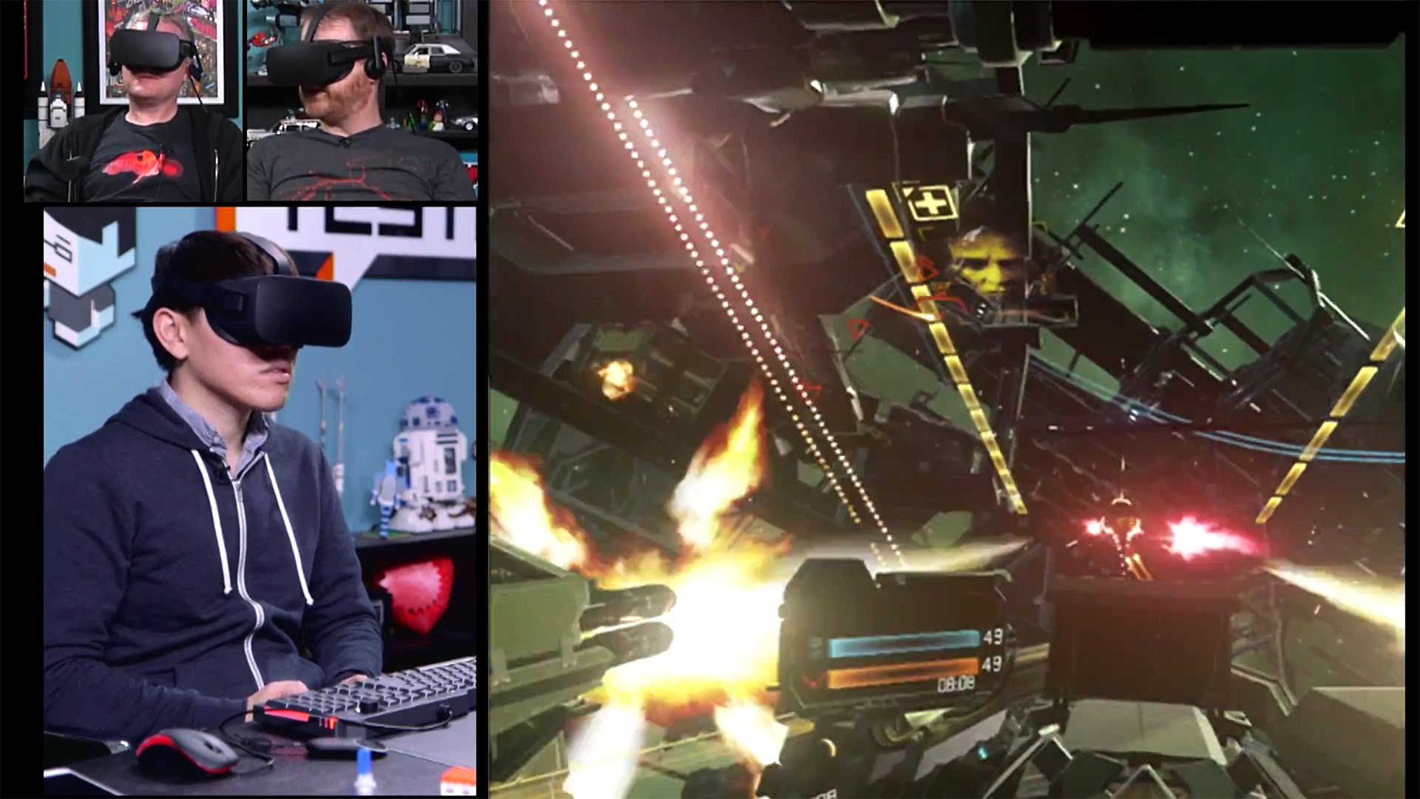
Multiple VR Systems Connected via LAN
The following is a simplified logical network connectivity diagram of the above use case scenario where multiple VR systems are connected to a remote content server. The VR HMD is receiving the VR content service rendered or decoded in the local content server. The remote content server is computing the data sent by the local content servers and redistributing the calculated data back to the local content servers.
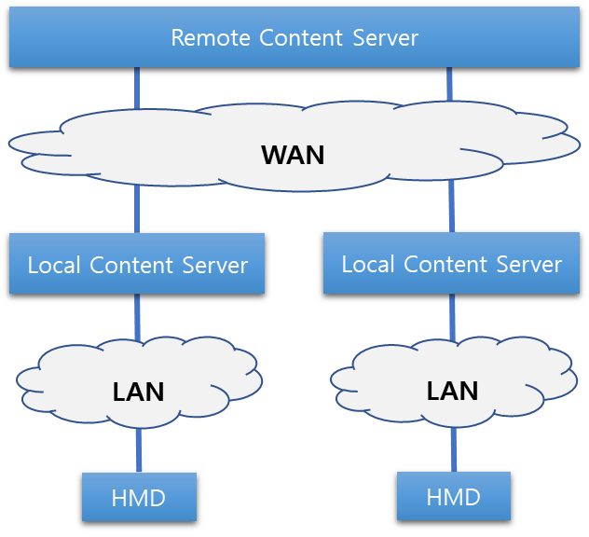

    - Issues/Limitations
The user mobility is limited due to the HDMI and the USB cables connecting to the VR HMD and to the local content server. The network between the remote content server and the local content servers may create some additional latency depending on the network conditions. The increased latency may cause the improper change of content and may create an incorrect impression of the certain events of the game. Also, it may drop the video quality and the frame rate. This drop of video quality results to VR sickness.
    - Recommendation
The wireless LAN connecting the VR HMD and the local content server should be capable of delivering the required bandwidth that VR content data demands and the link between the two should be always maintained. The WAN connecting the remote content server and the local content servers should provide very low latency to reflect the real-time changes made in VR content according to the users’ input.

  - Case 4: Multiple VR Systems Connected via a WAN
    - Use Case Scenario
In the following picture, two or more users are watching a live streamed video game match from their respective home using their mobile phone-based VR HMD systems. The users watching the same content in a virtual movie theater rendered in a cloud service provider and they are being represented as a form of a virtual avatar in the virtual reality theater. They are able to interact with each other and also can communicate via audio. The live-streamed video game match and the virtual reality theater are all being rendered in a remote server situated in the cloud service provider network and the VR HMD system is only running a small application for obtaining the cloud rendered VR content.
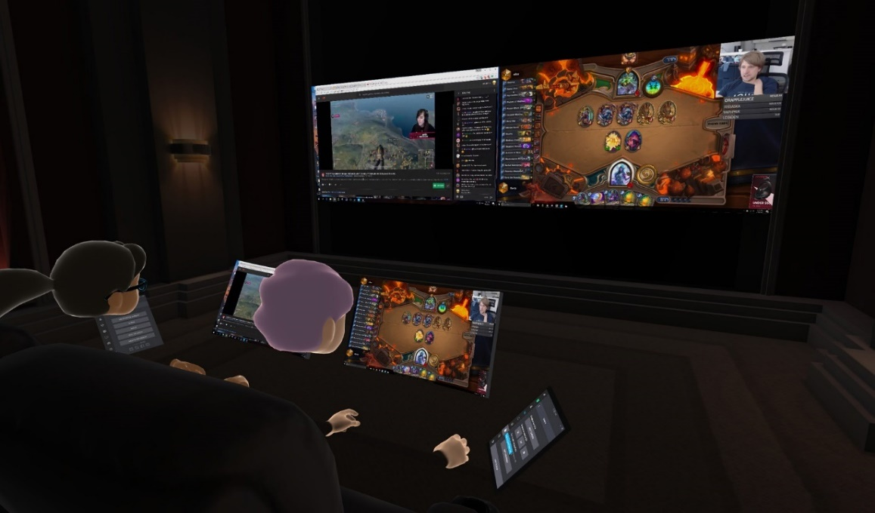
Multiple VR Systems Connected via WAN
The following is a simplified logical network connectivity diagram of the above use case scenario where more than one VR HMD systems are communicating to the remote content server and receiving the VR content service rendered or decoded in the remote content server.
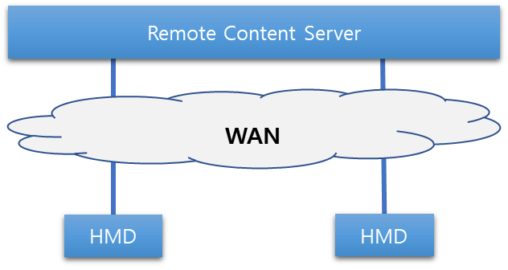

    - Issues/limitations
The network between the remote content server and the VR HMD systems may add additional latency to the content delivery depending on the network conditions (e.g., due to congestion). This increased latency may affect to the real-time effect in the content delivery that in turn may create an incorrect impression to the change of events. In addition, it may drop the video quality and the frame rate. This drop of video quality results to VR sickness.
    - Recommendation
The network connected to the remote content server where the VR content is being rendered or encoded should have required (e.g. 8 Gbps for uncompressed Quad High Definition (QHD) resolution video) data throughput to send a high-quality video and audio data with required frame rate (e.g., 90 FPS) to the remote VR HMDs. In addition, the network should provide very low latency to reflect the real-time changes made in VR content according to the users’ input.

  - Case 5: Special Use Case – Change of Network
In the following picture, a user is watching a streamed movie using a mobile phone-based VR HMD while travelling in a bus or a train. The movie is encoded in the remote server and sent to the VR HMD system via a wide area network. The VR HMD system is only decoding the content sent by the remote server.
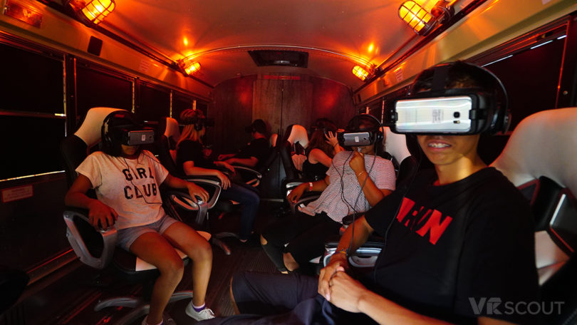
Multiple VR Systems Connected via LAN with Network Mobility
The following is a simplified logical network connectivity diagram of the above use case scenario where the VR HMD system is connected to either the bus or train Wi-Fi networks or connected directly to the mobile network depending upon the network conditions. Therefore, the network connection is switched between two local access networks that leads to a network handover condition.
    - Issues/Limitations
As the mobile network offers a limited amount of data usage depending on the personal mobile data plan, users normally prefer to use of Wi-Fi network when it is available. When the network connectivity moves from mobile network to Wi-Fi network, a network handover occurs and causes a drop of data, also known as data cliff, shown in the diagram below.
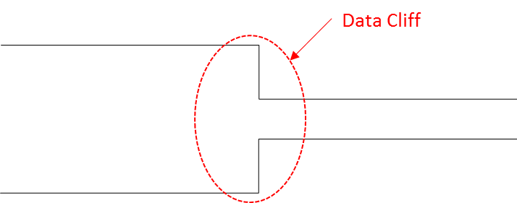
When this data cliff occurs, there is a good chance to lose the data header file of the application that contains the data packet structure. When the header file is lost, the network needs to resend the entire data packet and this creates additional latency. This increased latency may drop the video quality and the frame rate that results to VR sickness.

    - Recommendation
When the above handover results to moving from a higher throughput to a lower throughput network, the data cliff can be avoided if there is a way to make the network switching smooth as shown in the diagram below.
When the network handover occurs from the faster network to the slower network, maintaining both the high frame rate and the high resolution for the VR content may not be possible. In this case, maintaining the high frame rate needs to be considered as a higher priority as the frame rate is more critical issue for the VR sickness.

Consider 802.11be and 802.15.3c

Performance Requirements for Low Latency Communication
Derived from the discussion on applications in Section 2 and also using other sources such as the ITU definition of URLLC, will list the performance requirements of low latency communication such as:
- End-to-end data transfer latency (Edge to Edge)
- Session establishment latency(?)
- Perhaps radio access latency (noting that in some fora, this distinction is made) E.G. use cases with edge intelligence where the device to edge computing service is the critical path.
- Reliability, noting that many applications also have this requirement
- Data capacity (identify trade-offs between achieving low latency and most efficient use of bandwidth)
- Synchronization among flows (e.g., with audio/video for haptic+AV applications…?)
- Etc.
- What is the opportunity for networks to retry lost packets? How does this vary for different applications and use cases?
- Describe the relationship between reliability requirements and data rate. Not all low latency applications require high bandwidth, but the application demands very high reliability (in terms of meeting the latency requirement)
- Some applications have a requirement for precision in the haptic feedback (precision is related to low latency – delay results in error)

Requirements for AR/VR

Network Requirements
In recent years, the VR sickness caused by the VR content service is considered as one of the major problems for VR industry. In order for VR HMD to be accepted as a mass-market device, VR sickness needs to be addressed. To address this problem, several standards organizations, such as (draft) IEEE P802.11ay [1], MPEG (Moving Picture Experts Group) [2], and 3GPP (Third Generation Project Partnership) [3], have identified both network and non-network related issues and functional requirements in their studies. It is evident that VR industry imposes new network requirements for the connectivity between the content server and the HMD device. These requirements are for example, higher frame rate, reducing the motion-to-photon latency, higher data transmission rate, low jitter, longer transmission range, better mobility, higher resolution and low packet error rate. Below we highlight few such important requirements:
- Peak data rate:
  - Peak data rate should be 1.5 Gbps for compressed 4K UHD 3840×2160 24 bits/pixel, 60 frames/s, 8 bits/color.
  - Peak data rate should be 8 Gbps for compressed 8K UHD 7,680×4,320 24 bits/pixel, 60 frames/s, 8 bits/color.
  - Peak data rate should 18 Gbps for uncompressed 4K UHD 3,840×2,160, 60 frames/s, 8 bits/color, (4:4:4) chroma subsampling.
  - Peak data rate should be 28 Gbps for uncompressed 8K UHD 7,680×4,320, 60 frames/s, 8 bits/color, (4:2:0) chroma subsampling [4].
- Jitter
- Jitter should be less than 5ms [1] since greater jitter can cause distortion in video and audio rendering.
- Transmission range
  - For an indoor environment, it should not exceed 5 m by 5 m.
  - For an outdoor environment, it may reach up to several hundred meters.
- Mobility of device and session
  - For an indoor environment, it should be s less than 4 km/h.
  - For an outdoor environment, it may reach up to 300 km/h.
  - Packet loss for session mobility during network handover should be as minimum as possible.
      - PER (Packet error rate)
        - PER should be less than ${10}^{-2}$
      - Resolution
  - 40 pixels/degree or 12K (11520x6480) is required [2].
  - While 4K UHD (3840x2160) seems to be sufficient to the current display technology, higher that 4K UHD is required. This is due to the fact that HMD is mounted very closely to the human eyes and the display tends to be enlarged.
      - Frame rate
  - 90 fps (frames per second).
It is important to note that the frame rate is directly related to motion-to-photo latency. A lower frame rate allows a user’s reaction to be rendered in HMD after a reciprocal of the frame rate. The less the frame rate is, the more it can cause fatigue and motion sickness. The total motion-to-photon/audio latency in the VR system should be less than or equal to 20 ms [3]. This leaves the motion-to-photon latency for the wireless medium should be less than 5 ms, i.e., between two wireless transceivers [4].

- Quality of Experience (QoE)
QoE is a measure of the overall level of users’ satisfaction with a VR system. QoE is related to but differs from Quality of Service (QoS), which refers to any technology that manages data traffic to reduce packet loss, latency, and jitter on the network transport of a VR system. QoS constitutes only the network portion of the QoE but QoE will be measured by the user. QoE is something that VR system or content developers must take into account to offer a high-quality user experience. The following table illustrates the QoS-related conditions needed to be considered for each use case described in the previous section.
Use Case | Network Requirements
 | Data TX rate | Motion-to-photon/audio latency | Jitter | TX range | Mobility | PER
- Single VR System via LAN |  |  |  |  |  | 
- Single VR System via WAN |  |  |  |  |  | 
- Multiple VR System via LAN |  |  |  |  |  | 
- Multiple VR System via WAN |  |  |  |  |  | 
- Network Mobility |  |  |  |  |  | 
strong: , average: , weak: 

Key Technologies/Solutions Supporting Low Latency Communication
Summarizing those technologies that have to be considered/utilized in order to achieve low latency, often in conjunction with high reliability. For example:
- Changes to framing to minimize wait time to receive a frame before processing the frame
- Rendering of video can be optimized based on the importance of the image, and whether the user’s eye is looking in that direction. This can allow lower latency overall.
- Video interpolation can potentially compensate for bandwidth limits that would otherwise limit frame rate.
- Prioritization of data within an application can ensure that the most user-perceptible aspects are provided the lowest latency handling in the overall system.
- Softwarization to optimize communication path through invoking elements in software at better locations?
- Network sharing to optimize communication path; neutral hosting, etc., etc.
- Multi-connectivity (as a means to still achieve reliability while reducing latency—noting that many low latency applications also require a vast increase in reliability compared with what is currently achieved (at least wirelessly))
- New coding approaches to achieve latency and high reliability
- New protocols
- Others (e.g., security implications and solutions)?
- Using adaptive links, multi path, and multi-band links. Multi-connectivity.
- Etc., etc. (to be added to a refined)

IEEE 802 Standards Supporting Low Latency Communications
List of IEEE 802 standards/amendments, etc., that can already assist or realize in low latency (some in tandem with high reliability) communication, and reasoning as to how. Also listing target standards for enhancements towards low latency communication, and reasoning as to why.

Current Standards (published)
802.1 TSN (family of standard – pull from 802.24 TSN white paper)
802.3br Interspersing Express Traffic

802.11ad (60 GHz) defines a scheduled MAC layer

802.11ai Fast Initial Link Setup, 802.11r Fast Handover (“Fast” is a relative term)

802.15.4 TSCH (more predictable, but not extremely low latency – 100 mS range)

802.15.3 support low latency, isochronous streaming. Two way streaming. 802.15.3e specifies fast link setup and teardown.

802.16 and 802.22 provide scheduled MAC with predictable latency (10s of mS)

Target Standards for Enhancements (amendments being considered or underway)

    - IEEE 802.11ax
IEEE 802.11ax, known as High Efficiency WLAN (HEW) Task Group, has started its standard development with a main goal to reduce the performance degradation in a Wi-Fi dense area. IEEE 802.11ax have accomplished Draft 2.0 in November 2017. The standard is expected to be completed by the end of 2019.
IEEE 802.11ax, which achieves four times as high as 802.11ac, is designed to operate in 2.4 GHz and 5G Hz spectrums. Through increased link efficiency in frequency domain, time domain, and modulation scheme, the 802.11ax can achieve as high as 12.01 Gbps in an ideal condition [6].
At the current development state, this technology does not satisfy the VR network considerations.

    - IEEE 802.11ay
To develop the follow-up of IEEE 802.11ad, IEEE 802.11ay is formed in May 2015 to achieve a maximum throughput of at least 20 Gbps using the unlicensed mm-Wave (60 GHz) band, while maintaining or improving the power efficiency per STA. They have completed Draft 1.0 in January 2018. The standard is planned to be completed in December 2019.
IEEE 802.11ay can provide a high throughput utilizing various technologies, such as channel bonding/aggregation, MIMO (multiple-input and multiple output), and multiple channel access, etc. [6].
At the current development state, the maximum throughput is satisfied but it needs to consider the device mobility due to the directional propagation of electromagnetic wave in 60 GHz band.

    - 802.11be EHT
The Task Group includes Real Time Applications as part of the scope.

    - 802.11bd V2X
Low latency is a requirement for V2V use cases

Adaptions and Recommendations for IEEE 802 Standards to Enhance Low Latency Communications Support
Suggestions on which technologies (mentioned in Section 4 above) must be introduced, and very high-level suggestions on how it might be done. Both to enhance current standards supporting low latency, as well as the target ones.

Are there common themes that can be applied across 802 technologies to enhance low latency?

We expect the 802.1 TSN TG to continue to provide the overall framework and architecture for low latency across multiple standards.

The RTA TIG discussed multiple real-time applications in several domains (gaming, industrial automation, drone control, etc.) and their requirements are summarized in Table 7-1. Real-time applications have been evolving, so do their communication requirements. While voice and video accounted for most of the real-time traffic in the past, new and emerging applications such as real-time gaming, AR/VR, robotics and industrial automation are expected to become more prevalent in the future. Some of these applications also impose new worst-case latency and reliability requirements for Wi-Fi systems. Therefore, one of the recommendations of the RTA TIG to the 802.11 working group is to consider a broader range of real-time application requirements as summarized in Table 6.1.

Use cases |  | Intra BSS latency/ms | Jitter variance/ms  [4] | Packet loss | Data rate/  Mbps
Real-time gaming [2] |  | < 5 | < 2 | < 0.1 % | < 1
Cloud gaming [15] |  | < 10 | < 2 | Near-lossless | < 0.1 (Reverse link)  > 5Mbps (Forward link)
Real-time video [3] |  | < 3 ~ 10 | < 1~ 2.5 | Near-lossless | 100 ~ 28,000
Robotics and  industrial automation [1] | Equipment control | < 1 ~ 10 | < 0.2~2 | Near-lossless | < 1
 | Human safety | < 1~ 10 | < 0.2 ~ 2 | Near-lossless | < 1
 | Haptic technology | <1~5 | <0.2~2 | Lossless | <1
 | Drone control | <100 | <10 | Lossless | <1  >100 with video
Table 6-1 Requirements metrics of RTA use cases

New capabilities to support real time applications

Potential enhancements and new capabilities to address requirements of emerging real-time applications can be grouped in the following categories:

Extensions of TSN capabilities to 802.11: As described earlier, 802.1 TSN standards are addressing real-time applications over Ethernet and extensions of TSN over 802.11 can help better support such applications over wireless medium. TSN features have already been enabled in 802.11, including traffic/stream identification, time synchronization, and integration with Ethernet bridging. But new extensions are required to address the worst-case latency problems in current Wi-Fi deployments. Time-Aware shaping and redundancy through dual links (FRE capability) are examples discussed in this report, which exist in Ethernet TSN, but need support from 802.11 in other to be adapted to wireless medium as discussed in [7]. Other TSN features may also be considered, such as alignment with the TSN management model defined by the 802.1Qcc standard.

Multiband operation simultaneously: Due to the diversity demands for Wi-Fi networks, dual-band even tri-band AP and STA products have been brought up to market and more features are expected, since nowadays one end user tend to utilize multiple media thus multiple traffic streams. So, requests for high con-currency, reducing impact of interference and traffic differentiation are becoming universal demands.
Multiband operations simultaneously can benefit not only real-time applications but also those applications request high throughput and traffic separation.

New MAC/PHY capabilities that reduce latency and improve reliability: There is also need for improvements in the 802.11 MAC and PHY layers to enable more predictable worst case latency, which is a fundamental requirement for most real-time application, as discussed previously in the report. It should be noted that for many real-time applications, predicable worst cast latency does not necessarily mean extremely low latency, but the ability to provide more predictable performance is the main requirement. However, in some use cases, the worst case latency requirement may also need to be low. Another related are for improved identified is reliability. Enabling features that can be used to improve overall reliability of 802.11 links are also needed to support emerging real-time applications. Although operation is unlicensed spectrum makes it difficult to provide hard performance guarantees, many Wi-Fi deployments can be managed. Therefore, it is important to enable capabilities that can be leveraged in managed environments to provide more predictable performance.
Potential areas for further enhancements include: reduced PHY overhead, predictable and efficient medium access, better support for time-sensitive small packet transmissions, improving management and time-sensitive data coexistence, coordination between APs, more flexible OFDMA resource allocation scheme, etc.

Conclusion and Future Work/Timeplan
Per usual content in this section. But could also try to project an overall vision/timeplan for implementation of such work—or such content might be extracted to its own Section? Of course, would require careful coordination with the relevant WGs.

Develop a roadmap for all 802 standards relevant to Low Latency
Identify any gaps at the architecture level for consideration by 802.1 TSN

References

[1] IEEE 802.11 TGay Use Cases: https://mentor.ieee.org/802.11/dcn/15/11- 15-0625-07-00ay-ieee-802-11-tgay-usage-scenarios.pptx.
[2] Quality Requirements for VR, ISO/IEC JTC1/ SC29/WG11 MPEG 116 Std. m39532, 2016.
[3] IMT-Vision – Framework and overall objectives of the future development of IMT for 2020 and beyond, Recommendation ITU-R M.2083-0, Sep. 2015

There may be other wireless applications in industrial automation that are not considered real-time, therefore they are out of the scope of this report.

