IEEE 802.24 Proposal:
To request IEEE 802.24 to develop a white/application paper to highlight how IEEE 802 technologies (802.1, 802.3, 802.11, 802.15, 802.16, 802.20, 802.21, and 802.22) can work together to provide a true end-to-end solution.
The grid modernization is progressing by adding communications, networking, and control to the power grid. While some may say that they have an end-to-end solution, most, if not all, are based on specific product offerings by the vendor. Most understand that not one technology will be able to do everything across all domains in the smart grid. Networking and communication is no exception.
The paper can highlight the benefits for each specific technology and the application/environment that the technology works best in (possibly provided by experts from the relevant working group). Then, there would be a section that can explain how leveraging each technology (possible use cases) for a hybrid approach that can provide the economically and efficient solution that the end user (the utility) can apply.
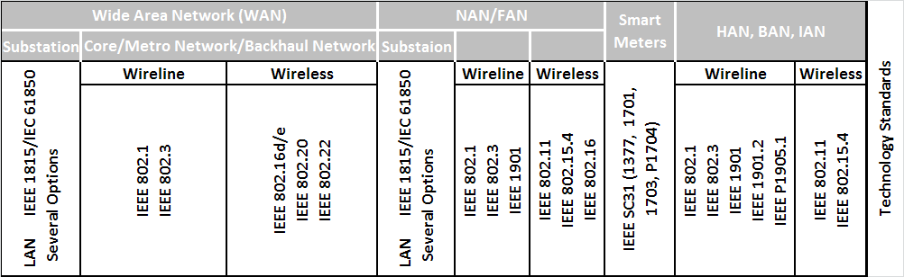
While the work in the SGIP PAP2 is good, it does not highlight how the IEEE 802 work can be used/leveraged/applied to the utility community. This would give IEEE 802 a platform to showcase its work and provide a document to the utility community that can be reference for future implementations and adaptations of IEEE 802 technologies.

