6.7 Assessment of Modeling Tool Results
In this section the ‘SG Wireless Framework, Modeling Tool’ described in Section 6.5 is applied to various terrestrial wireless deployment scenarios. This analysis will provide some insights as to the wireless base station equipment required to meet specific network requirements under varied terrain and demographic characteristics and wireless technology choices. The focus of this analysis is on the AMI/FAN or NAN with the key output being the number of DAPs required for deployment to meet the Smart Grid network coverage, capacity, and latency requirements.
As described in Section 6.1, a wireless deployment can be described as being either range-limited, capacity-limited, or limited in its ability to meet latency requirements.
From a wireless technology perspective, whether a deployment will be range-limited or limited by capacity or the ability to meet latency requirements depends on the following key metrics:
- Wireless Channel Goodput which in turn is a function of the channel BW, the modulation and coding scheme (MCS), and the total channel OH (including OH contributions from lower and higher layers). The modeling tool estimates the channel goodput using the methodology described in section 5.2.3.
- Wireless Range which is a function of the system gain, link margins for fade, interference, and penetration losses, and the path loss predicted by one or more of the wide area outdoor path loss models described in Section 5
- Packet size and whether it is fixed or variable: As we will see later, this can have a major impact on the networks ability to meet latency requirements and, to some degree, can also influence goodput and range.
From a SG network perspective, key metrics are:
- Density of Actors (or End-Points)
- Data payload requirements for ‘baseload’ and ‘highload’ in both the DL and UL direction
- Average and maximum payload size in Bytes
- End-to-end (e2e) latency requirement per payload
In the SG Wireless Framework and Modeling Tool average data capacity requirements, expressed as a data density in bytes per sq-mi, are provided for five (5) demographic regions as shown in the following table.

 | Dense Urban | Urban | Suburban | Rural | Low Density Rural
Avg HU/sq-Mi | 7483 | 1794 | 303 | 26 | 2.2
Avg Comm/Indus/sq-mi | 1320 | 317 | 54 | 4.6 | 0.4
Avg End-Points/sq-mi | 14212 | 3447 | 1111 | 65 | 4
Average ‘Baseload’ Requirements
UL Bytes/sq-mi | 1234 | 449 | 5239 | 10.4 | 1.4
Avg UL Payload (Bytes) | 1020 | 344 | 189 | 274 | 190
DL Bytes/sq-mi | 5.2 | 102 | 124 | 3.3 | 0.7
Avg DL Payload (Bytes) | 90 | 99 | 89 | 99 | 100
Average ‘Highload’ Requirements
UL Bytes/sq-mi | 16129 | 2314 | 51283 | 66 | 25.7
Avg UL Payload (Bytes) | 8116 | 1517 | 911 | 1538 | 3178
DL Bytes/sq-mi | 29327 | 5472 | 116023 | 108 | 9
Avg DL Payload (Bytes) | 65649 | 4806 | 2538 | 3003 | 1189

From a wireless technology perspective, both channel goodput and packet size will influence how well latency requirements are met for a given number of end-points. The effect that packet size has on performance with respect to range, capacity, and meeting latency requirements deserves further discussion.
6.7.1 Impact of packet size
The submissions made to fill out the Wireless Capabilities Matrix in section 4 indicate maximum packet sizes that vary from 96 Bytes to 14,400 Bytes for the UL and from 640 Bytes to 14,400 Bytes in the DL. Channel BWs range from 0.208 MHz (208 KHz) to 20 MHz in the frequency bands between 700 MHz and 5800 MHz and for the 450 MHz band, the submitted channel BW is 0.0125 MHz (12.5 KHz)
The relative tradeoffs between small and large packet sizes are summarized in the following tables.

Small packet size:
Pros | Cons
- A higher probability of falling within the latency window  - Reduced requirements for cell edge goodput | - Higher Channel OH since each packet must contain some OH bits  - Payloads larger than the maximum packet size must be divided into smaller packets and the payload latency requirement must then be divided by the number of packets to arrive at a latency requirement per packet.

Large packet size:
Pros | Cons
- Better OH efficiency.  - A greater number of payloads can be accommodated without breaking it into smaller packets  - Very large payloads can be transmitted with less segmentation | - Lower probability of falling within the latency ‘window’  - Larger packet size places greater demands on cell edge performance which in turn will impact the receive sensitivity at the cell edge  - Higher probability of a ‘packet error’ due to a ‘bit error’  - For some combinations of channel bit rate and packet size, the packet time will exceed the packet latency requirement
.
Summary of e2e packet payload minimum latency requirements for a Suburban Region
Maximum UL Packet Sizeª | 96 Bytes | 2042 Bytes | 14400 Bytes
Baseload UL | 0.080 Sec^{b} | 1.33 Sec | 2.40 Sec
Highload UL | 0.006 Sec^{b} | 0.125 Sec^{c} | 0.879 Sec
Maximum DL Packet Sizeª | 640 Bytes | 2042 Bytes | 14400 Bytes
Baseload DL | 1.20 Sec | 2.40 sec | 2.40 Sec
Highload DL | 0.039 Sec^{b} | 0.125 Sec^{c} | 0.879 Sec
- UL OH is assumed to be 31% and DL OH is assumed to be 29%
- Indicates packet latency requirements that will VERY LIKELY be exceeded by node processing and other higher layer latency contributions, i.e. ‘Latency OH’
- Indicates packet latency requirements that MAY be exceeded by node processing and other higher layer latency contributions

The following figure shows the requirements for cell edge goodput to meet a specific ‘packet time’ for different packet sizes. Obviously a larger packet size requires a higher cell edge goodput which will affect the threshold sensitivity and subsequently, the system gain and propagation range. Channel BW, channel OH, and MCS also come into play, thus for the same cell edge goodput, there will be differences in threshold sensitivity from technology to technology.
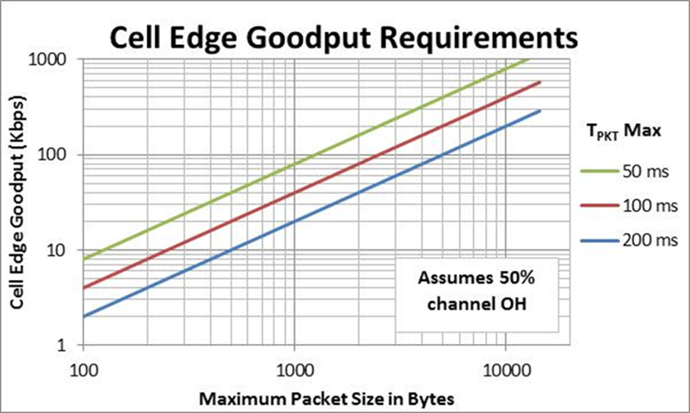
Figure 60: Cell Edge Goodput vs. Maximum Packet Size

Even with a modest channel BW and low peak spectral efficiency, most wireless technologies of interest will be able to meet capacity requirements for rural and low density rural AMI/Fan deployments due to the very low density of end-points or actors and the resulting low data rate requirements.
In urban and dense urban areas the range is severely limited due to deployments requiring relatively low base station antenna heights in the presence of multi-story buildings and high penetration losses with basement-located end-points. The limited range in these cases will result in fairly modest capacity requirements for each base station.
The range in suburban areas will generally be greater than urban areas due to reduced building clutter and more favorable outdoor end-point locations. Additionally, as shown in the table above, even though the average end-point density is lower than in urban areas, the SG data requirement per end-point is higher.
Predicting the networks ability to meet latency requirements is not as straightforward as it is for range and capacity predictions. As one would expect, as the traffic transmitted on any given channel approaches the channel capacity there will be a diminishing number of ‘time slots’ for packets ‘queued’ for transmission. This channel congestion leads to longer packet delays and typically creates a situation in which latency becomes the limiting performance factor long before data traffic levels reach the channel capacity limit. In practice, QoS would come into play to help alleviate issues with high priority latency-sensitive payloads. One of the limitations of the modeling tool however, is that it does not take QoS into account. With respect to meeting SG latency requirements, this limitation should be kept in mind when evaluating the results that follow in later sections.
6.7.2 Summary of terrestrial-based technology submissions
There are a great number of demographic and wireless technology-related parameters that can be adjusted or selected when using the modeling tool. Although many of the wireless technology parameters are specified by an applicable standard, some parameters will be vendor-specific. At this point it is informative to look at a summary of the terrestrial-based wireless submissions provided by the SDOs in response to the requests made in section 4 with a focus on the performance parameters that directly influence the output of the ‘framework, modeling tool’.
The following table summarizes the frequency band coverage. Note that there were no wireless submissions to cover frequency bands from: 1000 to 1400 MHz, 2700 to 3300 MHz, and 3700 to 5800 MHz and only there was only one solution submitted for the 5800 MHz band.
Frequency Band Coverage
3 | 8 | 8 | 4 | 4 | 1
 | LTE | LTE
 | WiMAX | WiMAX/ WiGRID
 | HSPA+ | HSPA+
 | WCDMA | WCDMA
 | GSM-EDGE | GSM-EDGE | LTE | LTE
xHRPD | xHRPD | xHRPD | WiMAX/ WiGRID | WiMAX/ WiGRID
HRPD EV-DO | HRPD EV-DO | HRPD EV-DO | HSPA+ | HSPA+
CDMA2000 | CDMA2000 | CDNA2000 | WCDMA | WCDMA | WiGRID
450 MHz | 700-1000 MHz | 1400-1900 MHz | 2000-2700 MHz | 3300-3700 MHz | 5800 MHz

With respect to channel bandwidth, three of the submissions provided a wide range of choices, whereas, six of the technologies offer .only one choice.

Channel Bandwidth Options
1 | 1 | 2 | 2 | 3
 |  |  |  | LTE
 |  | xHRPD | HSPA+ | WiMAX/ WiGRID
?IG Band? | GSM EDGE | CDMA2000 | WCDMA | HRPD EV-DO
0.0125 MHz | 0.208 MHz | 1.25 MHz | 5.0 MHz  (3.84 MHz) | ≤ 3 MHz to ≥ 10 MHz

For duplex choices four of the technologies offer only FDD and four have solutions for both FDD and TDD. Adaptive TDD when available can provide improved spectral efficiency for traffic that is highly asymmetric.
Duplex Options
4 | 4 | 1
xHRPD | HSPA+
HRPD EV-DO | WCDMA
CDMA2000 | LTE
GSM EDGE | WiMAX | WiMAX/WiGRID
FDD Only | TDD or FDD | Adaptive TDD

In addition to the channel BW, key parameters for estimating channel and base station capacity is the peak UL and peak DL modulation index. Although this information was not requested specifically in Section 4 it can be derived from the over-the-air submissions for peak DL and UL data rates or from the references cited for the technologies in the wireless capabilities matrix.
Peak UL and DL Modulation
DL
64QAM |  | LTE  WiMAX  HSPA+  HRPD EV-DO |  | WiGRID  WiMAX (UL Optional)
32QAM |  |  | GSM EDGE
16QAM | WCDMA  CDMA2000 | xHRPD
 | QPSK | 16QAM | 32QAM | 64QAM | UL

6.7.3 Baseline parameter choices for modeling tool assessment
To maximize its utility, the Framework and Modeling Tool has a number of variables that can be inputted or selected by the user. To enable a fair analysis for the purposes of this document a number of parameter choices have been made to ensure relative consistency with technology to technology comparisons. For the five different demographic regions the deployment related parameter choices are shown in the following table.
 | Dense Urban | Urban | Suburban | Rural | Low Density Rural
Coverage Area | 5 sq-mi | 20 sq-mi | 100 sq-mi | 1,000 sq-mi | 3,000 sq-mi
BS Antenna Height¹ | 10 m | 10 m | 10 m | 25 m | 30 m
End-Point Antenna Height | n/a | 2 m | 2 m | 2 m | 2 m
End-Point Location² | Indoor Basement | Indoor Business | Outdoor | Outdoor | Outdoor
Alternate Propagation Paths³ | 2 | 3 | 3 | 1 | 1
Terrain Type⁴ | n/a | n/a | Type A | Type A
BS MIMO⁵ | (1x1) | (1x1) | (1x1) | ≤ 1800 MHz (1x1)  > 1800 MHz (2x2)  > 3600 MHz (4x4)
Number of Links⁶ | 1 | 1 | 1 | 2 | 3
Frequency Range⁷ | 1900 MHz-6000 MHz | 700 MHz-6000 MHz |  | 450 MHz-6000 MHz
Notes 1 | Higher average heights are anticipated in rural and low density rural, taking advantage of existing transmission towers. Heights in other regions consistent with typical utility pole heights.
2 | Dense Urban meter banks are typically basement-located consistent with underground utilities. Meter banks in Urban areas are more likely to be at grade in alleys outdoors or in an indoor enclosure.
3 | Less likely to have access to multiple BS in rural areas due to wider BS-to-BS spacing and less requirement for ubiquitous coverage. Limited access in Dense Urban regions due to building blockage with low BS antenna heights
4 | Terrain type only applicable for Erceg-SUI path loss model, not applicable below 700 MHz. Type A defines terrain that is ‘hilly with moderate to heavy tree density’.
5 | Multiple antenna options in the higher frequency bands will be more practical in rural areas where there is less objectionable visual impact and existing towers that can handle the increased wind loading
6 | Rural regions will more likely require multiple hops or links to complete an e2e connection
7 | Frequency limitations due to lack of valid path loss model for selected antenna heights

Technology and network related parameter choices for the analysis are as follows:
- Latency ‘Overhead’ (L_{OH}): Inherent with any deployment will be a baseline latency due to node processing times at Layer 1/Layer 2 and further processing delays in the higher levels.
These are assumed to be: 25 ms per node (2 nodes per link) plus 50 ms per link
The assumed ‘L_{OH}’ is then: for 1 hop, 100 ms; for 2 hops, 125 ms; and for 3 hops, 150 ms.
- Channel OH: This is an especially important performance parameter for technology comparative purposes but, unfortunately, a difficult metric to quantify since it is dependent on many different factors, including the average packet size, traffic type, number of end-points, etc. Most wireless technologies use a simulation approach to arrive at an estimate for average layer 2 data throughput (see Group 5 in Section 4) but since the simulation parameters and assumptions differ between technologies and additionally, the deployment assumptions used for the simulations will not typically reflect what is called for in a SG Network, the channel throughput and OH arrived at with this approach can only be considered a guideline. For the purposes of this section the following assumptions are made for channel OH for each of the wireless technologies that are analyzed:
Nominal layer 2 DL Channel OH = 29% and layer 2 UL Channel OH = 31% (total OH including higher layers is 49% and 51% for DL and UL respectively and no adjustment is made for different packet or frame sizes).
For range-limited deployments the any errors in the channel OH estimate will have little or no effect on the resulting number of required base stations or DAPs. Channel OH will only play a role in deployments that are latency or capacity-limited. In those cases, solutions will be shown with a plus and minus channel OH variation so as to illustrate the sensitivity to that parameter.
- Cell Edge Goodput: This is calculated to ensure a maximum time of 1 sec for the average ‘highload’ payload size for each demographic region in the DL and for an average packet size of 8116 bytes in the UL or a modulation-coding index of QPSK-1/4 whichever results in a higher cell-edge goodput.
- Packet Size: The packet size is assumed to be the maximum submitted by each of the technologies. Since the modeling tool does not account for the packet size impact on channel OH, this only impacts the latency requirement and the ability to meet the requirement.
- Link availability: This is assumed to be 96% at the cell edge, which, in turn, determines the value for fade margin.
- Base station configuration and frequency reuse: 3-sector base stations are assumed with one channel per sector and a reuse factor of 1 with dedicated as opposed to ‘shared’ spectrum (no additional margin for inter-operator interference)
- Smart meter antenna gain and Tx power: 0 dBi and 0.5 W (+27 dBm) respectively
- Base Station Noise Figure: <3000 MHz = 4 dB, ≥3000 MHz = 5 dB
- Base Station Antenna Gain: There will generally be size constraints, especially with low base station heights. For the same size antenna the higher frequency bands have an advantage. The BS/DAP antenna gains assumed for the modeling tool assessment are shown in figure 61.

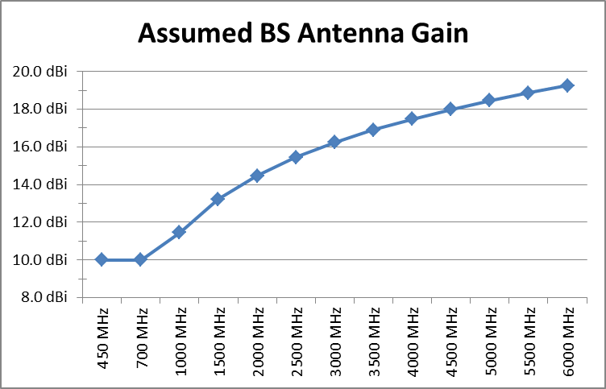
Figure 61: Base Station (DAP) Antenna Gain

6.7.4 Wireless technology assessment
6.7.4.1 Meeting ‘highload’ demand
Tables are provided for four (five) frequency bands; 450 MHz (tentative),700 MHz, 1900 MHz, 3700 MHz and 5800 MHz. These tables make use of the following key to summarize the results.
- Number of BS/DAPs: BS = Total # of BS followed by letter; R = Range-limited, C = Capacity-limited, and L = Latency limited. When used in this context latency limited means the BS/DAP is limited in the number of end-points that can be supported to meet either the minimum latency required or a latency specified in the model as ‘acceptable’.
- End-Points: EP = Total number of End-Points per BS. Divide by 3 to get the number of end-points per channel (or sector).
- Latency requirement, in sec (L): If the minimum latency requirement, L, is met; L= -/L, if not met; L = ‘latency value that can be met in sec’/L. In some cases L_{OH} the will be greater than the required latency, L, these cases will have the notation, ‘L_{OH} > L’.
- Percentage of BS capacity for SG: For ‘Range-Limited’ deployments there will be excess BS capacity, SGL (Smart Grid Load) = % will indicate what percentage of the total 3-sector BS capacity is for the SG AMI/FAN.

450 MHz  Highload | Dense Urban | Urban | Suburban | Rural | Low Density Rural
CDMA2000  - FDD  - BW=1.25 MHz  - Pkt=1536 | n/a | n/a | n/a | BS = 102 R  EP = 636  L = 0.15/0.06  L_{OH} > L  SGL=0.28% | BS = 235 R  EP = 47  L = 0.2/0.04  L_{OH} > L  SGL=0.14%
HRPD EV-DO  - FDD  - BW=1.25 MHz  - Pkt=1024 | n/a | n/a | n/a | BS = 102 R  EP = 636  L =0.15/0.04  L_{OH} > L  SGL=0.20% | BS = 235 R  EP = 47  L = 0.2/0.03  L_{OH} > L  SGL=0.10%
xHRPD  - FDD  - BW=1.25 MHz  - Pkt=96 | n/a | n/a | n/a | BS = 102 R  EP = 636  L =0.15/.004  L_{OH} > L  SGL=0.28% | BS = 235 R  EP = 47  L =0.2/.003  L_{OH} > L  SGL=0.14%
IG Band  - H-FDD  - BW=11.25 KHz  - Pkt= 70 | n/a | n/a | n/a | BS =  EP =  L = | BS =  EP =  L =

700 MHz  Highload | Dense Urban | Urban | Suburban  Type A | Rural  Type A | Low Density Rural  Type A
Coverage Area | 5 mi² | 20 mi² | 100 mi² | 1,000 mi² | 3,000 mi²
GSM EDGE  - FDD  - BW=208 KHz  - Pkt=1560 | n/a | BS = 11 L  EP = 6267  L = -/0.12  BS = 10 R | BS = 391 L  EP = 284  L = -/0.12  BS = 59 C  BS = 12 R | BS = 133 R  EP = 488  L=0.15/0.06  L_{OH} > L  SGL=0.72% | BS = 348 R  EP = 32  L = 0.2/0.04  L_{OH} > L  SGL=0.33%
WCDMA  - FDD  - BW=3.84 MHz  - Pkt=12750 | n/a | BS = 10 R  EP = 6894  L = -/0.94  SGL=0.58% | BS = 12 R  EP = 9274  L = -/0.93  SGL=56% | BS = 129 R  EP = 503  L = -/0.47  SGL<0.1% | BS = 337 R  EP = 33  L = -/0.31  SGL<0.1%
HSPA+  - FDD  - BW=3.84 MHz  - Pkt=2874 | n/a | BS = 10 R  EP = 6894  L = -/0.40  SGL=.71% | BS = 12 R  EP = 9274  L = -/0.4  SGL=65.2% | BS = 129 R  EP = 503  L = -/0.19  SGL<0.1% | BS = 337 R  EP = 33  L = 0.2/0.13  L_{OH} > L  SGL<0.1%
CDMA2000  - FDD  - BW=1.25 MHz  - Pkt=1536 | n/a | BS = 8 R  EP = 8617  L = -/0.11  SGL=2.23% | BS = 80 L  EP = 1389  L = -/0.11  BS = 15 C  BS = 11 R | BS = 110 R  EP = 590  L=0.15/0.06  L_{OH} > L  SGL=0.24% | BS = 286 R  EP = 39  L=0.2/0.04  L_{OH} > L  SGL=0.11%
HRPD EV-DO  - FDD  - BW=1.25 MHz  - Pkt=1024 | n/a | BS = 8 R  EP = 8617  L=0.15/0.08  L_{OH} > L  SGL=2.15% | BS = 24 L  EP = 4627  L=0.15/0.08  L_{OH} > L  BS = 14 C  BS = 11 R | BS = 110 R  EP = 590  L=0.15/0.04  L_{OH} > L  SGL=0.17% | BS = 286 R  EP = 39  L=0.2/0.03  L_{OH} > L  SGL<0.1%
xHRPD  - FDD  - BW=1.25 MHz  - Pkt=96 | n/a | BS = 8 R  EP = 8617  L=0.15/0.01  L_{OH} > L  SGL=2.23% | BS = 19 L  EP = 5845  L = 0.15/.01  L_{OH} > L  BS = 15 C  BS = 11 R | BS = 110 R  EP = 590  L=0.15/.004  L_{OH} > L  SGL=0.24% | BS = 286 R  EP = 39  L=0.15/.002  L_{OH} > L  SGL=0.11%
LTE  - FDD  - BW=3 MHz  - Pkt=8188 | n/a | BS = 8 R  EP = 8617  L = -/0.60  SGL=0.62% | BS = 11 R  EP = 10095  L = -/0.6  SGL=54.7% | BS = 110 R  EP = 590  L = -/0.3  SGL<0.1% | BS = 286 R  EP = 39  L = -/0.2  SGL<0.1%
WiMAX  - FDD  - BW=5 MHz  - Pkt=2042 | n/a | BS = 8 R  EP = 8617  L = -/0.15  SGL=0.37% | BS = 11 R  EP = 10095  L = -/0.15  SGL=32.8% | BS = 110 R  EP = 590  L=0.15/0.08  L_{OH} > L  SGL<0.1% | BS = 286 R  EP = 39  L = 0.2/0.05  L_{OH} > L  SGL<0.1%
700 MHz Summary  - BS for Range  - BS for Capacity  - BS for Latency | n/a | 8 to 10  8 to 11 | 11 to 12  11 to 59  11 to 391 | 110 to 133 | 286 to 348

1900 MHz  Highload | Dense Urban | Urban | Suburban  Type A | Rural  Type A | Low Density Rural  Type A
Coverage Area | 5 mi² | 20 mi² | 100 mi² | 1,000 mi² | 3,000 mi²
GSM EDGE  - FDD  - BW=208 KHz  - Pkt =1560 | BS = 64 R  EP = 1111  L =0.15/.12  T_{PKT} > L  SGL=1.94% | BS = 41 R  EP = 1682  L = -/0.12  SGL=1.88% | BS= 1158 L  EP = 96  L = -/0.12  BS = 69 C  BS = 28 R | BS = 232 R  EP = 280  L = 0.15/.06  L_{OH} > L  SGL=0.17% | BS = 597 R  EP = 19  L = 0.2/.04  L_{OH} > L  SGL<0.1%
WCDMA  - FDD  - BW=3.84 MHz  - Pkt=12750 | BS = 69 R  EP = 1030  L = -/0.94  SGL=0.17% | BS = 44 R  EP = 1561  L = -/0.94  SGL=0.13% | BS = 32 R  EP = 3471  L = -/0.94  SGL=20.2% | BS = 247 R  EP = 263  L = -/0.47  SGL<0.1% | BS = 636 R  EP = 18  L = -/0.31  SGL<0.1%
HSPA+  - FDD  - BW=3.84 MHz  - Pkt=2874 | BS = 69 R  EP = 1030  L = -/0.39  SGL=0.13% | BS = 44 R  EP = 1567  L = -/0.40  SGL=0.16% | BS = 32 R  EP = 3471  L = -/0.40  SGL=23.5% | BS = 247 R  EP = 263  L = -/0.19  SGL<0.1% | BS = 636 R  EP = 18  L=0.2/0.13  L_{OH} > L  SGL<0.1%
CDMA2000  - FDD  - BW=1.25 MHz  - Pkt=1536 | BS = 49 R  EP = 1451  L = -/.011  SGL=0.73% | BS = 35 R  EP = 1970  L = -/0.11  SGL=0.51% | BS = 159 L  EP = 699  L = -/0.11  BS = 26 RC | BS = 192 R  EP = 338  L =0.15/.06  L_{OH} > L  SGL<0.1% | BS = 491 R  EP = 23  L = 0.2/.04  L_{OH} > L  SGL<0.1%
HRPD EV-DO  - FDD  - BW=1.25 MHz  - Pkt=1024 | BS = 49 R  EP = 1451  L = 0.15/.08  L_{OH} > L  SGL=0.56% | BS = 35 R  EP = 1970  L = 0.15/.08  L_{OH} > L  SGL=0.53% | BS = 38 L  EP = 2023  L =0.15/.08  L_{OH} > L  BS = 26 RC | BS = 192 R  EP = 338  L =0.15/.04  L_{OH} > L  SGL<0.1% | BS = 491 R  EP = 23  L = 0.2/.04  L_{OH} > L  SGL<0.1%
xHRPD  - FDD  - BW=1.25 MHz  - Pkt=96 | BS = 49 R  EP = 1451  L=0.15/0.01  L_{OH} > L  SGL=0.73% | BS = 35 R  EP = 1970  L=0.15/0/01  L_{OH} > L  SGL=0.51% | BS = 26 R  EP = 4271  L=0.15/0/01  L_{OH} > L  SGL=76.8% | BS = 192 R  EP = 338  L=0.15/.004  L_{OH} > L  SGL<0.1% | BS = 491 R  EP = 23  L=0.2/.002  L_{OH} > L  SGL<0.1%
LTE  - FDD  - BW=3 MHz  - Pkt=8188 | BS = 49 R  EP = 1451  L = -/0.60  SGL=0.28% | BS = 35 R  EP = 1970  L = -/0.60  SGL=0.17% | BS = 26 R  EP = 4271  L = -/0.6  SGL=21.4% | BS = 192 R  EP = 338  L = -/0.3  SGL<0.1% | BS = 491 R  EP = 23  L = -/0.2  SGL<0.1%
WiGRID  - A-TDD  - BW=5 MHz  - Pkt=14400 | BS = 49 R  EP = 1451  L = -/1.1  SGL=0.25% | BS = 35 R  EP =1970  L = -/1.1  SGL=0.13% | BS = 26 R  EP = 4271  L = -/1.1  SGL=18.3% | BS = 192 R  EP = 338L = -/0.55  SGL<0.1% | BS = 491 R  EP = 23  L = -/0.35  SGL<0.1%
1900 MHz Summary  - BS for Range  - BS for Capacity  - BS for Latency | 49 to 69 | 35 to 44 | 26 to 32  26 to 69  26 to 1158 | 192 to 247 | 491 to 636

3550-3700 MHz  Highload | Dense Urban | Urban | Suburban  Type A | Rural  Type A | Low Density Rural  Type A
Coverage Area | 5 mi² | 20 mi² | 100 mi² | 1,000 mi² | 3,000 mi²
WCDMA  - FDD - 3550  - BW=3.84 MHz  - Pkt=12750 | BS = 280 R  EP = 254  L = -/0.94  SGL<0.1% | BS = 143 R  EP = 483  L = -/0.94  SGL<0.1% | BS = 62 R  EP = 1792  L = -/0.94  SGL=10.4% | BS = 455 R  EP = 143  L = -/0.47  SGL<0.1% | BS =1169 R  EP = 10  L = -/0.31  SGL<0.1%
HSPA+  - FDD – 3550  - BW=3.84 MHz  - Pkt=2874 | BS = 280 R  EP = 254  L = -/0.39  SGL<0.1% | BS = 143 R  EP = 483  L = -/0.40  SGL<0.1% | BS = 62 R  EP = 1792  L = -/0.40  SGL=12.1% | BS = 455 R  EP = 143  L = -/0.22  SGL<0.1% | BS =1169 R  EP = 10  L=0.15/0.13  L_{OH} > L  SGL<0.1%
LTE  - TDD – 3700  - BW=5 MHz  - Pkt=8188 | BS = 217 R  EP = 328  L = -/0.60  SGL<0.1% | BS = 125 R  EP = 552  L = -/0.60  SGL<0.1% | BS = 52 R  EP = 2136  L = -/0.60  SGL=12.7% | BS = 276 R  EP = 235  L = -/0.30  SGL<0.1% | BS= 700 R  EP = 16  L = -/0.20  SGL<0.1%
WiGRID  - A-TDD – 3700  - BW=5 MHz  - Pkt=14400 | BS = 217 R  EP = 328  L = -/1.10  SGL<0.1% | BS = 125 R  EP = 552  L = -/1.10  SGL<0.1% | BS = 52 R  EP = 2136  L = -/1.10  SGL=9.1% | BS = 276 R  EP = 235  L = -/0.55  SGL<0.1% | BS = 700 R  EP = 16  L = -/0.35  SGL<0.1%
3700 MHz Summary  - BS for Range  - BS for Capacity  - BS for Latency | 217 to 280 | 125 to 143 | 52 to 62 | 276 to 455 | 700 to 1169

5800 MHz  Highload | Dense Urban | Urban | Suburban  Type A | Rural  Type A | Low Density Rural  Type A
Coverage Area | 5 mi² | 20 mi² | 100 mi² | 1,000 mi² | 3,000 mi²
WiGRID  - A-TDD  - BW=3.5 MHz  - Pkt=2042 | BS =938  EP = 76  L = -/1.10  SGL<0.1% | BS = 406  EP = 170  L = -/1.10  SGL<0.1% | BS = 109  EP = 1019  L = -/1.10  SGL=4.33% | BS = 583  EP = 112  L = -/0.55  SGL<0.1% | BS = 1485  EP = 8  L = -/0.35  SGL<0.1%

6.7.4.2 Meeting ‘baseload’ demand
Of the eight wireless technologies analyzed with the ‘Framework and Modeling Tool’ in the 700 MHz band, the four with channel BWs of 1.25 MHz and below were capacity-limited for a suburban deployment. The same four technologies however, did have sufficient capacity for the other four demographic regions. GSM EDGE with a 0.208 MHz channel BW was also capacity-limited in the 1900 MHz band for suburban deployments.
The following table provides a summary of those four technologies at ‘baseload’ demand. For this case they all meet capacity requirements for demographic regions and three out of the four meet all latency requirements. As expected, xHRPD, with a 96 byte maximum packet size limitation, results in a minimum latency requirement that is less than L_{OH} in all of the demographic regions.
700 MHz  Baseload | Dense Urban | Urban | Suburban | Rural  Type A | Low Density Rural  Type A
Coverage Area | 5 mi² | 20 mi² | 100 mi² | 1,000 mi² | 3,000 mi²
GSM EDGE  - FDD  - BW=208 KHz  - Pkt=1560 | n/a | BS = 10 R  EP = 6894  L = -/1.25  SGL=1.20% | BS = 12 R  EP = 9254  L = -/1.25  SGL=58.2% | BS = 133 R  EP = 488  L=-/0.63  SGL=0.11% | BS = 348 R  EP = 39  L = -/0.4  SGL<0.1%
CDMA2000  - FDD  - BW=1.25 MHz  - Pkt=1536 | n/a | BS = 8 R  EP = 8617  L = -/1.25  SGL=0.43% | BS = 11 R  EP = 10095  L = -/1.25  SGL=20.1% | BS = 110 R  EP = 590  L= -/0.63  SGL<0.1% | BS = 286 R  EP = 39  L = -/0.4  SGL<0.1%
HRPD EV-DO  - FDD  - BW=1.25 MHz  - Pkt=1024 | n/a | BS = 8 R  EP = 8617  L = -/1.0  SGL=0.29% | BS = 11 R  EP = 10095  L = -/1.0  SGL=13.4% | BS = 110 R  EP = 590  L = -/0.5  SGL<0.1% | BS = 286 R  EP = 39  L = -/0.3  SGL<0.1%
xHRPD  - FDD  - BW=1.25 MHz  - Pkt=96 | n/a | BS = 8 R  EP = 8617  L = 0.15/0.1  L_{OH} > L  SGL=0.43% | BS = 11 R  EP = 10095  L=0.15/0.10  L_{OH} > L  SGL=20.1% | BS = 110 R  EP = 590  L=0.15/0.05  L_{OH} > L  SGL<0.1% | BS = 286 R  EP = 39  L =0.2/0.03  L_{OH} > L  SGL<0.1%

6.7.4.3 Sensitivity analysis
To facilitate the assessment of the eight terrestrial-based wireless technologies, assumptions were made for some key wireless parameters. In the next few paragraphs we will look at the relative sensitivity of some of these parameters and other factors that influence the number of base stations (or DAPs) necessary to meet Smart Grid requirements for an AMI/NAN deployment.
Specifically we look at the relative impact of:
- Channel OH
- Packet Size versus Latency Requirement
- Channel Bandwidth
- Terrain Type
- Link Budget and System Gain
Channel OH: As mentioned earlier, getting an accurate estimate for total channel OH can be a daunting task. That said, for the purposes of the assessment, we assumed 49% for the DL channel OH and 51% for the UL channel OH. For suburban deployments in the 700 MHz band four of the technologies with channel BWs of 1.25 MHz or less, were latency and, with more relaxed latency requirements, became capacity-limited. The technologies with larger channel BWs on the other hand, easily met capacity requirements in all five demographic regions. With respect to latency however, some were impacted by the maximum supportable packet size in the rural and low density rural deployments where we assumed 2 and 3 links respectively. Based on the model it would take a maximum packet size greater than approximately 6000 bytes to meet the latency requirements in these areas.
The sensitivity to either a lower or higher channel OH is illustrated in figure 62. The graph provides a view of the DAP and End-Point count for a range of UL channel OH values for CDMA2000 in the 700 MHz band for a suburban type A deployment. A fixed latency requirement of 200 ms (0.2 sec) is assumed to determine the number of supportable end-points per channel.

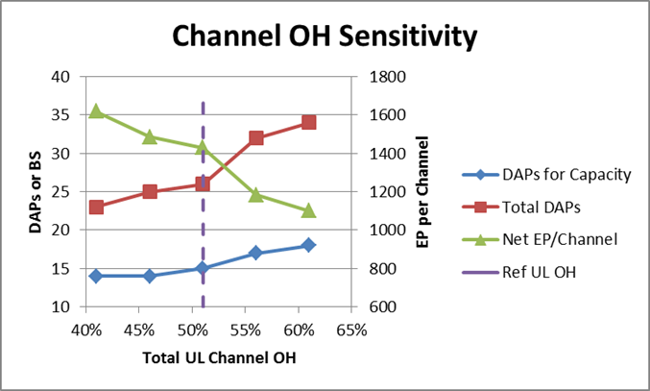
Figure 62: CDMA2000, 700 MHz, Suburban Highload, 0.2 Sec Latency

Packet Size and Latency Requirements: Both packet size and channel goodput play a role in determining latency performance. It is important to mention again that QoS is not taken into account in this technology assessment. Whereas QoS enables the assignment of higher priorities to more latency-sensitive payloads and packets, the model assumes all packets have the same priority. Despite this limitation, the model is useful in providing some insights as to how the different wireless parameters relate to the technology’s ability to meet latency requirements.
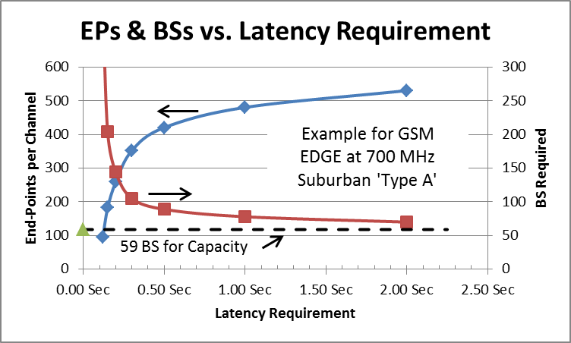
As the assessment results indicate, with a constrained channel BW meeting the minimum latency requirement may require a substantial increase in the number of BSs. With a 0.208 MHz channel BW limitation, GSM EDGE is limited to 284 end-points per BS (95 per channel) to meet a 0.12 second minimum latency requirement. As illustrated in figure 63, a modest relaxation in the latency requirement would greatly enhance the supportable end-points per channel and reduce the number of BSs required. With a latency of 2 or more seconds, the number of BS approaches 59, the number required to meet capacity requirements.

Figure 63: GSM EDGE at 700 MHz, Suburban Type A, ‘highload’ Demand
The minimum latency requirement is inversely proportional to the maximum packet size so it is also of interest to look at how the maximum packet size impacts BS requirements. Using GSM EDGE as an example again, figure 64 shows the end-points per channel and BS requirements for packet sizes larger than the 1560 bytes listed in the wireless capabilities matrix for GSM EDGE. It is not clear how much flexibility there is with this parameter but as the chart indicates, an increased packet size results in a dramatic decrease in the number of required BSs.

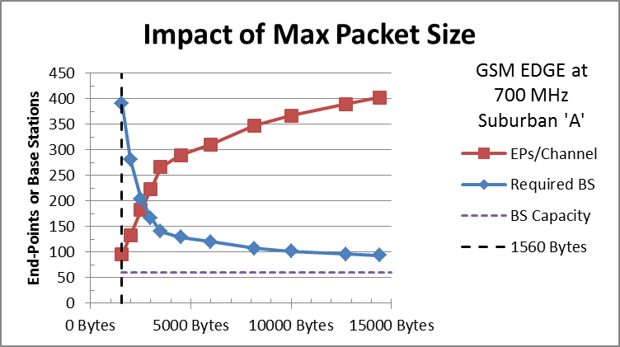
Figure 64: Increasing the maximum packet size for GSM EDGE
Another example that is interesting to look at in more detail is xHRPD. This technology has the lowest maximum packet size, 96 bytes for the UL, of the 8 technologies reviewed. At 96 bytes, the minimum latency requirement is less than the latency overhead for all demographic regions at all frequencies supported by xHRPD. For a suburban deployment and ‘highload’ demand, the 96 byte packet size reduced the minimum latency requirement to 0.007 seconds. The latency that can be achieved with 19 BS is 0.15 seconds. As described earlier, one of the benefits of a smaller packet size is an increased probability the packet will fall within a specified latency period, in this case, 0.15 seconds. With an increase in packet size the BS count goes up due to the drop in probability until the packet size gets to about 2000 bytes. Although more BS are required, the minimum latency requirement can be met at that point. Beyond 2000 bytes the minimum latency requirement increases more quickly than the packet size resulting in an increasing probability and a decreasing BS count. At about 13000 bytes, the BS count is at the same level it was at 96 bytes, but instead of missing the minimum latency requirement by more than 20x the latency requirement can be met with the larger packet size.

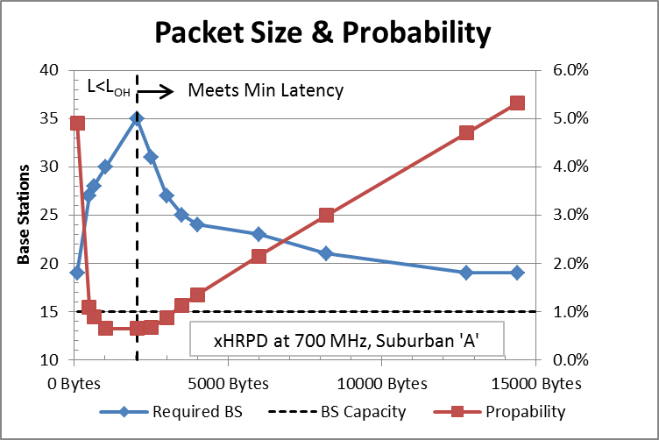
Figure 65: Relationship between packet size and BS requirements

Channel BW: The following chart illustrates how channel BW affects the base station requirements necessary to meet capacity requirements for a suburban deployment. At approximately 135 KHz for ‘baseload’ and 2.5 MHz for ‘highload’, the deployment transitions from capacity-limited to range-limited.
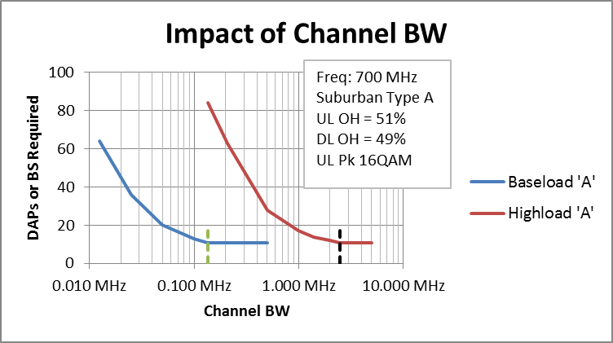
Figure 66: Channel BW for meeting capacity requirements
To account for latency as well as capacity it would be necessary to plan for excess channel capacity by an amount inversely related to the maximum packet size. Typical numbers for ‘highload’ are:

Approx. Packet Size | Channel BW | Meets ….
- | ≥ 2.5 MHz | Capacity only
< 1500 Bytes | 5.0 MHz | Capacity, Latency = 0.15 sec (L_{OH} > L)
1500 to 2000 Bytes | ~ 4.5 MHz (+80%) | Capacity and Latency
2000 to 3000 Bytes | ~ 4.0 MHz (+60%) | Capacity and Latency
≥ 3000 Bytes | ~ 3.5 MHz (+40%) | Capacity and Latency

Terrain Type: From a propagation perspective the wireless assessment summarized in the above tables assumes a worst case scenario for suburban, rural, and low density rural regions by assuming terrain ‘Type A’. This terrain type is defined as ‘hilly with moderate to heavy tree density’. Although there will be more extreme cases than this, Type A represents the most extreme case for which we have a valid path loss model. Terrain types that are more ‘propagation friendly’ are Types B and C. The following figure shows the reduced BS requirements for deployments in terrain Types B and C relative to Type A. The propagation benefits of more favorable terrain are less significant in suburban areas where a lower BS antenna height (10 m vs. 30 m) is assumed.
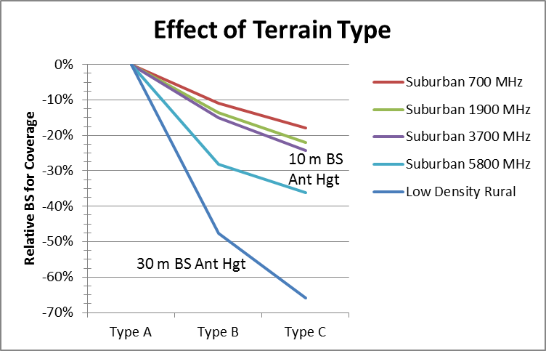
Figure 67: Relative number of BSs vs. Terrain Type
Link Budget and System Gain: System gain, which is the major component of the link budget, is not generally defined by wireless standards organizations. Although the wireless standard may set some guidelines, there is usually considerable latitude left to equipment vendors for the parameters that comprise system gain. That said, one can expect some variations from the system gain parameters assumed for this assessment. The other terms used to determine the link budget include fade margin, penetration loss, and interference margin. The same values have been applied to all of the technologies for this assessment. Of these, interference margin may differ somewhat between technologies, but probably not more than 1 or 2 dB.
The following graph shows the difference in BS requirements for coverage for a link budget range from -3 dB to +3 dB. As the chart indicates, a couple of dB can make a significant difference.
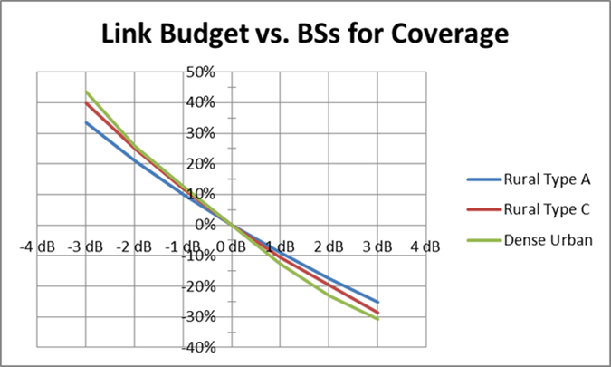
Figure 68: Link budget impact on BS requirements

6.7.5 Assessment Results Summary
The ‘SG Framework Modeling Tool’ has been used to assess eight terrestrially based wireless technologies using parameters submitted for the Wireless Capabilities Matrix described in Section 4 with other assumed deployment and wireless variables described earlier in this section. The Smart Grid requirements for this analysis is based on a FAN or NAN network with end-points estimates based on US census data.
Some general observations are:
- Suburban: This demographic region represents the greatest challenge from a capacity and latency perspective, especially in the lower frequency bands. For solutions with Channel BW constraints either additional channels or more base stations are necessary. Even, when range-limited, SG requirements consumed a significant portion of the base station capacity. This could limit the use of existing public or other shared networks.
- Dense Urban and Urban: With the range limited by less favorable end-point locations, capacity requirements for SG typically consumed less than 1 % of the available base station capacity with the exception of GSM EDGE for urban deployment in the 700 MHz band due its limited channel BW.
- Rural and Low Density Rural: Capacity requirements were typically at about 0.1% or below of the available base station capacity for all technologies. Latency was an issue with many of the technologies where we assumed 2 and 3 links respectively for Rural and Low Density Rural. This was alleviated with larger packet sizes and of course QoS can also play a role. On the other hand, there will be many cases where a greater number of links will be required and in some cases a satellite link might have to be included for these regions. Meeting latency requirements for large latency-sensitive payloads are likely to be an on-going challenge in these areas.
The following table provides a perspective on deployment requirements with respect to: Technology, Frequency, and Demographic Region. The entries in the table show the requirements for each technology for an ‘average’ US state, arrived at by estimating the number of base stations or DAPs necessary to cover 1/50th of the total US land area for each demographic region. It is informative to summarize requirements solely on the basis of coverage, even though, some of the suburban area deployments were latency or capacity-limited, since in many of those cases the limitations can be addressed by adding more channels rather than adding more base stations. Additionally QoS, supported by all of the assessed technologies, can address many of the latency limitations.
There is no data for Dense Urban in the 700 MHz band since we have not found a suitable path loss model for base station antenna heights below surrounding roof-tops.
Data is included for terrain Types A, B, and C for suburban and rural areas. It is up to the reader to decide which is more applicable for the geographic characteristics of the area being analyzed. In some cases Type B might be a reasonable average. If, on the other hand, the region of interest is mountainous and/or heavily forested, Type A may be a better estimate for the ‘average’ terrain.
It should also be noted it may not be realistic to assume the same spectrum availability over any very large geographic area. Licensed spectrum in the US has its own geographic boundaries that may or may not coincide with specific utility regions. Additionally, with respect to spectrum, the different wireless solutions are grouped into four categories to simplify the presentation of the data. There are numerous frequency allocations between 1400 MHz and 2700 MHz covered by one or more of the wireless technologies. While 1900 MHz is a reasonable choice for purposes of this assessment, it should be obvious, based on link budget and path loss differences alone, that a solution in the 2300 MHz band with one wireless technology would yield quite different results in the 1800 or 1900 MHz band even though the wireless attributes are the same.

Demographic Region | Dense Urban | Urban | Sub-urban | Rural | Low Density Rural | Totals
1/50 US Land Area | 36.1 | 449 | 2,306 | 16,127 | 51,310 | 70,228
Total End-Points | 512,627 | 1,547,290 | 2,562,144 | 1,048,285 | 205,240 | 5,875,586
 |  |  | Type A | Type A | Type A
700 MHz
CDMA2000¹, HRPD EV-DO¹, xHRPD¹, LTE, WiMAX | - | 2,381 | 254 | 1,775 | 4,892 | 9,302
WCDMA, HSPA+ | - | 2,976 | 277 | 2,081 | 5,764 | 11,098
GSM EDGE¹ | - | 2,976 | 277 | 2,145 | 5,952 | 11,350
1900 MHz
CDMA2000², HRPD EV-DO², xHRPD, LTE, WiGRID | 354 | 10,416 | 600 | 3,097 | 8,398 | 22,865
GSM EDGE² | 462 | 12,202 | 646 | 3,742 | 10,211 | 27,263
WCDMA, HSPA+ | 498 | 13,095 | 738 | 3,984 | 10,878 | 29,193
3550, 3700 MHz
LTE, WiGRID | 1,566 | 37,200 | 1,200 | 4,452 | 11,973 | 56,391
WCDMA, HSPA+ | 2,020 | 42,557 | 1,430 | 7,338 | 19,994 | 73,339
5800 MHz
WiGRID | 6,767 | 120,826 | 2,514 | 9,403 | 25,399 | 164,909
 |  |  | Type B | Type B | Type B
700 MHz
CDMA2000¹, HRPD EV-DO¹, xHRPD¹, LTE, WiMAX | - | 2,381 | 227 | 930 | 2,561 | 6,099
WCDMA, HSPA+ | - | 2,976 | 247 | 1,090 | 3,018 | 7,331
GSM EDGE1 | - | 2,976 | 247 | 1,123 | 3,116 | 7,462
1900 MHz
CDMA2000², HRPD EV-DO², xHRPD, LTE, WiGRID | 354 | 10,416 | 519 | 1,622 | 4,396 | 17,307
GSM EDGE² | 462 | 12,202 | 559 | 1,959 | 5,345 | 20,527
WCDMA, HSPA+ | 498 | 13,095 | 638 | 2,086 | 5,694 | 22,011
3550, 3700 MHz
LTE, WiGRID | 1,566 | 37,200 | 1,020 | 2,331 | 6,268 | 48,385
WCDMA, HSPA+ | 2,020 | 42,557 | 1,216 | 3,841 | 10,466 | 60,100
5800 MHz
WiGRID | 6,767 | 120,826 | 1,809 | 4,922 | 13,295 | 147,619
 |  |  | Type C | Type C | Type C
700 MHz
CDMA2000¹, HRPD EV-DO¹, xHRPD¹, LTE, WiMAX |  | 2,381 | 209 | 604 | 1,665 | 4,859
WCDMA, HSPA+ |  | 2,976 | 228 | 709 | 1,962 | 5,875
GSM EDGE¹ |  | 2,976 | 228 | 730 | 2,026 | 5,960
1900 MHz
CDMA2000², HRPD EV-DO², xHRPD, LTE, WiGRID | 354 | 10,416 | 468 | 1,054 | 2,858 | 15,150
GSM EDGE² | 462 | 12,202 | 504 | 1,274 | 3,475 | 17,917
WCDMA, HSPA+ | 498 | 13,095 | 575 | 1,356 | 3,702 | 19,226
3550, 3700 MHz
LTE, WiGRID | 1,566 | 37,200 | 910 | 1,515 | 4,074 | 45,265
WCDMA, HSPA+ | 2,020 | 42,557 | 1,084 | 2,497 | 6,803 | 54,961
5800 MHz
WiGRID | 6,767 | 120,826 | 1,606 | 3,200 | 8,642 | 141,041
Note 1 | Additional channels or base stations will be required for 700 MHz suburban deployments to meet capacity and/or latency requirements
Note 2 | Additional channels or base stations will be required for 1900 MHz suburban deployments to meet capacity and/or latency requirements

The intent of this analysis has been to provide some insights as to how the ‘Framework and Modeling Tool’ can be used to assess the different terrestrial-based wireless technologies based on the mathematical path loss models described in Section 5 and the wireless technology attributes presented in Section 4. In this analysis, the Smart Grid AMI/NAN average data throughput and latency requirements were derived from the end-point densities based on US census data.
Despite the limitations stated earlier, the above tables should prove useful for early planning purposes to assess how the different terrestrial-based wireless technologies are likely to perform with respect to frequency, demographics, and relative propagation conditions. The above assessment should also provide a perspective on the role that different wireless parameters play in determining the number of base stations and equipment necessary to meet SG AMI/NAN requirements for coverage, latency, and capacity.

