IEEE P802.22
Wireless RANs
P802.22 Coexistence Assurance Document
Date: 2019-01-13
Author(s):
Name | Company | Address | Phone | email
Apurva N. Mody | BAE Systems / WhiteSpace Alliance | USA |  | apurva.mody@baesystems.com  apurva.mody@WhiteSpaceAlliance.org
Oliver Holland | King’ s College London | UK |  | oliver.holland@ieee.org
Chang-Woo Pyo | NICT | Japan |  | cwpyo@nict.go.jp
Abstract
This serves as the coexistence assurance document for 802.22 Revision for meeting the requirement of the Criteria for the Standards Development (CSD).

Section 1.Introduction
Notice: This document has been prepared to assist IEEE 802.22. It is offered as a basis for discussion and is not binding on the contributing individual(s) or organization(s). The material in this document is subject to change in form and content after further study. The contributor(s) reserve(s) the right to add, amend or withdraw material contained herein.

Release: The contributor grants a free, irrevocable license to the IEEE to incorporate material contained in this contribution, and any modifications thereof, in the creation of an IEEE Standards publication; to copyright in the IEEE’s name any IEEE Standards publication even though it may include portions of this contribution; and at the IEEE’s sole discretion to permit others to reproduce in whole or in part the resulting IEEE Standards publication. The contributor also acknowledges and accepts that this contribution may be made public by IEEE 802.22.

Patent Policy and Procedures: The contributor is familiar with the IEEE 802 Patent Policy and Procedures
<http://standards.ieee.org/guides/bylaws/sb-bylaws.pdf>, including the statement "IEEE standards may include the known use of patent(s), including patent applications, provided the IEEE receives assurance from the patent holder or applicant with respect to patents essential for compliance with both mandatory and optional portions of the standard." Early disclosure to the Working Group of patent information that might be relevant to the standard is essential to reduce the possibility for delays in the development process and increase the likelihood that the draft publication will be approved for publication. Please notify the Chair Apurva Mody <apurva.mody@ieee.org> as early as possible, in written or electronic form, if patented technology (or technology under patent application) might be incorporated into a draft standard being developed within the IEEE 802.22 Working Group. If you have questions, contact the IEEE Patent Committee Administrator at <patcom@ieee.org>.

The IEEE 802.22-Revision Standard proposes to combine IEEE 802.22-2011, IEEE 802.22a and IEEE 802.22b. It plans to make corrections to the previously published standards. It also proposes to extend the use of the IEEE 802.22 Standard in bands that allow spectrum sharing.

This standard is intended to enable deployment of interoperable IEEE 802.22® multivendor wireless regional area network products, to facilitate competition in broadband access by providing alternatives to wireline broadband access and extending the deployability of such systems into diverse geographic areas, including sparsely populated rural areas, while preventing harmful interference to incumbent licensed services. The standard specifies operation in the bands that allow spectrum sharing where the communications devices may opportunistically operate in the spectrum of the primary service such as VHF/UHF TV broadcast bands between 54 MHz to 862 MHz generally designated for such service, 1300 MHz to 1750 MHz and 2700 MHz to 3700 MHz.

Following IEEE 802 standards have been approved for use in the TV Band White Spaces whose operation may span from 54 MHz to 862 MHz: IEEE Std. 802.11af -2013, IEEE Std. 802.15.4m-2014, IEEE Std. 802.22-2011, IEEE 802.22b-2015, IEEE 802.22a-2014. IEEE 802 Systems that operate in 3500MHz to 3700 MHz includes IEEE 802.16-2017 and IEEE 802.11y.

TV Band White Spaces 54 to 862 MHz

This document outlines the features of the IEEE P802.22 revision standard and the coexistence between like and unlike systems when they appear in this band. Today, there has not been enough deployement of communication systems, also known as whitespace devices (WSDs) since the white space regulations around the world are still emerging. Deployments of TVWS equipment has started in the USA, South Africa (RSA), UK, Singapore and Colombia. Regulations are emerging in many other countries within the African subcontinent, Asia and South America. The unique characteristics of TV whitespace today allow spectrum etiquette and coexistence enabled through the geo-location databases. This standard is expected to be a global standard based on emerging regulations in various countries.

The IEEE 802.22 systems propose to serve large regional areas spanning anywhere from 10 km to 30 km, whereas IEEE 802.11af/ IEEE 802.15.4m propose to serve smaller areas spanning few hundred meters to a few km. As a result, 802.22 systems fall in the Fixed Device category as defined by some of the regulations that have been specified for TV Band White Spaces [5], typicaly using 1 Watt of conducted and 4 Watts of radiated power, whereas IEEE 802.11af and IEEE 802.15.4m typically fall into personal portable Mode II and Mode I device category [5].

In the United States, after the proposed incentive auctions [1] of the TV channels, FCC is likely to allow the operation of low power personal portable devices in the Guard Bands, however, the Fixed 4 Watt devices will be prohibited from operating on those channels. Also, personal portable low power devices are allowed to operate on channels that are adjacent to the TV Broadcast services, whereas Fixed 4 Watt devices are prohibited from operating on those channels. Since IEEE 802.22 Systems operate with 4 Watts of Transmit Power, wheras IEEE 802.11af and IEEE 802.15.4m fall in the personal portable category, this means that there is a natural separation of the channels on which the IEEE 802.11af / IEEE 802.15.4m systems and the IEEE 802.22 family of systems may operate. As a result, co-existence between IEEE 802.22 and IEEE 802.11af / IEEE 802.15.4m systems is facilitated as a by-product of the regulatory rules that have been defined. IEEE 802.15.4m systems may also operate in the skirts of the IEEE 802.22 Systems due to zero-padding in the frequency domain. Finally, if IEEE 802.22 and IEEE 802.11af systems want to operate on the same channel, then some form of co-existence mechanism (e. g. IEEE 802.19.1 assisted) would be desirable.

Table 1: FCC Transmit Power Limitations [5]
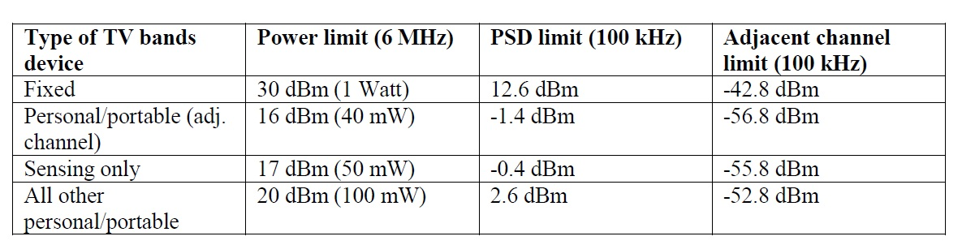
Operation in other frequency bands that allow Spectrum Sharing
Since the inception of the regulations for the TV Band White Spaces, spectrum sharing in other frequency bands has become a new norm. In fact, there are more frequency bands that are being opened for commercial use on a shared spectrum basis today than clearing up the bands, or re-farming them for future use-cases. In the United States and many other countries, we anticipate frequency bands, such as 1.3-1.75 GHz, 2.7-3.7 GHz and others, to be opened for commercial use on a shared spectrum basis. The Primary Users in these frequency bands may range from Satellite Service, Radars, Terrestrial Microwave Links, etc. Since IEEE Std. 802.22 is the first international standard that provides Cognitive Radio operation allowing sharing of the spectrum in the TV Broadcast Bands while avoiding harm to the Primary Users, we anticipate, that the standard could advantageously be extended for use in those other frequency bands provided, the regulatory regime allows spectrum to be shared.

As a matter of definition, a cognitive radio (CR) is a radio that can be programmed and configured dynamically to use the best wireless channels in its vicinity to avoid user interference and congestion. Such a radio automatically detects available channels in wireless spectrum, then accordingly changes its transmission or reception parameters to allow more concurrent wireless communications in a given spectrum band at one location. This process is a form of dynamic spectrum management.

The standards operating in these bands may need Spectrum Database access also known as Spectrum Access System (SAS), Spectrum Sensing, or Beaconing approaches. IEEE Std. 802.22 covers all these techniques in its specification. IEEE 802.16 Systems currently operate in the 3.5 GHz band. Also, the IEEE 802.11y Standard was created for operation in the 3.65 to 3.7 GHz Band. It is likely that this band will turn into a shared spectrum band in the United States and elsewhere and will require the access to the SAS. IEEE 802.22 Systems have the capability to access the Spectrum Database or SAS to ensure co-existence between the Primary Users and the Secondary Users, as well as various Secondary Users.

Section 2.P802.22 Revision PHY Operation Modes (OMs)

The 802.22 Revision supports two types of PHYs: PHY Operation Mode 1 (PHY OM1) and PHY operation mode 2 (PHY OM2). The details of each PHY OM are shown below.

PHY-OM1

PHY OM1 is the same as the one defined in IEEE Std. 802.22-2011.

Table 2 – System Parameters for PHY-OM1

Parameters | Specifications
Frequency Range | 54~862 MHz, 1300 – 1750 MHz, 2700 – 3700 MHz
Channel bandwidth | 6, 7, or 8 MHz
Transmit Power | 1 Watt maximum conducted power for CPEs and BS in the USA regulatory domain.
Multiple Access | OFDMA
FFT Size (N_{FFT}) | 2048
Duplex | TDD

PHY-OM2

PHY OM2 was defined in the 802.22b amendament. This Mode supports higher throughputs using features such as MIMO.

Table 3 – System Parameters for PHY-OM2
Parameters | Specifications
Frequency Range | 54~862 MHz, 1300 – 1750 MHz, 2700 – 3700 MHz
Channel bandwidth | 6, 7, or 8 MHz
Transmit Power | 1 Watt maximum conducted power for CPEs and BS in the USA regulatory domain.
Multiple Access | OFDMA
FFT Size (N_{FFT}) | 1024
Duplex | TDD

Section 3. P802.22 Revision Coexistence Features

Spectrum Database and IEEE 802.19.1 Enabled Co-existence

The FCC and other regulatory domains [5, 6, 7] require the use of a geo-location spectrum database to ensure that unlicensed devices operating in a band requiring the use of a geolocation database do not interfere with licensed users. The IEEE P802.22 Revision incorporates database access mechanisms prescribed by the FCC Part 15.700 rules to avoid interfering with the protected license holders. The IEEE P802.22 Revision systems provide their Geolocation information to the database in order to get the available channels for their configuration of operation.

It is possible for the Geolocation Spectrum Database to enable co-existence between dissimilar systems. Such co-existence mechanisms are discussed in the UK Ofcom regulatory rules [6] where the WSDs may provide their Technology Identifiers to the Geolocation Database. In the US, some Database Aministrators have suggested providing this co-existence technology between dissimilar systems as a value added services.

Note that IEEE 802.19.1 should also be used to facilitate co-existence between dissimilar WSD systems.

Transmit Power Control

The IEEE P802.22 Revision as mandated by regulations, utilizes Transmit Power Control (TPC) as a means for maintaining the transmitted signal at a level that ensures that no interference is caused to the incumbents. Transmit power control is another technique that may be used to minimize interference between systems.

Coexistence Protocols

Self-Coexistence

With regards to self-coexistence, the IEEE P802.22 Revision provides the coexistence beacon protocol (CBP) which is used to exchange coexistence beacons to achieve efficient self-coexistence among overlapping 802.22 cells. The combination of the incumbent protection and self-coexistence mechanisms forms a MAC layer that is flexible and adaptive to the environment, and can react to changes to reduce interference to others, through Dynamic Spectrum Access (DSA) which is also known as Dynamic Frequency Selection (DFS).

The CBP frame contains common WRAN information in a superframe control header and a frame control header. If a CPE receives CBP frame transmitted by another WRAN, the CPE performs self-coexistence via spectrum etiquette or quiet period scheduling/spectrum sensing.

Spectrum etiquette

Figure 1 shows the fundamental logic as incorporated in the IEEE P802.22 Revision for Spectrum Etiquette mechanism. Figure 2 shows the concept of operation of the Spectrum Etiquette as defined in the P802.22 Revision. Spectrum etiquette is used to select primary and backup channels that are orthogonal when sufficient channels are available. Note, while currently P802.22 systems exchange the spectrum etiquette information amongst themselves, in future the 802.22 systems may send this information back to the database or an IEEE 802.19.1 co-existence server, and this database/802.19.1 will facilitate co-existence. In fact, such Technology Identifier feedback to database has been incorporated in the TV White Space rules specified by the UK Ofcom [6].

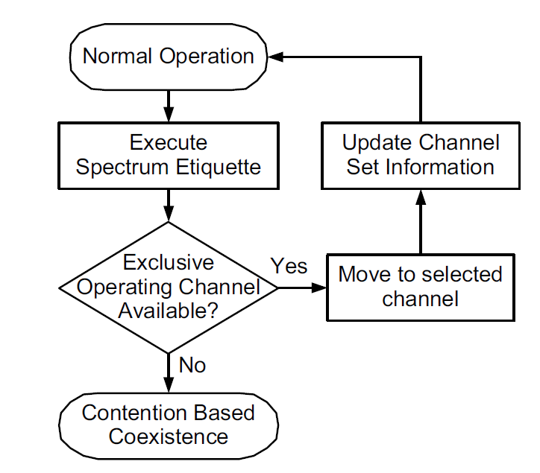
Figure 1 – Spectrum Etiquette Operation

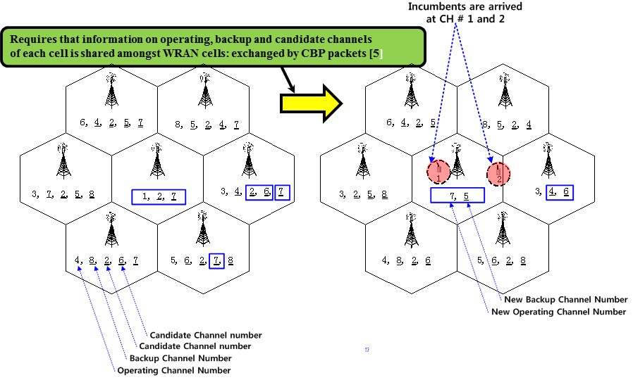
Figure 2 – Example of Spectrum Etiquette Operation

Quiet Period (QP) scheduling and Spectrum Sensing

For detecting the presence of incumbents, as well as dissimilar systems such as 802.11af and 802.15.4m in the operating channel, the P802.22 Revision schedules network-wide quiet periods for sensing. During these quiet periods, all network traffic is suspended and base stations and CPEs perform in-band sensing. This process is coordinated by the Base Station (BS), which is responsible for scheduling the quiet periods.

On-Demand Frame Contention (ODFC)

On-demand frame contention is used as a coexistence mechanism when a single TVWS channel must be shared between systems. ODFC allows up to Sixteen P802.22 systems to share a single channel, using Time Division contention of the frames in a super-frame between various P802.22 systems. Our simulation results indicate that the ODFC contention algorithm provides a fair allocation of frames to various users [8]. While currently, the ODFC has been proposed for intra-system co-existence between the 802.22 systems, it is possible in future to extend it to inter-system co-existence where some of the Frames may be freed up for IEEE 802.11af / IEEE 802.15.4m systems.
Figure 3. On Demand Frame Contention (ODFC) Mechanism as incorporated in P802.22b.

Section 5. Conclusion

This coexistence assurance document shows the main features of P802.22 Revision which will enable improvement for coexistence between like and unlike systems in the TV Band White Spaces and other emerging bands that allow spectrum sharing.

References:

[1] http://hraunfoss.fcc.gov/edocs_public/attachmatch/FCC-10-174A1.pdf

[2] Doc # 802.11-11/0177r1 “11af Coexistence Assurance Document” https://mentor.ieee.org/802.11/dcn/11/11-11-0177-01-00af-coexistence-assurance.doc

[3] Doc # 802.15-13/166r3 “TG 15.4m Coexistence Assurance Document” https://mentor.ieee.org/802.15/dcn/13/15-13-0166-03-004m-tg-15-4m-coexistence-assurance-document-cad.pdf

[4] FCC-12-118A1 (2012-10-Incentive Auction)

[5] FCC-12-36A1 “THIRD MEMORANDUM OPINION AND ORDER”

[6] Ofcom TV WhiteSpaces Statement
https://www.ofcom.org.uk/__data/assets/pdf_file/0034/68668/tvws-statement.pdf
Ofcom TV WhiteSpaces Statement Annexes
https://www.ofcom.org.uk/__data/assets/pdf_file/0025/58921/annexes.pdf
Ofcom TV WhiteSpaces Law
http://www.legislation.gov.uk/uksi/2015/2066/pdfs/uksi_20152066_en.pdf

[7] IDA Singapore: PROPOSED REGULATORY FRAMEWORK FOR TV WHITE SPACE OPERATIONS IN THE VHF/UHF BANDS, http://www.ida.gov.sg/Policies-and-Regulations/Consultation-Papers-and-Decisions/Store/Proposed-Regulatory-Framework-for-TV-White-Space--Operations-in-the-VHF-UHF-Bands

[8] W. Hu, “Adaptive On Demand Channel Contention,” https://mentor.ieee.org/802.22/dcn/08/22-08-0078-00-0000-adaptive-on-demand-channel-contention.ppt

[9] FCC 14-144A1 Amendment of Part 15 of the Commission’s Rules for Unlicensed Operations in the Television Bands, Repurposed 600 MHz Band, 600 MHz Guard Bands and Duplex Gap, and Channel 37 – ET Docket No. 14-165

