DCN 22-18-0034-00-0003

  - Interactions
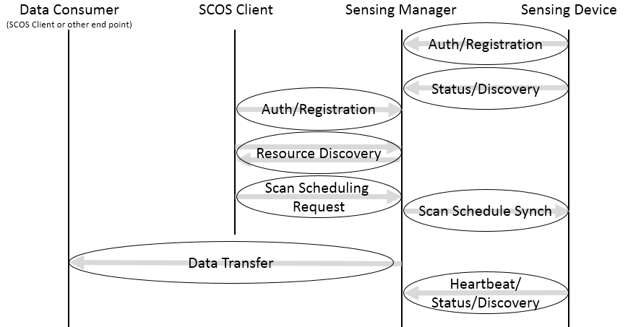
Figure 2: Simplified Interactions Model
A SCOS System is composed of one or more Sensor Devices and a Sensor Manager. The SCOS System provides sensing as a service to a SCOS Client, and transfers the data to an endpoint nominated by the SCOS Client.
- The Sensing Manager has two functional areas: Control and Data Distribution. The Control Service enables the Clients of SCOS system to do resource discovery and to make requests for sensing data. The SCOS Data Distribution Service collects and transmits the sensing data which enables the SCOS Clients to consume the requested data.
- A SCOS Client connects to Sensing Manager using a published address of the Sensing Manager and authenticates itself with the Sensing Manager. Upon successful authentication, the SCOS Client performs a query on the SCOS System using the resource discovery mechanism. A SCOS Client can then request sensing tasks to be performed by the SCOS System. A SCOS Client may request the status of the requested sensing task.
- A Sensing Device connects to the Sensor Manager of the SCOS System. The Sensing Device and Sensing Manager perform mutual authentication. Upon successful authentication, the SM performs capability discovery on the SD. The SM schedules sensing tasks on the SDs. The SM maintains periodic heartbeat with the SDs to maintain resource inventory and task status states.
- The SDs connect with the Sensing Manager Data Distribution Service. After successful mutual authentication, SD pushes the sensing data to the Sensing Manager.
- The Data Distribution Service distributes sensor data to the SCOS Client’s nominated endpoint.

