DCN 22-18-0033-00-0003

    - Sensing Device Requirements
One or more Sensing Devices should be deployed in the field to sense the radio spectrum environment. These devices consist of sensor capabilities, and a controller system that can perform platform functions (system authentication, discovery, data packaging and transmission, etc) along with signal detection and classification functions.
      - Sensing Device Hardware Requirements
A simplified hardware block diagram of a general SD model is depicted in Figure 4. SD hardware designs are not required to have each component shown in the block diagram. Metadata that describe each component (e.g., presence, model, operational parameters), however, are required in response to queries for sensor capabilities and to accompany data acquisitions.
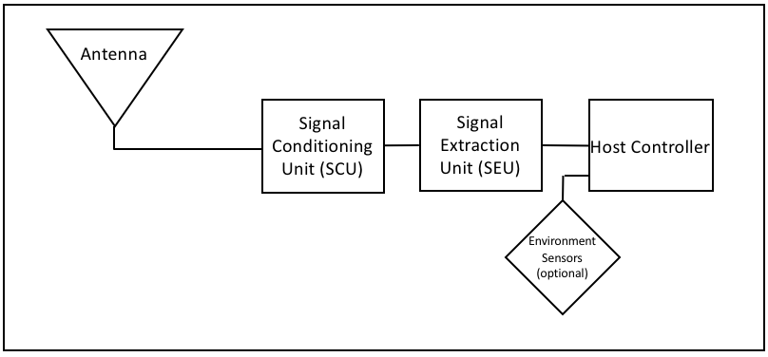
Figure 4: SD Simplified Hardware Model Block Diagram

- Functional element 1 – Antenna: An antenna converts environmental electromagnetic fields into a voltage. An RF cable connects the antenna with the next hardware component.
- Functional element 2 – Signal Conditioning Unit (SCU): An RF front end that could provide (among other things) preselection filtering, improved sensitivity via low noise amplification, and a calibration signal source. An RF cable connects the SCU with the next hardware component.
- Functional element 3 – Signal Extraction Unit (SEU): Analog Digital Converter (ADC), spectrum analyzer, Software Defined Radio (SDR), or other sampling device that also typically provides down-conversion and signal processing. A typical output of the SEU is a discrete baseband representation of the acquired signal.
- Functional element 4 – Host Controller: Provides control signals and messages to SCU and DEU. Raw data can be processed, e.g., to calculate calibrated absolute power at a reference point in the sensor RF path. Data acquisitions are packaged with metadata from sensor configuration onboard instruments, e.g., GPS. Furthermore the Host Controller receives configure and control metadata and sends necessary command and control signals to Functional Element 2 (Conditioning Unit), Functional Element 3 (Extraction Unit) and Functional Element 1 (Antenna), if the Antenna is a reconfigurable unit. It receives data from the Sensor/SDR, and polls any environment sensor input devices for necessary metadata items, such as GPS location. Interaction of the various elements is described in Figure 5.
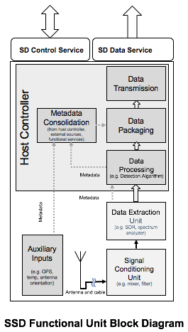
Figure 5: SD Functional Elements
This block diagram can be split into the hardware layer and the software processes that run alongside. These hardware blocks or software services generate metadata that is associated with each item.
      - Sensing Device Software Requirements
The algorithm model is described in terms of
- Inputs into black box: the Sensing Manager credentials and identity of the SCOS Client requesting the scan, the measurement parameters, which algorithm is to be used; and
- Outputs from the black box: the identity of the Sensing Manager and SCOS Client requesting the scan, the requested scan parameters, the identification of the algorithm model, and the processed results.
The following algorithms can be specified. At least once algorithm model needs to be supported by SD. Support for GenericEnergyDetection is normative. The standard allows development of advanced algorithms.
Table 19 SD Detection Algorithm Options
Scan Algorithm | Description
GenericEnergyDetection | Normative
CyclicFeatureDetection | Optional
CustomScanAlgorithm | Optional

It is the responsibility of the SCOS Administrator to publish algorithm definitions externally. The implementation does not need to be publicly accessible. Where these algorithms are non-proprietary, the metadata should include explicit links to repositories providing algorithm details, sample code and definition, on open access sites such as GitHub.
      - Sensing Device Data Requirements
The Sensing Device is exposed to the Sensing Manager via the SD Control Service, implemented as an API, which allows control and tasking messages to be exchanged. The SD transfers sensing data out to the Sensing Manager via a message transport mechanism through the SD Data Service. The SD can operate either as a slave device to the Sensing Manager, i.e. it performs scans on instruction, or it can operate semi-autonomously, i.e. it manages a schedule of scans that it periodically synchronizes with the Sensing Manager. This is defined by the particular mode of operation defined in Annex D “Operating Modes”.
To allow the SD to be given an instruction to perform sensing activity, it must initiate an association with the Sensing Manager and perform the required authentication and authorization functions. The mechanism for this is out of scope of this standard as it is implementation specific.

    - Sensing Manager Requirements
The Sensing Manager should allow users (SCOS Clients that are human individuals and/or technology systems) to interact with the SCOS Platform and its associated Sensing Devices. It exposes the capabilities of the SCOS platform to users, and manages and mediates tasks requests by users to the Sensing Devices. Once sensing tasks are performed and the respective Sensing Devices transmits the data back to the SM, the SM then manages distribution of that data according to its policies to one or more Data Consumer end points.
      - Sensing Manager Hardware Requirements
There are no normative hardware requirements for the Sensing Manager, as it is a software system running in a suitable compute environment. Choice of technology is implementation specific.
      - Sensing Manager Software Requirements
Detailed description of software requirements in Section 6.
      - Sensing Manager Data Requirements
Detailed description of software requirements in Section 6.

