DCN 22-18-0032-00-0003

  - System Requirements
The two key entities in this standard are the Sensing Manager (SM) and one or more Sensing Devices (SD), which make up the SCOS System. The interfaces between these entities are summaries in Figure 3: System Entities and Interfaces.
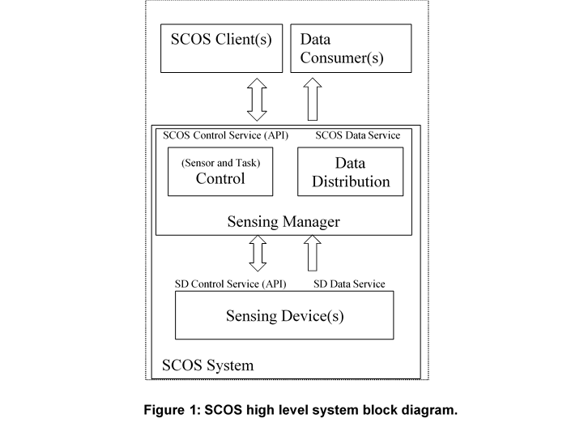
Figure 3: System Entities and Interfaces
The SM and SD entities interact via two key types of services: Control Services, and Data Distribution Services:
SCOS Control: Sensing task management and sensing device control form the SCOS Control Service. It involves the transfer and processing of sensing task requests from the SCOS Clients and scheduling the sensing tasks to Sensing Devices. In this standards document, the SCOS Control Service is defined normatively only around sensing tasks. Control Service activities for system configuration, management and monitoring tasks are described in informative annexes (Annex XXXxx), and considered out of scope of the normative standard as they are implementation dependent.
SCOS Data Distribution: This functional area involves collecting sensor data generated and locally processed by the Sensing Device, packaging of this data with related metadata and finally distributing it to the SCOS Clients for consumption. Data Distribution is done via any suitable transport mechanism, and is defined in terms of functional requirements in this standard as the technical method is implementation specific.

