DCN 22-18-0031-00-0003

  - System Entities and Services
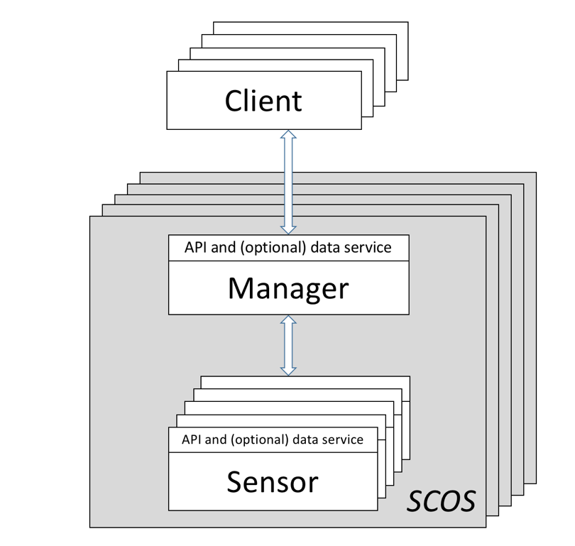
Figure 1: Simplified Block Diagram

Figure 1 illustrates a simplified block diagram of the SCOS architecture. The SCOS system architecture is based on the separation of function between command & control systems and sensing systems.
The two SCOS entities are Sensing Manager (SM) and Sensing Device (SD), which together make up the SCOS Platform:
Sensing Manager: The Sensing Manager allows user clients (whether individuals or other systems) to interact with the SCOS Platform. It exposes the capabilities of the SCOS platform to users, and manages and mediates tasks requests by users to the sensing devices. Once sensing tasks are performed and the respective Sensing Devices transmits the data back to the SM, the SM then manages distribution of that data according to its policies to one or more end points. The Sensing Manager entity is exposed to the SCOS Client via the SCOS Control Service via a directly coupled interface, or via an API.
Sensing Device: SDs gather, condition and sample the radio frequency environment, taking the processed samples, and package them within a compute platform into a standardized format along with relevant metadata. This is transmitted to the Sensing Manager for final transmission to the appropriate end point for consumption by the SCOS Client.

