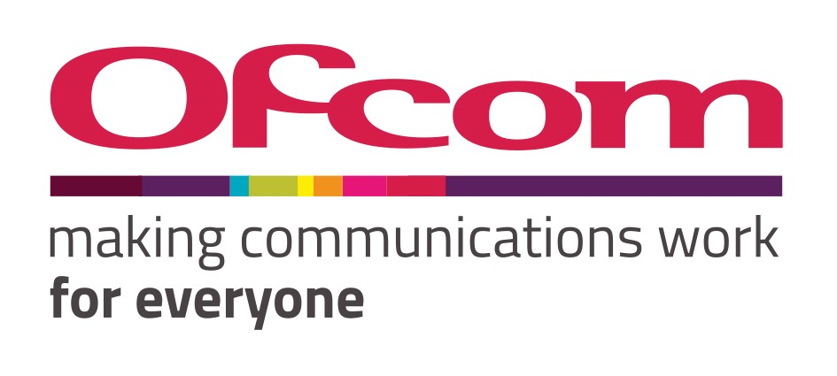

Unlocking the potential of
Terahertz radio spectrum
The role of spectrum management

Discussion document Published 2 December 2021

Summary

Radio spectrum is vital to make wireless connectivity happen - but it is a scarce and valuable resource. Almost all spectrum currently usable for terrestrial purposes - that is, spectrum up to about 100 GHz - is already authorised for use by a variety of different services that benefit multiple sectors of the economy.
Advances in technology across different fields are now starting to open up opportunities to use radio spectrum at extremely high frequencies.
Terahertz spectrum sits between around 100 GHz and 3 THz - that’s the very top of the spectrum range currently authorised for use. It offers very wide bandwidths and has properties that can provide unique insights into the world around us. It has the potential to play a role in meeting the ever-growing demand for data and enabling new, valuable and exciting applications.

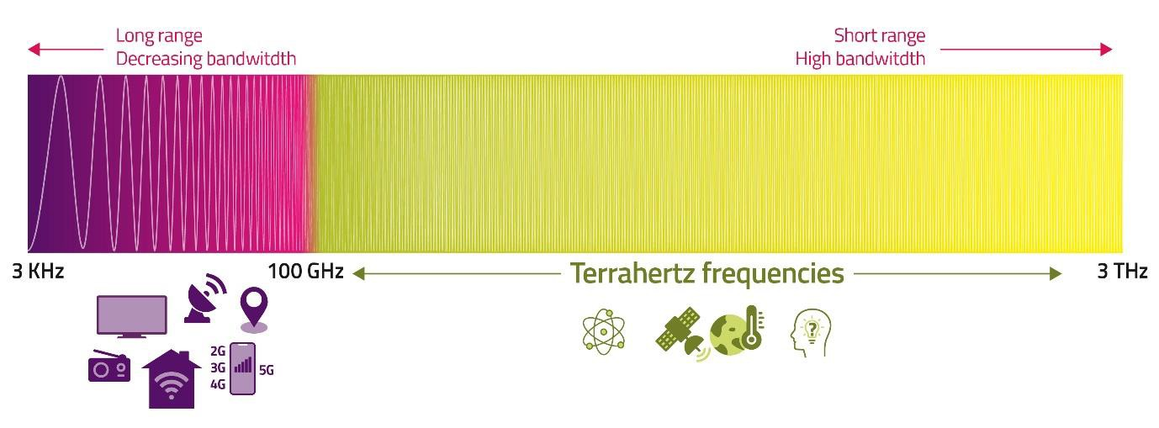
Figure 1: Position of the Terahertz spectrum
Source: Ofcom

At the moment, use of Terahertz spectrum is mainly limited to some scientific applications using specific frequencies. These include making high-sensitivity measurements used for weather forecasting and climate change predictions.
It is important to protect these activities from interference where necessary and support their future expansion. But we want to make sure the wider potential of Terahertz spectrum for other uses is also realised.
The development of compact, mass market equipment capable of using these high frequencies could open up a range of possibilities. Uses might include terabit speed wireless links in datacentres and outdoors; highly accurate positioning to aid robotics and autonomous vehicles; and high-resolution imaging and sensing to generate holograms. There is also academic interest in combining these features in future 6G networks and devices.

Given the characteristics of these frequencies and their limited current use, we have a rare opportunity to take a fresh look at how this spectrum could be managed in the future. We want to avoid ‘spectrum silo’ approaches likely to meet short term demand but which might create barriers to entry for future potential uses.

Our objective is to enable growth by existing services - but also keep options open for innovative new services.
We cannot predict which services will become technically and commercially viable (many are still the subject of early academic research) and so it’s important that the spectrum management approach we adopt is as flexible and efficient as possible (in line with our Spectrum Management Strategy).
We think that an approach which adopts spectrum sharing by default could help meet our objectives. Under this approach, users would be granted access on the expectation that ‘their’ frequencies may also be used by others wherever this is possible. We want to foster an environment based on cooperation and collaboration between spectrum users to make this happen.
The rules and approaches to spectrum authorisation that applied at lower frequency ranges should not dictate the way we approach the authorisation and use of this spectrum - given its unique properties and the potential uses being envisaged. New technologies are opening up greater options for sharing. These technologies include careful steering of narrow radio beams; interference cancellation techniques; and sophisticated online platforms and protocols for coordinating spectrum use across different services and users.
We will engage with interested parties to start a national and international dialogue, with a view to maximising the long-term value of Terahertz spectrum while it is still relatively lightly used. We will use our role and voice in international regulatory groups - such as the ITU and CEPT - to encourage greater collaboration and cooperation between different types of emerging spectrum uses in these bands and explore opportunities to use the spectrum more efficiently.
We know the full benefits of this new approach to spectrum management will not be realised overnight. But we also know that missing the opportunity to do things differently from now onwards means those full benefits may never be realised.

This paper is intended to start that dialogue. In it we share our current understanding of the potential uses for Terahertz spectrum, the challenges we think need to be overcome to fully unlock its potential, and why we think spectrum sharing is key. We encourage anyone with views or suggestions to contact us at Terahertz@ofcom.org.uk.

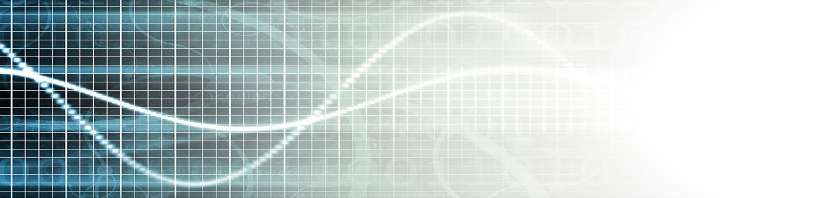

The potential of Terahertz

Introduction
What is Terahertz?
Terahertz frequencies are currently being studied to support a variety of potential uses that could open up a new frontier for usable spectrum. Once dubbed ‘tremendously high frequency’, Terahertz pushes the upper boundary of usable spectrum well beyond the range currently used by devices like mobile phones and Wi-Fi.
It is generally identified as lying between around 100 GHz and 3 THz (3,000 GHz), extending possibilities into frequencies considered of little practical value for terrestrial use even a few years ago. There is more than one thousand times more spectrum in the Terahertz range than is currently allocated for mobile networks in the UK.
Until now, practical use of Terahertz spectrum has been mainly for taking scientific measurements of the earth from satellites.
These include the use of passive sensors to receive and measure natural emissions produced by the Earth’s surface and its atmosphere. Knowledge of these emissions helps us monitor weather and climate change. The particular frequencies used are determined by physics and are unalterable.
Other uses starting to emerge include high speed point to point wireless data links.
But advances in technology mean that, over the next decade, there could be opportunities to make much wider use of these frequencies, with an initial focus on spectrum below 275 GHz.
Advances in the use of wireless services continue at pace. Invention and innovation continue to deliver new technologies and applications unimagined even a few years ago. And it all relies on the invisible electromagnetic spectrum that carries signals and data from place to place.
Spectrum is the lifeblood of all wireless connectivity. Without spectrum there can be no mobile phone networks; no broadcasting; no Wi-Fi; no smart homes or smart cities; no satellites; no remote sensing; and much more.
As a result, demand for spectrum continues to grow, in line with rapid technological progress, consumer demand, and digitisation across different industry sectors. But spectrum is a finite resource. In order to help avoid access to spectrum becoming a bottleneck to innovation and growth, it is important we take full advantage of emerging technologies to enable its efficient use.

Ofcom’s role
As the UK’s communications regulator, one of Ofcom’s key duties is the management of radio spectrum to support a wide range of electronic communications services across the UK. We must ensure the use of spectrum is optimised.
As technology developments enable wider use of Terahertz spectrum, it is important we take the time to consider the best way to manage the frequencies. We have already opened up access to 18 GHz of Terahertz spectrum expressly for innovation, and we are now thinking about how best to manage the full Terahertz range to maximise both short-term and long-term benefits. At the same time, we recognise there is great uncertainty about when, and if, the various ideas currently the subject of research will become commercial reality.

The starting point – what are the current uses of Terahertz?
Terahertz spectrum is being seen as something of a blank page for future exploitation. But there are existing users, and various services have started to be earmarked in different parts of the Terahertz range – especially at the lower end.
The International Telecommunications Union (ITU), which determines worldwide spectrum allocations through its Radio Regulations, has already made a number of frequency allocations for different radio services all the
way up to 275 GHz - and identified further bands up to 450 GHz for other services.
As can be seen below, this means the overall picture below 275 GHz looks very busy, with numerous blocks of spectrum being allocated to a long list of service types. However, this hides a big difference between spectrum that has been allocated by the ITU in the Radio Regulations (as shown in the diagram) and spectrum that is actually being used in and over the UK today. There is in fact sparse use (in terms of time, frequencies and place) of the Terahertz spectrum.
Although the spectrum is sparsely used, some existing uses are highly valued. The most notable actual use of Terahertz spectrum at present is by the space science community for earth observation. This includes measurements that help us understand and predict changing weather patterns and inform climate change modelling – although the spectrum is also used for earth-based astronomy.
Many of the space science uses are highly sensitive to interference and have benefitted from being positioned in the relatively unoccupied Terahertz frequencies - far away from other spectrum users in lower frequencies. Current Radio Regulations prohibit other transmissions in a number of bands to protect scientific uses. The allocations identified in the illustration above by black blocks are the ones considered by the ITU to be most sensitive to potential interference.

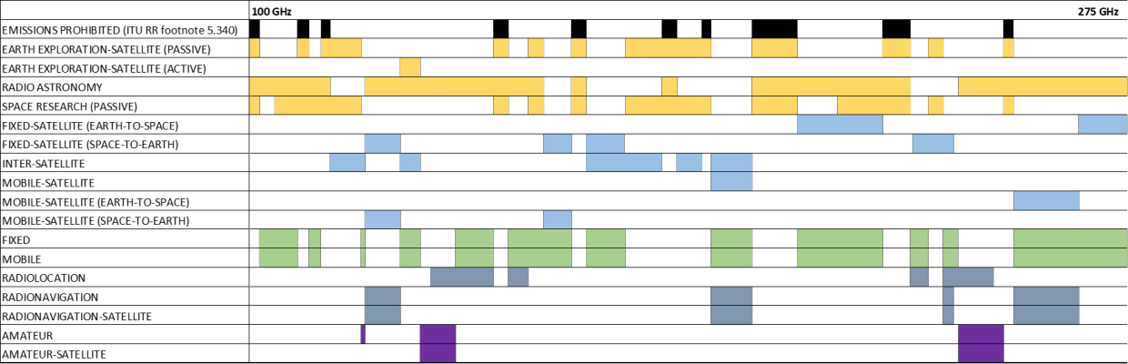
Figure 2: ITU Radio Regulation spectrum allocations relevant to the UK
Source: Ofcom derived from efis.cept.org.

These current allocations mean there is a large degree of fragmentation that could present an obstacle to future wide band uses unless it can be overcome. The highly protected bands between 100 and 275 GHz represent 20% of the spectrum and create 10 fragmented bands available for other users, with bandwidths ranging from 2 to 33 GHz.
Allocations to other service types could potentially create further fragmentation.
The frequencies above 275 GHz have less current use, primarily due to the limitations of today’s technologies. However, the ITU has identified some bands for fixed, mobile and science services, and the space science community is developing next generation sensors to use specific frequencies.

What are potential future uses?
Ofcom’s role is to establish the best possible conditions for the market to operate to the benefit of society, people and business. We like to let the market, to the extent this is possible, determine the most valuable use of the frequencies.

Characteristics of Terahertz spectrum
That said, we need to understand the characteristics of particular spectrum bands to determine the best ways to make them available for the benefit of many users, existing and new. The Terahertz spectrum will ultimately offer a very large body of new frequencies, even though we expect early interest to be focussed on the lower part of the range (i.e. below 275 GHz).
The pioneers who’ve started exploring the frontiers of Terahertz say its use could deliver advantages compared to deploying systems in other developing frequencies like mmWave bands. Terahertz spectrum can provide bigger
bandwidths, more compact equipment and higher directionality - and the way the signals interact with the environment offers unique measurement capabilities not possible in other bands.
There are also a number of challenges due to the nature of propagation at these high frequencies, and we need to understand this further. Signals can easily be degraded by obstacles and frequency-dependent molecular absorption. And signals can be scattered in complex ways by different types of rainfall, leading to shorter and less predictable transmission paths.

Overview of potential uses
Although it is not possible to predict all future uses of the Terahertz bands, given the interest and the type of research currently being undertaken, it is likely that a mixture of active terrestrial uses and growing passive uses will emerge.
For communications applications, Terahertz spectrum has the potential to allow very high throughput and a very low latency but, typically, over relatively short distances.
Narrow radio beams could enable very dense deployment of communications devices.
For sensing applications, the different transparency of materials to Terahertz signals would allow their use for non-destructive product inspection, molecular analysis and material characterisation in security, industrial and various medical applications.
For positioning and imaging applications, Terahertz spectrum can provide centimetre and sub-centimetre level accuracy and high- resolution maps of the environment. This could be exploited in robotics and autonomous vehicles, as well as improving communications using advanced virtual reality and holograms.

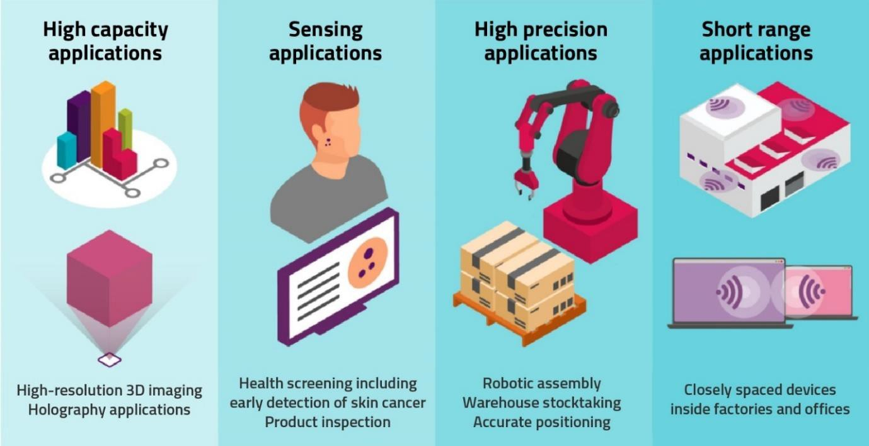
Figure 3: Types of potential uses for Terahertz spectrum
Source: Ofcom

One early use of Terahertz spectrum in the next few years could be for communications fixed links. This could include
capacity upgrades for some existing wireless data links and high capacity 5G small cells, avoiding the need for fibre optic cables.
Two bands in particular – the W band, which extends below 100 GHz (92 to 114.25 GHz), and the D band (130 GHz to 174.8 GHz) are already being considered for wireless backhaul/access applications at speeds in the order of 10 Gbps over distances of a few hundred metres, with technical standards already well advanced.
In addition to data links, European standards groups are studying the potential extension of ultra-wide band (UWB) short range radar applications to bands between 116 and 260 GHz and potentially up to 1 THz. As well as industrial applications, such as measuring flow rates and depth of fluids, there are potential uses in automotive radar (both inside and outside vehicles).
We also expect use of the Terahertz spectrum for space science purposes to grow. One of the main areas of growth is likely to be for more passive sensing of the Earth from satellites to provide valuable information for studies that will improve weather forecasting
capability and inform our understanding of various parameters that feed into climate change modelling – both nationally and globally.
Technology advances will allow sensors to monitor higher frequencies, and there is potential for many more sensors to be deployed as the cost of building and launching satellites falls – providing more timely and more accurate information.
In the longer term, there is a major opportunity to design systems that combine communication, sensing and positioning in a single, mobile device. There is already speculation about the use of Terahertz spectrum for 6G mobile technology over the coming decade. 6G won’t just mean better and faster services delivered by mobile network operators – though these will inevitably be an important element – it is also likely to mean new positioning, imaging and sensing applications in handsets enabling services that are not possible with current technology.
Beyond 6G, uses might include gateway links to low earth orbit (LEO) satellites and links between satellites, indoor data links (e.g. datacentres) and nano level communications (including on chip). The diagram below

illustrates some potential uses and we’ve
included links to a selection of research
papers as the end of this paper that provide further examples of potential uses.

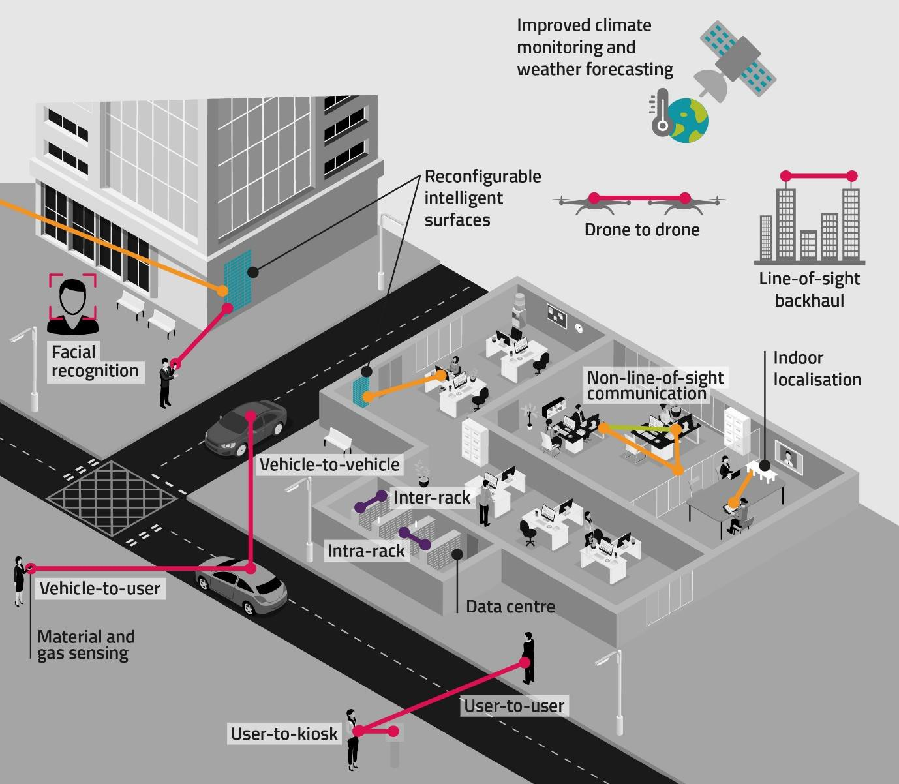
Figure 4: Illustrative examples of specific services that Terahertz spectrum might support
Credit: Based on illustration in Next Generation Terahertz Communication: A Rendezvous of Sensing, Imaging and Localization (May 2020)

As outlined above, opening up access to Terahertz spectrum could enable a diverse range of exciting and high value applications and services. Many of these technologies are still in early stages of research (and there may be others that have yet to be invented) and it is not yet clear which will become a commercial reality and by when.
Given the uncertainty on future demand, and if we are to ensure access to spectrum is not a barrier to innovation and investment in both the short and long run, it is important to develop a flexible and agile approach to managing this spectrum, that can accommodate as many users as possible.

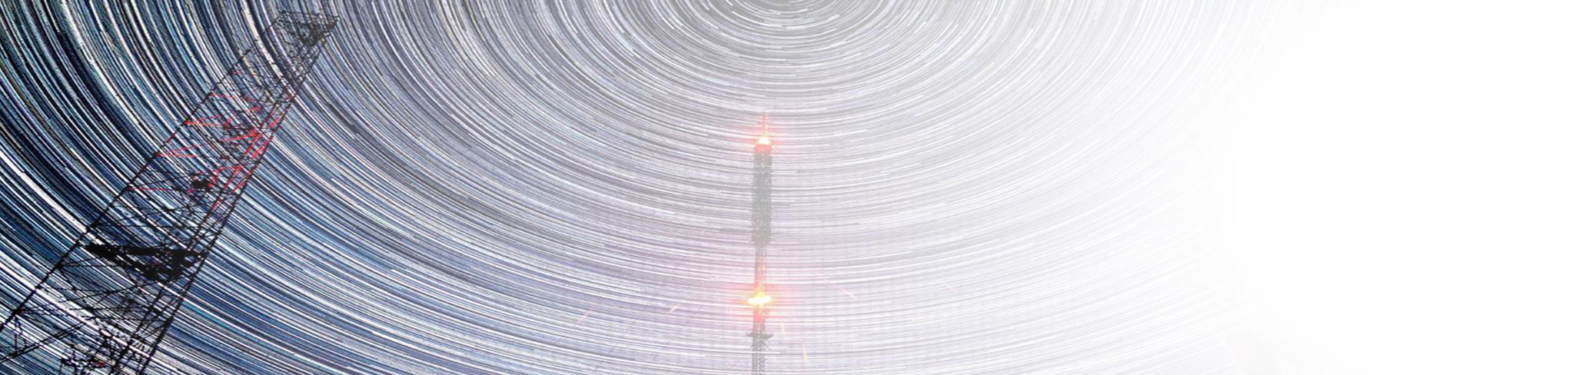Although we recognise the opportunities the Terahertz spectrum presents, we also need to consider the potential pitfalls to be avoided or navigated when managing access to the spectrum.

What challenges do we need to overcome?

Fragmentation
We have already identified in this document that existing ITU allocations, particularly those for highly protected frequencies used for space science, have led to fragmented allocations for other services, especially in the lower Terahertz frequencies. As noted, we are committed to protecting and enabling growth for these applications, not least because of the role they play in our understanding of the environment.
But we also want to ensure that fragmentation does not become a barrier to future innovation by inhibiting the development of new applications. For many of the potential applications we’ve outlined above, wider, contiguous channel bandwidth would result in better performance - whether that be faster wireless communication speeds or higher resolution images. Service quality may be reduced if the available spectrum is fragmented and technology development may take longer and cost more – creating a barrier to investment and reducing benefits.

Concentration of demand
Like all new frontiers, the boundary of Terahertz spectrum is being pushed out slowly starting from already occupied areas. Early interest and allocation is being concentrated in the relatively lower frequencies, starting around 92 GHz (the bottom of the W-band).
There has already been some interest in spectrum in the bands below 275 GHz

allocated by the ITU, such as from fixed links. Operators of short-range radar devices are also seeking to extend their own use into the same bands, prompting questions on whether they would cause interference to each other.
Although it may be argued that technology developments will gradually open up the use of Terahertz spectrum beyond 275GHz, this won’t necessarily avoid a sub optimal use of the frequencies. For example, if Terahertz is to be supported in mass market mobile handsets then component costs should be minimised. This may best be achieved by using the lower end of the Terahertz range, where the technologies may mature and commoditise earlier.

Technical standards
Early discussion around 6G indicates that several uses for Terahertz spectrum could be combined in a single set of technical standards. This would allow any interoperability and coexistence challenges to be more easily addressed e.g. supporting hybrid sensing/imaging and high-speed communications in the same technical standard could allow them to operate using the same frequencies. Such an approach could enable more efficient use of spectrum and lower the cost and complexity of devices.
However, it is unrealistic to expect a single standards body could develop standards that meet the needs of a disparate set of spectrum users ranging from earth observation, fixed links, standalone sensors and 6G mobile.
There is also a risk that relying on a single standards body could stifle
innovation, reduce diversity, and not serve all sectors equally.

International consensus
There are a number of reasons why international consensus around a new spectrum management paradigm may be necessary if we’re to maximise the potential of the Terahertz spectrum.
Although there are fewer cross-border interference considerations for Terahertz frequencies – because of their short propagation distances – there is a different global aspect to consider because of their important use for space-based applications which are inherently global by their nature.
The international regulatory groups, such as the ITU and CEPT, have an important part to play in setting the parameters for new technical standards and can influence how different standards bodies work together.
Increasingly, international consensus on technical standards and harmonisation of spectrum use is also vital to encourage R&D investment and product development. The fixed costs of developing technologies for Terahertz may only be justified if they can be recouped from a global market – the relatively small size of the UK market means we cannot expect vendors to develop products and services that are unique to the UK.
We recognise that achieving international consensus on spectrum management and
spectrum use can be challenging and hard to achieve at pace.

Risk from delay
The opportunity to adopt a new approach to spectrum management in the Terahertz spectrum may be short lived. Potential users of the spectrum are already developing technical standards and seeking access to spectrum in traditional ways, based on primary allocations and expectations of priority access.
National regulators and international bodies will need to work together to avoid the risk of uses becoming entrenched, and seeing the opportunity to get wider value for everyone lost. New approaches will need to be agreed in a timely way to give industry the certainty around spectrum access they need in order to invest in the development of new technologies and services.

Our proposed approach to Terahertz spectrum management
We have already set out our vision for spectrum management in the 2020’s through the spectrum strategy document we published in July 2021.

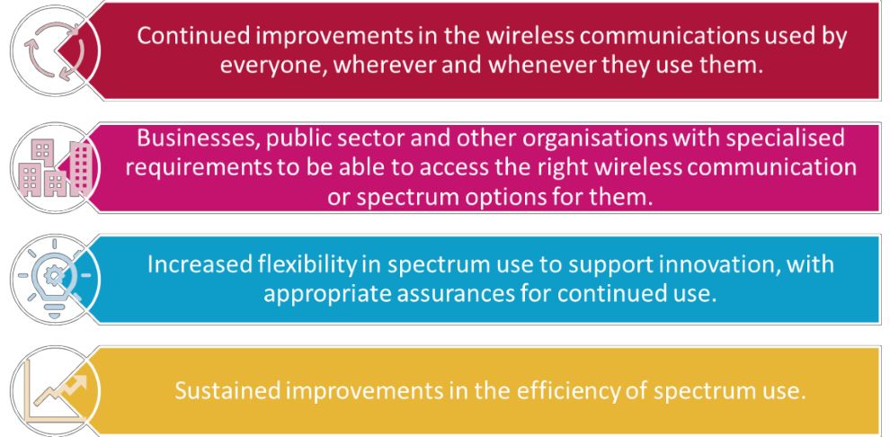
Figure 5: Our spectrum management vision

Our objectives and proposed approach for Terahertz spectrum are in line with the vision
– our focus is on flexible and agile management of spectrum to support innovation and growth in the short and long run.
Given the challenges we have identified, we believe an approach to spectrum management that assumes sharing by default will be instrumental to make the most of the opportunities Terahertz spectrum presents.
The challenges of fragmentation and concentration of demand can be mitigated if ways can be found to enable sharing of spectrum between users of different services, and maximising channel bandwidth. Sharing could use automated solutions to coordinate access, rather than individual assignments issued by the regulator.
The time is right to consider new ideas and approaches. New technologies, such as advances in cloud computing, software defined radios, AI, antenna design and ubiquitous access to the internet are opening up new options for spectrum sharing, and wider re-use of this scarce resource.
In the future, devices may need to adopt mutually agreed, ‘polite’ ways to coordinate with other users/uses – perhaps in the way that different Wi-Fi routers share their frequencies, or the way they share spectrum with Bluetooth devices.
Many Terahertz applications are likely to use very small and highly focussed radio beams and careful management and coordination between users could enable multiple networks and services to use the same spectrum with minimal interference. Where interference does occur, advanced signal processing and the use of AI might be used to identify and, potentially, mitigate its impact.
For uses that do not require constant access to spectrum, others could make use of the frequencies at times when it is not required - whether on an hour to hour basis or millisecond by millisecond. This might be achieved by real time synchronisation of networks or coordination between devices,
either directly with each other or via online platforms.
The different characteristics of this spectrum; the different nature of existing and potential future uses; and the technology developments in place to allow for greater sharing are setting the path to consider and manage this spectrum differently. Using the processes that have driven spectrum management in lower frequency bands - such as the development of very use-specific coexistence studies based on conservative protection requirements - will not allow the full benefits of these bands to be realised.
Standards bodies are focussed on different sectors and uses, but they will need to work together to find solutions. We would like to see technologies using different technical standards to coexist through sharing, with a presumption of co-channel as well as adjacent channel sharing. Ideally, the regulatory framework would comprise of very simple overarching rules that will allow more detailed solutions to be developed by the market through cross sector collaboration.
We want to develop an environment which will allow innovators to access the spectrum alongside the major sectors or most influential companies. Technical solutions should be open and available to all and seek to minimise development, deployment and operational costs. We want to avoid unnecessarily complex solutions that risk discouraging the innovation and use that we want to enable.
We would like all current and potential users of the spectrum to play their part in enabling sharing if we’re to achieve our vision of using Terahertz spectrum to the maximum. Where sharing is not possible today, due to limitations of current systems, solutions should be explored to enable sharing when next generation systems are deployed.
We know the full benefits of a new approach to spectrum management will not be realised overnight. However, missing the opportunity to consider and do things differently from now onwards means those full benefits may never be realised.

How we will take this forward
In publishing this paper, we hope to start a discussion and set out some early ideas - a vision of a forward looking approach to managing Terahertz spectrum - and encourage an international conversation with industry and regulators.
We are interested in hearing the views of all interested sectors on the matters discussed in this paper. We want to know what others think about the opportunities, options and solutions. We encourage anyone with views or suggestions to contact us at Terahertz@ofcom.org.uk.
We will engage with the space science community to better understand their future plans; and how they might share spectrum with new users in the future.
We will engage with potential new users of the Terahertz spectrum (e.g. those considering fixed links and short range radar devices, and also the more speculative uses of Terahertz spectrum for 6G applications) to understand their needs; how they plan to
work with existing users; what constraints they feel existing users place on them; and how they could, in turn, accommodate future users.
We want to explore with industry the benefits and incentives for collaboration. We’re interested in engaging with academia, vendors and end users to explore opportunities to leverage investment in R&D across sectors, and develop solutions that lead to mutual benefits. We
welcome views on practical measures we can take to enable cross sector cooperation.
We recognise there are limits to what national regulators like Ofcom can achieve on their own. So, we will use our role and voice in international regulatory groups - such as the ITU and CEPT - to encourage greater collaboration and cooperation between different types of emerging spectrum uses in these bands and explore opportunities to use the spectrum more efficiently.
We will share the feedback received and our evolving thinking in our Spectrum Roadmap, which we plan to publish in Spring 2022.

Annex: Links to Terahertz spectrum related research

The following (non-exhaustive) list of research papers provides background information on the potential uses and characteristics of Terahertz spectrum:

Wireless Communications and Applications Above 100 GHz: Opportunities and Challenges for 6G and Beyond (May 2019) Theodore S. Rappaport , Yunchou Xing, Ojas Kanhere, Shihao Ju, Arjuna Madanayake, Soumyajit Mandal, Ahmed Alkhateeb, Georgios C. Trichopoulos https://ieeexplore.ieee.org/ielx7/6287639/86 00701/08732419.pdf
Seven Defining Features of Terahertz (THz) Wireless Systems: A Fellowship of Communication and Sensing (September 2021) Christina Chaccour, Mehdi Naderi Soorki, Walid Saad, Mehdi Bennis , Petar Popovski and Merouane Debbah https://arxiv.org/pdf/2102.07668.pdf
Exploiting Rarely Capitalised Spectrum Future Technologies using THz and beyond THz bands: Presentation for TechUK Spectrum Policy Forum (September 2021) Muhammad Ali Imran, Qammer H. Abbasi https://www.techuk.org/asset/21B93B5F- F267-4C05-B3F983F8AA168538/
Propagation Measurement System and Approach at 140 GHz–Moving to 6G and Above 100 GHz (August 2018), Yunchou Xing, Theodore S. Rappaport, NYU WIRELESS https://arxiv.org/pdf/1808.07594.pdf
Beyond-5G Wireless Tbps Scenarios and Requirements (January 2018), Majed Saad, Carlos F. Bader, Jacques Palicot, Siradel: Yoann Corre, Grégory Gougeon, Jean-Batiste Dore.
http://www.brave-beyond5g.com/wp- content/uploads/2018/12/BRAVE-D1.0-B5G- wireless-Tbps-Scenarios-and-Requirements- v1-1.pdf
Terahertz Wireless Communications: Co- Sharing for Terrestrial and Satellite Systems Above 100 GHz (October 2021) Yunchou Xing, Theodore S. Rappaport https://ieeexplore.ieee.org/stamp/stamp.jsp? tp=&arnumber=9450810
Toward End-to-End, Full-Stack 6G Terahertz Networks (January 2021) Michele Polese, Josep Jornet, Tommaso Melodia, Michele Zorzi
https://arxiv.org/pdf/2005.07989.pdf
Millimeter-wave and Terahertz Spectrum for 6G Wireless (February 2021) Shuchi Tripathi, Nithin V. Sabu, Abhishek K. Gupta, Harpreet S.
Dhillon https://arxiv.org/pdf/2102.10267.pdf
Next Generation Terahertz Communications: A Rendezvous of Sensing, Imaging, and Localization (May 2020) Hadi Sarieddeen, Nasir Saeed, Tareq Y. Al-Naffouri, Mohamed- Slim Alouini https://www.researchgate.net/publication/34 2058358_Next_Generation_Terahertz_Comm unications_A_Rendezvous_of_Sensing_Imagin g_and_Localization

