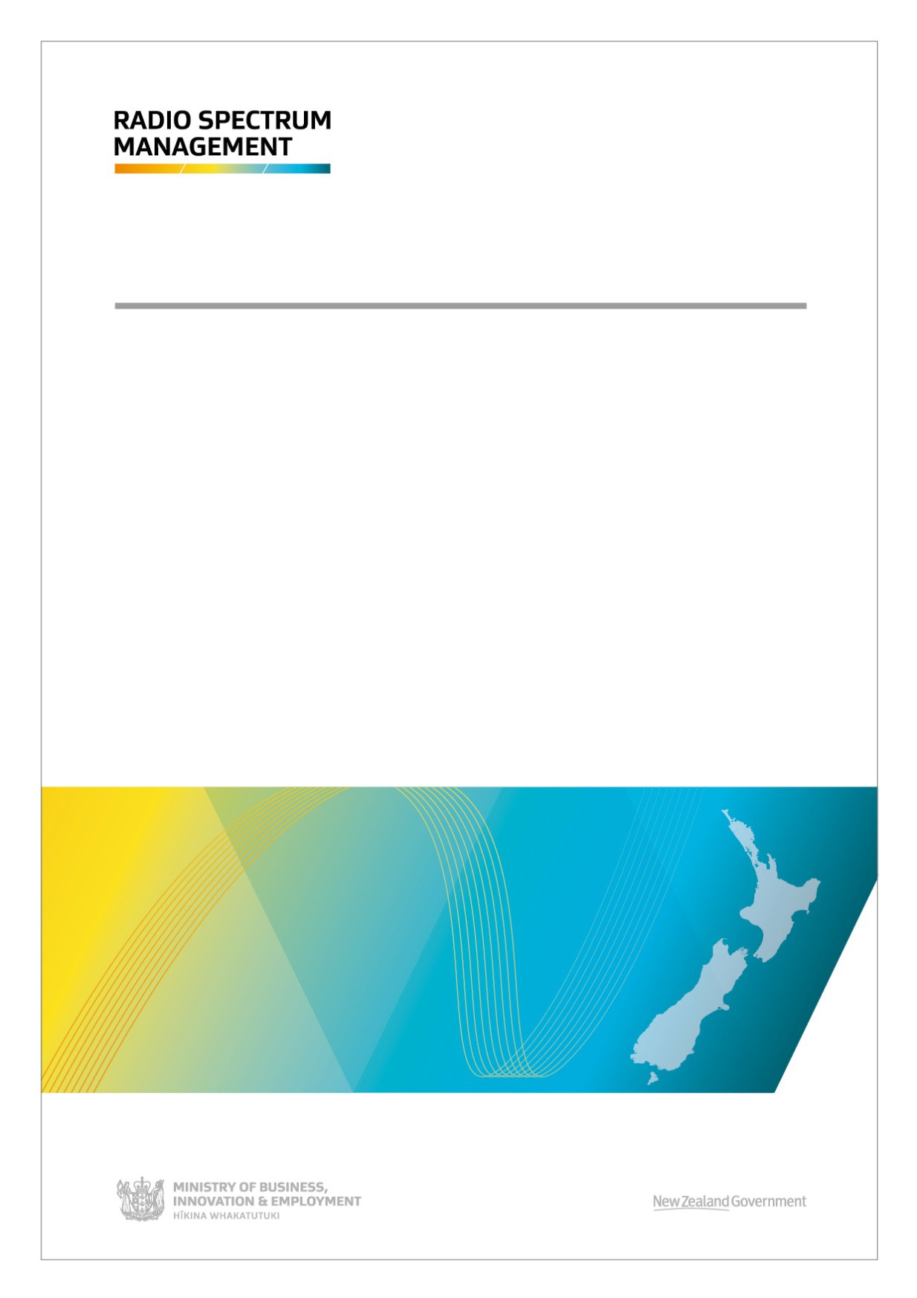

NOT GOVERNMENT POLICY

WLAN use in the 6 GHz band
Discussion document June 2021

Disclaimer
The opinions contained in this document are those of the Ministry of Business, Innovation and Employment and do not reflect official government policy. Readers are advised to seek specific legal advice from a qualified professional person before undertaking any action in reliance on the contents of this publication. The contents of this discussion paper must not be construed as legal advice. The Ministry does not accept any responsibility or liability whatsoever whether in contract, tort, equity or otherwise for any action taken as a result of reading, or reliance placed on the Ministry because of having read, any part, or all, of the information in this discussion paper or for any error, inadequacy, deficiency, flaw in or omission from the discussion paper.
ISBN: 978-1-99-100829-9

CONTENTS
INVITATION FOR SUBMISSIONS IV
Publication and public release of submissions v
Privacy Act 2020 v
EXECUTIVE SUMMARY 2
INTRODUCTION 3
WLAN USE IN NEW ZEALAND 3
The importance of Wi-Fi 3
A growing spectrum demand for Wi-Fi 4
GLOBAL DEVELOPMENTS IN PLANNING 6 GHZ MOBILE USE 6
ITU developments (WRC-23) 6
Australia 6
Europe 7
United Kingdom 7
United States 7
NEW ZEALAND PROPOSAL 8
5925 - 6425 MHz for WLAN use 8
General user licence for low power and very low power device 9
Higher power devices 9
SUMMARY 11
ANNEX 1: TECHNICAL STUDIES 12
WLAN technologies in the 6GHz band 12
Wi-Fi 6E and Wi-Fi 7 12
5G NR Unlicensed 13
Sharing and compatibility studies 14
Compatibility with Fixed Service 15
Compatibility with Fixed Satellite Service 17
Sharing with UWB systems 18

FIGURES IN DOCUMENT
Figure 1 5 GHz Wi-Fi channel plans in New Zealand 5
Figure 2 Wi-Fi 6E frequency bands and channels 6
Figure 3 FCC’s channel plan from 5925 - 7125 MHz 7
Figure 4 Overview of FCC’s AFC system 8
Figure 5 Evolution of Wi-Fi radio performance 12
Figure 6 Available bandwidth over 2.4 GHz, 5 GHz and 6 GHz frequency bands in Wi-Fi 7 13
Figure 7 5G NR in unlicensed spectrum with 3GPP Release 16 14
Figure 8 Fixed service use in New Zealand 16
Figure 9 A close look of fixed service in Auckland, Wellington and Dunedin 17

TABLES IN DOCUMENT
Table 1 Maximum EIRP for 6 GHz unlicensed devices in the US 8
Table 2 Frequency allocation and usage in 5925 - 7125 MHz 14
Table 3 GUL for UWB devices overlapping with WLAN 6 GHz 18

Invitation for submissions
This document sets out the spectrum plan for future use of frequencies between 5925 and 7125 MHz in New Zealand.
Interested parties are invited to comment on the content of this document, in particular the questions posed and on any related issues. Comments should be submitted in writing, no later than 5pm on 30th of June 2021 to:
By email: (preferred option)

Radio.Spectrum@mbie.govt.nz
Subject line: “Consultation Submission - WLAN use in the 6 GHz band” Or

By post:

Planning for WLAN use in the 6 GHz band
Radio Spectrum Management Policy and Planning Ministry of Business, Innovation and Employment PO Box 2847
WELLINGTON 6140
Any party wishing to discuss the proposals with Ministry officials should, in the first instance, email Radio.Spectrum@mbie.govt.nz

Next steps
Once the window for submissions has closed, RSM will:
- publish the submissions,
- analyse the submissions and feed into our planning work,
- finalise its advice and brief the Minister for the Digital Economy and Communications, and,
- publish the final decision.

Publication and public release of submissions
Except for material that may be defamatory or out of scope, the Ministry of Business, Innovation and Employment (the Ministry) will post all written submissions on the Radio Spectrum Management website at www.rsm.govt.nz. The Ministry will consider you to have consented to posting by making a submission, unless you clearly specify otherwise in your submission.
Submissions are also subject to the Official Information Act 1982. If you have any objection to the release of any information in your submission, please set this out clearly with your submission. In particular, identify which part(s) you consider should be withheld, and explain the reasons(s) for withholding the information. The Ministry will take such objections into account when responding to requests under the Official Information Act 1982.

Privacy Act 2020
The Privacy Act 2020 establishes certain principles with respect to the collection, use and disclosure by various agencies, including the Ministry, of information relating to individuals and access by individuals to information relating to them, held by such agencies. Any personal information you supply to the Ministry in the course of making a submission will be used by the Ministry in conjunction with consideration of matters covered by this document only.
Please clearly indicate in your submission if you do not wish your name to be included in any summary the Ministry may prepare for public release on submissions received.

Executive Summary
Radio Spectrum Management (RSM) is considering the use of radio spectrum from 5925 MHz - 7125 MHz to support the ever growing need wireless broadband traffic. This consultation document outlines the preliminary views and proposals of RSM on the future use of this frequency range in New Zealand and seeks your feedback.
WLAN (Wireless Local Area Network) use in New Zealand is continuing to increase. The technology is important for providing internet connectivity and delivering broadband to end users. This is creating a growing demand for more spectrum. The COVID-19 pandemic has also increased the reliance on WLAN networks as more and more people work and learn from home.
Internationally there have been a number of regions and countries making the 6 GHz band available for WLAN, especially the bottom 500 MHz (5925 - 6425 MHz). There is growing interest in harmonising further spectrum bands for generally authorised (also known as unlicensed and licence exempt). This is partly due to the view that current spectrum available for WLAN devices will soon be insufficient.
Given the growing spectrum demand for WLAN and international developments in this band, RSM is proposing to make the lower 6 GHz band (5925 - 6425 MHz) available for WLAN use. To co-exist with the incumbent Fixed, Fixed Satellite, and Ultra Wide Band systems, we have proposed two power limits for WLAN devices operating indoors and outdoors respectively.
For the upper 6 GHz band (6425 - 7125 MHz), some countries have already made the band available for unlicensed WLAN use; some countries indicated the band might be used for licensed International Mobile Telecommunications (IMT) systems. In addition, the ITU-R is studying the 6425 - 7125 MHz under WRC agenda item 1.2 for a possible IMT identification. Therefore, we propose to keep monitoring the international allocation and studies of this frequency band before making decisions.

Introduction
There continues to be strong growth in wireless broadband traffic. The drivers behind this growth are a dramatic increase in video use, device proliferation and application uptake. The growing use of applications to stream content is particularly noteworthy. Sufficient radio spectrum is important for supporting the growth of wireless broadband traffic.
The 6 GHz band (5925 - 7125 MHz) is currently generating substantial interest internationally. Numerous countries are opening up access to the band – or parts of it – for use by wireless local area network (WLAN) systems1, the most common of which is Wi-Fi. Currently, the International Telecommunications Union – Radio Sector (ITU-R) is studying the 6425 - 7125 MHz band for International Mobile Telecommunications (IMT) (5G) for agenda item 1.2 of the 2023 World Radiocommunications Conference (WRC-23).
This discussion document presents information on current spectrum use and international harmonisation activities in the 6 GHz band. It sets out RSM’s preliminary thinking on the future use of WLAN devices to begin a discussion with industry stakeholders about the future of this band in New Zealand. We have also analysed current regulatory arrangements, results of international studies on sharing, and the available technologies.
We are interested in understanding the use cases and receiving feedback on licensing options and technical parameters that will determine how to make 6 GHz band available for WLAN use. Details on the wider RSM work program can be found in the Radio Spectrum Management Five Year Spectrum Outlook.

WLAN use in New Zealand

The importance of Wi-Fi
The COVID-19 pandemic has changed internet use patterns globally. Consumer requirements for home broadband now include a more expansive use of Wi-Fi throughout the house, more concurrent uses, and higher performance. Broadband traffic being carried over, Wi-Fi networks have continued to increase, with more people working, learning, and socialising from home using real-time online communications such as video conferencing.
New Zealanders are using the internet more and more. In a recent InternetNZ survey, 96% of respondents said they are accessing the internet at home on a daily basis and 70% of internet users are accessing it daily at work. This shows the growing importance of connectivity for businesses in New Zealand. 90% of households with broadband access in New Zealand include Wi-Fi access, and 71% of telecommunications traffic is transported through Wi-Fi networks.
Wi-Fi networks are also important for the Internet of Things and Machine-to-Machine connectivity. Today, it is rare to find a digital device that does not rely significantly on a Wi-Fi connection. Wi-Fi effectively provides connectivity in many homes and businesses, linking devices such as TVs, audios, printers, monitors, and appliances.
In addition to residential use and consumer devices, Wi-Fi’s enablement of industrial devices’ and enterprise networks’ seamless and secure information flow is critical to companies’ operations across many industries and businesses. Enterprises can also accelerate the

1 WLAN is a radio network that links devices using wireless communication to form a local area network (LAN) within a limited area. Some countries also call it Wireless Access Systems (WAS) or Radio Local Area Networks (RLAN). This document use WLAN to be consistent with the terminology in the Radiocommunications Regulations (General User Radio License for Short Range Devices) Notice.

adoption of Intelligent Edge, which help to reduce the network latency and growing cost of cloud infrastructure.
The value of Wi-Fi, and the advantages it brings, has significantly increased over the past years. The Wi-Fi Alliance estimated that the global economic value of Wi-Fi in 2021 is US$3.3 trillion, growing to US$4.9 trillion by 2025. For New Zealand, these numbers are US$7 billion in 2021 and US$10 billion by 20252.

A growing spectrum demand for Wi-Fi
There are four spectrum blocks in 2.4 GHz and 5 GHz that are currently available and used for WLAN under the General User Radio Licence for Short Range Devices (GURL-SRD) regime in New Zealand. Table 1 summarises these bands and the licence conditions.
Table 1. Current Wi-Fi bands in New Zealand

Frequency band | EIRP (dBm) | Licence conditions
2400 - 2483.5  MHz | 36 | Indoor and outdoor use, frequency hopping required if EIRP is greater than 30 dBm
5150 - 5350 MHz | 30 | Indoor and outdoor use, EIRP mask, DFS3, TPC4 for upper 100 MHz
5470 - 5725 MHz | 30 | Indoor and outdoor use, DFS, TPC
5725 - 5875 MHz | 36 | Indoor and outdoor use, frequency hopping required if EIRP is greater than 30 dBm

Figure 1 shows the available 5 GHz Wi-Fi channels in New Zealand. The three frequency blocks in the 5 GHz spectrum can support 6 x 80 MHz or 2 x 160 MHz Wi-Fi channels. 5150 - 5250 MHz was originally allowed for indoor use only. In November 2020, RSM approved the use of outdoor WLAN system in the frequency range in line with the outcomes of WRC-19 and the corresponding updates to the ITU Radio Regulations, Resolution 229. This change also increased the maximum EIRP from 23 to 30 dBm. The frequency range from 5470 - 5725 MHz requires dynamic frequency selection and transmit power control to mitigate the interference to other services (e.g. Radars). 5725 - 5850 MHz allows 36 dBm EIRP, the band is also shared with the GURL-fixed link service.

2 Wi-Fi Alliance, Global Economic Value of Wi-Fi 2021 – 2025
3 Dynamic Frequency Selection (DFS) is a channel allocation scheme specified for Wi-Fi. It is designed to prevent RF interference with other usages of the C band that predated Wi-Fi, such as military radar, satellite communication, and weather radar.
4 Transmit Power Control (TPC) is a technical mechanism to automatically reduce the transmit output power when other networks are within range. It is commonly used in UMTS, LTE and Wi-Fi in order to prevent too much unwanted interference between different wireless networks.

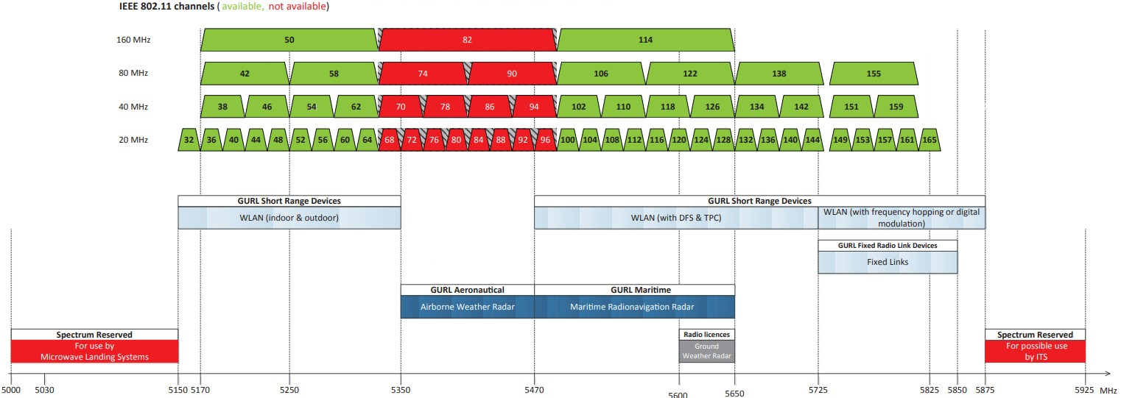

Figure 1 5 GHz Wi-Fi channel plans in New Zealand

Wi-Fi devices are typically connected to an access point which links to FTTx5 networks. In New Zealand, the fibre network is available to 84% of population under the government Ultra Fast Broadband programme6. By the end of 2022, this is expected to cover 87%. Fibre technology is rapidly evolving. Fibre broadband with speeds of 4 Gbps is now commonly available for home, business and education use here in New Zealand. The technology is based on 10G-PON (also known as XG-PON7), which is capable of delivering shared Internet access rates up to 10 Gbps over fibre infrastructure. The evolution of fibre technology means that the wireless connection (e.g. Wi-Fi) to the user devices may become the bottleneck for overall network performance. It requires Wi-Fi devices to be capable of delivering a data speed of Gigabits per second.
Improved performance of mobile data services from 5G rollout will also increase demand for Wi-Fi as users expect seamless network performance transitions between 5G and Wi-Fi.
The ever-growing number and diversity of Wi-Fi devices, along with increased connection speeds and data traffic volumes could exceed Wi-Fi network capacity. In the past two years, IEEE 802.11 technology has evolved from Wi-Fi 5 (802.11ac) to Wi-Fi 6 (802.11ax). Wi-Fi 6 can operate in the existing 2.4 GHz and 5 GHz spectrum. With 8 spatial streams and 1024 QAM modulation, Wi-Fi 6 can deliver a throughput of 9.6 Gbps.
Data rates of several gigabits can be achieved in low density Wi-Fi networks. However, when the user equipment and access point density increases, the likelihood of achieving these throughputs diminishes as channel contention increases.
Wi-Fi uses the carrier-sense multiple access method. This means devices can only transmit when the channel is sensed to be ‘idle’. Under this access method, network capacity is largely determined by the level of spectrum congestion. As the 2.4 GHz and 5 GHz spectrum is getting more and more congested, a variant of Wi-Fi 6, known as Wi-Fi 6E, extends its frequency range to 6 GHz (5925 - 7125 MHz) to address the spectrum shortage. Depending on the amount of spectrum made available, the 6 GHz band could provide between three and seven contiguous spectrum blocks of 160MHz.

5 Fibre to the “x” (FTTx) is a collective term used to describe a wide range of broadband network architecture options utilizing optical fibre for some or all of their last mile connectivity. With “x” representing the fibre termination point.
6 Crown Infrastructure Partners, Quarterly Connectivity Update.
7 10G-PON is the ITU-T’s next generation standard following on from GPON or Gigabit-capable PON. ITU- T G.987 is the standard for 10G-PON.

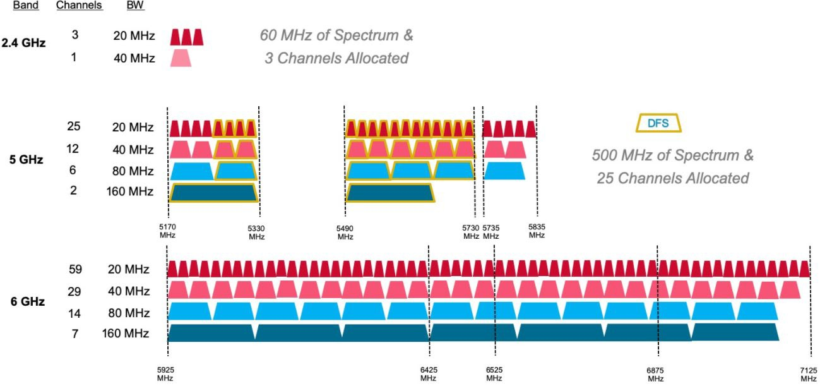
Figure 2 Wi-Fi 6E frequency bands and channels8

Global developments in Planning 6 GHz Mobile Use
A current focus in numerous telecommunication markets internationally is the 6 GHz band (5925 - 7125 MHz), which is being considered for a new generally licensed (also referred to as licence exempt and unlicensed) band to support Wi-Fi, 5G NR-Unlicensed (5G NR-U) etc.
In the last two years, many regulators have permitting WLAN use in the 6 GHz band under general authorisation, promoting an equipment ecosystem. Countries, including Japan, UK, Australia and the USA and countries in Europe have made or are making 6 GHz spectrum available for people to use under a general authorisation.
The IMT industry also views 6 GHz as a core component of the mid band spectrum needed to realise 5G connectivity. Some countries are already planning to make the upper portion (6425 - 7125 MHz) or the whole 6 GHz band available for IMT (e.g. China).

ITU developments (WRC-23)
The ITU-R is currently studying the upper portion of the 6 GHz band for a potential IMT identification under agenda item 1.2 for WRC-23. This will consider additional frequencies for IMT in various bands. This includes two portions of the 6 GHz band: 6425 - 7025 MHz in ITU Region 1 (Europe, Russia, Africa, Middle East), and 7025 - 7125 MHz globally.

Australia
The Australian Communications and Media Authority regulator (ACMA) consulted on RLAN use in the 6 GHz band in April 2021. The ACMA formed the preliminary view that the bottom 500 MHz (5925 - 6425 MHz) be made available for use in Australia under the Low Interference Potential Devices (LIPD) class licence (similar to General Authorisation). In addition, the devices operating within that frequency range be allowed to operate at two different power limits: 24 dBm (11 dBm/MHz), if only used indoors or 14 dBm (1 dBm/MHz) in all locations.
ACMA has indicated that by limiting proposed WLAN use to the lower 6 GHz band for now, this allows additional time for future developments in the upper 6 GHz band to become clearer.

8 Cited from Broadcom Website, Wi-Fi 6E: Faster Speed, Lower Latency and Higher Capacity

Europe
Europe have made decisions on making the bottom part of the 6 GHz band (5925 - 6425 MHz) available for generally authorised use for low power indoor and very low power indoor and outdoor devices. In November 2020, CEPT/ECC made a decision on the harmonised use of the frequency band 5945 - 6425 MHz for Wireless Access Systems including Radio Local Area Networks (WAS/RLAN). Based on its sharing and compatibility studies, ECC decided the following use cases and related conditions for WAS/RLAN in the bands 5945 - 6425 MHz:
- Low power indoor use, maximum mean 23 dBm (10 dBm/MHz) EIRP, with no outdoor use allowed;
- Very low power portable use, maximum mean 14 dBm (1 dBm/MHz) EIRP, that may both operate indoor and outdoor.

CEPT/ECC didn’t approve the use between 5925 - 5945 MHz for the purpose of protecting the Urban Rail Intelligent Transport System which operates in 5855 - 5925 MHz in some European countries. In addition, CEPT/ECC has implemented an out-of-band emission limit below 5935 MHz to protect Urban Rail communications.
ETSI is currently working on the development of a draft harmonised standard ETSI EN 303 687 (Log in required) where the results of the CEPT/ECC decision and studies will be will be taken into account.

United Kingdom
In the UK, the regulator Ofcom, following consultation, issued a statement on 24 July 2020: “Improving spectrum access for Wi-Fi – spectrum use in the 5 and 6 GHz bands” outlining its decisions.
Ofcom allowed Wi-Fi and other WLAN technologies to operate licence exempt in the lower 6 GHz band (5925 - 6425 MHz) for indoor use with a maximum EIRP 24 dBm, or very low power 14 dBm outdoor.

United States
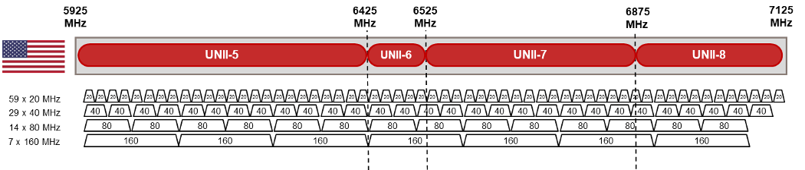
The Federal Communications Commission (FCC) implemented the entire 6 GHz band (5925– 7125 MHz) for Wi-Fi 6 and other unlicensed uses in the US in April 2020.
Figure 3 FCC’s channel plan from 5925 - 7125 MHz

The FCC authorises indoor low-power operations over the full 1200 MHz and standard-power devices in 850 MHz in the 6 GHz band. The FCC requires the standard-power devices to use an automated frequency coordination system (AFC)9 to prevent interference to incumbent services.

9 Federal Register, Unlicensed Use of the 6 GHz Band

Table 1 Maximum EIRP for 6 GHz unlicensed devices in the US

Devices Class | Operating bands | Maximum EIRP | Maximum EIRP Power Spectral Density
Standard-Power AP (AFC controlled) | U-NII-5 (5925 - 6425 MHz)  U-NII-7 (6525 - 6875 MHz) | 36 dBm | 23 dBm/MHz
Client Connected to Standard-Power AP |  | 30 dBm | 17 dBm/MHz
Low-Power (indoor only) | U-NII-5 (5925 - 6425 MHz)  U-NII-6 (6425 - 6525 MHz)  U-NII-7 (6525 - 6875 MHz)  U-NII-8 (6875 - 7125 MHz) | 30 dBm | 5 dBm/MHz
Client Connected to Low-Power AP |  | 24 dBm | -1 dBm/MHz

An AFC contains a database of incumbent 6 GHz operators. The database includes information transmitter geolocation, frequency channels, power levels, antenna radiation, and more. The basic concept of an AFC is that a new WLAN access point will consult a registered database to confirm its operation, avoiding interfere with any incumbent users.
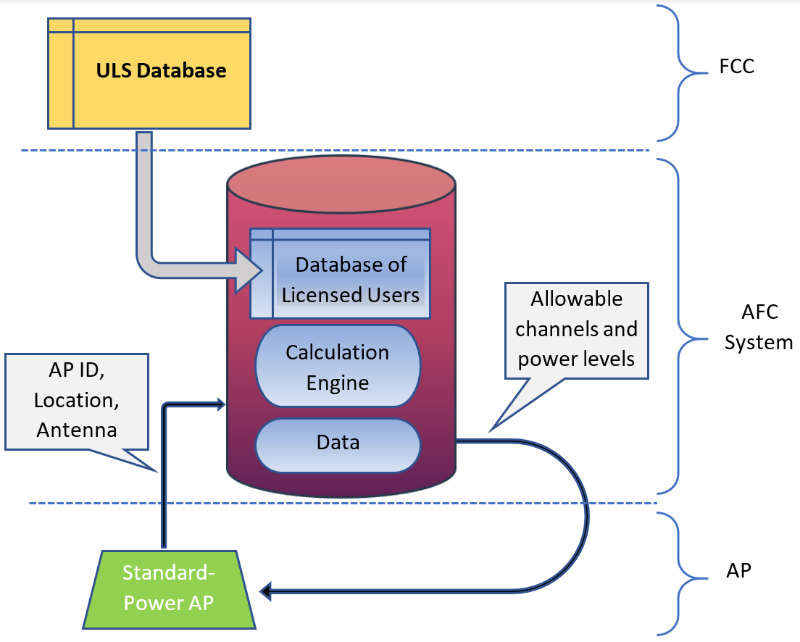
Figure 4 Overview of FCC’s AFC system10

New Zealand Proposal

5925 - 6425 MHz for WLAN use
Given the increasing demand for spectrum for WLAN use and the recent development from other countries and regions globally, RSM proposes to make the bottom of the 6 GHz frequency band (5925 - 6425 MHz) available for WLAN use. RSM consider this additional 500 MHz should provide sufficient spectrum for WLAN at this point.
For the upper 6 GHz band (6425 - 7125 MHz), there are different options for use of the spectrum internationally. Agenda item 1.2 of WRC-23 will also consider the band for IMT identification in different regions. At this stage, RSM will monitor international developments

10 Cite from 5G technology world, “New regulations for unlicensed 6 GHz operation – explained”

and studies in this frequency band. While we are not making decisions on future use of the band, we welcome submitters providing views on applications, technical requirements, and international regulatory frameworks for the upper 6 GHz band (6425 - 7125 MHz).
Q1. Do you agree with RSM’s proposal on making the 5925 - 6425 MHz available for WLAN use?
Q2. What are your views on the potential future use of 6425 - 7125 MHz for new applications (e.g. Wi-Fi or IMT)?

General user licence for low power and very low power devices
We propose to authorise use through the General User Radio Licence (GURL) for Short Range Devices (SRD) to cover the use of low power and very lower power WLAN devices.
The proposed power limits for WLAN devices operating in 5925 - 6425 MHz are:
  - 24 dBm (11 dBm/MHz) for indoor use only
  - 14 dBm (1 dBm/MHz) for all locations (includes user devices, outdoor access point)
The proposed provisions will be technology neutral. Any WLAN or IMT technologies that can meet the technical conditions of the GURL and comply with an appropriate radio standard would be allowed. Currently, ETSI is developing the 6 GHz RLAN Harmonised Standard for access to radio spectrum EN 303 687. In addition, we expect that AS/NZ 426811 will be updated to include 6 GHz WLAN.
There have been a number of technical studies internationally. We have reviewed the most relevant studies and have provided the details in Annex 1: Technical Studies. Regarding the sharing and compatibility with existing services, we use ECC Report 30212 and Report 31613 as our main analysis guidance, because the radio services and input assumptions in those two reports are similar to New Zealand. We consider these studies to support our proposal of allowing low power level GURL in New Zealand.
Q3. Do you agree that RSM should include 5925 - 6425 MHz in the GURL-SRD for WLAN low power indoor and very low power use?
Q4. Do you agree that RSM should mandate ETSI EN 303 687 as the radio standard for WLAN use in the 6 GHz band? Is there any other regulatory compliance standard we should consider?

Higher power devices
The US and Canada allow unlicensed use for indoor access points transmitting 30 dBm EIRP and client devices transmitting 24 dBm. These regulators also permit 36 dBm EIRP for access points that are controlled by an AFC system.

11 AS/NZ 4268:2017 Radio equipment and systems - Short range devices - Limits and methods of measurement
12 ECC Report 302, “Sharing and compatibility studies related to Wireless Access Systems including Radio Local Area Networks (WAS/RLAN) in the frequency band 5925-6425 MHz.”
13 ECC Report 316, “Sharing studies assessing short-term interference from Wireless Access Systems including Radio Local Area Networks (WAS/RLAN) into Fixed Service in the frequency band 5925-6425 MHz.”

RSM recognises that there may be occasions where users want to deploy an access point with a higher power level than permitted by the GURL-SRD. We suggest two possible approaches to accommodate this:
Approach 1. Radio Licence – to support 30 dBm EIRP devices
Although we are not aware of other regulators using a licensing approach, conventional location specific radio licensing could be a solution. In this approach, RSM would require users to apply for radio licences where the EIRP of WLAN device is above GURL-SRD limits. The maximum EIRP permitted on a licence would be 30 dBm. We would require applicants to engage an Approved Radio Certifier/Engineer to certify a licence and ensure it will not cause interference to existing licensed services. The licence would need to register the location of each access point and its horizontal radiation pattern.
Approach 2. Automatic Frequency Coordination (AFC) system – to support 36 dBm EIRP devices
Devices that support 36 dBm standard power would be required to have an AFC system and power settings that are not readily accessible by users.
FCC and ISED Canada propose the AFC system for managing standard power access points. Under these systems, new devices seeking to access the band must contact an accredited AFC system to determine their allowable operating parameters.
The AFC’s primary function is to protect licensed fixed services. New WLAN devices need to report their location to the AFC, which then allocates free channels that devices can use to transmit. AFC will also calculate the required power for new devices to mitigate the interference to incumbent licences.
RSM will not take on the development and management of the AFC system. We would instead look to industry to provide this solution. We note that the Wi-Fi alliance has provided a specification for AFC system to AFC device interface.

Q5. What are your views on using a licensing approach to support 30 dBm EIRP WLAN devices?
Q6. What are your views on supporting 36 dBm EIRP standard power devices using Automatic Frequency Coordination (AFC) system? Do you have any proposals to provide AFC systems to New Zealand?

Summary
This discussion document has presented RSM’s preliminary thoughts and proposals on WLAN use in the 6 GHz band. We have proposed options for making the 5925 - 6425 MHz band available including the technical requirements for this band, based on an analysis of international approaches.
We are inviting you to comment on the content of this document, in particular the questions posed, and on any related issues.
Please refer to Annex 1 for the technical studies including the technologies and compatibility analysis.

Summary of Consultation Questions
Q1. Do you agree with RSM’s proposal on making the 5925 - 6425 MHz available for WLAN use?
Q2. What are your views on the potential future use of 6425 - 7125 MHz for new applications (e.g. Wi-Fi or IMT)?
Q3. Do you agree that RSM should include 5925 - 6425 MHz in the GURL-SRD for WLAN low power indoor and very low power use?
Q4. Do you agree that RSM should mandate ETSI EN 303 687 as the radio standard for WLAN use in the 6 GHz band? Is there any other regulatory compliance standard we should consider?
Q5. What are your views on using a licensing approach to support 30 dBm EIRP WLAN devices?
Q6. What are your views on supporting 36 dBm EIRP standard power devices using Automatic Frequency Coordination (AFC) system? Do you have any proposals to provide AFC systems to New Zealand?
Q7. Any other comments?

Annex 1: Technical Studies

WLAN technologies in the 6GHz band
The most successful WLAN technologies use the IEEE 802.11 (Wi-Fi) series standards. In addition to 802.11, 3GPP have also developed cellular technical standards such as LTE-LAA14 to enable cellular technology to operate in generally authorised bands. Even though the 3GPP Release 16 continues to provide support for LTE-LAA, 5G NR-Unlicensed is likely to be the only 3GPP-based technology operating in the 6 GHz bands.

Wi-Fi 6E and Wi-Fi 7
In the 2.4 GHz band, IEEE 802.11n (Wi-Fi 4) devices are allowed to transmit in a 40 MHz channel by aggregating two adjacent 20 MHz channels into a single 40 MHz channel. To support high-speed wireless communication demands, IEEE 802.11ac (Wi-Fi 5) / IEEE 802.11ax (Wi-Fi 6) introduced the capability of extending the number of basic channels, thereby allowing mobile devices to transmit over an 80 MHz/160 MHz channel in the 5 GHz band.
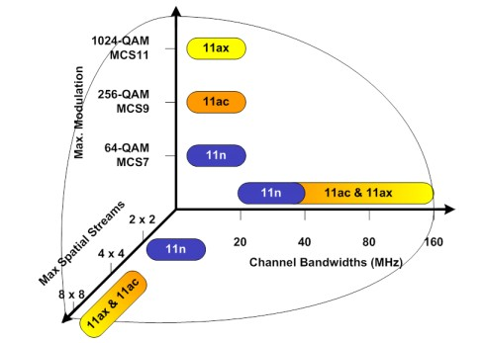
In addition to increased channel bandwidth, Wi-Fi also evolved with higher modulation orders and more spatial streams. The latest Wi-Fi 6 can support a maximum of eight spatial streams with 1024 QAM modulation.
Figure 5 Evolution of Wi-Fi radio performance15
Wi-Fi 6E has the same features and capabilities as Wi-Fi 6. It extends the operating frequencies to the 6 GHz band to access more continuous wide band channels.
IEEE 802.11be is the potential next amendment of the 802.11 IEEE standard, and will likely be designated as Wi-Fi 7. It will build upon 802.11ax, focusing on WLAN indoor and outdoor operation with stationary and slow moving (pedestrian speed) user terminals in the 2.4, 5 and 6 GHz frequency bands. Wi-Fi 7 will build on the current Wi-Fi 6E frequency band with the additional 320 MHz channel bandwidth.

14 Licensed Assisted Access (LAA), LAA is an LTE feature that uses the 5 GHz unlicensed band in combination with licensed spectrum to boost throughput for mobile users.
15 Cite from Strategy Analytics, The Ultimate Wi-Fi Access Point: Which Wi-Fi 6 Features Define the New Premium Tier?

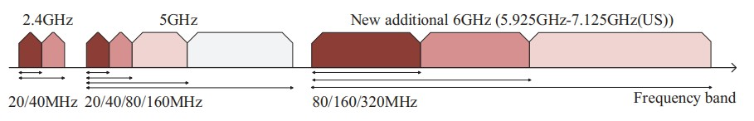
Amendment and standard approval of the IEEE 802.11be is ongoing, with a goal of an initial draft by May 202116, and a final version expected by early 2024.
Figure 6 Available bandwidth over 2.4 GHz, 5 GHz and 6 GHz frequency bands in Wi-Fi 717
The main candidate features mentioned in the 802.11be Project Authorization Request are:
- 320 MHz bandwidth and support for contiguous and non-contiguous 320/160+160 MHz and 240/160+80 MHz bandwidth.
- Multi-band/multi-channel aggregation and operation.
- 16 spatial streams and MIMO protocol enhancements and new 4096-QAM modulation
- Multi-Access Point coordination (e.g. coordinated and joint transmission).
- Enhanced link adaptation and retransmission protocol (e.g. Hybrid Automatic Repeat Request).
- Integrating Time-Sensitive Networking extensions for low-latency real-time traffic (IEEE 802.11aa).

5G NR Unlicensed
In Release 16, 3GPP developed specifications for unlicensed 5G NR (NR-U). Two frequency bands - n69 (5925 - 6425 MHz) and n97 (5925 - 7125 MHz) are defined in the radio access specifications. NR-U is the successor of unlicensed LTE. The technology could operate under the same unlicensed regulatory provisions and is considered a candidate technology operating in the 6 GHz band.
In 3GPP specifications, there are two types of unlicensed spectrum use for NR, which is anchored NR-U and standalone NR-U respectively. In the anchored mode, mobile network operator (MNO)’s licensed spectrum functions as the anchor carrier for communicating control protocol. Some of the data traffic will be offloaded to unlicensed spectrum to improve the overall throughput. The mode suits MNOs’ deployment as the Marco-cell can use licensed spectrum as an anchor of their RAN and a local small-cell can use unlicensed spectrum as the supplementary.
The standalone NR-U doesn’t require licensed spectrum as an anchor. Operators can deploy a network without requiring their own spectrum asset. Both types of NR-U are designed to co- exist with Wi-Fi system by using the listen before talk (LBT) channel access mechanism.

16 IEEE P802.11-TASK GROUP BE (EHT) MEETING UPDATE, Status of Project IEEE P802.11be
17 Quote from: C. Deng et al., “IEEE 802.11be Wi-Fi 7: New Challenges and Opportunities,” in IEEE Communications Surveys & Tutorials, vol. 22, no. 4, pp. 2136-2166, Fourth quarter 2020, doi: 10.1109/COMST.2020.3012715.

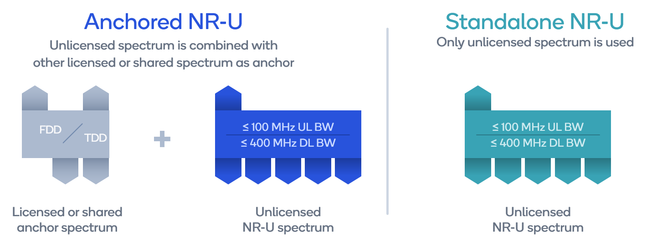

Figure 7 5G NR in unlicensed spectrum with 3GPP Release 1618

Sharing and compatibility studies
Table 2, which is an extract of the New Zealand table of frequency allocations - PIB 21, summarises the current international and domestic allocations and usage for 5925 - 7125 MHz. In Region 3, 5925 - 7075 MHz is allocated to Fixed, Fixed Satellite, and Mobile. 7075 - 7145 MHz is allocated to Fixed and Mobile.
In New Zealand, the frequency range is currently used by fixed links and fixed satellite service earth stations. 5925 - 6725 MHz is used by C-band Satellite earth station uplinks. Part of the band (5925 - 6425 MHz) also has a shared use with fixed links in the “6 GHz” fixed service band. The frequency range 6440 - 7125 MHz is predominantly used by fixed links in rural areas for data backhaul.
Table 2 Frequency allocation and usage in 5925 - 7125 MHz

Frequency Range | ITU Region 3 Allocation | New Zealand Allocation | Summary of Usage
5 925-6 700  MHz | FIXED 5.457  FIXED-SATELLITE (Earth-to- space) 5.457A 5.457B  MOBILE 5.457C  5.149 5.440 5.458 | FIXED  FIXED-SATELLITE (Earth-to-  space) | 5 925-6 725 MHz  Fixed satellite “C” band – uplink  5 925-6 425 MHz  Fixed “6 GHz” band  6 440-7 100 MHz  Fixed “7 GHz (Lower)” band
6 700-7 075  MHz | FIXED  FIXED-SATELLITE (Earth-to-  space) (space-to-Earth) 5.441 MOBILE  5.458 5.458A 5.458B | FIXED  FIXED-SATELLITE (Earth-to-  space) (space-to-Earth) | 6 440-7 100 MHz  Fixed “7 GHz (Lower)” band

18 Cite from Qualcomm blog, “How does support for unlicensed spectrum with NR-U transform what 5G can do for you?”

7 075-7 145  MHz | FIXED MOBILE 5.458 | 7 075–7 250 MHz FIXED | 6 440-7 100 MHz  Fixed “7 GHz (Lower)” band  7 100-7 425 MHz  Fixed “7 GHz (Middle)” band

Studies on compatibility and sharing between WLAN generally authorised users and the existing users of the 5925 - 6425 MHz bands (including adjacent bands) in Europe are contained in ECC Report 302. These current users include fixed links, fixed satellite, Intelligent transportation system (ITS), Urban Rail ITS, Communication-based Train Control (CBTC), radio astronomy, and UWB systems. Among them, ITS, CBTC and radio astronomy are not currently used in New Zealand, although there is a reservation in the statement of government policy and direction for ITS use from 5875 - 5925 MHz.

Compatibility with Fixed Service
ITU-R recommends system parameters and considerations for both long and short term interfering signal criteria between fixed and other services19. Excess long-term interference to FS receivers reduces the margin available to protect the fixed link against fading, causing a reduction in link availability. Short-term interference requires separate consideration because the interference power may be high enough to produce degradation even when the desired signal is unfaded.
ECC Report 302 analysed the long-term interference risk by using the approaches of minimum coupling loss (MCL) and Monte Carlo statistical analysis. The ECC considered -10 dB as the threshold of interference to noise ratio (I/N)20.
The MCL analysis revealed typical deployment scenarios. For low power indoor scenario (24 dBm EIRP), the theoretical separation distance to fixed services varies from 43 m to 600 m. For very low power outdoor scenarios (14 dBm EIRP), the distance varies from 800 m to 1400 m. The variation depends on several factors such as transmission bandwidth, antenna height, azimuth and building material.
When considering the worst case, where a WLAN device is located within the boresight of a fixed service main antenna lobe, the separation distance is 24.2 km for indoor WLAN and 28.7 km for outdoor deployment. The probability of a WLAN device transmitting in the direction of the main lobe of the fixed antenna would be very low, as this would mean that the device would need to be located in the line of the fixed link between its transmitter and receiver.
An overview of fixed service use in New Zealand within 5925 - 6425 MHz can be found in Figure 8 (national use) and Figure 9 (metro use in Auckland, Wellington and Dunedin). The band is very lightly used with most fixed links deployed in rural areas. The conclusion of MCL analysis from ECC Report 302 shows the interference risk from WLAN devices to fixed services is very low. RSM considers that these conclusions can also be applied to New Zealand.

19 Recommendation ITU-R F.758-7 System parameters and considerations in the development of criteria for sharing or compatibility between digital fixed wireless systems in the fixed service and systems in other services and other sources of interference.
20 CEPT Report 73, “to study feasibility and identify harmonised technical conditions for Wireless Access Systems including Radio Local Area Networks in the 5925-6425 MHz band for the provision of wireless broadband services” Report A: Assessment and study of compatibility and coexistence scenarios for WAS/RLANs in the band 5925-6425 MHz.

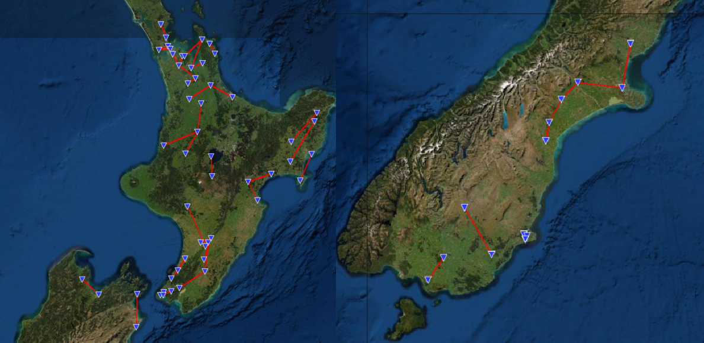

Figure 8 Fixed service use in New Zealand
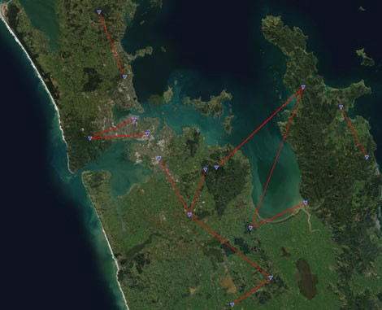
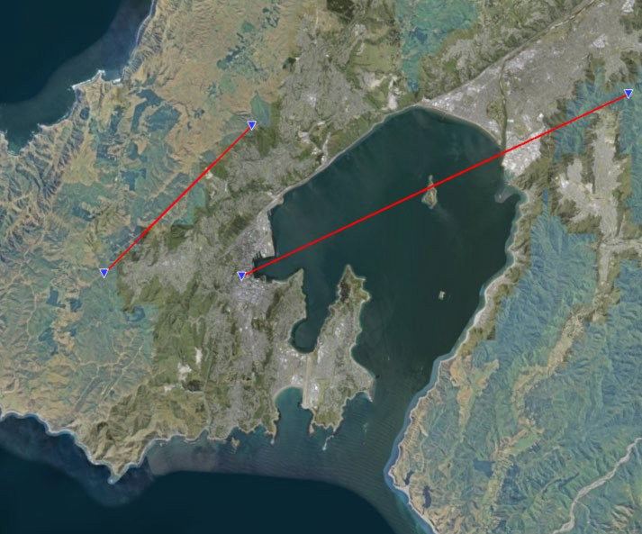

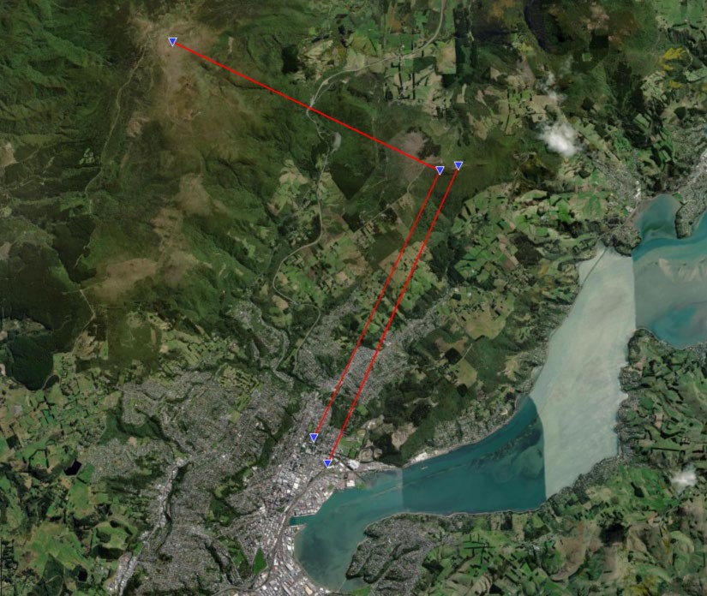
Figure 9 A close look of fixed service in Auckland, Wellington and Dunedin

MCL calculations represent some critical scenarios but do not allow conclusions to be made about the statistical likelihood of occurrence of these scenarios. Therefore, ECC carried a statistical approach study based on Monte Carlo analysis in ECC Report 302.
The study uses fixed link data from the UK and Netherlands. The result of this Monte Carlo study shows that the long-term interference criteria is met as the interference above the -10 dB I/N threshold is less than 2% of the time for all FS links, which is far less than the 20% requirement for meeting long term interference criteria.
ECC Report 316 further expands the compatibility studies by assessing the possible short-term interference impact of the WAS/RLANs onto point-to-point fixed service. The site-general Monte Carlo simulations show that the percentage of events for which the short-term threshold (I/N = 19 dB) is not exceeded for more than 4.5⋅10−4 % (which was used as a proxy for short-term protection criterion) for the studied combinations of FS antenna heights, population densities, and WAS/RLAN deployment. The site-specific sensitivity analysis shows that the size of the area from where a WAS/RLAN may create interference to the fixed service is sensitive to clutter loss and building loss etc.
ECC’s analysis methodology also applies to New Zealand as the radio applications and input assumptions are similar. We consider that the interference risk to fixed services is negligible in New Zealand. First, there will be a lower level of density of WLAN devices deployed in New Zealand as against in Europe. Second, fixed links in the 6 GHz band have very little use in the high density population areas, this will further reduce any interference risks.

Compatibility with Fixed Satellite Service
Wi-Fi access points and small cell base stations typically use downward-tilted, e.g. ceiling- mounted units, or horizontal emissions patterns, which would reduce the interference towards satellites. However, the aggregate interference from a large number of deployed access points could increase the strength of the emission towards a satellite.
ECC Report 302 analysed the aggregate interference from Wi-Fi devices to satellite space station receivers. The analysis shows limiting the use to indoor only and/or introducing an EIRP limit for outdoor operation would mitigate the interference risks and further ensure long-term protection of FSS space stations from aggregate interference from WAS/RLAN devices in the band 5925 - 6425 MHz. RSM consider that this analysis can also be applied in New Zealand. As there will be a lower level of density of WLAN devices in New Zealand than in Europe, we consider this will further reduce any interference risks.

Sharing with UWB systems
The proposed 6 GHz WLAN band also shares with Ultra Wide Band (UWB) devices operating at two frequency ranges. UWB devices operate in the General User Licence regime, it coexists with licensed services without causing interference.
Table 3 GUL for UWB devices overlapping with WLAN 6 GHz

Low (MHz) | High (MHz) | Maximum EIRP | Remarks
4800 | 6000 | -60 dBW | Special condition 3
6000 | 8500 | -30 dBW | Special conditions 5, 8 and 9

4800 - 6000 MHz is rarely used due to strict power limits, 6000 - 8500 MHz is the main frequency range for very short range communication and location tracking. The MCL analysis in ECC Report 302 shows UWB communication devices need a maximum separation distance of 473 m away from a 24 dBm Wi-Fi AP to avoid the 3dB degradation of receiver sensitivity. For UWB sensor devices, the maximum separation distance is decreased to 106 m. The simulation uses an open space propagation model and doesn’t count any building loss.
The general conditions of the GURL-SRD require that frequency use is on a shared basis. This means that UWB must share with other radio systems and must accept interference from those systems, the same rule also applies to the WLAN devices. As only the low power indoor and very low power devices are proposed for general use, we consider 6 GHz WLAN can share with UWB systems.

