SMSE-014-20
November 2020

Spectrum Management and Telecommunications

Consultation on the Technical and Policy Framework for Licence-Exempt Use in the 6 GHz Band

Closing date for comments: January 19, 2021 Closing date for reply comments: February 22, 2021

Aussi disponible en français—SMSE-014-20

Contents
- Intent 1
- Legislative mandate 1
- Policy objectives 1
- Background 2
- International context 4
  - Use of the 6 GHz band in other countries 4
  - Details of the U.S. approach to the introduction of RLANs in the 6 GHz band 5
  - Development of the 6 GHz licence-exempt ecosystem 8
- Current use of the 6 GHz band in Canada 8
  - Fixed services 10
  - Fixed satellite services 11
  - Radio astronomy 12
  - Other applications in the band 12
- Changes to the spectrum utilization for the 6 GHz band 13
- Proposals for the introduction of licence-exempt operation in the 6 GHz band 14
  - Proposals related to standard-power RLAN operation 14
  - Proposals related to low-power indoor-only RLAN operation 17
  - Proposals related to very low-power RLAN operation 18
- Proposals related to the automated frequency coordination system 19
  - Coexistence by standard-power access points with automated frequency coordination... 22
  - General matters related to automated frequency coordination implementation 22
- Next steps 24
- Submitting comments 24
- Obtaining copies 24
Annex A: Sample terms and conditions of an AFC system administrator agreement 26

i

Licence-Exempt Use in the 6 GHz Band SMSE-014-20

1. Intent

- Through the release of this document, Innovation, Science and Economic Development Canada (ISED), on behalf of the Minister of Innovation, Science and Industry (the Minister), is hereby initiating a consultation on the technical and policy framework for licence-exempt use of the 5925-7125 MHz frequency band (referred to as the 6 GHz band).

Legislative mandate

- The Minister, through the Department of Industry Act, the Radiocommunication Act and the Radiocommunication Regulations, with due regard to the objectives of the Telecommunications Act, is responsible for spectrum management in Canada. As such, the Minister is responsible for developing national goals and policies for spectrum utilization and for ensuring effective management of the radio frequency spectrum resource.

Policy objectives

- Wireless services play an important part in the lives of Canadians, whether they are accessing multi-media applications, conducting business while on the move or from home, accessing online education, connecting with family and friends, or managing their finances. As wireless services become increasingly integrated into their lives, Canadians expect these services to be high-quality, affordable and available in every region of the country. Especially during critical times, which has been the case during the COVID-19 pandemic, Canadians demand more, and have relied more on their wireless services to stay connected.

- One of ISED’s objectives is ensuring all Canadian consumers as well as business and public institutions have access to the latest wireless telecommunications services at affordable prices. A robust wireless telecommunications industry not only drives the adoption and use of digital technologies, it also enhances the productivity of the Canadian economy.

- ISED releases different frequency bands for various uses. In so doing, it takes into account factors that are specific to Canada, such as the existing uses of the band and the need to increase spectrum access in rural areas. It also considers factors such as international band allocation, the evolution of wireless technology, current and emerging technical standards, and the ecosystem for network and end-user equipment. As a result, Canadians benefit from having access to a much bigger global marketplace, economies of scale, lower prices, and timely introduction of new wireless services and devices to Canada.

- Over the past few decades, licence-exempt spectrum has witnessed a significant increase in use and innovation due to low barriers to entry, such as easy access to spectrum and the low cost of devices. For instance, Canadians rely on Wi-Fi routers and hotspots using licence-exempt spectrum to enable access to the Internet and other applications on their smartphones, tablets and laptops, as well as for

Licence-Exempt Use in the 6 GHz Band SMSE-014-20

data-intensive activities such as video streaming and multi-player gaming. Wi-Fi also serves a crucial function in support of Canadian commercial wireless service providers, who rely on it to offload traffic from their mobile cellular networks. Rural broadband service providers leverage licence-exempt spectrum to deliver broadband to residential and business customers in rural areas. Furthermore, licence- exempt spectrum is used by Internet of Things (IoT) devices, from smart watches to industrial and agricultural sensor networks. The demand is increasing for outdoor enterprise services supported by IoT for applications such as asset tracking services in container port terminals, railyards and mining and extraction. Additional spectrum for licence-exempt use will support the introduction of next-generation licence-exempt wireless technologies that are deployed both indoor and outdoor, operating over distances ranging from less than a metre to several hundred metres, and delivering increased capacity and reliability for existing use cases as well as new and emerging use cases.

- In developing this consultation, ISED was guided by the Spectrum Policy Framework for Canada (SPFC), which states that the spectrum program objective is to maximize the economic and social benefits that Canadians derive from the use of the radio frequency spectrum resource. This objective and the enabling policies listed in the SPFC remain relevant for guiding ISED in delivering its spectrum management mandate.

- In May 2019, the Government of Canada released Canada’s Digital Charter: Trust in a digital world. The Digital Charter lists universal access as the first of ten principles that will lay the foundation for a made-in-Canada digital approach, and guides policies and actions towards establishing an innovative, people-centred and inclusive digital and data economy built on trust. Universal access is the principle that all Canadians will have an equal opportunity to participate in the digital world and have the necessary tools to do so, including access, connectivity, literacy and skills.

- In consulting on this band, ISED is guided by the objectives of the Telecommunications Act, the SPFC and Canada’s Digital Charter. ISED’s objectives for licence-exempt use of the 6 GHz band in Canada are to:
- foster innovation and investment in new wireless technologies and services
- support greater choice and affordability of wireless services for consumers and businesses
- facilitate deployment and timely availability of wireless broadband Internet across the country

4. Background

- Wi-Fi is the most widely used Radio Local Area Network (RLAN) technology to provide high data rate wireless access over a local area. Wi-Fi enables low-cost Internet connectivity for Canadians on a wide range of licence-exempt consumer devices. It also serves a crucial function in support of commercial wireless service providers, who rely on it to offload traffic from their mobile cellular networks. According to a recent ABI Research forecast, the annual unit shipments of Wi-Fi-enabled devices are set to increase from 3.3 billion units in 2019 to more than 4.5 billion by 2024. In April 2020, WiFiForward published a United States (U.S.)-focused study where faster broadband speed from deploying Wi-Fi in the 6 GHz band could contribute $13.25 billion to the U.S. gross domestic product

Licence-Exempt Use in the 6 GHz Band SMSE-014-20

by 2025. The same study projected that the total economic value derived from a variety of economic contributors (e.g. broader IoT deployment, savings in wireless enterprise traffic) would increase by at least $153.76 billion between 2020 and 2025, by allowing low-power and very low-power Wi-Fi use in the 6 GHz band. For emerging applications and services that rely on ubiquitous high data rate and low latency, Wi-Fi will continue to play a fundamental and complementary role to 5G cellular connectivity. For example, the WiFiForward study forecasts that cellular operators will benefit with savings of $13.60 billion between 2020 and 2025, through offloading 5G-originated traffic to Wi-Fi devices. ISED is of the view that making the 6 GHz band available for RLAN use will offer proportionally similar economic benefits for Canada.

- Wi-Fi operates in mid-band spectrum, specifically in the 2400-2483.5 MHz (2.4 GHz) band and in several sub-bands of the 5150-5850 MHz (5 GHz) band. The adjacent 6 GHz band is therefore a natural fit for the extension of spectrum for Wi-Fi technologies. However, the 6 GHz band is currently being used and will remain in use by a number of licensed systems such as fixed microwave backhaul systems, fixed satellite service systems, television auxiliary systems and radio astronomy.

- ISED recognizes that wireless technology development continues to evolve, and that there are new technologies and techniques being developed, such as dynamic spectrum access (DSA) that will provide new opportunities for improving efficiency for spectrum access. DSA may be realized through the use of mechanisms such as radio-environment sensing and/or the use of a geolocation database to perform automated frequency control. These new approaches to enable efficient spectrum access make it increasingly feasible to share spectrum between multiple services, including opportunistic access to licensed spectrum. In order to maximize the use of the spectrum resource and make spectrum available for a variety of services and applications, ISED is committed to further enabling technologies and approaches that will support the increased sharing of spectrum. ISED views the 6 GHz band as an opportunity to begin considering some of these new spectrum sharing techniques in order to provide access for new services in the band while maintaining access and protection for existing services.

- In Spectrum Outlook 2018 to 2022 (the Spectrum Outlook), ISED concluded that demand for spectrum in licence-exempt bands will continue to grow, largely due to growth in the number of Wi-Fi and IoT devices, and that more spectrum for licence-exempt use is therefore required. During the consultation process for the Spectrum Outlook, ISED received several comments supporting the release of the 6 GHz band for licence-exempt use. Some of the comments generally supported the view that Wi- Fi and similar devices already operating in the adjacent 5 GHz band could benefit from the increased economies of scale resulting from the introduction of licence-exempt equipment in the adjacent 6 GHz band. Some proponents of 5G commercial mobile systems expressed support for licence-exempt use for offloading of data from their licensed spectrum and to improve end-user throughput when used together with commercial mobile technologies, especially if the same approach is taken internationally. However, concerns were raised by incumbent licensees who requested protection of their existing systems if new services were to be introduced in the band. In the Spectrum Outlook, ISED indicated its view that co- existence in the 6 GHz band between existing and certain new services may be possible depending on the technical and operational characteristics that are implemented in the equipment to protect existing

Licence-Exempt Use in the 6 GHz Band SMSE-014-20

services. ISED classified this band as a Priority 3 and indicated that it would revisit the priority of the band should there be significant advancements internationally. Through the Spectrum Licensing Policy Branch SLPB-002-20, Consultation on the Technical and Policy Framework for the 3650-4200 MHz Band and Changes to the Frequency Allocation of the 3500-3650 MHz Band, ISED announced that it now considers the 6 GHz band as Priority 1 based on the developments taking place internationally, and indicated that it would be developing a consultation on making this spectrum available in Canada.

- This consultation takes into consideration the policy objectives, the Spectrum Outlook, the international momentum for licence-exempt use in the 6 GHz band described in section 5 and the current incumbent situation in the band described in section 6.

5. International context

- This section provides context on international developments in the 6 GHz band.

Use of the 6 GHz band in other countries

- It is recognized internationally that access to additional licence-exempt spectrum is needed to meet the exponentially increasing demand for innovative wireless services operating in licence-exempt spectrum. Globally, the 6 GHz band has traditionally been used for fixed services (FS) and fixed satellite services (FSS), among other services and applications. Spectrum regulators in many regions of the world have released or are planning to release the 6 GHz band or portion of the band for licence-exempt use, alongside the licensed incumbents currently using this band.

- In the U.S., the 6 GHz band is heavily used with approximately 50,000 stations deployed across four services: fixed services, fixed satellite services, mobile services and radio astronomy. While recognizing the current use of the band, the Federal Communications Commission (FCC) decided to open up 1200 MHz of the 6 GHz band for licence-exempt use. In April 2020, the FCC published Report and Order (FCC-20-51) (the Report and Order) titled Unlicensed Use of the 6 GHz Band; Expanding Flexible Use in Mid-Band Spectrum Between 3.7 and 24 GHz, which allows licence-exempt use of the 6 GHz Band. The FCC permitted two types of licence-exempt devices, commonly referred to as access points (APs), to operate under different technical rules to minimize the potential of interference to incumbent services: (1) low-power (maximum equivalent isotropically radiated power (e.i.r.p.) of 30 dBm) indoor only APs across all 1200 MHz of the band, and (2) standard-power APs (maximum e.i.r.p. of 36 dBm) for indoor and outdoor use. Standard-power APs are only permitted in two sub-bands (5925- 6425 MHz and 6525-6875 MHz) and must be under the control of Automated Frequency Coordination (AFC). The Report and Order’s accompanying Further Notice of Proposed Rulemaking (FNPRM) also proposed to permit very low-power (max e.i.r.p. of 14 dBm) devices to operate both indoors and outdoors across the entire band.

- In the European Union (EU), the European Conference of Postal and Telecommunication Administrations released a report in May 2020 on the introduction of wireless access systems (WAS) including radio local area networks (WAS/RLAN) in the frequency band 5945-6425 MHz, with low- power (max e.i.r.p. of 23 dBm) for indoor use only and very low-power (max e.i.r.p. of 14 dBm) portable use both indoor and outdoor. The report concluded that WAS/RLAN with specified power limits could coexist with incumbent services. For example, lower-power, indoor-only WAS/RLAN could coexist with incumbent fixed-satellite services, fixed services, Communication Based Train Control systems, and Road Intelligent Transport Systems. The Electronic Communications Committee is expected to formally respond to the European Commission by November 2020.

- In the United Kingdom (U.K.), Ofcom issued a decision in July 2020, enabling the use of Wi-Fi in the 6 GHz band. The decision makes the lower 6 GHz band (5925-6425 MHz) available for Wi-Fi and other licence-exempt technologies, enabling low-power (max e.i.r.p. of 23 dBm) indoor use and very low-power (max e.i.r.p. of 14 dBm) outdoor use.

- In July 2020, South Korea’s Ministry of Science and ICT announced that low-power (maximum
e.i.r.p. of 24 dBm) licence-exempt devices will be permitted to operate indoors across the entire 1200 MHz of the 6 GHz band. Very low-power (maximum e.i.r.p. of 14 dBm) devices will be permitted to operate outdoors in the 5925-6425 MHz frequency range. Furthermore, by 2022, outdoor use with a form of database-driven spectrum sharing, similar to the FCC’s AFC system, will be allowed over the entire 1200 MHz of the band.

- While some countries are introducing licence-exempt use in the 6 GHz band, the International Telecommunications Union (ITU) is currently studying (as agenda item 1.2 of the 2023 World Radiocommunication Conference (WRC-23)) whether parts of the 6 GHz band could be identified for International Mobile Telecommunications (IMT) to support commercial mobile broadband services. The WRC-23 agenda item will consider identifying spectrum for IMT in the 6425-7025 MHz band for Region 1 and in the 7025-7125 MHz band globally.

Details of the U.S. approach to the introduction of RLANs in the 6 GHz band

- As mentioned above, the FCC has allowed licence-exempt use of the 6 GHz band through technical and operational rules to protect incumbent services operating in the band. The technical rules took into account extensive comments from stakeholders, studies submitted by various stakeholder groups and internal studies performed by the FCC.

- The FCC divided the 6 GHz band into four sub-bands designated as:

• U-NII-5 from 5925-6425 MHz
• U-NII-6 from 6425-6525 MHz
• U-NII-7 from 6525-6875 MHz
• U-NII-8 from 6875-7125 MHz

The different sub-bands and use types mandated in the U.S. are shown in figure 1.

Figure 1: U.S. 6 GHz band plan for licence-exempt use
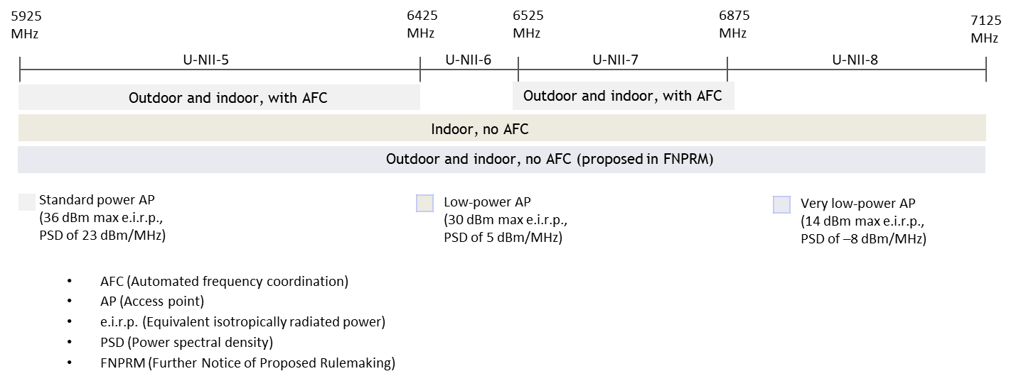

- Standard-power outdoor devices: Indoor and outdoor standard-power operation under the control of an AFC system is permitted in portions of the band, namely the 5925-6425 MHz (U-NII-5) and 6525-6875 MHz (U-NII-7) sub-bands, which are primarily in use by licensed fixed systems and FSS. The standard-power devices may operate at a maximum e.i.r.p. of 36 dBm and a power spectral density (PSD) of 23 dBm/MHz. The AFC system would protect the following services:
  - fixed microwave systems and radio astronomy

- Fixed microwave systems and radio astronomy: The FCC concluded that protection of fixed microwave systems by AFC will be done through exclusion zones around the fixed systems operating in the band. The AFC system will calculate these exclusion zones and provide a list of available channels for a standard-power AP, including the permissible operating power of the AP on each of those channels. The FCC decided that the AFC system would also incorporate exclusion zones to protect radio
astronomy stations in the U.S. The FCC mandated several technical interference protection criteria to be incorporated in the AFC system, which include:

  - the use of a designated radio propagation model (free space path loss, or the Wireless World Initiative New Radio phase II, or the Irregular Terrain Model (ITM) combined with the appropriate clutter model)

  - a protection criterion based on an interference-to-noise (I/N) objective of -6 dB; the computation of exclusion zones based on minimizing interference to both the co-channel and adjacent channel transmissions
  - the exclusion zone calculation based on interference from individual interferers rather than
performing an aggregate interference calculation

- Fixed satellite systems: The FCC concluded that fixed satellite receivers aboard orbital platforms would have a low likelihood of interference from RLAN operations given the low-power levels and large separation distances involved as well as the building attenuation applicable to indoor access points. In order to provide extra protection, the FCC mandated a vertical elevation mask (from the horizon) with a maximum e.i.r.p. limit of 125 mW above a 30 degree elevation angle, to protect satellite receivers. The FCC did not apply the AFC approach to the protection of satellite receivers since these receivers typically cover the majority of North America and span the entire band, and therefore, there would be no alternate frequencies for an RLAN to tune to.

- Broadcast auxiliary systems: In the U.S., the Broadcast Auxiliary Service (BAS) and Cable Television Relay Service (CTRS) operate in the 6425-6525 MHz (U-NII-6) sub-band on a mobile basis, and in the 6875-7125 MHz (U-NII-8) sub-band on both a fixed and mobile basis. These services (analogous to television auxiliary services in Canada) are used for electronic news gathering (ENG), local television transmission and low-power auxiliary stations such as portable cameras and wireless microphones. The FCC did not allow licence-exempt standard-power operation in the 6425-6525 MHz and the 6875-7125 MHz sub-bands on the basis that the AFC system would not be able to effectively determine exclusion zones given the mobile nature of these broadcasting auxiliary services.

- Low-power indoor devices: As set out in the final U.S. rules, low-power indoor operation is permitted across the entire 5925-7125 MHz band. The low-power indoor-only devices may operate at a maximum e.i.r.p. of 30 dBm and a PSD of 5 dBm/MHz, without the control of an AFC system. However, the low-power devices are required to implement a contention-based protocol (e.g. listen- before-talk) to protect licensed incumbents. Such a protocol consists of procedures for determining the state of the channel (available or unavailable) to avoid colliding with the active transmission of a co- located licensed incumbent system. In addition to protection of incumbent licensees, the contention- based protocol facilitates co-existence amongst licence-exempt devices.

- Very low-power devices: In its Further Notice of Proposed Rulemaking (FNPRM), the FCC also proposed the introduction of very low-power devices operating over the entire 1200 MHz at a maximum e.i.r.p. of 14 dBm and a PSD of -8 dBm/MHz.

Licence-Exempt Use in the 6 GHz Band SMSE-014-20

Development of the 6 GHz licence-exempt ecosystem

- A viable equipment ecosystem has already emerged for RLAN technologies in the 6 GHz band. Two RLAN technologies are currently considered candidates for use in this band, namely Wi-Fi 6E and 5G New Radio-Unlicensed (NR-U), while other technologies could also be developed to operate in the band. The new Wi-Fi 6 (IEEE 802.11ax) standard introduces wider channel bandwidths (up to 160 MHz), and provides higher performance in the form of lower latency higher throughput rates. Many Wi- Fi device manufacturers are already shipping Wi-Fi 6 equipment for operation in the 2.4 GHz and 5 GHz bands, and the low-power variant of Wi-Fi 6E IEEE 802.11ax compliant devices for operation in the 6 GHz band could become available by the end of 2020. Meanwhile, the 3rd Generation Partnership Project (3GPP) standards development body has standardized licence-exempt NR-U technology in its Release 16 published in July 2020. The ecosystem availability for NR-U devices is yet to be confirmed by major device vendors.

- With the introduction of an AFC requirement, the availability of standardized and certified AFC solutions and devices is another important element to consider for the overall 6 GHz ecosystem. In the U.S., the development of AFC solutions for the 6 GHz band is under way, while multi-stakeholder discussions are continuing to refine and standardize AFC system parameters and operation. It is expected that AFC required for the operation of standard-power devices could be approved by the end of 2021, with AFC-enabled devices potentially available starting in 2022.
Q1
ISED is seeking comments on the timelines for the availability of:
- low-power equipment ecosystems, both Wi-Fi 6E and 5G NR-U
- standard-power equipment ecosystems, both Wi-Fi 6E and 5G NR-U, under the control of an AFC
- AFC

6. Current use of the 6 GHz band in Canada

- In the Canadian Table of Frequency Allocations (CTFA), the 6 GHz band is allocated to fixed service and fixed satellite service on a co-primary basis, as shown in figure 2 below and the associated table 1 showing excerpts of relevant footnotes from the ITU Radio Regulations and CTFA regarding the use in the band.

Licence-Exempt Use in the 6 GHz Band SMSE-014-20

Figure 2: Frequency allocation in the 6 GHz band in Canada
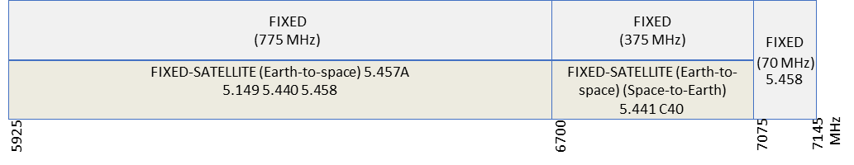

Table 1: Excerpts from Canadian and ITU footnotes in the Canadian Table of Frequency Allocations for the 6 GHz band

Footnotes | Excerpts
5.149 | To protect the radio astronomy service from harmful interference.
5.440 | The standard frequency and time signal-satellite service may be authorized to use the frequency 6427 MHz for Earth-to-space transmissions. Such transmissions shall be confined within the limits of ±2 MHz of these frequencies, subject to  agreement obtained under No. 9.21.
5.458 | In the band 6425-7075 MHz, passive microwave sensor measurements are carried out over the oceans. In the band 7075-7250 MHz, passive microwave sensor measurements are carried out. Administrations should bear in mind the needs of the Earth exploration-satellite (passive) and space research (passive) services in  their future planning of the bands 6425-7075 MHz and 7075-7250 MHz.
5.458A | In making assignments in the band 6700-7075 MHz to space stations of the fixed- satellite service, administrations are urged to take all practicable steps to protect spectral line observations of the radio astronomy service in the band 6650-6675.2 MHz from harmful interference from unwanted emissions.
5.458B | The space-to-Earth allocation to the fixed-satellite service in the band 6700-7075  MHz is limited to feeder links for non-geostationary satellite systems of the  mobile-satellite service and is subject to coordination under No. 9.11A. The use of the band 6700-7075 MHz (space-to-Earth) by feeder links for non-geostationary satellite systems in the mobile-satellite service is not subject to No. 22.2.
5.441 | The use of the bands 4500-4800 MHz (space-to-Earth), 6725-7025 MHz (Earth-to- space) by the fixed-satellite service shall be in accordance with the provisions of Appendix 30B.
C40 | (CAN-12) Use of the fixed-satellite (Earth-to-space) allocation in the 7025-7075  MHz band is limited to general inter-Regional fixed-satellite networks.

- In 2004, ISED published the Spectrum Utilization Policy SP 3-30 GHz, Revision to Spectrum Utilization Policies in the 3-30 GHz Frequency Range and Further Consultation. This policy includes designation of the 5925-7025 MHz band for fixed satellite and fixed services, with coordination being carried out on a first-come, first-served basis.

Licence-Exempt Use in the 6 GHz Band SMSE-014-20

Fixed services

- In Canada, fixed service licensees, specifically those operating point-to-point microwave systems, are the largest user group in the 6 GHz band with close to 10,000 licences (see figure 3) across the country. The fixed service licensees make especially heavy use of the 5925-6930 MHz band. The size and scale of the fixed microwave networks depend on each service provider’s business needs and service area. Some of these networks consist of a few links whereas others consist of hundreds of links that span the entire country. Wireless service providers rely heavily on the band for backhaul deployments along transportation corridors between population centres to bring basic telecommunications services such as phone and Internet into a locale from which it will be distributed to end users using other technologies. Electrical utilities operate fixed point-to-point systems across Canada in both urban and remote areas to monitor and control the electrical grid and to deliver
electricity services to the public. Public safety agencies use backhaul systems in this band to inter- connect the base stations used by their push-to-talk radio systems. Broadcasters use fixed microwave links to provide consumers with services such as direct-to-home television services.

Figure 3: Fixed microwave stations in the 6 GHz band

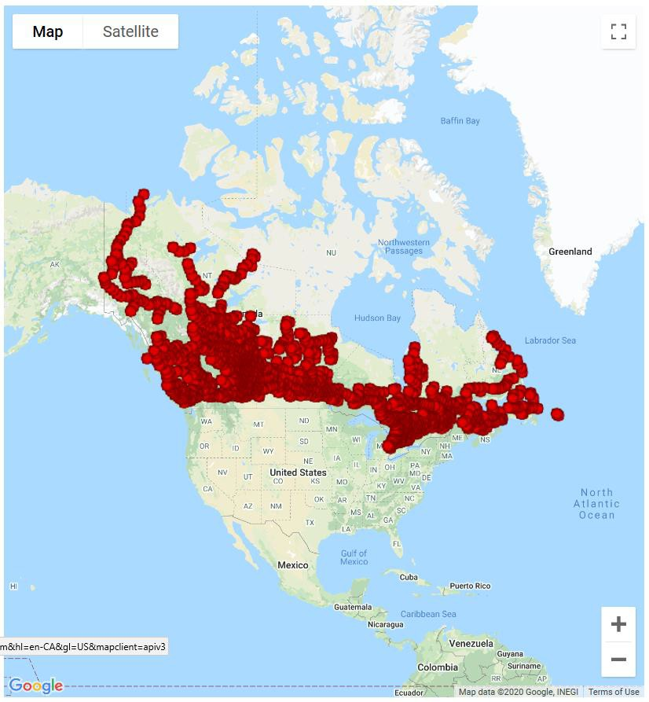

Licence-Exempt Use in the 6 GHz Band SMSE-014-20

- The 6590-6770 MHz band is primarily used by one-way point-to-point line-of-sight radio systems in the fixed service to provide television auxiliary services (TAS) in support of broadcasting applications. These services are fixed point-to-point applications (such as TV-studio-transmitter links (STL)), which are used to support the transmission of television programs from a studio to a television broadcasting station. Other fixed point-to-point TAS applications used in this band include TV inter- studio program links, and CATV studio-headend links.
- In addition to the above-mentioned applications in the 6590-6770 MHz band, broadcasters also use the 6930-7125 MHz band for TAS. In this case, the specific application is for TV pick-up services (i.e. electronic news gathering (ENG)), a type of television auxiliary service with transportable equipment that is used to transmit program material from event locations to central receive sites in a town or city. ENG operations are often located in metropolitan areas; however, they may also be rapidly deployed in other areas to cover breaking news events. Although broadcasters are typically only authorized to use a single frequency at a time within their defined coverage area, they are licensed for multiple frequencies to facilitate coordination with other broadcasters and fast deployment within a given area.

Fixed satellite services

- Satellites operating in the 5925-7125 MHz band receive signals from licensed Earth stations located throughout the country. There are in excess of 500 FSS licenses in ISED’s SMS database corresponding to a few hundred Earth station sites distributed across Canada. Together, these stations transmit to 3 Canadian satellites and over 20 foreign satellites.

- FSS (Earth-to-space) operations are heaviest in the 5925-6425 MHz band, which is paired with the 3700-4200 MHz (space-to-Earth) frequency band used as the downlink; the paired band is commonly referred to as the C-Band. The 3700-4200 MHz portion is currently under consultation
though the SLPB-002-20, Consultation on the Technical and Policy Framework for the 3650-4200 MHz Band and Changes to the Frequency Allocation of the 3500-3650 MHz Band.

- FSS systems operate mainly in the Earth-to-space direction, primarily to support telecommunications (including broadband Internet) and broadcasting. There are two main uses of the Earth-to-space FSS in this band. The FSS in this band provides connectivity in remote areas, where fibre or terrestrial wireless connections are not practical or economically feasible. As such, multiple communities, many of them located in the North, are dependent on satellite services for broadband connectivity, Internet access and telephony. Enterprises also use satellite services for various
applications such as virtual private networks (VPN), banking terminals, and communications with oil platforms. Additionally, the FSS band is used for the distribution of broadcast programming, including television and radio. Content is transmitted towards satellites from content creators, broadcasting undertakings, and cable companies, intended for eventual distribution to multiple stations via paired downlink bands.

Licence-Exempt Use in the 6 GHz Band SMSE-014-20

- In the space-to-Earth direction, currently only two receive-only Earth station sites are licensed, both of which are gateway stations as part of feeder links for a mobile-satellite service (MSS) system. The stations support communication between MSS user terminals and the public switched telephone network. The two receive-only Earth stations are operating within the 6875-7055 MHz range; one in High River, Alberta, and the other in Smiths Falls, Ontario. The Earth station in Smiths Falls operates as a gateway while the Earth station in High River is a back-up. Other MSS operators in Canada have generally moved away from the 6700-7075 MHz band for MSS feeder links, so further increase in the usage of this band by such Earth stations is unlikely.

Radio astronomy

- Radio astronomy service uses the 6650-6675.2 MHz band for observing the 6668.518-MHz methanol spectral line. Where regions around a young star are too dense for it to be directly observed from Earth, this spectral line may be associated with molecular clouds around the star and serve as an indirect tracer of the activity around it.

- In Canada, the Dominion Radio Astrophysical Observatory (DRAO) is the only radio astronomy station authorized in the band. Located in Kaleden, British Columbia, the DRAO is an internationally recognized research facility that participates in a number of international collaborations with universities and astronomical observatories. Of the several instruments it operates or hosts on its radio-quiet site, a 26-m telescope may receive on the 6668.518 MHz methanol spectral line.

Other applications in the band

- Other licensed and licence-exempt applications operate in the 6 GHz band. As per the Radio Standards Specifications RSS-123, Licensed Wireless Microphones, and the Client Procedures Circular CPC-2-1-11, Licensing Procedure for Licensed Wireless Microphones, low-power apparatus used primarily by broadcasting and media companies can be licensed, but must operate on a no-interference, no-protection basis in the 6930-6955 MHz and 7100-7125 MHz bands. These systems include wireless microphones, wireless cameras, systems for cue and control communications and systems for the synchronization of video camera signals.

- Licence-exempt ultra-wideband (UWB) devices certified under RSS-220, Devices Using Ultra- Wideband (UWB) Technology, such as key fobs, baby monitors, sleep apnea monitors and high- precision location devices operate in the 6 GHz band. These UWB devices must operate on a no- interference, no-protection basis. Additionally, the 5925-7125 MHz band is used by other types of licence-exempt devices such as level probing radars and wideband devices certified under RSS-211,
Level Probing Radar Equipment, and annex K of RSS-210, Licence-Exempt Radio Apparatus: Category I Equipment, respectively.

Licence-Exempt Use in the 6 GHz Band SMSE-014-20

7. Changes to the spectrum utilization for the 6 GHz band

- ISED recognizes that sufficient and appropriate spectrum resources should be made available to ensure that Canadians continue to benefit from advancements in wireless technology. Additionally, ISED acknowledges the prominent role of Wi-Fi and other licence-exempt technologies that support many aspects of the Canadian economy. Internationally, as discussed in section 5, several countries are considering the 6 GHz band as a candidate band for licence-exempt use along with incumbent licensed services in the band, with the U.S. being the first country moving ahead with the introduction of licence- exempt use in the band.

- Given the potential of a broad-based international equipment ecosystem and new sharing approaches, ISED is of the view that the time is right for considering the adoption of new licence- exempt technologies operating in the 6 GHz band in Canada, while maintaining current use of the band. This access to new technology will support a variety of existing and innovative use cases while allowing the continued operation and growth of existing users in the band.

- Through this consultation, ISED is proposing to establish a new spectrum policy and technical framework for licence-exempt RLAN operation in the 5925-7125 MHz band. Given this proposal, for the purpose of informing users of the band of the change in spectrum utilization policy, ISED is proposing to modify the CTFA to include the following footnote:

ADD Cxx: Licence-exempt RLAN applications in the 5925-7125 MHz band must operate in accordance with the established spectrum policy and technical framework; and must not cause harmful interference to, or claim protection from, licensed systems operating in the band.

- The proposed revisions to the CTFA are shown in table 2 below.

Table 2: CTFA revisions to 6 GHz band allocation

MHz
5 925 - 6 700
FIXED
FIXED-SATELLITE (Earth-to-space) 5.457A 5.149 5.440 5.458 ADD Cxx
6 700 - 7 075
FIXED
FIXED-SATELLITE (Earth-to-space) (space-to-Earth) 5.441 C40
5.458 5.458A 5.458B ADD Cxx
7 075 - 7 145
FIXED
5.458 ADD Cxx

Licence-Exempt Use in the 6 GHz Band SMSE-014-20
Q2
ISED is seeking comments on its proposals to allow licence-exempt RLAN use in the 5925-7125 MHz band.

Q3
ISED is seeking comments on the proposed footnote Cxx and the changes to the CTFA as shown in table 2.

8. Proposals for the introduction of licence-exempt operation in the 6 GHz band

- ISED has performed detailed technical analysis on the co-existence of RLANs with existing users. Furthermore, ISED has reviewed and analyzed the various studies submitted to the FCC related to the 6 GHz NPRM 18-147 as well as the conclusions made by the FCC in Report and Order (20-51). These studies support the view that, with the appropriate technical measures in place, the proposals for the operation of RLANs in the 6 GHz band would sufficiently protect Canadian licensed incumbents and support ISED’s goal of enabling technologies and approaches that will support the increased sharing of spectrum.

- In order to leverage a U.S. equipment ecosystem, ISED is proposing to align with the use of the 6 GHz band adopted by the FCC. Specifically, ISED is proposing to allow the operation of the following three classes of RLANs:
  - standard-power RLANs (both indoor and outdoor) under the control of an automated frequency coordination (AFC) system, with detailed proposals for the AFC system in section 9
  - low-power indoor-only RLANs without AFC control
  - very low-power RLANs (both indoor and outdoor) without AFC control

Further details for the different classes of RLANs are provided in the sub-sections below.

Proposals related to standard-power RLAN operation

- The introduction of standard-power APs is anticipated to improve broadband Internet access for a large number of users in both residential and commercial contexts. Standard-power APs may be deployed to serve existing and emerging high bandwidth applications in outdoor and indoor high-density venues such as industrial areas, sporting arenas, and campuses. Standard-power APs could also serve rural broadband use (e.g. town centres and other developed areas) as a portion of a larger system using other wide area wireless technologies to reach more distant rural users.

- As mentioned previously, the FCC allowed indoor and outdoor standard-power operation under the control of an AFC system in the 5925-6425 MHz and 6525- 6875 MHz sub-bands (as shown in figure 1). The FCC did not permit standard-power operation in the two sub-bands allocated for Broadcast Auxiliary Service (BAS) and Cable Television Relay Service (CTRS), that is the 6425-6525 MHz and the 6875-7125 MHz sub-bands, which include electronic news gathering (ENG), local

Licence-Exempt Use in the 6 GHz Band SMSE-014-20

television transmission and low-power auxiliary stations such as portable cameras and wireless microphones (as shown in figure 4).

- In comparison to the U.S., Canada does not allow the operation of transportable TV pick-up services, which are mobile in nature, in the 6425-6525 MHz frequency range; transportable TV pick-up services (i.e. ENG) can only operate in the 6930-7125 MHz frequency range. This presents an opportunity for more spectrum to be made available for standard power operation in Canada. Consistent with the U.S. decision, ISED is proposing to not permit standard-power RLANs operation in the 6875- 7125 MHz sub-band because the AFC system would not be able to effectively determine exclusion zones given the mobile nature of these broadcasting auxiliary services. While transportable TV pick-up
services currently do not operate in the 6875-6930 MHz frequency range, not permitting the operation of standard-power RLANs in this frequency range will allow flexibility for additional spectrum for broadcasting auxiliary services if needed in the future.

Figure 4: Comparing services in Canada and the U.S.
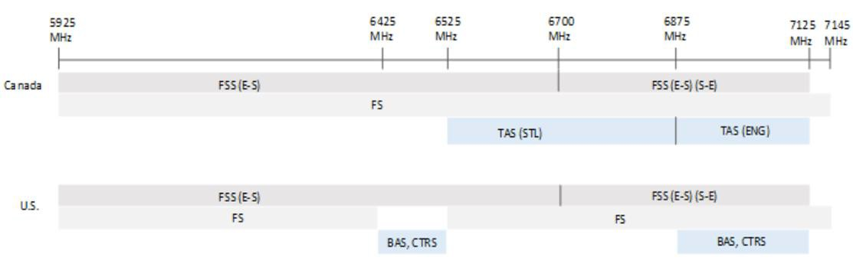
- BAS (Broadcast auxiliary service)
- CTRS (Cable television relay service)
- FS (Fixed service)
- FSS (E-S) (Fixed satellite service (Earth-space))
- FSS (E-S) (S-E) (Fixed satellite service (Earth-space) (Space-Earth))
- TAS (ENG) (Television auxiliary service (Electronic news gathering))
- TAS (STL) (Television auxiliary service (Studio-transmitter links))

- ISED is of the view that the co-existence between licensed users and standard-power RLANs can be achieved through appropriate technical requirements imposed on standard-power APs under the control of an AFC.
- ISED is proposing to permit the operation of standard-power RLANs in the 5925-6425 MHz sub-band, the 6425-6525 MHz sub-band, and the 6525-6875 MHz sub-band (as shown in figure 5), subject to the following limits:
  - indoor and outdoor operation would be permitted

Licence-Exempt Use in the 6 GHz Band SMSE-014-20

  - maximum permitted e.i.r.p. would be 36 dBm
  - maximum permitted power spectral density would be limited to 23 dBm/MHz
  - standard-power access points would only be permitted to operate under the control of an AFC system
  - operation would only be permitted on specific frequency channels at the corresponding maximum permitted e.i.r.p. (at or below 36 dBm) on each of the channels, as dictated by the AFC system

Figure 5: Operating frequency band for standard-power APs with AFC
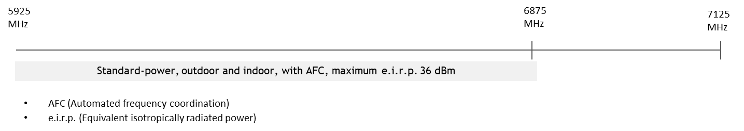

- As noted above, ISED is proposing to allow access to an additional 100 MHz of spectrum in the 6425-6525 MHz sub-band for standard-power operation with AFC. ISED is of the view that standard- power APs and the AFC systems can be easily adapted for extending their operation into the 6425-6525 MHz sub-band.

- The standard-power APs will be sharing the 5925-6875 MHz band with the following licensed systems in the band: fixed microwave systems, fixed point-to-point television auxiliary systems, FSS, and radio astronomy use. ISED is proposing that the AFC system would control the operation of standard-power APs to protect fixed microwave systems, fixed point-to-point television auxiliary systems and radio astronomy systems. The details related to the protection of these services are further discussed in section 9.1.

- The protection of FSS satellite receivers (with continent-level geographic coverage and whole- band spectrum usage) from standard-power devices operating outdoors would not be addressed through the use of an AFC system. To address coexistence with FSS, ISED is proposing to limit the radiated power of RLAN devices at angles near the geostationary satellite orbital arc through the use of a vertical elevation mask. Specifically, ISED proposes to limit the standard-power RLAN’s maximum e.i.r.p. to 125 mW at elevation angles above 30 degrees over the horizon. ISED notes that similar e.i.r.p. limitations to avoid interference with satellite systems, already exist in other cases, such as those described in the following Standard Radio System Plan (SRSP) technical standards:

  - SRSP-305.9, Technical Requirements for Fixed Line-of-Sight Systems Operating in the Band 5925-6425 MHz

Licence-Exempt Use in the 6 GHz Band SMSE-014-20

  - SRSP-306.4, Technical Requirements for Fixed Line-of-Sight Radio Systems Operating in the Band 6425-6930 MHz
  - SRSP-306.5, Technical Requirements for Line-of-sight Radio Systems Operating in the Fixed Service and Providing Television Auxiliary Services in the Bands 6590-6770 and 6930-7125 MHz

Q4
ISED is seeking comments on the proposed rules for standard-power RLANs:
- indoor and outdoor operation would be permitted
- RLAN access points would only be permitted to operate under the control of an AFC system in the 5925-6875 MHz frequency range
- maximum permitted e.i.r.p. would be 36 dBm
- maximum permitted power spectral density would be limited to 23 dBm/MHz
- use of a vertical elevation mask, with a maximum e.i.r.p. of 125 mW at elevation angles above 30 degrees over the horizon, would be required

Q5
ISED is seeking comments on allowing access to the additional 100 MHz of spectrum in the 6425- 6525 MHz sub-band for standard-power operation.

Q6
ISED is seeking comments on the equipment availability of standard-power RLANs in the 6425- 6525 MHz band and the impact on the development of AFC systems for Canada due to a potential lack of international harmonization for that sub-band.

In providing comments, respondents are requested to include supporting arguments and rationale and take the Canadian context into consideration in their response.

Proposals related to low-power indoor-only RLAN operation

- The introduction of low-power APs will serve a number of applications benefiting Canadian consumers and businesses and could promote new innovations. Applications that could be supported by low-power APs include virtual and augmented reality, ultra-high definition television, connected healthcare and other emerging applications in the indoor home and business environments.

- ISED has reviewed the existing body of knowledge based on developments in other countries as well as performed its own technical analysis. Consequently, ISED is of the view that co-existence between licensed users and indoor low-power RLANs can be achieved through appropriate technical requirements imposed on low-power APs.

- ISED is proposing to permit indoor low-power RLAN operation throughout the frequency range 5925-7125 MHz (as shown in figure 6), subject to the following limits:

Licence-Exempt Use in the 6 GHz Band SMSE-014-20

  - operation would be permitted indoor only across the 5925-7125 MHz band
  - the use of a contention-based protocol (e.g. listen-before-talk) would be required
  - maximum permitted e.i.r.p. would be 30 dBm
  - maximum permitted power spectral density would be limited to 5 dBm/MHz

Figure 6: Operating frequency band for low-power indoor APs
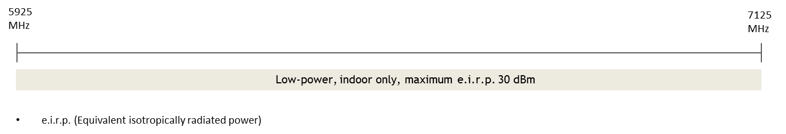
Q7
ISED is seeking comments on the proposed rules for low-power indoor-only RLANs:
- operation would be permitted indoor only across the 5925-7125 MHz band
- the use of a contention-based protocol (e.g. listen-before-talk) would be required
- maximum permitted e.i.r.p. would be 30 dBm
- maximum permitted power spectral density would be limited to 5 dBm/MHz

In providing comments, respondents are requested to include supporting arguments and rationale and take the Canadian context into consideration in their response.

Proposals related to very low-power RLAN operation

- Next generation short-range wireless applications such as high-speed tethering, mobile augmented reality, in-vehicle entertainment and personal healthcare applications require devices that operate at very low power. Such applications could be facilitated through devices that will be characterized by a prolonged battery life, lower cost, and compact size. To address these applications, ISED is considering the introduction of very low-power licence-exempt devices throughout the frequency range 5925-7125 MHz for indoor and outdoor use (as shown in figure 7).

- Very low-power devices would tentatively be subject to the following limits:
  - operation would be permitted indoors and outdoors across the frequency range 5925-7125 MHz band
  - the use of a contention-based protocol (e.g. listen-before-talk) would be required
  - maximum permitted e.i.r.p. would be 14 dBm
  - maximum permitted power spectral density would be limited to -8 dBm/MHz

Licence-Exempt Use in the 6 GHz Band SMSE-014-20

Figure 7: Operating frequency band for very low-power APs
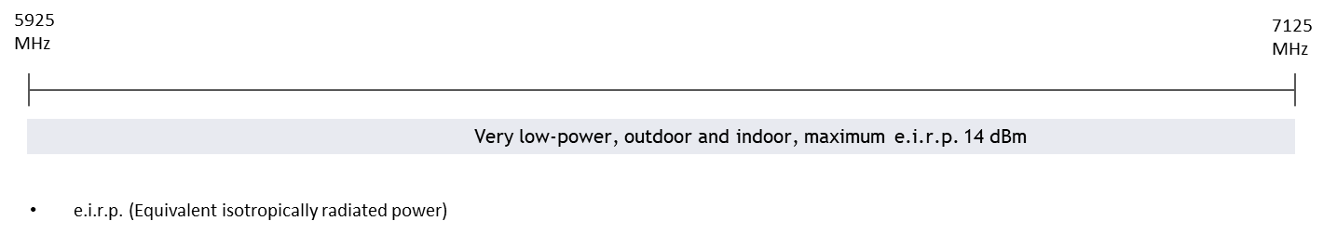

- ISED is of the view that, with appropriate technical requirements, co-existence can be achieved between licensed users and very low-power RLANs.
Q8
ISED is seeking comments on the proposed rules to allow very low-power RLAN devices:
- operation would be permitted indoors and outdoors across the frequency range 5925-7125 MHz band
- the use of a contention-based protocol (e.g. listen-before-talk) would be required
- maximum permitted e.i.r.p. would be 14 dBm
- maximum permitted power spectral density would be limited to -8 dBm/MHz

In providing comments, respondents are requested to include supporting arguments and rationale and take the Canadian context into consideration in their response.

9. Proposals related to the automated frequency coordination system

- Coexistence between licensed radio systems and standard-power RLAN devices requires technical rules to be placed on RLANs. Consequently, as proposed in section 8.1, standard-power RLAN APs would be operating under the control of an AFC system, which will enable sharing of spectrum while protecting existing users; thus improving access to mid-band spectrum.

- Designating AFC systems: ISED is proposing to approve third-party AFC administrators to operate their AFC systems in Canada. In order to support innovative approaches and a variety of potential business models as well as to promote a competitive marketplace of AFC database providers, ISED is proposing to permit multiple AFC systems to be approved to support the operation of standard- power devices. However, in the event that there is not a sufficient level of interest to result in the provision of AFC services and the roll-out of standard power APs in Canada in a similar timeframe to other countries, ISED may pursue alternative approaches to the implementation of AFC systems.

Licence-Exempt Use in the 6 GHz Band SMSE-014-20
Q9
ISED is seeking comments on potential business models for AFC administrators to operate their AFC systems in Canada.

Q10
ISED is seeking comments on its proposal to permit the approval of multiple, third party AFC systems, taking into account the potential for the development of a sustainable market for AFC systems in Canada.

Q11
ISED is seeking comments on potential exit strategies if the AFC administrator decides to cease operation in Canada.

In providing comments, respondents are requested to include supporting arguments and rationale.

- Harmonization with the U.S.: ISED is proposing to introduce a simple centralized database- driven AFC system model to control the operation of standard-power APs. Furthermore, ISED is proposing that the AFC system model would be harmonized to the maximum extent possible with the AFC system model being implemented in the U.S. and other international markets. Close alignment of Canadian AFC requirements with those of the U.S. in particular, will facilitate business viability for Canadian AFC system administrators by leveraging the ecosystem built for the broader U.S. market.
Q12
ISED is seeking comments on adopting an AFC system model that is harmonized to the maximum extent possible with the AFC system model being implemented in the U.S. and other international markets.

In providing comments, respondents are requested to include supporting arguments and rationale and take the Canadian context into consideration in their response.

- Implementation considerations: Approved AFC systems would be required to obtain information about the licensed stations to be protected from ISED’s Spectrum Management System Data. ISED’s Spectrum Management System (SMS) database currently comprises of a comprehensive list of technical information for site-based licenses. The information contained in the database includes operating frequency, bandwidth, the make and model of the antenna in use, antenna polarization, antenna height, and transmitter and receiver locations. ISED is of the view that this information is adequate for the AFC system to define exclusions zones for protecting incumbent licensed services. However, ISED recognizes that in order for an AFC system to be effective, licensees’ data must be kept up-to-date and be as accurate as possible. ISED intends to consider this requirement when developing or amending policy, technical and operational requirements for licensed services in the 6 GHz band. Moreover, licensees are encouraged to ensure that their data is timely and accurate such that they can be protected through the AFC system.

Licence-Exempt Use in the 6 GHz Band SMSE-014-20

- The AFC system would use this information to protect the licensed systems with exclusion zones computed by the AFC system. The exclusion zone computation would be done by using technical interference protection criteria developed by ISED, which would be harmonized, wherever possible, to those used by the U.S. The interference protection criteria would include the use of one or more radio propagation models combined with the appropriate clutter model, and an interference-to-noise (I/N) objective of -6 dB. The computation of exclusion zones would be based on minimizing interference to both the co-channel and adjacent channel transmissions. The exclusion zone calculation would be based on interference from individual interferers rather than performing an aggregate interference calculation.

- Approved AFC systems would also obtain relevant information (such as location information) from standard-power APs. The AFC system would use this information, together with computed exclusion zones around the incumbent stations to be protected, to provide the operating parameters (available frequencies and the corresponding maximum permissible operating power level) to the standard-power AP, thus minimizing any risk of interference to the licensed systems to be protected.

- To ensure up-to-date information for the services it would protect, the AFC system would obtain the information on the incumbent systems from ISED’s SMS database at least once daily and update its database accordingly. The AFC system would update the exclusion zones when new licensed systems are added or data from an existing licensed system is modified.

- ISED will require that the licensees’ data in the AFC system be secure. Furthermore, the AFC operation will be required to comply with Canadian privacy laws and regulations.

- Detailed AFC system requirements consistent with the above principles would be set out in technical standards, which AFC systems would be required to meet and follow in order to obtain and maintain their designation.
Q13
ISED is seeking comments on the implementation considerations for the operation of an AFC system, specifically:
- information required from licensed users
- interference protection criteria for computation of exclusion zones
- information required from standard-power APs
- frequency of AFC update of licensee information
- security and privacy requirements

Q14
ISED is seeking comments on any additional considerations, limits or general concerns that should be taken into account in setting detailed standards and procedures for AFC operation.

In providing comments, respondents are requested to include supporting arguments and rationale and take the Canadian context into consideration in their response.

Licence-Exempt Use in the 6 GHz Band SMSE-014-20

Coexistence by standard-power access points with automated frequency coordination

- ISED is proposing to protect licensed fixed microwave services from the risk of harmful interference from standard-power devices through the use of an AFC system. The AFC system would incorporate the details regarding the licensed fixed microwave services to be protected in the band and calculate the exclusion zones outside which a channel could be available for use by licence-exempt standard-power devices operating in the band.

- One-way fixed point-to-point television auxiliary stations operating in the 6590-6770 MHz band are very similar to point-to-point microwave backhaul systems in their technical configuration and operation. Furthermore, both of these systems use the same type of highly directional antenna models. Therefore, ISED is of the view that the interference protection methodology used by the AFC system to protect fixed microwave services could be extended to protect these fixed point-to-point stations from standard-power licence-exempt devices operating in the band.

- ISED is proposing to protect the DRAO radio astronomy site with an exclusion zone around the observatory campus in the AFC system. ISED notes that SRSP-306.4 presently encourages fixed service licensees to take steps to avoid causing harmful interference to the DRAO when their proposals overlap the 6650-6675.2 MHz frequency range and are within the vicinity of the DRAO.

- An AFC system can be used to protect incumbent licensed systems that use specific channels at well-defined sites. For satellite receivers that provide coverage using the entire band on a continent-wide basis, AFC is not a practical protection mechanism. As proposed in section 8.1, a vertical elevation mask imposed on standard-power outdoor APs would be the most appropriate mechanism to ensure the protection of FSS receivers aboard satellite stations.
Q15
ISED is seeking comments on its proposal to require AFC systems to protect the following types of licensed stations from standard-power APs:
- fixed microwave stations
- fixed point-to-point television auxiliary stations
- radio astronomy stations

In providing comments, respondents are requested to include supporting arguments and rationale.

General matters related to automated frequency coordination implementation

- AFC systems will have eligibility requirements and principles of operation that will be set out in a technical document to be developed following a decision on this consultation. AFC systems will be obliged to meet these requirements in order to obtain and maintain a designation from ISED.

Licence-Exempt Use in the 6 GHz Band SMSE-014-20

- Agreement with AFC administrators: Consistent with the specifications for TVWS database administrators set forth in CPC-4-1-01 Application Procedures for White Space Database Administrators (WSDBAs), ISED is proposing to execute an agreement with each AFC administrator. The agreement would include a number of requirements encompassing provisions related to AFC administration in Canada. A proposed sample agreement is provided in annex A.

- Incremental implementation: In order to support different business models, ISED is proposing to allow incremental AFC system implementation. Under this proposal, ISED would accept applications for AFC systems covering limited geographic areas and/or limited portions of the potentially available spectrum, provided they meet or exceed ISED’s AFC requirements. The administrators of AFC systems with limited geographical and/or spectrum coverage would be permitted to apply for incremental increase in the scope of their operation as they add capacity to their systems, thus providing a path to reach full geographic and frequency coverage. ISED anticipates that a number of AFC systems could be approved under this model, which would be aimed at reducing barriers to entry for the introduction of new AFC systems in Canada.

- Exploiting synergies: ISED notes that there are a number of parallels between the AFC system proposed for the 6 GHz band and white space database systems (WSDB) rules already adopted in Database Specifications DBS-01, White Space Database Specifications, for access to spectrum in television bands. In both cases, a central database would automatically provide a set of usable channels to licence-exempt devices according to specified technical calculations based on the device location. Although systems in both bands would be permitted to operate and be approved independently, there is a potential for synergies between the AFC and WSDB systems, including potential synergies with the introduction of database-driven spectrum sharing systems in additional bands that could be added in the future. Therefore, where possible, in order to maximize synergies between databases addressing
different bands under different technical regimes, ISED proposes to align the technical and administrative requirements and procedures between those for WSDB and 6 GHz AFC.
Q16
ISED is seeking comments on the sample agreement related to the designation and operation of an AFC system in Canada.

Q17
ISED is seeking comments on the proposed approach to incremental implementation of an AFC system in Canada.

Q18
ISED is seeking comments on the objective to maximize the potential for synergies, where possible, in defining the technical and administrative requirements for the respective databases addressing different bands under different technical regimes.

Licence-Exempt Use in the 6 GHz Band SMSE-014-20

10. Next steps

82. ISED intends to review the comments received and publish its decision on the issues raised in this consultation. Following the publication of a decision, ISED will develop the final technical standards, in consultation with stakeholders.

11. Submitting comments

- Respondents are requested to provide their comments in electronic format (Microsoft Word or Adobe PDF) by email.

- In addition, respondents are asked to specify question numbers for ease of referencing. Respondents are requested to provide supporting arguments and rationale for each response. Additionally, respondents are requested to take the Canadian context into consideration in their response.

- Paper submissions should be mailed to the following address:

Innovation, Science and Economic Development Canada Senior Director, Spectrum Planning and Engineering Engineering, Planning and Standards Branch
235 Queen Street, (6th Floor, East Tower) Ottawa ON K1A 0H5

- All submissions should cite the Canada Gazette, Part I, the publication date, the title and the notice reference number (SMSE-014-20). Parties should submit their comments no later than January 19, 2021, to ensure consideration. Soon after the close of the comment period, all comments received will be posted on ISED's Spectrum management and telecommunications website.

- ISED will also provide interested parties with the opportunity to reply to comments from other parties. Reply comments will be accepted until February 22, 2021.

- Following the initial comment period, ISED may, at its discretion, request additional information if needed to clarify significant positions or new proposals. In such a case, the reply comment deadline may be extended.

12.Obtaining copies

- All spectrum-related documents referred to in this paper are available on ISED’s Spectrum management and telecommunications website.

Licence-Exempt Use in the 6 GHz Band SMSE-014-20

- For further information concerning the process outlined in this consultation or related matters, contact:

Innovation, Science and Economic Development Canada Senior Director, Spectrum Planning and Engineering Engineering, Planning and Standards Branch
235 Queen Street (6th Floor, East Tower) Ottawa ON K1A OH5
Telephone: 343-291-3752
Cellular: 613-415-4663
Email: ic.spectrumengineering-genieduspectre.ic@canada.ca

Licence-Exempt Use in the 6 GHz Band SMSE-014-20

Annex A: Sample terms and conditions of an AFC system administrator agreement

A sample agreement draft of terms and conditions that would be signed by each entity who wishes to become designated as an Automated Frequency Coordination system administrator (AFCSA) operation in Canada is provided below.

- The AFCSA certifies all information submitted to Innovation, Science and Economic Development Canada (ISED) in relation to its designation application to be accurate and complete, and that it will promptly (but in no event later than 30 calendar days subsequently) notify ISED if it becomes aware of any material change in this information. It is a breach of this Agreement to knowingly provide inaccurate information or to fail to disclose a material change to ISED.

- The AFCSA has, and will maintain, business office(s) located at [street/mailing address] or elsewhere in Canada, and agrees to maintain one or more delegated individuals as its personnel/representatives in Canada at all times. These delegated individuals will provide public contact information and strive to provide timely responses to complaints or enquiries from its customers, equipment manufacturers, spectrum users, ISED or any other party.

- Any such requests for information by the AFCSA or notices to the AFCSA under this Agreement may be sent via telephone, facsimile, standard mail or email, as appropriate to the following coordinates: [insert AFCSA telephone number, street/mailing/email address]. Any information that the AFCSA is required to forward to ISED may be sent via email [email address] or by standard mail to [mailing address]. Information provided pursuant to this Agreement may be exchanged either by standard mail or by email. Both parties shall notify each other of any relevant change in addresses of offices, delegated individuals or other contact information.

- The parties agree that, irrespective of the hosting location of the AFC system, the laws of the province in which the AFCSA’s Canadian business office is physically located shall apply to this Agreement.

- The AFCSA shall not promote its designation status to provide AFC system services beyond the scope of this Agreement, nor indicate that it is an agent or representative of ISED or the Government of Canada.

- The AFCSA agrees that it will comply on an ongoing basis with all eligibility, technical and operational requirements, as set out in this Agreement and in the AFC technical specifications [insert reference once developed], as amended from time to time. In addition, the AFCSA must keep abreast of all relevant ISED regulations, policies, procedures, requirements, standards and specifications and amendments thereto related to the operation of the AFC system in Canada. This may include active participation in evaluation tests, discussion groups, meetings, or teleconferences established as deemed necessary by ISED to facilitate or address AFC system issues.

Licence-Exempt Use in the 6 GHz Band SMSE-014-20

- The AFCSA shall strive to maintain continuous operation of the AFC system and provide notification to its customers and ISED when it becomes temporarily unavailable (both planned and unplanned).

- The AFCSA shall not make publicly available the individual location of RLANs.

- The AFCSA shall not compromise the privacy of users of its services. Any time the AFCSA collects, uses or discloses personal information in the course of commercial activity, including transfer for third party processing, it must comply with the relevant portions of the Personal Information Protection and Electronic Documents Act (PIPEDA) or substantially similar provincial legislation, where applicable.

- Unless otherwise stated in this Agreement, the AFCSA is not required to disclose any information that it may collect to support additional services.

- ISED may audit or investigate compliance with terms and conditions of this Agreement at any time, and the AFCSA shall be required to provide any information or documentation as required, typically within 30 calendar days of the date of request.

- The AFCSA agrees to cooperate with ISED in any review or audit of its AFC system operations, and to provide any information that ISED may request in order to ensure compliance.

- The AFCSA will address all complaints forwarded to it by ISED regarding potential non-compliance with terms of designation, will implement the necessary corrective action(s) and will report back to ISED within 30 calendar days. Failure to reply in a satisfactory and timely manner will be considered by ISED as a potential breach of this Agreement.

- The AFCSA shall provide ISED with access to detailed logs of Radio Local Area Network (RLAN) queries and responses (including those that are personally identifiable) contained in its database, for the purposes of evaluation and enforcement. Upon formal written request from ISED, the AFCSA may also be required to implement interference mitigation measures, including ceasing to provide available frequencies to a particular RLAN or within a specified area.

- The AFCSA shall permit ISED to examine its repository of incumbent licensee information obtained from ISED’s Spectrum Management System to allow for the detection and correction of errors, resulting either from an inadvertent entry of incorrect data or as a result of a deliberate entry of false data.

- In addition to any other reporting requirements, the AFCSA will provide ISED, by March 31 each year and also upon ISED’s request, with a report and statistical information regarding overall AFC system performance, operational issues, developments, client complaints or enquiries received, including the timing and content of responses provided and efforts at resolution and incidents of

Licence-Exempt Use in the 6 GHz Band SMSE-014-20

RLANs causing interference with licensed radio systems operating in the 6 GHz band. This report shall address the above-noted matters for the previous calendar year, and will be provided to ISED in a suitable format for assessment.

- Where it is determined by ISED that an AFCSA is not in compliance with the terms and conditions of this Agreement, the AFCSA must take immediate corrective action, to the satisfaction of ISED, in order to maintain designation status. Failure to take such corrective action may result in the AFCSA’s suspension or revocation of designation status.

- Without prejudice to any other remedies available at law, in the event of any breach of this Agreement by the AFCSA, ISED may take any or all of the following actions:
  - provide notice of the breach and a timeline within which the breach must be remedied
  - enforce the terms of this Agreement via a court order
  - require that the AFCSA provide a separate enforceable undertaking to do or refrain from doing something under this Agreement
  - declare that this Agreement is terminated with or without the consent of the AFCSA
  - revoke the designation of the AFCSA
  - require the ARFCSA to transfer its AFC system database along with the IP (Internet protocol) addresses and URLs (uniform resource locator) used to access the AFC system and list of registered RLANs, to ISED or to another designated AFC system administrator at ISED’s direction

- An AFCSA whose designation status has been revoked by ISED will be removed from ISED’s list of designated AFCSAs.

- The AFCSA and ISED may terminate this Agreement upon joint consent, or upon provision of 90 calendar days’ advance notice. In addition, ISED may terminate this Agreement at any time upon confirmation of breach of conditions or terms of this Agreement by the AFCSA, in accordance with paragraph 18 (d) above.

- The AFCSA shall use its best efforts to comply with all terms of this Agreement.

- This Agreement may be amended in writing upon consent of both parties.

- The invalidity or unenforceability of any provision of this Agreement shall not affect the validity and enforceability of any other provision of this Agreement, which shall remain in full force and effect.

