Project | IEEE 802.16 Broadband Wireless Access Working Group <http://ieee802.org/16>
Title | Representative Channel Performance for 802.16s
Date Submitted | 2017 Mar 16 Rev 2017 Apr 22
Source(s) | Doug Gray, EPRI | E-mail: dgray.tcs@gmail.com  *<http://standards.ieee.org/faqs/affiliationFAQ.html>
Re: | IEEE 802.16s GRIDMAN Task Group
Abstract | Performance for selected channel bandwidths from 0.100 MHz to 1.000 MHz with parameters based on draft 802.16s amendment to IEEE Std 802.16-20xx.
Purpose | This is intended to provide further channel performance details for inclusion in SDD GRIDMAN Document
Notice | This document does not represent the agreed views of the IEEE 802.16 Working Group or any of its subgroups. It represents only the views of the participants listed in the “Source(s)” field above. It is offered as a basis for discussion. It is not binding on the contributor(s), who reserve(s) the right to add, amend or withdraw material contained herein.
Copyright Policy | The contributors are familiar with the IEEE-SA Copyright Policy <http://standards.ieee.org/IPR/copyrightpolicy.html>.
Patent Policy | The contributors are familiar with the IEEE-SA Patent Policy and Procedures:  <http://standards.ieee.org/guides/bylaws/sect6-7.html#6> and <http://standards.ieee.org/guides/opman/sect6.html#6.3>.  Further information is located at <http://standards.ieee.org/board/pat/pat-material.html> and <http://standards.ieee.org/board/pat>.

The following table corrects an error in row 33, ‘TR-Gap Symbols for 40 mi Range’, from version in 16-17-0017-01-000s
Table 1: OFDMA parameters and channel performance estimates for selected channel bandwidths
1 | Parameter | Channel Bandwidth
2 | Nominal Channel BW | 1.00 MHz | 0.75 MHz | 0.50 MHz | 0.25 MHz | 0.10 MHz
3 | FFT | 128 | 128 | 128 | 128 | 128
4 | Permutation | AMC 2x3 | AMC 2x3 | AMC 1x3 | AMC 1x3 | AMC 1x3
5 | DC Subcarriers | 1 | 1 | 1 | 1 | 1
6 | Guard Subcarriers - Left | 10 | 10 | 10 | 10 | 10
7 | Guard Subcarriers - Right | 9 | 9 | 9 | 9 | 9
8 | % Subchannels Used | 100% | 100% | 50% | 33% | 25%
9 | Used Subcarriers (Pilots+Data) | 108 | 108 | 54 | 36 | 27
10 | Pilot Subcarriers | 12 | 12 | 6 | 4 | 3
11 | Data Subcarriers | 96 | 96 | 48 | 32 | 24
12 | Number of Inband Subchannels | 6 | 6 | 6 | 4 | 3
13 | Data Subcarriers per Subchannel | 16 | 16 | 8 | 8 | 8
14 | Pilot Subcarriers per Subchannel | 2 | 2 | 1 | 1 | 1
15 | Sampling Factor | 28/25 | 28/25 | 11/5 | 82/25 | 109/25
16 | Sampling Frequency (Clock) | 1.120 MHz | 0.840 MHz | 1.100 MHz | 0.820 MHz | 0.436 MHz
17 | Subcarrier Spacing | 8.750 kHz | 6.563 kHz | 8.594 kHz | 6.406 kHz | 3.406 kHz
18 | Occupied BW (incl DC Subcarrier) | 0.954 MHz | 0.715 MHz | 0.473 MHz | 0.237 MHz | 0.095 MHz
19 | Occupied BW % of Nominal BW | 95.38% | 95.38% | 94.53% | 94.81% | 95.38%
20 | Subchannel BW (excludes DC SC) | 0.158 MHz | 0.118 MHz | 0.077 MHz | 0.058 MHz | 0.031 MHz
21 | Symbol Time-microsec | 114.29 us | 152.38 us | 116.36 us | 156.10 us | 293.58 us
22 | Cyclic Prefix | 1/16 | 1/16 | 1/16 | 1/16 | 1/16
23 | Guard Time-microsec | 7.14 us | 9.52 us | 5.95 us | 7.52 us | 8.93 us
24 | Symbol Duration-microsec | 121.43 us | 161.90 us | 122.32 us | 163.62 us | 302.51 us
25 | Frame Duration-millisec | 5.0 ms | 5.0 ms | 5.0 ms | 10.0 ms | 20.0 ms
26 | Frames per Second | 200 | 200 | 200 | 100 | 50
27 | Samples per Frame | 5600 | 4200 | 5500 | 8200 | 8720
28 | Total OFDMA Symbols per Frame | 41 Symbols | 30 Symbols | 40 Symbols | 61 Symbols | 66 Symbols
29 | Symbols for TR Gap | 1 Symbol | 1 Symbol | 1 Symbol | 1 Symbol | 1 Symbol
30 | OFDMA Symbols per Frame (after TR Gap) | 40 Symbols | 29 Symbols | 39 Symbols | 60 Symbols | 65 Symbols
31 | TTG+RTG Gap in microsec | 142.86 us | 304.76 us | 229.68 us | 183.02 us | 337.07 us
32 | Range Limit for selected TR-Gap | 13.31 mi | 28.39 mi | 21.39 mi | 17.05 mi | 31.40 mi
33 | TR-Gap Symbols for 40 mi range | 3 Symbols | 3 Symbols | 3 Symbols | 3 Symbols | 2 Symbols
34 | N = # Bins | 2 Bins | 2 Bins | 1 Bins | 1 Bins | 1 Bins
35 | M = # Symbols | 3 Symbols | 3 Symbols | 3 Symbols | 3 Symbols | 3 Symbols
36 | Preamble Overhead | 1 Symbol | 1 Symbol | 1 Symbol | 1 Symbol | 1 Symbol
37 | UL OH Symbols (CQICH*, ACK*,Ranging) | 1 Symbol | 1 Symbol | 1 Symbol | 1 Symbol | 1 Symbol
38 | Net OFDMA Symbols per Frame | 38 Symbols | 27 Symbols | 37 Symbols | 58 Symbols | 63 Symbols
39 | Slots per Sector/Frame for Reuse 1,3,3 | 24 Slots | 18 Slots | 24 Slots | 19 Slots | 21 Slots
40 | DL-MAP (bits) | 60 Bits | 60 Bits | 60 Bits | 60 Bits | 60 Bits
41 | DL-MAP (Bytes) | 8 Bytes | 8 Bytes | 8 Bytes | 8 Bytes | 8 Bytes
42 | UL-MAP (bits | 139 bytes | 139 bytes | 139 Bits | 139 Bits | 139 Bits
43 | UL-MAP (Bytes) | 18 bytes | 18 bytes | 18 Bytes | 18 Bytes | 18 Bytes
44 | Frame Control Header (FCH) | 1 Slot | 1 Slot | 2 Slot | 2 Slot | 2 Slot
45 | Bytes per Slot at QPSK-1/2 (1 rep) | 6 Bytes | 6 Bytes | 3 Bytes | 3 Bytes | 3 Bytes
46 | Total # OH Slots for DL-MAP+UL-MAP+FCH | 6 Slots | 6 Slots | 11 Slots | 11 Slots | 11 Slots
47 | UL+DL Data Slots/Sector for scheduling | 18 Slots | 12 Slots | 13 Slots | 8 Slots | 10 Slots
48 | Desired UL/DL Data Ratio | 2.00 | 2.00 | 2.00 | 2.00 | 2.00
49 | UL Data Slots/Sector for scheduling | 12 Slots | 8 Slots | 9 Slots | 6 Slots | 7 Slots
50 | DL Data Slots/Sector for scheduling | 6 Slots | 4 Slots | 4 Slots | 2 Slots | 3 Slots
51 | Unused Symbols | 2 Symbols | 0 Symbols | 1 Symbols | 1 Symbols | 0 Symbols
52 | Actual UL/DL Data Slot Ratio | 2.00 | 2.00 | 2.25 | 3.00 | 2.33
53 | Avg SE over Coverage Area | 2.0 bps/Hz | 2.0 bps/Hz | 2.0 bps/Hz | 2.0 bps/Hz | 2.0 bps/Hz
54 | Peak Bytes/Slot (64QAM-5/6) | 30 Bytes | 30 Bytes | 15 Bytes | 15 Bytes | 15 Bytes
55 | Cell Edge Bytes/Slot (QPSK-1/2) | 6 Bytes | 6 Bytes | 3 Bytes | 3 Bytes | 3 Bytes
56 | Avg Bytes/Slot | 12.0 Bytes | 12.0 Bytes | 6.0 Bytes | 6.0 Bytes | 6.0 Bytes
57 | OTA Sector Rate for Reuse (1,3,3)&(SISO)
58 | Peak UL PHY Rate per Sector | 576.0 kbps | 384.0 kbps | 216.0 kbps | 72.0 kbps | 42.0 kbps
59 | Avg UL PHY Rate per Sector | 230.4 kbps | 153.6 kbps | 86.4 kbps | 28.8 kbps | 16.8 kbps
60 | Peak DL PHY Rate per Sector | 288.0 kbps | 192.0 kbps | 96.0 kbps | 24.0 kbps | 18.0 kbps
61 | Avg DL PHY Rate per Sector | 115.2 kbps | 76.8 kbps | 38.4 kbps | 9.6 kbps | 7.2 kbps
62 | OTA Cell Rate for Reuse (1,3,3)&(SISO)
63 | Avg UL PHY Rate per Cell | 691.2 kbps | 460.8 kbps | 259.2 kbps | 115.2 kbps | 50.4 kbps
64 | Avg DL PHY Rate per Cell | 345.6 kbps | 230.4 kbps | 115.2 kbps | 38.4 kbps | 21.6 kbps
65 | Avg Cell Spectral Efficiency | 1.04 bps/Hz | 0.92 bps/Hz | 0.75 bps/Hz | 0.61 bps/Hz | 0.72 bps/Hz
66
67 | Subchannels included in per-cell OTA rate but not in per-sector rate | 0 | 0 | 0 | 1 | 0
68
69 | Maximum UL:DL or DL:UL Data Slot Ratio | > 10:1 | > 10:1 | > 10:1 | 7 | 9
70 | Increased Latency Relative to 5 ms Frame | 0 ms | 0 ms | 0 ms | 10 ms | 30 ms

The following tables and graphs provide further details and trade-offs for the channel performance based on proposed IEEE 802.16s amendment
FRAME DURATION OPTIONS:
Table 2: Frame durations for channel sub-group 4 per P80216s, Clause 12.9
 | Subgroup 4 (1.20 to 0.55 MHz in 50 kHz increments)
Nominal Channel BW | 1.20 MHz | 1.00 MHz | 0.75 MHz | 0.55 MHz
Permutation | AMC 2x3 or AMC 1x6 | AMC 2x3 or AMC 1x6 | AMC 2x3 or AMC 1x6 | AMC 2x3 or AMC 1x6
Minimum Frame Duration | 5.0 ms | 5.0 ms | 5.0 ms | 5.0 ms
Alternative Frame Durations | 10.0 ms | 10.0 ms | 10.0 ms | 10.0 ms
 | 12.5 ms | 12.5 ms | 12.5 ms | 12.5 ms
 | 20.0 ms | 20.0 ms | 20.0 ms | 20.0 ms
 | 25.0 ms | 25.0 ms | 25.0 ms | 25.0 ms

Table 3: Frame durations for channel sub-groups 3, 2, and 1 per P80216s, Clause 12.9
 | Subgroup 3 |  |  |  | Subgroup 2 |  |  | Subgroup 1
Nominal Channel BW | 0.50 MHz | 0.45 MHz | 0.40 MHz | 0.35 MHz | 0.30 MHz | 0.25 MHz | 0.20 MHz | 0.15 MHz | 0.10 MHz
Permutation | AMC 1x3 | AMC 1x3 | AMC 1x3 | AMC 1x3 | AMC 1x3 | AMC 1x3 | AMC 1x3 | AMC 1x3 | AMC 1x3
Minimum Frame Duration | 5.0 ms | 5.0 ms | 5.0 ms | 5.0 ms | 10.0 ms | 10.0 ms | 12.5 ms | 12.5 ms | 20.0 ms
Alternative Frame Durations | 10.0 ms | 10.0 ms | 10.0 ms | 10.0 ms | 12.5 ms | 12.5 ms | 20.0 ms | 20.0 ms | 25.0 ms
 | 12.5 ms | 12.5 ms | 12.5 ms | 12.5 ms | 20.0 ms | 20.0 ms | 25.0 ms | 25.0 ms | 40.0 ms
 | 20.0 ms | 20.0 ms | 20.0 ms | 20.0 ms | 25.0 ms | 25.0 ms | 40.0 ms | 40.0 ms
Permutation | AMC 2x3 or AMC 1x6 | AMC 2x3 or AMC 1x6 | AMC 2x3 or AMC 1x6 | AMC 2x3 or AMC 1x6 | AMC 1x6 | AMC 1x6 | AMC 1x6 | AMC 1x6 | AMC 1x6
Minimum Frame Duration | 10.0 ms | 10.0 ms | 10.0 ms | 10.0 ms | 12.5 ms | 12.5 ms | 20.0 ms | 20.0 ms | 25.0 ms
Alternative Frame Durations | 12.5 ms | 12.5 ms | 12.5 ms | 12.5 ms | 20.0 ms | 20.0 ms | 25.0 ms | 25.0 ms | 40.0 ms
 | 20.0 ms | 20.0 ms | 20.0 ms | 20.0 ms | 25.0 ms | 25.0 ms | 40.0 ms | 40.0 ms | 50.0 ms
 | 25.0 ms | 25.0 ms | 25.0 ms | 25.0 ms | 40.0 ms | 40.0 ms | 50.0 ms | 50.0 ms

CHANNEL THROUGHPUT VS. FRAME DURATION AND PERMUTATION CHOICE
Assumptions for the following graphs are as follows:
- Antenna: Single Input Single Output (SISO)
- Frequency reuse: Reuse 3, (1,3,3)
- Deployment: Uniform end-point distribution with uniform propagation characteristics over cell coverage area, average spectral efficiency over coverage area of 2 bps/Hz
- TR Gap: 1 Symbol
- Cyclic prefix: 1/16
- Frame duration: Per Table 2 and 3

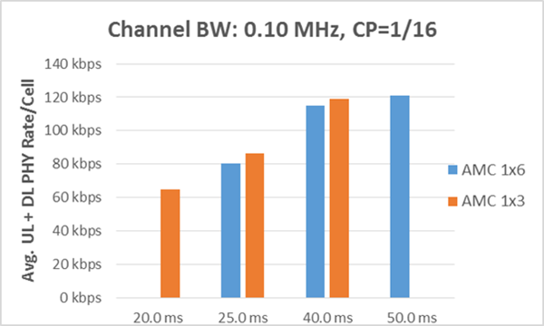

IMPACT OF CYCLIC PREFIX (at minimum recommended frame duration)

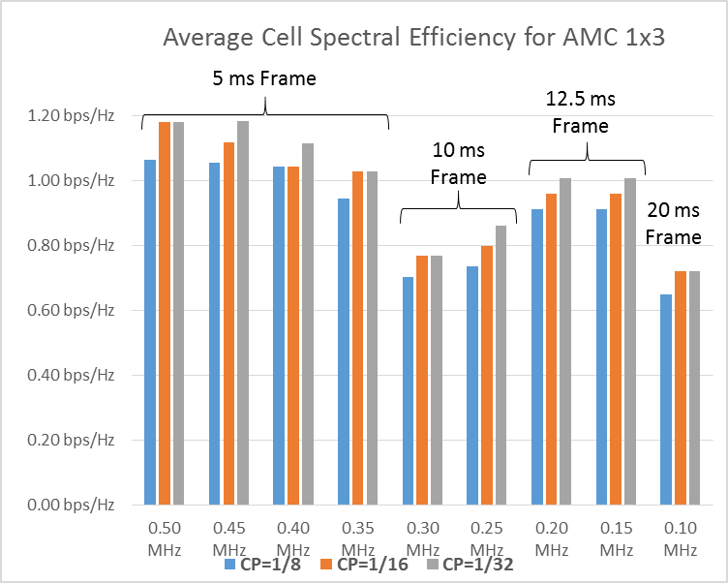

ADAPTIVE TDD SPLIT (10:1 TARGET)
To support UL/DL or DL/UL ratios greater than or equal to 10, it is necessary to have 11 or more DATA SLOTS for scheduling. All channel bandwidths in subgroup 4 (1.2 MHz to 0.55 MHz) will support ATDD splits greater than 10:1 with either AMC 2x3 or AMC 1x6 and a frame duration ≥5 ms.
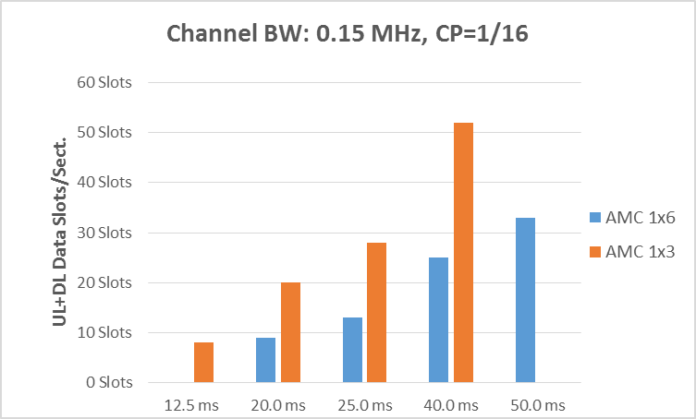
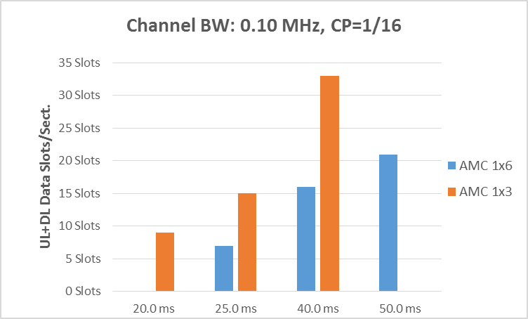
With smaller channel bandwidths it will be necessary to trade off LATENCY with desired ATDD SPLIT. This is clearly illustrated in the following bar charts for channel bandwidths of 0.15 MHz and 0.10 MHz. Whereas, a 12.5 ms and 20 ms frame duration respectively will provide a reasonable net throughput, the UL/DL or DL/UL ratio is limited to 7:1 and 8:1 respectively. A 20 ms and 25 ms frame duration with band AMC 1x3 is required for an ATDD split ≥10 for 0.15 MHz and 0.10 MHz BW respectively.

40 MILE RANGE REQUIREMENT AND UNUSED SYMBOLS
All of the above examples assume a TR Gap of 1 symbol and, as shown on row 32 in Table 1, supports a range of 13 to 31 miles for the channel BWs shown in the table. To achieve a 40 mile range as many as 3 additional symbols (Table 1, row 33) will be required for the TR-Gap. Since the available number of symbols must be a multiple of 3 for AMC 2x3 or AMC 1x3 and a multiple of 6 for AMC 1x6, there will, in many cases, be some unused symbols. These unused symbols can be allocated to the TR-Gap for increased range without impacting the throughput. The following shows the unused symbols with AMC 2x3 for channel bandwidths ≥ 0.55 MHz and with AMC 1x3 permutation for channel bandwidths between 0.50 MHz and 0.10 MHz.
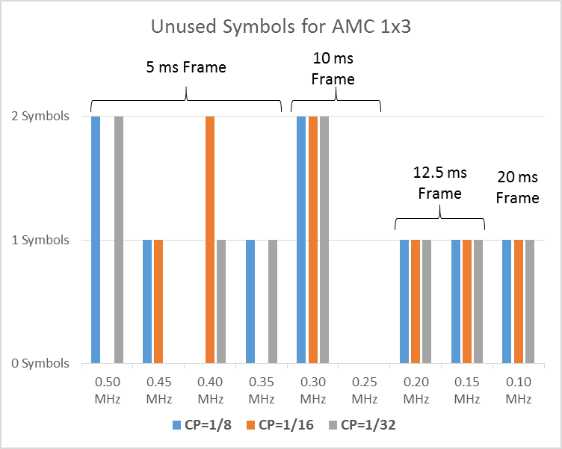
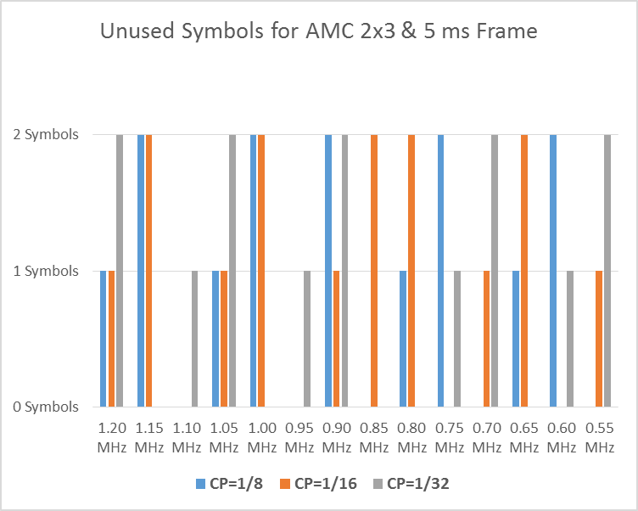

FRAME DURATION UP TO 50 MS FOR CHANNEL SUBGROUP 4
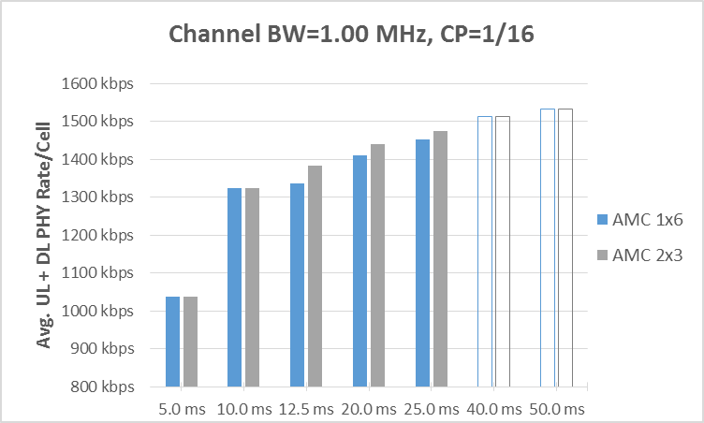
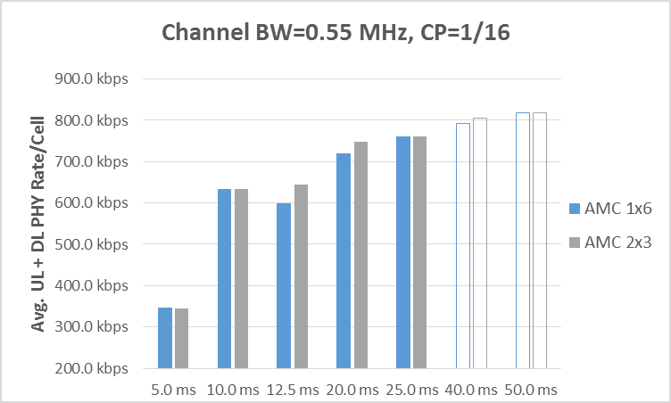

The throughput gain for increasing the frame duration to 40 ms and 50 ms is under 5% and under 2% respectively for a 1.0 MHz channel BW and about 6 % and 1.4 % for a 0.55 MHz channel BW. The latency, on the other hand will increase 60% and 25% respectively.
The 0.55 MHz channel BW in going from a 10 ms frame to a 12.5 ms frame illustrates another trade-off. The following explains the throughput reduction for AMC 1x6 with the increase in frame size.
Table 4: 12.5 ms vs. 10 ms frame duration for 0.55 MHz channel BW with band AMC 1x6 permutation
10 ms Frame with AMC 1x6 | 12.5 ms Frame with AMC 1x6 | Frame increase = 25 %
Unused symbols = 0 | Unused symbols =5
Data slots = 22 | Data slots = 26 | Data slot increase = 18 %
While the increased frame duration does result in more data slots with AMC 1x6 the slot increase as a percent is less that the frame size increase, thus a reduction in the data rate.
It should be noted that; if the Cyclic Prefix were changed from 1/16 to 1/32 with the 12.5 ms frame size 2 symbols would be added and the number of data slots would increase by 36 % relative to a 10 ms frame and 1/16 CP.

SUMMARY
Table 5: Some Pros and Cons of various parameter choices
Parameter | PROs | CONs
Frame durations >20 ms | - Channel BWs ≤0.50 MHz: Essential for sufficient throughput  - Channel BWs >0.50 MHz: Marginal throughput increase, may be OK for latency-tolerant applications | - Increased latency (linear relationship to frame duration)  - Channel BWs >0.50 MHz: Generally insufficient throughput benefit to offset latency increase
Cyclic prefix decrease (1/32 vs. 1/8 or 1/16) | - Reduced OH  - Will increase throughput in many (but not all) cases | - Increased inter-symbol-interference (ISI)  - Must add sufficient number of symbols to gain at least 1 data slot
Band AMC 1x6 vs. Band AMC 2x3 | - 2x more sub-channels for increased flexibility with frequency reuse | - Potential for higher number of unused symbols (up to 5 vs. up to 2)
Band AMC 1x3 vs. Band AMC 1x6 | - Potential for fewer unused symbols with Band AMC 1x3 (higher efficiency)  - Channel BWs ≤0.50MHz: AMC 1x3 is essential for viable throughput at minimum frame duration (lowest latency)

