Project | IEEE 802.16 Broadband Wireless Access Working Group <http://ieee802.org/16>
Title | IEEE 802.16s Approved System Description Document
Date Submitted | 2017-07-11
Source(s) | GRIDMAN Task Group | Voice:  E-mail:
Re: | GRIDMAN Task Group: Narrowband Channel
Abstract | Approved system requirements document
Purpose | System Description Document
Notice | This document does not represent the agreed views of the IEEE 802.16 Working Group or any of its subgroups. It represents only the views of the participants listed in the “Source(s)” field above. It is offered as a basis for discussion. It is not binding on the contributor(s), who reserve(s) the right to add, amend or withdraw material contained herein.
Copyright Policy | The contributor is familiar with the IEEE-SA Copyright Policy <http://standards.ieee.org/IPR/copyrightpolicy.html>.
Patent Policy | The contributor is familiar with the IEEE-SA Patent Policy and Procedures:  <http://standards.ieee.org/guides/bylaws/sect6-7.html#6> and <rmation is located at <http://standards.ieee.org/board/pat/pat-material.html> and <http://standards.ieee.org/board/pat>.

IEEE 802.16s
System Description Document

July 11, 2017

Introduction
This document describes the technical approach for IEEE 802.16 operation in channels less than 1.25 MHz bandwidth.

PAR Scope (From 802.16-16-0038-00-000s):
This project specifies WirelessMAN-OFDMA TDD operation in exclusively-licensed spectrum with channel bandwidth from 100 kHz up to 1.25 MHz, including 1 MHz explicitly. The amendment will target operation in the 700 MHz band but will also support operation in other VHF/UHF bands. The project amends Clause 12 of IEEE Std 802.16, adding a new system profile and amending other clauses as required to support the narrower channel widths. The range and data rate supported by the added profile are commensurate with those of the base standard, as scaled by the reduced channel bandwidth.

The italicized phrase is the reasoning behind the section for MAC changes related to improving efficiency, which is necessary to meet SRD requirements in narrower channel bandwidths.

Informative Section – rationale for changes:

System-level PHY Design Aspects
- The amendment supports Band AMC operation exclusively. The amendment removes mandatory requirement for PUSC in Zone 1.
- Adjustment of sampling clock is used as a mechanism to adjust channel occupancy to better meet regulatory requirements in various regions.
- Disassociate preamble ID from sector ID
- Provide information for auto-configuration of remotes, through a combination of periodic system information as well as scanning by the remotes.

Definition of Band AMC
IEEE 802.16-2012 does not explicitly define the term “Band AMC”. The meaning is “a subcarrier allocation scheme in which all subcarriers in one sub-channel are adjacent to each other. “
There are three Band AMC schemes used in this amendment.
Band AMC 2x3: Each sub-channel employs two bins, and each slot is defined as two bins by 3 OFDMA symbols.
Band AMC 1x6: Each sub-channel employs one bin, and each slot is defined as one bin by 6 OFDMA symbols.
Band AMC 1x3: Each sub-channel employs one bin, and each slot is defined as one bin by 3 OFDMA symbols.
A bin is 9 subcarriers, including 8 data subcarriers and 1 pilot.

Performance Analysis (derived from SRD: 802.16-16-0044)
Quantifying the PHY Layer Throughput Benefits

Table 1 - Summary of throughput enhancements for specific feature modifications, compared to 802.16-2012
Baseline: 1 MHz channel BW, 128 FFT with PUSC in DL and optional UL PUSC, with 28/25 sampling factor, and 5 ms frame size
Feature or Attribute | Change or Modification | Notes | Throughput Impact  Relative to baseline
Permutation | PUSC to Band AMC | Mobility is a low priority & other PUSC ‘benefits’ less significant with smaller channel BWs | +33.3%
Frame Size | 2x Increase from 5 ms to  10 ms | Tradeoff with 2x increased latency | +24.1%
 | Further increases to 15 ms, 20 ms, and 25 ms, | Subsequent increases will incur considerable additional latency | An additional gain of; +5.5%, +3.3%, +1.4% respectively
Cyclic Prefix | Reduce from 1/8 to 1/16 | Symbol OH is reduced from >11% to <6% | +11.5%
Sampling Factor | 28/25 to 11/5, 82/25, and 109/25 | Selected to limit occupied bandwidth to ~95%

Note: The improvements become more significant as channel sizes are reduced further below 1 MHz.

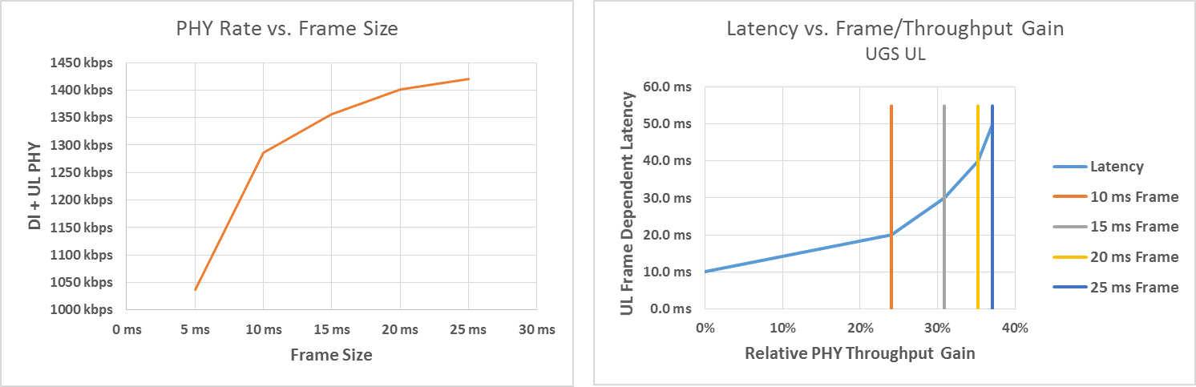
Left: Shows UL + DL PHY throughput for example 5, 10, 15, 20, and 25 mS frame sizes, Right: Shows minimal frame dependent UL latency for unsolicited grant service for same 5 frame sizes
Figure 1 - relationship between throughput, latency, and frame size
CHANNEL THROUGHPUT VS. FRAME DURATION AND PERMUTATION CHOICE
Assumptions for the following graphs are as follows:
- Antenna: Single Input Single Output (SISO)
- Frequency reuse: Reuse 3, (1,3,3)
- Deployment: Uniform end-point distribution with uniform propagation characteristics over cell coverage area, average spectral efficiency over coverage area of 2 bps/Hz
- TR Gap: 1 Symbol
- Cyclic prefix: 1/16
- Frame duration: Per Table 2 and Table 3
Figure 2 – Channel Throughput vs. Frame Duration and Permutation Choice

Figure 3 - Channel Throughput vs. Frame Duration and Permutation Choice (2)

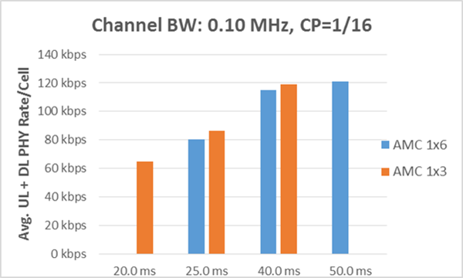
Figure 4 - Channel Throughput vs. Frame Duration and Permutation Choice (3)

ADAPTIVE TDD SPLIT (10:1 TARGET)
To support UL/DL or DL/UL ratios greater than or equal to 10, it is necessary to have 11 or more DATA SLOTS for scheduling. All channel bandwidths in subgroup 4 (1.2 MHz to 0.55 MHz) will support ATDD splits > 10:1 with either AMC 2x3 or AMC 1x6 and a frame duration ≥5 ms.
With smaller channel bandwidths it will be necessary to trade off LATENCY with the desired ATDD SPLIT. This is clearly illustrated in the following bar charts for channel bandwidths of 0.15 MHz and 0.10 MHz. Whereas, a 12.5 ms and 20 ms frame duration respectively, will provide a reasonable net throughput, the UL/DL or DL/UL ratio is limited to 7:1 and 8:1 respectively. A 20 ms and 25 ms frame duration with band AMC 1x3 is required for an ATDD split ≥ 10:1 for 0.15 MHz and 0.10 MHz BW respectively.

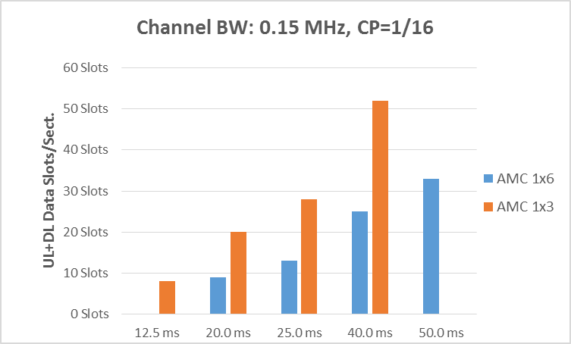
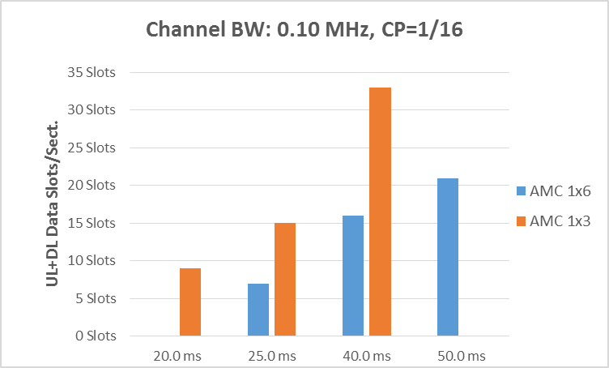
Figure 5 - Number of Slots available for channel bandwidth and frame duration

40 MILE RANGE REQUIREMENT AND UNUSED SYMBOLS
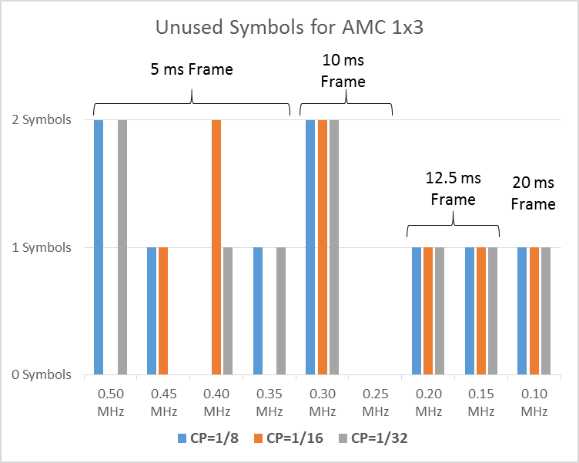
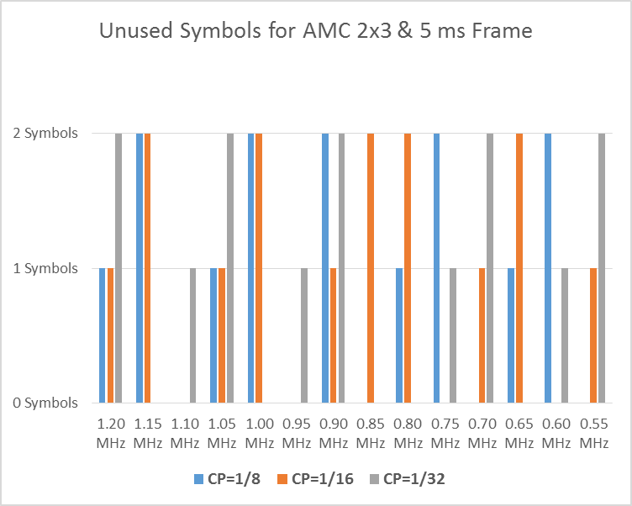
All of the above examples assume a TR Gap of 1 symbol and, as shown on row 32 in Table 1, supports a range of 13 to 31 miles for the channel BWs shown in the table. To achieve a 40 mile range as many as 3 additional symbols (Table 1, row 33) will be required for the TR-Gap. Since the available number of symbols must be a multiple of 3 for AMC 2x3 or AMC 1x3 and a multiple of 6 for AMC 1x6, there will, in many cases, be some unused symbols. These unused symbols can be allocated to the TR-Gap for increased range without impacting the throughput. The following shows the unused symbols with AMC 2x3 for channel bandwidths ≥ 0.55 MHz and with AMC 1x3 permutation for channel bandwidths between 0.50 MHz and 0.10 MHz.
Figure 6 - Unused Symbols that could be used for expanding TR slot for longer range

FRAME DURATION UP TO 50 MS FOR CHANNEL SUBGROUP 4
As summarized in Tables 2 and 3, frame durations of 40 and 50 ms were not recommended profiles for channel bandwidths in subgroups 3 and 4. These large frame durations are not recommended due to the tradeoff between significantly increased latency for only a marginal improvement in throughput. The following graphs illustrate this for a 1.0 MHz and 0.55 MHz channel BW where frame durations of 40 ms and 50 ms are shown.
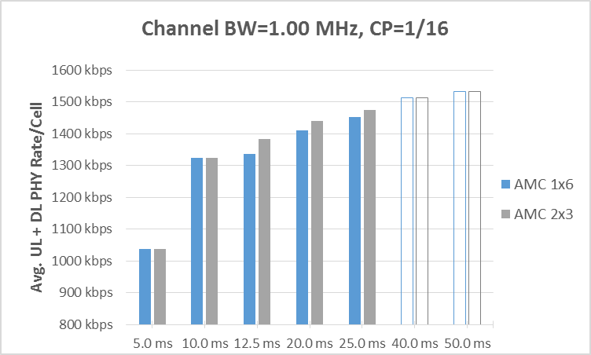
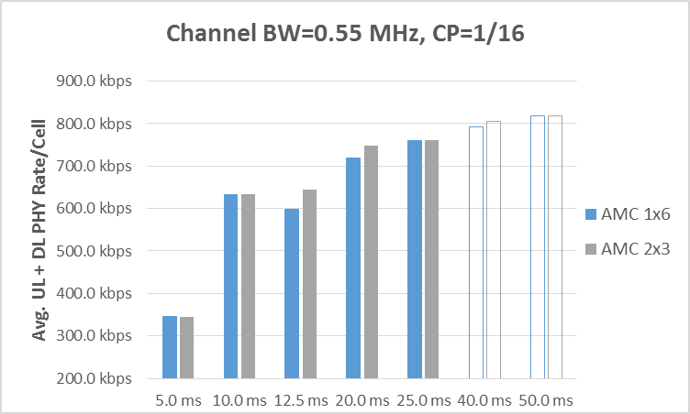
Figure 7 - Throughput Gain for increasing frame duration

The throughput gain for increasing the frame duration from 25 ms to 40 ms and, subsequently to 50 ms is under 5% and under 2% respectively for a 1.0 MHz channel BW and about 6 % and 1.4 % for a 0.55 MHz channel BW. The latency, on the other hand will increase 60% for a frame duration of 40 ms and an additional 25% for a 50 ms frame duration.
The graph for 0.55 MHz channel BW also illustrates another issue that may arise with different parameter choices. Note that while increasing the frame duration from 10 ms to 12.5 ms provides a small (~1 %) increase in throughput for AMC 2x3, it results in a throughput decrease of almost 6 % for AMC 1x6. This is due to the larger number of unused symbols, 5 vs. 0, with the increased frame size. AMC 1x6 requires 6 symbols to support a data slot, in this particular case 11 symbols are added supporting only 1 additional data slot, a 14 % increase in data slots compared to a 25 % increase in the time duration. While the increased frame duration does result in more data slots with AMC 1x6 the slot increase as a percent is less than the frame duration increase, thus a reduction in the data rate. The following table provides further details.

Table 2 - 12.5 ms vs. 10 ms frame duration for 0.55 MHz channel BW with band AMC 1x6 permutation
Scenario 1 | Scenario 2 | Impact
10 ms Frame with AMC 1x6 & CP=1/16 | 12.5 ms Frame with AMC 1x6 & CP=1/16 | Frame duration increase = 25 %
42 ‘Net’ Symbols per Frame,  Unused symbols = 0 | 53 ‘Net’ Symbols per Frame,  Unused symbols = 5
Data slots per sector = 7 | Data slots per sector = 8 | Per sector data slot increase = 14 % for a  25 % time increase, thus a lower throughput.
In addition to increasing the frame duration the cyclic prefix can also be decreased from 1/16 to 1/32
 | 12.5 ms Frame with AMC 1x6 & CP=1/32 | Frame duration increase = 25 %  CP reduced by 50 %
 | 55 ‘Net’ Symbols per Frame will support 9 data slots per sector  Unused symbols = 1 | Provides a sector data slot increase of 29 % compared to 10 ms frame duration with CP=1/16

It should be noted that, if the Cyclic Prefix (CP) were changed from 1/16 to 1/32 with the 12.5 ms frame size 2 additional symbols would be added and the number of data slots would increase by almost 30 % relative to a 10 ms frame and 1/16 CP. In this case there would only be 1 unused symbol.

SUMMARY

Table 3 - Some Pros and Cons of various parameter choices
Parameter | PROs | CONs
Frame durations >20 ms | - Channel BWs ≤0.50 MHz: Essential for sufficient throughput  - Channel BWs >0.50 MHz: Marginal throughput increase, may be OK for latency-tolerant applications | - Increased latency (linear relationship to frame duration)  - Channel BWs >0.50 MHz: Generally insufficient throughput benefit to offset latency increase
Cyclic prefix decrease (1/32 vs. 1/8 or 1/16) | - Reduced OH  - Will increase throughput in many (but not all) cases | - Increased inter-symbol-interference (ISI)  - Must add sufficient number of symbols to gain at least 1 data slot
Band AMC 1x6 vs. Band AMC 2x3 | - 2x more sub-channels for increased flexibility with frequency reuse | - Potential for higher number of unused symbols (up to 5 for 1x6 vs. up to 2 for 2x3)
Band AMC 1x3 vs. Band AMC 1x6 (applicable for channel subgroups 1, 2, and 3) | - Potential for fewer unused symbols with Band AMC 1x3 (higher efficiency)  - Channel BWs ≤0.50MHz: AMC 1x3 is essential for viable throughput at minimum frame duration (lower latency) | - Potential for higher number of unused symbols (up to 5 for 1x6 vs. up to 2 for 1x3)

PHY Description
The following table defines the key parameters defining the PHY operation affecting channel bandwidth.
Based on the SRD, Band AMC is assumed, and TDD is assumed.

Table 4 - Parameter Ranges
Primary |  | Description | Description
X | Nominal Channel Bandwidth |  | 100 kHz to 1.20 MHz in steps of 50 kHz.
 | Sampling frequency (MHz) |  | Nominal Channel BW * Sampling Factor
X | FFT size |  | 128
 | Subcarrier spacing (kHz) |  | Sampling Frequency / FFT Size
X | Subcarrier Allocation Scheme in downlink and in uplink (permutation) |  | Band AMC 2x3, 1x3, and 1x6 (Note: 802.16s operation is not defined for PUSC)
X | Number of Subchannels used (#Subchannels) |  | 3, 6, or 12 (based on channel width, in full channel)
 | Preamble Scheme |  | Standard 128 FFT, or modified to ½, 1/3, and ¼ fit into effective BW
X | Cyclic Prefix |  | 1/8, 1/16, and 1/32
 | CDMA Codes |  | Standard 128 FFT, or modified to fit into effective BW
X | Frame Size (ms) |  | Frame Size (ms) 5, 10, 12.5, 20, 25, 40, 50mS
 | Duplexing Mode |  | TDD
 | Forward Error Correction |  | CTC mandatory for 802.16s
X | UL / DL Ratio Range |  | Defined in symbols, but supporting a range up to 10:1 to 1:10. To be defined per frame duration and per channel size

* Notes: Sampling frequency has to be selected to address out of band emission regulations.

Table 5 - OFDMA parameters and channel performance estimates for selected channel bandwidths
1 | Parameter | Channel Bandwidth
2 | Nominal Channel BW | 1.00 MHz | 0.75 MHz | 0.50 MHz | 0.25 MHz | 0.10 MHz
3 | FFT | 128 | 128 | 128 | 128 | 128
4 | Permutation | AMC 2x3 | AMC 2x3 | AMC 1x3 | AMC 1x3 | AMC 1x3
5 | DC Subcarriers | 1 | 1 | 1 | 1 | 1
6 | Guard Subcarriers - Left | 10 | 10 | 10 | 10 | 10
7 | Guard Subcarriers - Right | 9 | 9 | 9 | 9 | 9
8 | % Subchannels Used | 100% | 100% | 50% | 33% | 25%
9 | Used Subcarriers (Pilots+Data) | 108 | 108 | 54 | 36 | 27
10 | Pilot Subcarriers | 12 | 12 | 6 | 4 | 3
11 | Data Subcarriers | 96 | 96 | 48 | 32 | 24
12 | Number of Inband Subchannels | 6 | 6 | 6 | 4 | 3
13 | Data Subcarriers per Subchannel | 16 | 16 | 8 | 8 | 8
14 | Pilot Subcarriers per Subchannel | 2 | 2 | 1 | 1 | 1
15 | Sampling Factor | 28/25 | 28/25 | 11/5 | 82/25 | 109/25
16 | Sampling Frequency (Clock) | 1.120 MHz | 0.840 MHz | 1.100 MHz | 0.820 MHz | 0.436 MHz
17 | Subcarrier Spacing | 8.750 kHz | 6.563 kHz | 8.594 kHz | 6.406 kHz | 3.406 kHz
18 | Occupied BW (incl DC Subcarrier) | 0.954 MHz | 0.715 MHz | 0.473 MHz | 0.237 MHz | 0.095 MHz
19 | Occupied BW % of Nominal BW | 95.38% | 95.38% | 94.53% | 94.81% | 95.38%
20 | Subchannel BW (excludes DC SC) | 0.158 MHz | 0.118 MHz | 0.077 MHz | 0.058 MHz | 0.031 MHz
21 | Symbol Time-microsec | 114.29 us | 152.38 us | 116.36 us | 156.10 us | 293.58 us
22 | Cyclic Prefix | 1/16 | 1/16 | 1/16 | 1/16 | 1/16
23 | Guard Time-microsec | 7.14 us | 9.52 us | 5.95 us | 7.52 us | 8.93 us
24 | Symbol Duration-microsec | 121.43 us | 161.90 us | 122.32 us | 163.62 us | 302.51 us
25 | Frame Duration-millisec | 5.0 ms | 5.0 ms | 5.0 ms | 10.0 ms | 20.0 ms
26 | Frames per Second | 200 | 200 | 200 | 100 | 50
27 | Samples per Frame | 5600 | 4200 | 5500 | 8200 | 8720
28 | Total OFDMA Symbols per Frame | 41 Symbols | 30 Symbols | 40 Symbols | 61 Symbols | 66 Symbols
29 | Symbols for TR Gap | 1 Symbol | 1 Symbol | 1 Symbol | 1 Symbol | 1 Symbol
30 | OFDMA Symbols per Frame (after TR Gap) | 40 Symbols | 29 Symbols | 39 Symbols | 60 Symbols | 65 Symbols
31 | TTG+RTG Gap in microsec | 142.86 us | 304.76 us | 229.68 us | 183.02 us | 337.07 us
32 | Range Limit for selected TR-Gap | 13.31 mi | 28.39 mi | 21.39 mi | 17.05 mi | 31.40 mi
33 | TR-Gap Symbols for 40 mi range | 3 Symbols | 3 Symbols | 3 Symbols | 3 Symbols | 2 Symbols
34 | N = # Bins | 2 Bins | 2 Bins | 1 Bins | 1 Bins | 1 Bins
35 | M = # Symbols | 3 Symbols | 3 Symbols | 3 Symbols | 3 Symbols | 3 Symbols
36 | Preamble Overhead | 1 Symbol | 1 Symbol | 1 Symbol | 1 Symbol | 1 Symbol
37 | UL OH Symbols (CQICH*, ACK*,Ranging) | 1 Symbol | 1 Symbol | 1 Symbol | 1 Symbol | 1 Symbol
38 | Net OFDMA Symbols per Frame | 38 Symbols | 27 Symbols | 37 Symbols | 58 Symbols | 63 Symbols
39 | Slots per Sector/Frame for Reuse 1,3,3 | 24 Slots | 18 Slots | 24 Slots | 19 Slots | 21 Slots
40 | DL-MAP (bits) | 60 Bits | 60 Bits | 60 Bits | 60 Bits | 60 Bits
41 | DL-MAP (Bytes) | 8 Bytes | 8 Bytes | 8 Bytes | 8 Bytes | 8 Bytes
42 | UL-MAP (bits | 139 bytes | 139 bytes | 139 Bits | 139 Bits | 139 Bits
43 | UL-MAP (Bytes) | 18 bytes | 18 bytes | 18 Bytes | 18 Bytes | 18 Bytes
44 | Frame Control Header (FCH) | 1 Slot | 1 Slot | 2 Slot | 2 Slot | 2 Slot
45 | Bytes per Slot at QPSK-1/2 (1 rep) | 6 Bytes | 6 Bytes | 3 Bytes | 3 Bytes | 3 Bytes
46 | Total # OH Slots for DL-MAP+UL-MAP+FCH | 6 Slots | 6 Slots | 11 Slots | 11 Slots | 11 Slots
47 | UL+DL Data Slots/Sector for scheduling | 18 Slots | 12 Slots | 13 Slots | 8 Slots | 10 Slots
48 | Desired UL/DL Data Ratio | 2.00 | 2.00 | 2.00 | 2.00 | 2.00
49 | UL Data Slots/Sector for scheduling | 12 Slots | 8 Slots | 9 Slots | 6 Slots | 7 Slots
50 | DL Data Slots/Sector for scheduling | 6 Slots | 4 Slots | 4 Slots | 2 Slots | 3 Slots
51 | Unused Symbols | 2 Symbols | 0 Symbols | 1 Symbols | 1 Symbols | 0 Symbols
52 | Actual UL/DL Data Slot Ratio | 2.00 | 2.00 | 2.25 | 3.00 | 2.33
53 | Avg SE over Coverage Area | 2.0 bps/Hz | 2.0 bps/Hz | 2.0 bps/Hz | 2.0 bps/Hz | 2.0 bps/Hz
54 | Peak Bytes/Slot (64QAM-5/6) | 30 Bytes | 30 Bytes | 15 Bytes | 15 Bytes | 15 Bytes
55 | Cell Edge Bytes/Slot (QPSK-1/2) | 6 Bytes | 6 Bytes | 3 Bytes | 3 Bytes | 3 Bytes
56 | Avg Bytes/Slot | 12.0 Bytes | 12.0 Bytes | 6.0 Bytes | 6.0 Bytes | 6.0 Bytes
57 | OTA Sector Rate for Reuse (1,3,3) & (SISO)
58 | Peak UL PHY Rate per Sector | 576.0 kbps | 384.0 kbps | 216.0 kbps | 72.0 kbps | 42.0 kbps
59 | Avg UL PHY Rate per Sector | 230.4 kbps | 153.6 kbps | 86.4 kbps | 28.8 kbps | 16.8 kbps
60 | Peak DL PHY Rate per Sector | 288.0 kbps | 192.0 kbps | 96.0 kbps | 24.0 kbps | 18.0 kbps
61 | Avg DL PHY Rate per Sector | 115.2 kbps | 76.8 kbps | 38.4 kbps | 9.6 kbps | 7.2 kbps
62 | OTA Cell Rate for Reuse (1,3,3) & (SISO)
63 | Avg UL PHY Rate per Cell | 691.2 kbps | 460.8 kbps | 259.2 kbps | 115.2 kbps | 50.4 kbps
64 | Avg DL PHY Rate per Cell | 345.6 kbps | 230.4 kbps | 115.2 kbps | 38.4 kbps | 21.6 kbps
65 | Avg Cell Spectral Efficiency | 1.04 bps/Hz | 0.92 bps/Hz | 0.75 bps/Hz | 0.61 bps/Hz | 0.72 bps/Hz
66
67 | Subchannels included in per-cell OTA rate but not in per-sector rate | 0 | 0 | 0 | 1 | 0
68
69 | Maximum UL:DL or DL:UL Data Slot Ratio | > 10:1 | > 10:1 | > 10:1 | 7 | 9
70 | Increased Latency Relative to 5 ms Frame | 0 ms | 0 ms | 0 ms | 10 ms | 30 ms

Note: The table above is for reference. The functional source spreadsheet is available in document 802.16-17-0040r0

MAC Changes related to overhead reduction

MAC Layer Modifications for efficiency (From 16-16-0059r0)
- The standard GMAC header is shown below. The number in bracket indicates the respective field size in bits. This structure is used in the standard for both the DL and UL MAPs.

HT (1) | EC(1) | Type (6) | ESF(1) | CI(1) | EKS(2) | Rsv(1) | LEN MSB(3)
LEN LSB (8) |  |  | CID MSB (8)
CID LSB (8) |  |  | HCS (8)
Table 6 - GMAC Header

- Modified DLMAP GMAC header structure: the DLMAP is always the first burst in the DLSF so it can be identified as DLMAP directly. CID indication is therefore not needed at the receiver side. The modified GMAC header consists of 1 byte length field and 1 byte for HCS field.

LEN (8) | HCS (8)
Table 7 - Modified DLMAP GMAC header:
- Modified ULMAP GMAC header structure:

  - The ULMAP, if present, is the first data burst in the DLSF after DL-MAP, but it may not always be present in a frame in which case, the first burst may carry data traffic. To avoid conflict, we propose to use the first bit HT = 1 as the key to identify the burst as ULMAP.
  - The modified UL MAP has reserved 7 bits for ULMAP length indication as it cannot exceed 128 bytes.

HT (1) | LEN (7) | HCS(8)
Table 8 - Modified ULMAP GMAC header:

- CRC: The standard specifies 32 bit CRC for the PDU. The modified DL/UL MAP has 8 bit CRC. This is justified because the modified MAPs length is drastically reduced. Based on the length field the DLMAP does not exceed 256 bytes and the ULMAP field does not exceed 128 bytes. An 8 bit CRC is sufficient to protect such a short PDU size.

CID switch IE

- This IE Indicates whether DL-MAP includes CID information or not. We propose to drop this IE and to always drop the CID information in the modified MAP. This can be done since the CID is also included in the data PDU header. This contributes to 12 bits savings.

Modified DL MAP IE structure

- Rectangular burst geometry is replaced by slots allocation, similar to the ULMAP burst structure. Rectangular fitting of DL bursts is replaced with linear filling of DL bursts. The number of slots per downlink burst is transmitted in the DL MAP IE. Slots allocation per burst is continuous by traversing first in frequency and then in time for a given frame configuration. With linear DLMAP structure, the first slot of the next burst is identified by the last slot of the previous burst. The number of slots per burst is sufficient to define the architecture of the burst.
- CID information is removed in the modified DLMAP. This implies the remote station PHY layer has to decode all downlink bursts. Filtering of the downlink PDUs of interest to a specific remote is done by the MAC layer based on the CID in the data PDU GMAC header.
- The information per DL MAP IE includes:
  - DIUC – 4 bits (this field is retained from the standard)
  - Number of slots per burst – 8 bits (this filed is added).

- The following fields in the standard DL MAP IE are dropped:
  - N_CID - The number of CIDs in the burst. This is dropped because the CIDs are not transmitted in the DLMAP.
  - CIDs - This is dropped because the CIDs are not transmitted in the DLMAP.
  - Symbol Offset - This is dropped due to DL MAP IE geometry change
  - Sub-channel Offset - This is dropped due to DL MAP IE geometry change
  - No of Symbols - This is dropped due to DL MAP IE geometry change
  - No of Sub-channels - This is dropped due to DL MAP IE geometry change
  - Boosting – It is proposed to avoid per burst boosting.
  - Repetition - This is dropped because an unused DIUC value is employed to identify QPSK1/2 with repetition 2. Due to the high overhead, repetition 4 and 6 should not be used in narrow channels.

Modified UL MAP IE structure

- IR/HR & PR/BR IEs
Initial Ranging/Handover Ranging (IR/HR) and Periodic Ranging/Bandwidth Request (PR/BR) IEs are used to identify the regions in the ULSF allocated for IR/HR and PR/BR CDMA code transmission.
For 128 FFT, IR/HR and PR/BR extends over a full channel.
The following rules are proposed for the construction of IR and PR IEs:
- IR/HR and PR/BR allocations extend over a fixed number of OFDMA symbols (e.g., 3 symbols @ 1 MHz wide channel).
- IR/HR and PR/BR are not allocated at the same frame.
- IR/HR and PR/BR are always allocated as the first burst in the ULSF.
- IR/HR is identified by UIUC = 12. PR/BR is identified by UIUC = 10.
With the above rules, the need to identify the geometry of IR/HR and PR/BR bursts is avoided.
Fields retained in the IR/PR IE:
- UIUC - 4 bits

The following fields are dropped:
- OFDMA Symbol Offset - Transmission of geometry information not needed
- Sub-channel Offset - Transmission of geometry information not needed
- No of Symbols - Transmission of geometry information not needed
- No of Sub-channels - Transmission of geometry information not needed
- Ranging Method – 0b00 Indicates 2 symbol initial/handover ranging 0b10 Indicates 1 symbol periodic/BR ranging. This is indicated by separate UIUC so dropped
- Ranging Indicator - 0b0 Indicates normal ranging 0b1 Indicates dedicated ranging. This is dropped as we propose to always do normal ranging
- CID – IR and PR bursts are always transmitted using broadcast CID.

- DATA Burst IE (UIUC = 1 to 8)

UL data burst geometry is defined by the “duration” field which contains the number of slots in the burst. Slots allocation per burst is continuous by traversing first in time and then in frequency for a given frame configuration. We propose to drop the repetition field and a new UIUC value for QPSK ½ with repetition 2.
The modified data burst IE includes:
- CID – 16 bits
- UIUC – 4 bits
- Duration – 10 bits

- CDMA-ALLOC IE (UIUC = 14)

CDMA-ALLOC IE identifies the region in the ULSF in which a remote station should transmit a ranging message.
Modified CDMA- ALLOC IE fields:
- UIUC- 4 bits
- Duration – 4 bits (9 slots allocated, but 4 bits are sufficient).
- Frame Number Index- 4 bits. Indicates the frame number in which the CDMA code to which this message responds was transmitted.
- Ranging Code – 8 bits. Indicates ranging code sent by the remote.
- BW request mandatory - Indicates whether the remote shall include a BR in the allocation.
Fields dropped:
- Ranging Symbol - Well known, can be dropped.
- Ranging sub channel - Well known, can be dropped.

- Power Control IE (UIUC = 9)

The standard power control IE which is carried in extended UIUC is replaced with un-used UIUC value 9.

Fields used in the modified power control IE:
- CID – 8 bits
- UIUC – 4 bits
- Power control – 8 bits (change in power level).

Fields dropped:
- Extended UIUC
- Length
- Power Measurement Frame

MAC Management Message (MMM) Structure
- DL MAP MMM Structure Modifications:

Fields used:
- Frame number: this field is retained from the standard DL MAP MMM but its length is reduced from 24 bites to 16 bits.

Fields dropped:
- Management Message Type = 2
DLMAP is always the 2nd burst (after FCH) in the DLSF and it is carried in every frame. As such, it can be identified without the presence of the type field which therefore can be dropped.

- Frame Duration Code
This field conveys frame duration with which BS is transmitting. For the given deployment, this is well known information so need not be transmitted every frame and hence dropped
- DCD Count
We propose to maintain DIUC to burst profile/FEC code mapping static per deployment and as such, this parameter can be dropped.
- Base Station ID
This information does not need to be carried in DL-MAP every frame. Instead BS can send this information as an additional parameter in registration response. This way this information is exchanges only during network entry which should be sufficient.
- Number of OFDMA symbols
This filed carrier information about total number of symbols in DL SF
This information changes based on deployment and it is fixed for a given deployment. It can be statically configured at the remote

- UL MAP MMM Structure Modifications:

Fields used: None
Fields dropped
- Management Message Type = 3
ULMAP is always the 3rd burst (after FCH and DLMAP) in the DLSF and it is carried in every frame. As such, it can be identified without the presence of the type field which therefore can be dropped.
- FDD Partition flag
This is FDD specific flag hence dropped as system is TDD
- Reserved (7 bits) – not used
- UCD Count
We propose to maintain UIUC to burst profile/FEC code mapping static per deployment and as such, this parameter can be dropped.
- Allocation Start Time
UL allocation start time is relative to start of frame. This is well-known at the remote and can be dropped.
- Number of OFDMA symbols
This field carries information about total number of symbols in ULSF. This information changes based on deployment and it is fixed for a given deployment. So it can be statically configured at the remote.

16-16-0047-01-000s-benefits-of-specific-phy-layer-parameters-to-support-1mhz-channels
From: 16-16-0047-01-000s-benefits-of-specific-phy-layer-parameters-to-support-1mhz-channels
In 802.16-2012, GMAC is not used, but spelled out as Generic MAC

