Project | IEEE 802.16 Broadband Wireless Access Working Group <http://ieee802.org/16>
Title | UE protocol behavior overview, Revision 0
Date Submitted | 2012-12-02
Source(s) | Antonio Bovo  TekComms | Voice: +390497623908  E-mail: antonio.bovo@tekcomms.com
Re: | IEEE 802.16-14-0099-00-03R0
Abstract | UE Protocol behavior proposal
Purpose | Review
Notice | This document does not represent the agreed views of the IEEE 802.16 Working Group or any of its subgroups. It represents only the views of the participants listed in the “Source(s)” field above. It is offered as a basis for discussion. It is not binding on the contributor(s), who reserve(s) the right to add, amend or withdraw material contained herein.
Copyright Policy | The contributor is familiar with the IEEE-SA Copyright Policy <http://standards.ieee.org/IPR/copyrightpolicy.html>.
Patent Policy | The contributor is familiar with the IEEE-SA Patent Policy and Procedures:  <http://standards.ieee.org/guides/bylaws/sect6-7.html#6> and <http://standards.ieee.org/guides/opman/sect6.html#6.3>.  Further information is located at <http://standards.ieee.org/board/pat/pat-material.html> and <http://standards.ieee.org/board/pat>.

UE protocol behavior overview
Antonio Bovo
TekComms

1.1.Scope

This note is a proposal for the UE behavior in the protocol handshakes related to the IEEE 802.16.3 measurements framework.

1.1. UE behavior
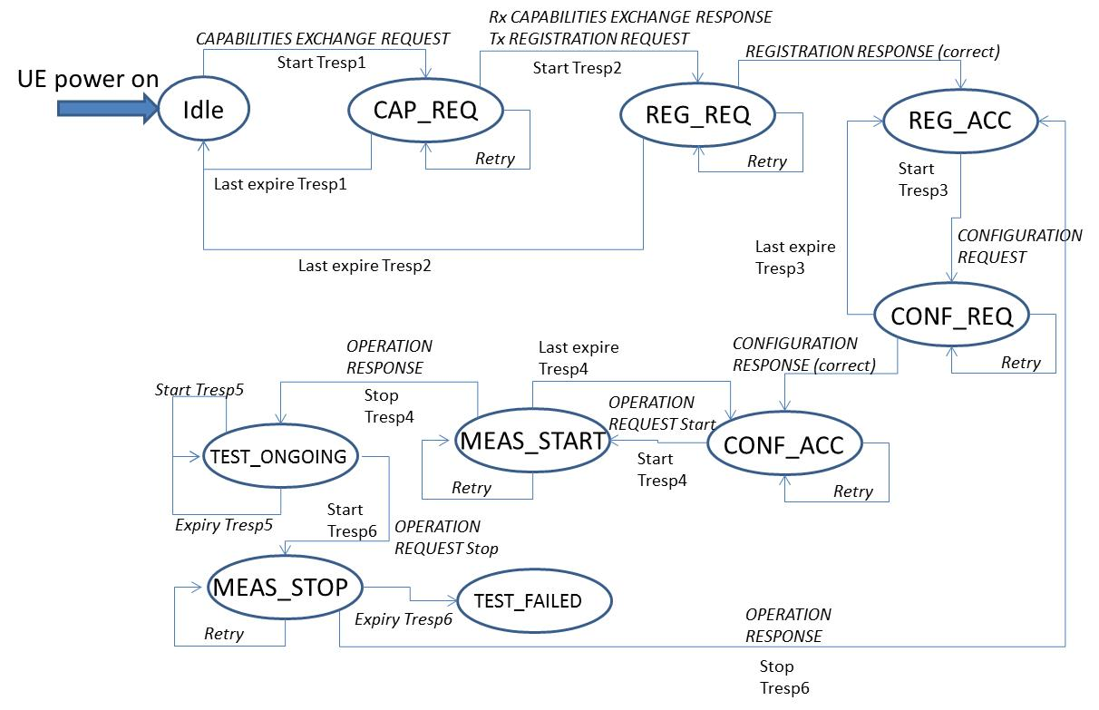

Figure 1: UE state diagram (simplified)

1.1. UE power on

Let’s consider a UE device that is hosting a 802.16.3-compliant measurement “app”. At the power-on of the UE, it is recommended that this specific “app” is loaded by default and it is reading from non-volatile memory the URL to contact for getting the address of the related “Controller”.
There isn’t an automatic activation of the measurement process.

1.1. UE measurements start-up

In order to start-up the measurement activity the user could activate a specific command within the “app”, for example double-clicking a predefined button in the “app” UI.
This could trigger the request to enter credentials (e.g. user name and password) for the specific measurement application.
The “app” could presents some predefined test-sets to choose and Controllers’ addresses to connect to. The user can in any case select a custom set of measurements to be activated, naming them as an additional test-set, or type the address of a specific Controller.
These measurements set will be negotiated later with the Controller.
The UI in any state and at any time can allow the user to restart the measurement session moving the state to IDLE again from the current state.

1.1. UE registration

From the point of view of the measurement “app” the UE is in IDLE state at the beginning, once the start-up is completed.
Then the “app” is performing the “Registration and capabilities exchange”.
The UE is retrieving the address of the Controller via DNS access. The UE is following the standard DNS procedures as per RFC 1035. From the point of view of the measurements state, it isn’t changed by the DNS procedures, so in this case it remains IDLE.

Now the UE proceed with the connection establishment to the Controller and the security channel establishment. Again, these steps depends really on the type of transport and security protocols used and follow the rules related to the specific mechanism adopted.

Once this steps are completed the UE sends the CAPABILITIES EXCHANGE REQUEST and moves its state to CAP_REQ. At the same time it starts the Tresp1 timeout.
When the UE receives the response it stops Tresp1 and process the message. If the timeout expires, then the UE restarts the timeout value resending the message up to Nretry value (value recommended = 2). If at the last tentative the timeout expires again, then the UE moves its state to IDLE again.

If the message is successfully decoded and processed, then the UE sends the REGISTRATION REQUEST message and moves to REG_REQ (requested) state, starting now the Tresp2 timeout.
The UE state isn’t changed by the handshake GET REG_PARAM REQUEST and RESPONSE, together with the SET REG_PARAM REQUEST and RESPONSE. There is no timeout specific for these optional handshakes that has to happen within the total time of Tresp2.

If Tresp2 expires, there is the resending of the REGISTRATION REQUEST message up to Nretry value. If at the last tentative the timeout expires again, the UE move its state to IDLE, providing a proper message error to the UI.

If REGISTRATION phase is completed successfully, the UE closes the connection if there is no measurement negotiated for the test at the moment, otherwise it moves to Configuration phase.

The UE moves the state from REG_REQ to REG_ACC (accepted) in the successful case.

1.1. UE configuration

The UE starts the CONFIGURATION handshake sending the CONFIGURATION REQUEST message and moving the state from REG_ACC to CONF_REQ, starting Tresp3 timeout.

The optional GET CONF PARAM and SET CONF PARAM handshakes are not changing the UE state and are bounded by timeout Tresp3.

If they fail and there is not a final CONFIGURATION RESPONSE with Successful Result within the timeout value, then the UE moves back the state to REG_ACC.

The UE can retry Nretry times to get configuration: if all the instances fail then the UE moves back to IDLE notifying the UI about the impossibility to manage the measurement session.

In the successful case, Tresp3 is stopped and the UE prepares to activate the tests, moving its state to CONF_ACC.
“Successful” case means that CONFIGURATION RESPONSE is received with correct information within the message. In case the message is received but with synthetically incorrect information, Configuration phase is unsuccessful as well and an error is notified in the UI “app”, moving the state to REG_ACC again.

1.1. Start of measurement session

The measurement session is started as soon as the UE sends the OPERATION REQUEST message. The UE state is moving to MEAS_START state, starting the usual Tresp4 timer.
This guard timer is controlling the arrival of the OPERATION RESPONSE message. If this response isn’t coming in time and timer expires, it is resent the message (up to Nretry times) and retriggered the timeout, as before.

After Nretry tentatives the measurement cannot be started and the state comes back to CONF_ACC, with a proper notification to the UI. Then the “app” could allow restarting or cancelling the measurement session, moving back to REG_ACC state.

In the successful case, the UE state is moved to TEST_ONGOING .

1.1. Measurements upload

The UE is periodically (or on session closure) sending the results to the Data Controller, once the upload is authorized via a successful NOTIFICATION procedure.
So, the UE is sending a NOTIFICATION REQUEST to the Data Collector, starting the Tresp5 timer.
The mechanism to request retrial on timer expiry is the same as for previous scenarios. This notification is not changing the status of the UE.
Once the NOTIFICATION RESPONSE is received the timer is stopped and the measurement data transfer can be initiated.
The measurement data transfer can be done in several ways, depending on the type of mechanism adopted. Let’s suppose that it is a plain FTP file transfer of the measurements: the behavior and error handling will be those according to RFC 761. The UE state isn’t changing as well during the measurement transfer.

The following NOTIFICATION procedure is related to the Data Collector and Controller peers, so they don’t involve the UE.

1.1. Stop of measurement session

The measurement session is stopped by the UE once the tests are completed, sending the OPERATION REQUEST message to the Controller, and activating the usual Tresp6 timer.
The mechanism is the same as for the start procedure, with the message retry in case of timeout expire.

In the successful case, the UE state is moved to REG_ACC again, as the measurements have been already sent to the Data Controller.
In the unsuccessful case, the UE state is moved to TEST_FAILED. If the UE state is TEST_FAILED the UI is notified and the “app” can be configured either to automatically move the state to REG_ACC or waiting for a manual intervention to do that.

The stop command can be sent at any time during the measurement process, once the UE is in REG_ACC.

