Project | IEEE 802.16 Broadband Wireless Access Working Group <http://ieee802.org/16>
Title | Region allocation for interference management in time-division multiplexed resource scheduling
Date Submitted | 2013-07-12
Source(s) | Jisoo Park, Young-il Kim  ETRI | E-mail: jsp@etri.re.kr  *<http://standards.ieee.org/faqs/affiliationFAQ.html>
Re: | In response to the IEEE 802.16 Working Group Call for Contributions: IEEE Project P802.16q Multi-tier Networks (IEEE 802.16-13-0108-01-000q)
Abstract | The contribution proposes the text changes related to region allocation for interference management.
Purpose | To discuss and adopt the proposed texts in IEEE P802.16q AWD
Notice | This document does not represent the agreed views of the IEEE 802.16 Working Group or any of its subgroups. It represents only the views of the participants listed in the “Source(s)” field above. It is offered as a basis for discussion. It is not binding on the contributor(s), who reserve(s) the right to add, amend or withdraw material contained herein.
Release | The contributor grants a free, irrevocable license to the IEEE to incorporate material contained in this contribution, and any modifications thereof, in the creation of an IEEE Standards publication; to copyright in the IEEE’s name any IEEE Standards publication even though it may include portions of this contribution; and at the IEEE’s sole discretion to permit others to reproduce in whole or in part the resulting IEEE Standards publication. The contributor also acknowledges and accepts that this contribution may be made public by IEEE 802.16.
Patent Policy | The contributor is familiar with the IEEE-SA Patent Policy and Procedures:  <http://standards.ieee.org/guides/bylaws/sect6-7.html#6> and <http://standards.ieee.org/guides/opman/sect6.html#6.3>.  Further information is located at <http://standards.ieee.org/board/pat/pat-material.html> and <http://standards.ieee.org/board/pat>.

Region allocation for interference management in time-division multiplexed resource scheduling
Jisoo Park, Young-il Kim
ETRI

- Introduction
This contribution proposes the text changes to the BS power management defined in draft AWD document [1] in response to the IEEE 802.16 Working Group Call for Contributions on IEEE Project P802.16q Multi-tier Networks (IEEE 802.16-13-0108-01-000q).
This contribution proposes the text change related to region allocation for the interference management among neighbor BSs and the clarification about region allocation and the movement of specification about it to subclause 17.3.2.1.
- Clarification about region allocation
A frame can be divided as different types of region according to whether bursts or reference signals are allocated or not in current draft AWD. It can be specified in detail into three types of region classified to resource allocation region, empty region and zero energy region. In a frame, the allocated portion to be occupied by data traffic and control signal such as FCH, MAP messages is referred to resource allocation region, and the rest portion to be empty is referred to empty region. In a DL frame, a part or the whole part of empty region is referred to zero energy region in which a BS does not transmit any signal including reference signal such as pilot.
- Region allocation for interference management
A DL frame or a DL subframe can be normally configured to the resource allocation region for transmitting data traffic and control signal (FCH, MAP messages, etc.) and the empty region in which there is no any data traffic or control signal. But the empty region as the rest of resource allocation region may have the subcarriers to be modulated as, for instance, common pilot to be used as a DL channel measurement by MSs. Then, the BS is requested for the transmission power of radio signal such as common pilot in empty region.
However, for interference mitigation of DL, the BS may make the best use of empty region to zero energy in which there is no any signal to be allocated and transmitted.
In some cases, a DL frame may be configured to different combinations with three regions of resource allocation region, empty region and zero energy region or two regions of resource allocation region and zero energy region or another two regions of resource allocation region and empty region. For the interference management, we focus on the usage of zero energy region. If a BS has not heavily loaded with data traffic, it can configure the rest of resource allocation region to the zero energy region for the interference mitigation, and this region may appear frequently in a DL frame.
The resource allocation region may include multiple zones (such as PUSC, FUSC, Optional FUSC, AMC, TUSC1, TUSC2, etc.) including modulated subcarriers for both data and pilot in the same manner as the standard IEEE Std 802.16-2012.
Additionally, if the BS suitably arranges the resource allocation region and the zero energy region by cooperation among neighbor BSs, it is possible to enhance the interference mitigation, Also the BS can additionally get the effect of the BS transmission power saving in DL. If it is necessary for the interference mitigation among neighbor BSs, it may be needed to cooperate with each other or hardly collaborate on the region arrangement. Then, this contribution provides an example of TDD Frame structure by region arrangement and primitive between IEEE 802.16 entity and NCMS for supporting interference mitigation with enhancing BS power saving.
- References
- IEEE 802.16-13-0026-01-000q, IEEE P802.16q, Part 16: Air Interface for Broadband Wireless Access Systems: Amendment for Multi-tier Networks, May 21, 2013
- Conclusion and Proposed Texts on IEEE 802.16q AWD
The contribution proposes the text changes related to region allocation for interference management in the current draft AWD document [1].

[Added texts and figures marked in blue font with underline and removed texts and figures marked in red font with strikeout]
------------------------------------------- Start of Proposed Text Changes --------------------------------------------
[Remedy #1: Adopt the following modification text in line 47 on page 21 subclause 17.4 in draft AWD [1] ]

  - Base Station Power Management
    - General Description
This subclause describes the power management functions of base stations for energy efficient operation. The power management function under this subclause details not only operation of single base station but also cooperative operations of adjacent base stations.
Base stations including macro and small base stations always operate in Normal mode when the base station power management is not supported at the base stations.

Base stations supporting the base station power management in this subclause can operate in one of the power saving operation modes such as Duty-cycled mode or Standby mode when the operation condition is met.
[Remedy #2: Adopt the following modification text in line 26 on page 19 subclause 17.3.1.2 in draft AWD [1] ]

Time-Division Multiplexed Resource Scheduling
Based on the channel measurement from MS and report the result from BS to the coordinator, the coordinator may (re-)configure the partitioning information such as used and non-used OFDMA symbols for zone boundary. If the DL resource is not partitioned currently, the corresponding zone may be partitioned using the partitioning information. Otherwise, the corresponding zone may be re-partitioned using the partitioning information. Configured partitioning information shall be exchanged through C-SAP/M-SAP via backhaul link.
When the usage of the OFDMA symbols in a DL/UL frame is limited, as a result of coordination among BSs, the corresponding partition is blocked to allocate resource to subordinate MSs. A DL and UL Zone Switch IE or the start of the DL and UL frame shall indicate the start of DL and UL partition, respectively. The DL and UL corresponding partition shall span continuous OFDMA symbols until terminated by another Zone Switch IE or the end of the DL and UL frame, respectively.
In a TDM partitioned zone, the corresponding zone may also be further time-division multiplexed and/or frequency-division multiplexed.
The BS may allocate the burst in any portion of a DL frame, however the BS may not allocate any burst in the rest of the DL frame. The DL frame is classified to resource allocation region, empty region and zero energy region, where the allocated portion to be occupied by data traffic and control signal such as FCH, MAP messages is referred to resource allocation region, the rest portion to be empty is referred to empty region, and a part or whole part of empty region is referred to zero energy region in which a BS does not transmit any signal.
The resource allocation region of a frame may include multiple zones (such as PUSC, FUSC, Optional FUSC, AMC, TUSC1, TUSC2, etc.). The empty region has no any data traffic or control signal, but it may have the subcarriers to be modulated as reference signal such as common pilot to be used as a DL channel measurement for MSs. The BS may be requested for the transmission power of radio signal such as common pilot in empty region.
In zero energy region, a BS shall not allocate, modulate and transmit any radio signal such as data subcarrier and common pilot, and then it may turn off the power of BS transceiver devices as a silent interval in DL transmission. The DL-MAP IE with DIUC = 13 as gap/safety zone indicates that the zero energy region is assigned in a DL frame or DL subframe. The MS shall ignore any received signal and shall not perform measurement in this region.
A DL frame can be normally configured to the resource allocation region and the empty region. In some cases, a DL frame or a DL subframe may be configured to different combinations with three regions of resource allocation region, empty region and zero energy region or two regions of resource allocation region and zero energy region. For interference mitigation of DL, the BS may make the best use of empty region to zero energy region. If a BS has not heavily loaded with data traffic, it can configure whole part of empty region into the zero energy region for the interference mitigation.
Both the resource allocation region and the zero energy region can be assigned to one region or more in a DL frame, respectively. Figure 17-x depicts an example of the TDD frame structure for interference mitigation by region arrangement.
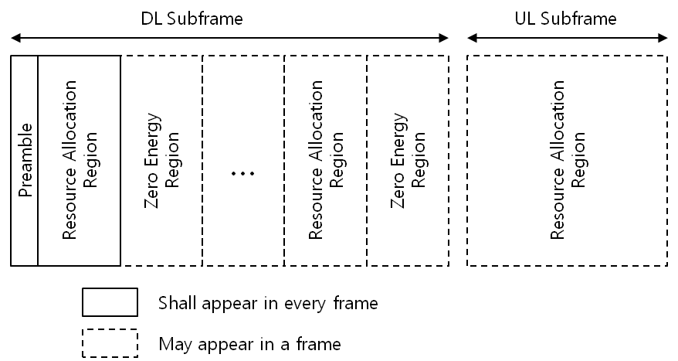
Figure 17-x – Example of TDD Frame structure for interference mitigation by region arrangement
For interference mitigation, one or more different regions may be scheduled among BSs. This is intended to provide reduced interference zones within the coverage area of a BS. The reduced interference zones are useful when the BS interfere with other BS. In such situations, the reduced interference zones may be used by the interfered BS to transmit data to MS that are registered with it, which would otherwise suffer from interference.
If a BS suitably arranges the resource allocation region and the zero energy region by cooperation among neighbor BSs, it is possible to enhance the interference mitigation, Also the BS can additionally get the effect of the BS transmission power saving in DL.
If it is needed to arrange the regions in a frame in order to interference mitigation among BSs in multi-tier networks or enhance BS power saving, the cooperative procedures such as region configuration are performed between the BS and NCMS.
…
------------------------------------------- End of Proposed Text Changes --------------------------------------------

