Project | IEEE 802.16 Broadband Wireless Access Working Group <http://ieee802.org/16>
Title | Reference signal for channel quality measurement on duty-cycle mode
Date Submitted | 2013-07-12
Source(s) | Jisoo Park, Young-il Kim  ETRI | E-mail: jsp@etri.re.kr  *<http://standards.ieee.org/faqs/affiliationFAQ.html>
Re: | In response to the IEEE 802.16 Working Group Call for Contributions: IEEE Project P802.16q Multi-tier Networks (IEEE 802.16-13-0108-01-000q)
Abstract | This contribution proposes frame preamble as reference signal for the channel quality measurement in duty-cycle mode operation.
Purpose | To discuss and adopt the proposed texts in IEEE P802.16q AWD
Notice | This document does not represent the agreed views of the IEEE 802.16 Working Group or any of its subgroups. It represents only the views of the participants listed in the “Source(s)” field above. It is offered as a basis for discussion. It is not binding on the contributor(s), who reserve(s) the right to add, amend or withdraw material contained herein.
Release | The contributor grants a free, irrevocable license to the IEEE to incorporate material contained in this contribution, and any modifications thereof, in the creation of an IEEE Standards publication; to copyright in the IEEE’s name any IEEE Standards publication even though it may include portions of this contribution; and at the IEEE’s sole discretion to permit others to reproduce in whole or in part the resulting IEEE Standards publication. The contributor also acknowledges and accepts that this contribution may be made public by IEEE 802.16.
Patent Policy | The contributor is familiar with the IEEE-SA Patent Policy and Procedures:  <http://standards.ieee.org/guides/bylaws/sect6-7.html#6> and <http://standards.ieee.org/guides/opman/sect6.html#6.3>.  Further information is located at <http://standards.ieee.org/board/pat/pat-material.html> and <http://standards.ieee.org/board/pat>.

Reference signal for channel quality measurement on duty-cycle mode
Jisoo Park, Young-il Kim
ETRI

- Introduction
This contribution proposes the text changes to the BS power management defined in draft AWD document in response to the IEEE 802.16 Working Group Call for Contributions on IEEE Project P802.16q Multi-tier Networks (IEEE 802.16-13-0108-01-000q).
In Duty-cycle mode, a BS periodically configures radio frames to active periods and inactive periods for any time interval. According to the draft AWD, the BS disables its air interface in inactive period, but it operates normally in active period.
When an MS tries to search neighbor BS in Duty-cycle mode, it should be considered for the performance improvement of channel measurements using reference signal such as frame preamble for mobility support as well as general channel measurement, by the following reason.
- For support MS mobility, DL control signals such as preamble may be needed to assist any MS to enter the cell or try to perform measurement for cell search, although there is no the traffic load or there are few attached MSs. An MS may access randomly or liberally the various small cells including macro for any purpose and at any time. However, if the BS is in progress of inactive period turning off the power of BS transceiver devices, the MS may not fast or wholly migrate into the cell. Then the MS may miss the opportunity to improve its throughput or not access directly the BS in the time interval of duty-cycle mode.
After scanning neighbor cell, the MS reports the scanning results to its serving BS with channel measurement metric, such as RSSI mean and CINR mean, for neighbor BSs. If the MS scans the neighbor BS at work on Duty-cycle mode, it may get and report inaccurate measurement results to the serving BS due to the inactive period without frame preamble. So, for improving the performance of the channel measurement and cell search, it is needed to activate at least frame preamble in inactive period.
This contribution proposes frame preamble as reference signal for the channel quality measurement in Duty-cycle mode operation.
- References
- IEEE 802.16-13-0026-01-000q, IEEE P802.16q, Part 16: Air Interface for Broadband Wireless Access Systems: Amendment for Multi-tier Networks, May 21, 2013
- Proposed Texts on IEEE 802.16q AWD
[Added texts and figures marked in blue font with underline and removed texts and figures marked in red font with strikeout]
------------------------------------------- Start of Proposed Text Changes --------------------------------------------
[Remedy #1: Adopt the following modification text in line 6 on page 22 subclause 17.4.2 in draft AWD [1] ]
    - Duty-cycled Mode
Besides the normal operation mode, BSs may support duty-cycled mode to reduce interference to neighbor cells and to conserve its power consumption. Duty-cycled mode is a BS operation mode in which a BS periodically consists of active periods and inactive periods. The BS disables its air interface except frame preamble during inactive period in a DL frame or DL subframe, but it normally operates during active period. Figure 17-x depicts an example of of frame structure in Duty-cycle mode.
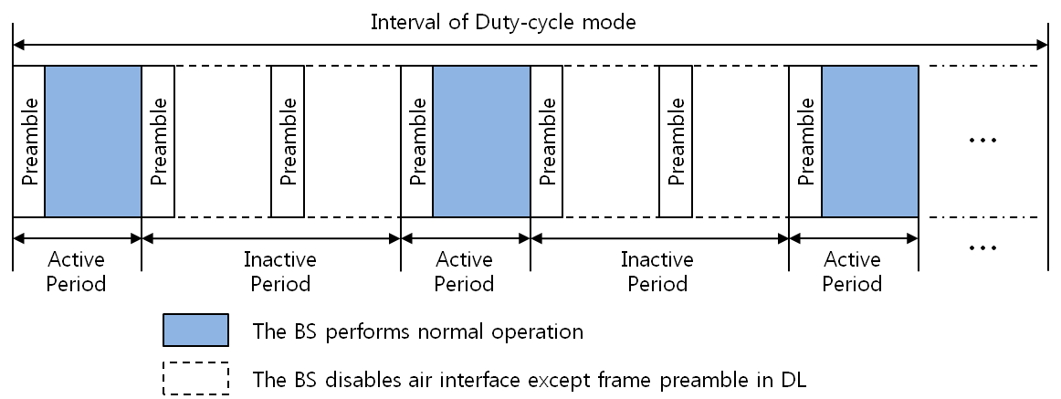
Figure 17.x Example of frame structure in Duty-cycle mode

The support of duty-cycled mode is negotiated during the BS initialization and configuration. Duty-cycled mode can be activated through negotiation between the BS and NCMS when the BS is in normal operation mode.
When duty-cycled mode is active for the BS, the BS shall be in either active period or inactive period. During an active period, the BS becomes active on the air interface for activities such as paging, transmitting system information, ranging, or data traffic transmission. During an inactive period, the BS does not transmit anything on the air interface except frame preamble and may power down one or more physical operation components after first symbol occupied by preamble or perform other activities such as synchronization with the overlay macro BS or measurement of the interference from neighbor cells.
The base station in the Duty-cycled mode goes into the inactive period when all of its associated mobile sta- tions are in unavailability interval. The inactive period of the base station shall be informed to the mobile stations to prevent UL attempts of mobile stations during inactive period of the base station. The MS shall perform channel measurements using only frame preamble for the REP-RSP message or fast-feedback (CQICH) channel in a frame in which the inactive period is applied.
The base station in the Duty-cycled mode goes into the inactive period when all of its associated mobile stations are in unavailability interval. The inactive period of the base station shall be informed to the mobile stations to prevent UL attempts of mobile stations during inactive period of the base station.
To increase the inactive period of the base station (i.e. a common unavailability interval of mobile stations), base station may adjust the configurations of Sleep mode (i.e. start frame number, window sizes, etc.) of associated mobile stations.
A BS in inactive period shall support an available interval of a paging cycle if it supports idle mode operation.
…
------------------------------------------- End of Proposed Text Changes --------------------------------------------

