Project | IEEE 802.16 Broadband Wireless Access Working Group <http://ieee802.org/16>
Title | Proposed Modification of Service Primitives for BS Power Management
Date Submitted | 2013-07-14
Source(s) | Jaesun Cha, Eunkyung Kim, Jae-joon Park, Hyun Lee, Kwangjae Lim, Sungcheol Chang  ETRI | E-mail: jscha@etri.re.kr  *<http://standards.ieee.org/faqs/affiliationFAQ.html>
Re: | Call for Contributions: Multi-tier Networks (16-13-0018-01-000q)
Abstract | This contribution proposes detailed parameters to be included in service primitives for BS power management.
Purpose | To discuss and adopt the proposed texts in IEEE P802.16q AWD
Notice | This document does not represent the agreed views of the IEEE 802.16 Working Group or any of its subgroups. It represents only the views of the participants listed in the “Source(s)” field above. It is offered as a basis for discussion. It is not binding on the contributor(s), who reserve(s) the right to add, amend or withdraw material contained herein.
Release | The contributor grants a free, irrevocable license to the IEEE to incorporate material contained in this contribution, and any modifications thereof, in the creation of an IEEE Standards publication; to copyright in the IEEE’s name any IEEE Standards publication even though it may include portions of this contribution; and at the IEEE’s sole discretion to permit others to reproduce in whole or in part the resulting IEEE Standards publication. The contributor also acknowledges and accepts that this contribution may be made public by IEEE 802.16.
Patent Policy | The contributor is familiar with the IEEE-SA Patent Policy and Procedures:  <http://standards.ieee.org/guides/bylaws/sect6-7.html#6> and <http://standards.ieee.org/guides/opman/sect6.html#6.3>.  Further information is located at <http://standards.ieee.org/board/pat/pat-material.html> and <http://standards.ieee.org/board/pat>.

Proposed Modification of Service Primitives for BS Power Management
Jaesun Cha, Eunkyung Kim, Jae-joon Park, Hyun Lee, Kwangjae Lim, Sungcheol Chang
ETRI

Introduction
This contribution proposes detailed parameters of service primitives for BS power management.

Proposed Texts
----------------- Start of the text proposal --------------------------------------------------------------------------------------
[Change Table 14-2 on page 21, line 6 as follows:]

Table 14-2 – M-SAP/C-SAP Event Types
Parameter name | Mandatory/  Optional
Event_Type | M | Specify the type of occurring event, valid values for Event_Type are:  Accounting,  EAP_Start,  EAP_Transfer,  Certificate_Information,  SMC_PAYLOAD,  IP_ALLOCATION,  Paging_Announce,  HO-Start,  HO-Cancel,  HO-Scan,  HO-CMPLT,  MIH-IND,  Spare Capacity Report,  Neighbor-BS Radio Resource Stations Update,  NBR_BS_Update,  Network_attached,  Location_Update_CMPLT,  Reset,  Hold,  Normal,  MBS Portion Layout,  LBS,  Standby_Mode_CMPLT
Destination | M | This indicates the destination of the primitive. Allowed values are:  SS or MS, BS, NCMS.
Attribute_list |  | Array of pair (Attribute_ID, Attribute_value)

[Change subclause 14.2 on page 22 as follows:]
14.2 Management and control functions

Insert new subclause 14.2.12 as indicated:

14.2.12 BS power management
The BS power management primitives are a set of primitives for supporting BS power management between IEEE 802.16 entity and NCMS. BS power management uses BS power management Services in the NCMS.

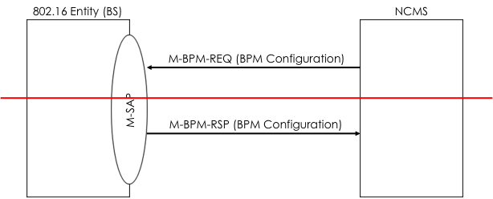
Figure 14-49 Primitive for configuration of BS power management

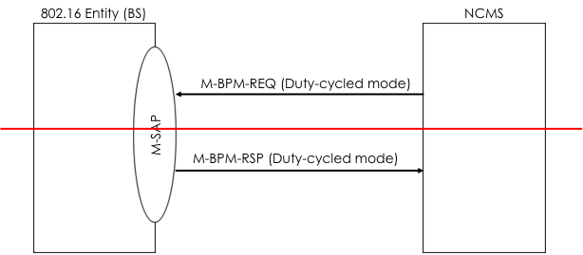
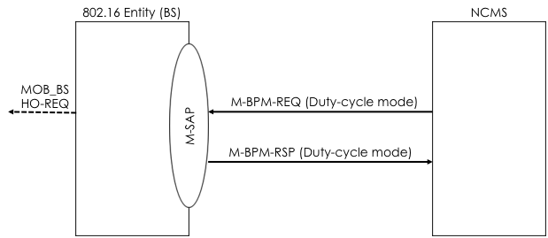
Figure 14-4950 Primitive flow for duty-cycled mode transition
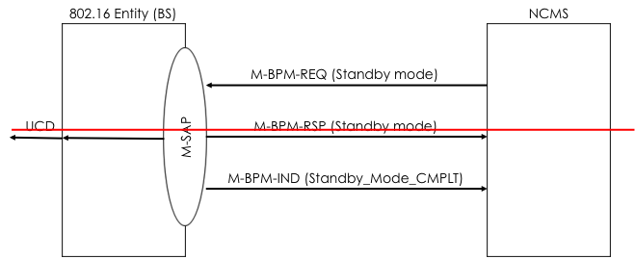
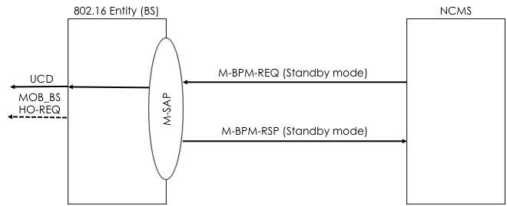
Figure 14-5051 Primitive flow for NCMS-initiated standby mode transition
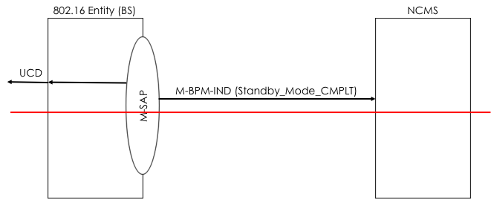
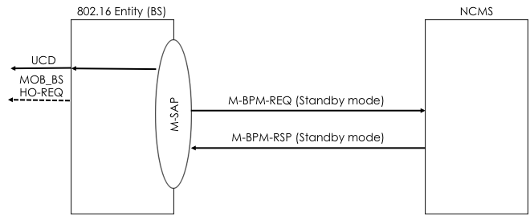
Figure 14-5152 Primitive flow for BS-initiated standby mode transition

14.2.12.1 M-BPM-REQ
This primitive is used by a BS or anthe NCMS to control BS power management operation.configure operation parameters required for BS power management operation or The NCMS generates this primitive to request the IEEE 802.16 entity (BS) to perform operational mode transition and update of operation parameters for a specific operation modechange its operation mode. The BS may generate this primitive to report BS-initiated mode transition to the NCMS. The possible Action_Types for this primitive are listed in table below:

Action_Type | Description
BPM Configuration | Configuration procedure between BS and NCMS for BS power management.
Duty-cycledDuty-cycle mode | Duty-cycledDuty-cycle mode transition procedure between BS and NCMS.
Standby mode | Standby mode transition procedure between BS and NCMS

14.2.12.1.1 M-BPM-REQ (Action_Type = Duty-cycle mode)
14.2.12.1.1.1 Function
This primitive is used by the NCMS to control an operational mode of a BS and to update operational parameters for duty-cycle mode. This primitive is also used by the BS to report BS-initiated mode transition to the NCMS. The primitive is only used between IEEE 802.16 entity and NCMS at BS side.

14.2.12.1.1.2 Semantics:
The following parameters are included in this primitive:
M-BPM-REQ
(
Operation_Type: Action,
Action_Type: Duty-cycle mode,
Destination: BS, NCMS
Attribute_List:
Operation,
Duty-cycle pattern,
Reason
)
Operation
Indicates a type of operation.
0: initiate duty-cycle mode
1: terminate duty-cycle mode
2: update of duty-cycle pattern
Duty-cycle pattern
Indicates a duty-cycle pattern that shall be used during duty-cycle mode. This parameter includes a length of an inactive interval, a length of an active interval and start frame offset. In case Operation is set to 2, the BS in duty-cycle mode shall update the current duty-cycle pattern with this duty-cycle pattern. This parameter is included in this primitive only when this primitive is generated by the NCMS.
Reason
Indicates a reason for mode transition. This parameter is included in this primitive only when this primitive is generated by the BS in duty-cycle mode to report the termination of duty-cycle mode (e.g., due to MS initial network entry or network reentry during an active interval).

14.2.12.1.1.3 When generated
- NCMS to BS: When a BS power controller in the NCMS makes a decision on mode transition of a BS for some reasons (e.g., interference mitigation, BS power saving, etc), the BS power controller in the NCMS generates this primitive to request the BS to initiate or terminate the duty-cycle mode. This primitive is also generated by the NCMS to request the BS in duty-cycle mode to update a duty-cycle pattern for an efficient operation of the duty-cycle mode.
- BS to NCMS: When a BS in duty-cycle mode has to terminate the duty-cycle mode for some reasons (e.g., a new initial network entry or network reentry), the BS generates this primitive to report the termination of the duty-cycle mode to the BS power controller in NCMS after transition to normal mode.

14.2.12.1.1.4 Effect of receipt
- NCMS to BS: If the BS receives this primitive, it shall perform the operation indicated by Operation parameter included in this primitive. If the Operation parameter is set to 0 (initiate duty-cycle mode), the BS first triggers its attached MSs, if any, to handover to the neighbor cells. After the completion of the operation requested by the NCMS, the BS shall generate M-BPM-RSP primitive to respond to this primitive.
- BS to NCMS: If the NCMS receives this primitive, it updates the current operational mode of the BS as normal mode and responds by generating M-BPM-RSP primitive.

14.2.12.1.2 M-BPM-REQ (Action_Type = Standby mode)
14.2.12.1.2.1 Function
This primitive is used by the NCMS to request initiation or termination of standby mode or to update mode transition time. This primitive is also used by the BS to report periodic mode transition to the NCMS. The primitive is only used between IEEE 802.16 entity and NCMS at BS side.

14.2.12.1.2.2 Semantics:
The following parameters are included in this primitive:
M-BPM-REQ
(
Operation_Type: Action,
Action_Type: Standby mode,
Destination: BS, NCMS
Attribute_List:
Operation,
Mode transition time
)
Operation
Indicates a type of operation.
0: initiate standby mode
1: terminate standby mode
2: update of standby mode parameter
Mode transition time
Indicates when the BS initiates or terminates standby mode. If this parameter is not included in this primitive, the BS shall initiate or terminate the standby mode as soon as it receives this primitive. Otherwise, the BS initiates or terminates the standby mode at the time specified this parameter.

14.2.12.1.2.3 When generated
- NCMS to BS: When a BS power controller in the NCMS makes a decision on mode transition of a BS for some reasons (e.g., interference mitigation, BS power saving, etc), the BS power controller in the NCMS generates this primitive to request the BS to initiate or terminate the standby mode. This primitive is also generated by the NCMS to specify when the BS performs standby mode initiation or termination.
- BS to NCMS: This primitive is generated by the BS after performing standby mode initiation or termination at the time that was previously specified by the NCMS.

14.2.12.1.2.4 Effect of receipt
- NCMS to BS: If the BS receives this primitive, it shall perform the operation indicated by Operation parameter included in this primitive. If the Operation parameter is set to 0 (initiate standby mode), the BS first triggers its attached MSs, if any, to handover to the neighbor cells. After the completion of the operation requested by the NCMS, the BS shall generate M-BPM-RSP primitive to respond to this primitive. If the Operation parameter is set to 1 (terminate standby mode), the BS shall transit to Initialization State after transmitting the M-BPM-RSP primitive. If the Operation parameter is set to 2 (update of standby mode parameter), the BS stays in the current operational mode and performs mode transition at the time specified by the Mode transition time parameter in this primitive.
- BS to NCMS: If the NCMS receives this primitive, it updates the current operational mode of the BS according to the Operation parameter in this primitive after generating M-BPM-RSP primitive.

14.2.12.2 M-BPM-RSP
This primitive is used by the IEEE 802.16 entity(BS) or the NCMS in response to M-BPM-REQ primitive for BS power management. The possible Action_Types for this primitive are listed in table belew:

Action_Type | Description
BPM Configuration | Configuration procedure between BS and NCMS for BS power management.
Duty-cycledDuty-cycle mode | Duty-cycledDuty-cycle mode transition procedure between BS and NCMS.
Standby mode | Standby mode transition procedure between BS and NCMS

14.2.12.2.1 M-BPM-RSP (Action_Type = Duty-cycle mode)
14.2.12.2.1.1 Function
This primitive is used by the BS or the NCMS in response to M-BPM-REQ primitive for BS power management.

14.2.12.2.1.2 Semantics:
The following parameters are included in this primitive:
M-BPM-RSP
(
Operation_Type: Action,
Action_Type: Duty-cycle mode,
Destination: NCMS, BS
Attribute_List:
Operation,
Result,
Reason
)
Operation
Indicates a type of operation. The value of this parameter shall be the same as one included in the received M-BPM-REQ primitive.
0: initiate duty-cycle mode
1: terminate duty-cycle mode
2: update of a duty-cycle pattern
Result
Indicates a result of the operation indicated by the Operation parameter included in the received M-BPM-REQ primitive. This parameter may include ‘success’ and ‘failure’.
Reason
Indicates a reason for failure. This parameter is included in this primitive only when the Result parameter in this primitive is set to ‘failure’.

14.2.12.2.1.3 When generated
- BS to NCMS: If the BS receives the M-BPM-REQ primitive, it generates this primitive after performing the operation indicated by Operation parameter included in the M-BPM-REQ primitive.
- NCMS to BS: If the NCMS receives the M-BPM-REQ primitive, it updates the current operational mode of the BS as normal mode and responds by generating this primitive.

14.2.12.2.1.4 Effect of receipt
- BS to NCMS: If the Result parameter is set to ‘success’, the NCMS updates a current operational mode of the BS. The NCMS may notify neighbor BSs of information on the BS’s operational mode and relevant parameters. This information may be used by the neighbor BSs for radio resource management. If the Result parameter is set to ‘failure’, the NCMS may re-generate M-BPM-REQ primitive or terminate the transaction according to service provider’s policy. If the NCMS does not receive this primitive within a pre-defined time, the NCMS regards this transaction as failure.
- NCMS to BS: If the BS receives this primitive, it terminates this transaction.

14.2.12.2.2 M-BPM-RSP (Action_Type = Standby mode)
14.2.12.2.2.1 Function
This primitive is used by the BS or the NCMS in response to M-BPM-REQ primitive for BS power management.

14.2.12.2.2.2 Semantics:
The following parameters are included in this primitive:
M-BPM-RSP
(
Operation_Type: Action,
Action_Type: Standby mode,
Destination: BS, NCMS
Attribute_List:
Operation,
Result,
Reason
)
Operation
Indicates a type of operation.
0: initiate standby mode
1: terminate standby mode
2: update of standby mode parameter
Result
Indicates a result of the operation indicated by the Operation parameter included in the received M-BPM-REQ primitive. This parameter may include ‘success’ and ‘failure’.
Reason
Indicates a reason for failure. This parameter is included in this primitive only when the Result parameter in this primitive is set to ‘failure’.

14.2.12.2.2.3 When generated
- BS to NCMS: If the BS receives the M-BPM-REQ primitive, it generates this primitive after performing the operation indicated by Operation parameter included in the M-BPM-REQ primitive.
- NCMS to BS: If the NCMS receives the M-BPM-REQ primitive, the NCMS updates the current operational mode of the BS according to the Operation parameter in the received M-BPM-REQ primitive after generating this primitive.

14.2.12.2.2.4 Effect of receipt
- BS to NCMS: If the Result parameter is set to ‘success’, the NCMS updates a current operational mode of the BS. The NCMS may notify neighbor BSs of the BS’s operational mode for them to manage neighbor BS list. If the Result parameter is set to ‘failure’, the NCMS may re-generate M-BPM-REQ primitive or terminate the transaction according to service provider’s policy. If the NCMS does not receive this primitive within a pre-defined time, the NCMS regards this transaction as failure
- NCMS to BS: If the BS receives this primitive, it terminates this transaction.

14.2.12.3 M-BPM-IND
This primitive is used by the IEEE 802.16 (BS) to inform the NCMS of the completion of standby mode transition. The possible Event_Types for in this primitive are listed in table below:

Event_Type | Description
Standby_Mode_CMPLT | Indicating the completion of standby mode transition at the BS.

----------------- Start of the text proposal --------------------------------------------------------------------------------------

