Project | IEEE 802.16 Broadband Wireless Access Working Group <http://ieee802.org/16>
Title | Primitives to Support BS Power Saving Mechanism
Date Submitted | 2013-05-08
Source(s) | Jaesun Cha, Eunkyung Kim, Jae-joon Park, Hyun Lee, Kwangjae Lim, Sungcheol Chang  ETRI | E-mail: jscha@etri.re.kr  *<http://standards.ieee.org/faqs/affiliationFAQ.html>
Re: | Call for Contributions: Multi-tier Networks (16-13-0064-01-000q)
Abstract | This contribution defines some service primitives to support BS Power saving mechanism
Purpose | To discuss and adopt the proposed texts in IEEE P802.16q AWD
Notice | This document does not represent the agreed views of the IEEE 802.16 Working Group or any of its subgroups. It represents only the views of the participants listed in the “Source(s)” field above. It is offered as a basis for discussion. It is not binding on the contributor(s), who reserve(s) the right to add, amend or withdraw material contained herein.
Release | The contributor grants a free, irrevocable license to the IEEE to incorporate material contained in this contribution, and any modifications thereof, in the creation of an IEEE Standards publication; to copyright in the IEEE’s name any IEEE Standards publication even though it may include portions of this contribution; and at the IEEE’s sole discretion to permit others to reproduce in whole or in part the resulting IEEE Standards publication. The contributor also acknowledges and accepts that this contribution may be made public by IEEE 802.16.
Patent Policy | The contributor is familiar with the IEEE-SA Patent Policy and Procedures:  <http://standards.ieee.org/guides/bylaws/sect6-7.html#6> and <http://standards.ieee.org/guides/opman/sect6.html#6.3>.  Further information is located at <http://standards.ieee.org/board/pat/pat-material.html> and <http://standards.ieee.org/board/pat>.

Service Primitives to Support BS Power Saving Mechanism
Jaesun Cha, Eunkyung Kim, Jae-joon Park, Hyun Lee, Kwangjae Lim, Sungcheol Chang
ETRI

Introduction
This contribution contains some service primitives and relevant procedures to support BS power management. Detailed BS operation related to the service primitives proposed in this contribution has been proposed in other contributions (IEEE 802.16-13-0087-00-000q and IEEE 802.16-13-0088-00-000q).

In this contribution, we have defined 3 service primitives to support BS power saving mechanism as shown in the table below. Detailed contents and operations of each primitive need to be developed further. However, our intention is to use these primitives for standby mode as well as duty-cycled mode by including different parameters in the service primitives.

Name | SAP | Source | Destination | Purpose
M-BPM-REQ | M-SAP | NCMS | BS | - Configuration of BS power management function  - Change of configuration parameters  - Request to change operation mode
M-BPM-RSP | M-SAP | BS | NCMS | - Configuration of BS power management function  - Response to the request from NCMS
M-BPM-IND | M-SAP | BS | NCMS | - Notification of a completion of mode transition at BS

Proposed Texts
----------------- Start of the text proposal --------------------------------------------------------------------------------------
[Remedy 1: Change subclause 14.1 as follows:]
14. Management interface and procedures
This subclause defines the service primitives for use at C-SAP and M-SAP at BS and MS side of the radio interface. The specific mapping of service primitives to protocol messages in the backhaul network is out of scope of this standard.

Change subclause 14.1 as indicated:

14.1 Service primitive template

14.1.1 Universal naming schema for SAP service primitive

The primitive name defined on the SAP consists of three fields—SAP, Function, and Operation:
SAP
C—Control plane SAP
M—Management plane SAP
Function
ACM—Accounting Management
HO—Handover
IMM—Idle Mode Management
LBS—Location Based Services
MBS—Multicast Broadcast Service
NEM—Network Entry Management
RRM—Radio Resource Management
SFM—Service Flow Management
SM—Security Management
SMC—Secondary Management Connection
SSM—Subscriber Station Management
BPM – BS Power Management
Operation
REQ—Request
RSP—Response to the REQ message
ACK—Acknowledgment to the reception of REQ or RSP or IND message
IND—Event Notification

These primitives are symmetrical between the IEEE 802.16 entity and the NCMS. That is, both the IEEE 802.16 entity (SS/MS or BS) and the NCMS can send these primitives depending on the functional behavior defined for M-SAP and C-SAP. ACK shall only be supported across the C-SAP.

- A service primitive of type REQ is used whenever a response to the primitive is solicited. If there is a REQ message on the radio interface, it is generally mapped to a REQ on C-SAP/M-SAP.
- A service primitive of type RSP is used in response to a REQ primitive. Moreover, if there is a RSP message on the radio interface, it is generally mapped to a RSP on C-SAP/M-SAP.
- A service primitive of type IND is used at C-SAP or M-SAP for event notification if a response to this primitive is not solicited, and if the primitive is not sent in response to a REQ primitive.
- A service primitive of type ACK can be used to acknowledge the receipt of a C-SAP primitive of type REQ, RSP, or IND.

The specific usage of these operation types for the respective control and management functions is specified in the subsequent subclauses.
The IEEE 802.16 entity shall support the primitives that are delivered through C-SAP or M-SAP interfacing with NCMS.

14.1.2 SAP service primitive object format

There are two types of services: M-SAP/C-SAP operation service primitive and M-SAP/C-SAP notification service primitive. The REQ and RSP operations shall use the operation service primitive and the IND operation shall use the notification service primitive. The ACK operation shall use the same primitive format as the primitive it acknowledges.

14.1.2.1 M-SAP/C-SAP operation service primitive

This primitive is defined as Primitive_name () with a parameter list.

The format shall be:
Primitive_name
(
Operation_Type,
Action_Type,
Destination,
Attribute_list
)
The parameters shall be described briefly in Table 14-1.

Table 14-1 – M-SAP/C-SAP Operation Types
Parameter name | Mandatory/  Optional
Operation_Type | M | Create, Delete, Get, Set, Action
Action_Type | O | When Operation_Type is Action, valid values for Action_Type are:  Certificate_Verification,  Context_Transfer,  Idle_Mode_Initiation,  Network_Re-Entry_from_Idle_Mode,  HO-Serving,  HO-Target,  HO-Mobile,  Spare Capacity Report,  PHY Report,  Ranging,  Registration,  SS Basic Capability,  Power On,  Power Down,  Reset,  Hold,  Normal,  Deregistration,  Location Update,  BPM Configuration,  Duty-cycled mode,  Standby mode
Destination | M | This indicates the destination of the primitive. Allowed values are:  SS or MS, BS, NCMS.
Attribute_list |  | Array of pair (Attribute_ID, Attribute_value). In Get request operation, Attribute_value is Null

14.1.2.2 M-SAP/C-SAP notification service primitive:

This primitive shall be defined as Primitive_name () with a parameter list.

The format shall be:
Primitive_name
(
Event_Type,
Destination,
Attribute_List
)

The parameters are described briefly in Table 14-2.

Table 14-2 – M-SAP/C-SAP Event Types
Parameter name | Mandatory/  Optional
Event_Type | M | Specify the type of occurring event, valid values for Event_Type are:  Accounting,  EAP_Start,  EAP_Transfer,  Certificate_Information,  SMC_PAYLOAD,  IP_ALLOCATION,  Paging_Announce,  HO-Start,  HO-Cancel,  HO-Scan,  HO-CMPLT,  MIH-IND,  Spare Capacity Report,  Neighbor-BS Radio Resource Stations Update,  NBR_BS_Update,  Network_attached,  Location_Update_CMPLT,  Reset,  Hold,  Normal,  MBS Portion Layout,  LBS,  Standby_Mode_CMPLT
Destination | M | This indicates the destination of the primitive. Allowed values are:  SS or MS, BS, NCMS.
Attribute_list |  | Array of pair (Attribute_ID, Attribute_value)

14.1.3 SAP service primitive flow diagram template

Four typical handshake scenarios shown in Figure 14-1. The procedures are applicable to BS and SS side.

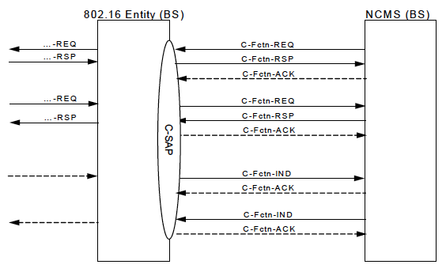
Figure 14-1 – SAP service primitive Flow Diagram template

The figure is illustrative only and provides an example of correct formatting of primitive figures.

[Remedy 2: Insert the following subclause on page 18 as follows:]
14.2 Management and control functions

Insert new subclause 14.2.12 as indicated:

14.2.12 BS power management
The BS power management primitives are a set of primitives for supporting BS power management between IEEE 802.16 entity and NCMS. BS power management uses BS power management Services in the NCMS.

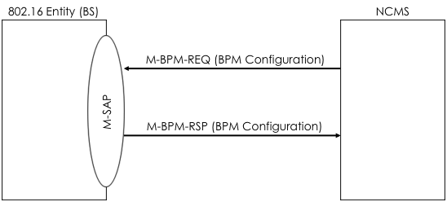
Figure 14-xxx Primitive for configuration of BS power management

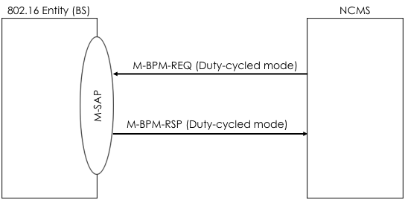
Figure 14-xxx Primitive flow for duty-cycled mode transition
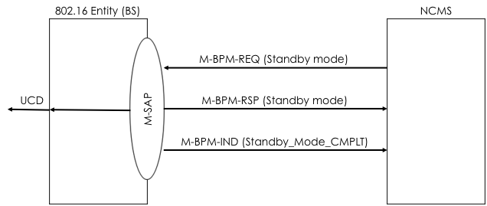
Figure 14-xxx Primitive flow for NCMS-initiated standby mode transition
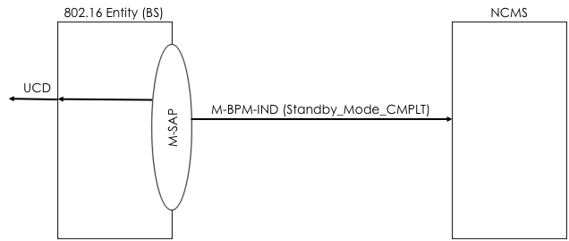
Figure 14-xxx Primitive flow for BS-initiated standby mode transition

14.2.12.1 M-BPM-REQ
This primitive is used by the NCMS to configure operation parameters required for BS power management operation or request the IEEE 802.16 entity (BS) to change its operation mode. The possible Action_Types for this primitive are listed in table below:

Action_Type | Description
BPM Configuration | Configuration procedure between BS and NCMS for BS power management.
Duty-cycled mode | Duty-cycled mode transition procedure between BS and NCMS.
Standby mode | Standby mode transition procedure between BS and NCMS

14.2.12.2 M-BPM-RSP
This primitive is used by the IEEE 802.16 entity(BS) in response to M-BPM-REQ primitive for BS power management. The possible Action_Types for this primitive are listed in table belew:

Action_Type | Description
BPM Configuration | Configuration procedure between BS and NCMS for BS power management.
Duty-cycled mode | Duty-cycled mode transition procedure between BS and NCMS.
Standby mode | Standby mode transition procedure between BS and NCMS

14.2.12.3 M-BPM-IND
This primitive is used by the IEEE 802.16 (BS) to inform the NCMS of the completion of standby mode transition. The possible Event_Types for in this primitive are listed in table below:

Event_Type | Description
Standby_Mode_CMPLT | Indicating the completion of standby mode transition at the BS.

[Remedy 3: Insert the following new clause on page 22 as follows:]
Annex R
(informative)
BS operation mode transition diagram

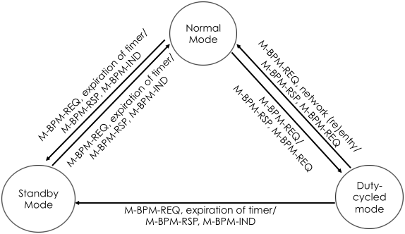
Figure R-1 BS operation mode transition

----------------- Start of the text proposal --------------------------------------------------------------------------------------

