Project | IEEE 802.16 Broadband Wireless Access Working Group <http://ieee802.org/16>
Title | Operation of Duty-Cycled Mode
Date Submitted | 2013-05-08
Source(s) | Jaesun Cha, Eunkyung Kim, Jae-joon Park, Huyn Lee, Kwangjae Lim, Sungcheol Chang  ETRI | E-mail: jscha@etri.re.kr  *<http://standards.ieee.org/faqs/affiliationFAQ.html>
Re: | Call for Contributions: Multi-tier Networks (16-13-0064-01-000q)
Abstract | This contribution proposes detailed operations of duty-cycled mode defined as BS power saving mechanism in IEEE P802.16q
Purpose | To discuss and adopt the proposed texts in IEEE P802.16q AWD
Notice | This document does not represent the agreed views of the IEEE 802.16 Working Group or any of its subgroups. It represents only the views of the participants listed in the “Source(s)” field above. It is offered as a basis for discussion. It is not binding on the contributor(s), who reserve(s) the right to add, amend or withdraw material contained herein.
Release | The contributor grants a free, irrevocable license to the IEEE to incorporate material contained in this contribution, and any modifications thereof, in the creation of an IEEE Standards publication; to copyright in the IEEE’s name any IEEE Standards publication even though it may include portions of this contribution; and at the IEEE’s sole discretion to permit others to reproduce in whole or in part the resulting IEEE Standards publication. The contributor also acknowledges and accepts that this contribution may be made public by IEEE 802.16.
Patent Policy | The contributor is familiar with the IEEE-SA Patent Policy and Procedures:  <http://standards.ieee.org/guides/bylaws/sect6-7.html#6> and <http://standards.ieee.org/guides/opman/sect6.html#6.3>.  Further information is located at <http://standards.ieee.org/board/pat/pat-material.html> and <http://standards.ieee.org/board/pat>.

Operation of Duty-Cycled Mode
Jaesun Cha, Eunkyung Kim, Jae-joon Park, Hyun Lee, Kwangjae Lim, Sungcheol Chang
ETRI

Introduction
Duty-cycled mode has been defined in IEEE P802.16q AWD as one of BS power saving operation mode but detailed operation of the duty-cycled mode has not been defined yet. The purpose of this contribution is to provide detailed description of duty-cycled mode operation conducted in IEEE 802.16 entities. Service primitives required to support duty-cycled mode have been proposed in other contribution (IEEE 802.16-13-0089-00-000q).

Use Cases
Duty-cycled mode is a BS operation mode in which a BS disables its air interface periodically as defined in IEEE P802.16q SRD and AWD and it can be used to reduce inter-BS interference and power consumption at a BS. In this contribution, we have considered the following three use cases in order to figure out what operation is required to meet requirements included in SRD.

Interference mitigation between macro BS and small BS
A duty-cycled mode can be used to decrease interference between macro BS and a small BS overlaid by the macro BS. As shown in Fig. 1, an MS that is attached to the macro BS and located near cell edge of the small BS may suffer from interference from the small BS. If the MS detects high interference from the small BS, it reports it to the macro BS and the macro BS requests a BS power controller in NCMS to activate duty-cycled mode of the small BS. During the request, the macro BS may send information on DL resource allocation for the MS to help the BS power controller to determine an efficient duty-cycle pattern. If the BS power controller knows when the macro BS allocates DL resource to the MS, it can map the allocation frames to inactive period and the idle frames to active period.

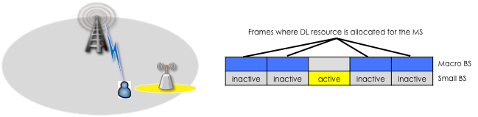
Figure 1 – Duty-cycle mode for interference mitigation between macro BS and small BS

Fig. 2 shows overall procedure for duty-cycled mode activation. The MS reports the macro BS the interference from the small BS and the macro BS forwards the BS power controller the received report together with the information on DL resource allocation for the interfered MS. After the BS power controller receives interference report from the macro BS, it determines whether the small BS needs to active duty-cycled mode or not based on several criteria such as transmission power or system load of the small BS, operator’s policy, etc. How to determine the activation of duty-cycled mode is out of scope of the standard and the standard just recommends the BS power controller to refer such parameters when it has to make a decision on duty-cycled mode activation.
Once the BS power controller determines that the small BS should activate duty-cycled mode, then it generates a service primitive with duty-cycle pattern and start time. The small BS that received the service primitive from the BS power controller responds with the received service primitive and activates duty-cycled mode after the assigned start timer offset. The BS power controller sends information on duty-cycled mode of the small BS to the macro BS and the macro BS updates the information of neighbor BSs.

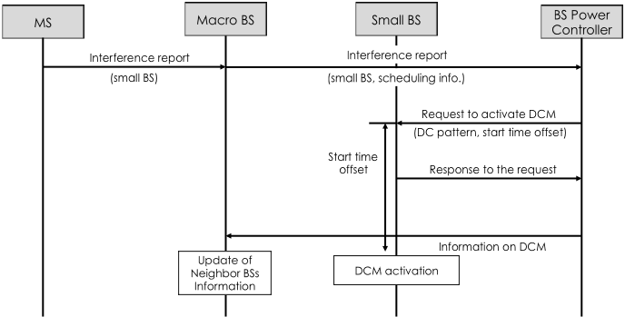
Figure 2 – DCM activation procedure

Interference mitigation among two small BS
The purpose of this use case is the same as one described in 3.1, which is to reduce inter-BS interference and operation procedure is also same. However, we need to think about another aspect of duty-cycled mode operation. Since small BSs, in general, are deployed densely, an active period of a small BS may overlapped with those of other small BSs if many small BSs are running duty-cycled mode simultaneously. In this case, although interference from a small BS to the macro BS is decreased, the interference among small BSs may increase if the active period of the small BS overlaps with those of the neighbor small BSs. In order to prevent such side effect, a BS power controller shall assign a duty-cycle pattern considering the duty-cycle patterns assigned to neighbor small BSs.

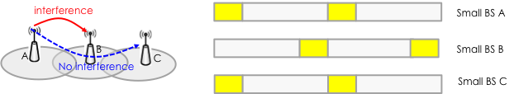
Figure 3 – an example of event-based mode transition

For easy and efficient assignment of duty-cycle pattern, the length of a duty-cycle pattern may be fixed and an active period may be distributed within the fixed duty-cycle pattern as shown in Fig. 3.

Power saving of a small BS
Besides interference mitigation, duty-cycled mode can be used to conserve power consumption at a small BS. If there is no active MSs attached to the small BS or if there is a few active MSs that require low QoS, then an idle time of the small BS when DL resource is not allocated for any MSs will increase. In this case, the small BS may conserve its power consumption by deactivating its air interface for several frames without degrading service quality of its subordinate MSs. In this contribution, we have assumed that a small BS may enter only when there is no active MSs attached to the small BS. The second case in which a small BS enters duty-cycled mode when there is a few active MSs needs to be investigated further because it may affect the operation of legacy MSs in normal mode as well as sleep mode.

Editorial Instruction
- Black text: the text is existing in the base standard
- Red text: with strike-through: the texts is removed from the amendment standard
- Blue text without underline:the text is added in the amendment standard without underline
- Blue text with underline: the text is added in the amendment standard and underline shall be added under the added text

Proposed Texts
----------------- Start of the text proposal --------------------------------------------------------------------------------------
[Change subclause 17.4 on page 22 as follows:]
17.4 BS power management
17.4.1 General Description
This subclause describes the power management functions of base stations for energy efficient operation. The power management function under this subclause details not only operation of single base station but also cooperative operations of adjacent base stations.
Base stations including macro and small base stations always operate in Normal mode when the base station power management is not supported at the base stations.
Base stations supporting the base station power management described in this subclause can operate in one of the power saving operation modes such as Duty-cycled mode or Standby mode when the operation condition is met.

17.4.2 Duty-cycled Mode
Duty-cycled mode is one of power saving operation mode in which a base station changes its operation state between active period and inactive period. A base station in the inactive period does not transmit/receive data to/from its subordinate mobile stations. A base station may enter Duty-cycled mode when the base station has small number of subordinate mobile stations and small traffic demands from the mobile stations.
Besides the normal operation mode, BSs may support duty-cycled mode to reduce interference to neighbor cells and to conserve its power consumption. Duty-cycled mode is a BS operation mode in which a BS disables its air interface periodically and consists of active periods and inactive periods. The support of duty-cycled mode is negotiated during the BS initialization and configuration. Duty-cycled mode can be activated through negotiation between the BS and NCMS when the BS is in normal operation mode.
When duty-cycled mode is active for the BS, the BS shall be in either active period or inactive period. During an active period, the BS becomes active on the air interface for activities such as paging, transmitting system information, ranging, or data traffic transmission. During an inactive period, the BS does not transmit anything on the air interface and may power down one or more physical operation components or perform other activities such as synchronization with the overlay macro BS or measurement of the interference from neighbor cells.
The base station in the Duty-cycled mode goes into the inactive period when all of its associated mobile stations are in unavailability interval. The inactive period of the base station shall be informed to the mobile stations to prevent UL attempts of mobile stations during inactive period of the base station.
To increase the inactive period of the base station (i.e. a common unavailability interval of mobile stations), base station may adjust the configurations of Sleep mode (i.e. start frame number, window sizes, etc.) of associated mobile stations.
A BS in inactive period shall support an available interval of a paging cycle if it supports idle mode operation.

17.4.2.1 Duty-cycle pattern
A sequence of active and inactive periods forms a duty-cycle pattern. The duty-cycle pattern is the iteration of one active period and one inactive period.
The duty-cycle pattern parameters include the following:
- Length of an active period (in unit of frames)
- Length of an inactive period (in unit of frames)
- Start frame offset
The active period starts at the frame number “N”,
where N modulo (active period + inactive period) == Start frame Offset
Once a BS enters duty-cycled mode, the duty-cycle pattern of the BS is activated. The duty-cycle pattern parameters may be pre-provisioned or unicasted to the MS during initial network entry with the BS in the TBD message. The duty-cycle parameters may be broadcast in the TBD message by the BS when they are changed, for certain duration of time as decided by the network.

17.4.3 Standby Mode
Standby mode is an another power saving operation mode in which a base station deactives its air interface to conserve energy consumption. A base station may enter Standby mode when the base station has no subordinate mobile stations.
Base stations in Standby mode wake up (i.e. change its operation mode into the Normal mode) when predefined inactive period timer expires or the network requests changes of state of the base station.

17.4.4 Cooperation of Base Stations for Power Management
The base stations cooperate with other adjacent base stations and/or NCMS (Network Control and Management System) to increase the power saving performance and to prevent the performance degradation (e.g. throughput decreases and coverage holes) due to the power saving operation of base stations.
----------------- Start of the text proposal --------------------------------------------------------------------------------------

