Project | IEEE 802.16 Broadband Wireless Access Working Group <http://ieee802.org/16>
Title | Network Interface for IEEE P802.16q Management Messaging
Date Submitted | 2012-11-07
Source(s) | Jaesun Cha, Eunkyung Kim, Anseok Lee, Wooram Shin, Kwangjae Lim  ETRI | E-mail: jscha@etri.re.kr  *<http://standards.ieee.org/faqs/affiliationFAQ.html>
Re: | Multi-tier Networks Call for Contributions (16-12-0617-00-Shet)
Abstract | This contribution proposes a definition of management messages based on the network reference model defined in IEEE Std 802.16-2012, which contains C-SAP, M-SAP and NCMS.
Purpose | To discuss and adopt the proposed texts in the System Requirement Document (SRD) on IEEE P802.16q Multi-tier Networks
Notice | This document does not represent the agreed views of the IEEE 802.16 Working Group or any of its subgroups. It represents only the views of the participants listed in the “Source(s)” field above. It is offered as a basis for discussion. It is not binding on the contributor(s), who reserve(s) the right to add, amend or withdraw material contained herein.
Release | The contributor grants a free, irrevocable license to the IEEE to incorporate material contained in this contribution, and any modifications thereof, in the creation of an IEEE Standards publication; to copyright in the IEEE’s name any IEEE Standards publication even though it may include portions of this contribution; and at the IEEE’s sole discretion to permit others to reproduce in whole or in part the resulting IEEE Standards publication. The contributor also acknowledges and accepts that this contribution may be made public by IEEE 802.16.
Patent Policy | The contributor is familiar with the IEEE-SA Patent Policy and Procedures:  <http://standards.ieee.org/guides/bylaws/sect6-7.html#6> and <http://standards.ieee.org/guides/opman/sect6.html#6.3>.  Further information is located at <http://standards.ieee.org/board/pat/pat-material.html> and <http://standards.ieee.org/board/pat>.

Network Interface for IEEE P802.16q Management Messaging
Jaesun Cha, Eunkyung Kim, Anseok Lee, Wooram Shin, Kwangjae Lim
ETRI

Introduction
According to IEEE P802.16q PAR apporved by the IEEE-SA Standards Borad on 30 August 2012, protocol enhancement on management messaging between base stations and between base station and mobile station is included in the scope of P802.16q project. However, the meaning of “protocol enhancement on management messaging” is not clear because management plane operation may be defined as protocol messages as done in general network standard or may be defined as service primitives as done in IEEE Std 802.16-2012.
In this contribution, we introduce management plane operation defined in IEEE Std 802.16-2012 and propose to add information on service primitives into IEEE P802.16q SRD in order to provide clear information on the scope of “protocol enhancement on management messaing” included in the approved PAR.

Management Interfaces in IEEE Std 802.16-2012
The 802.16 devices can include Subscriber Stations (SS) or Mobile Stations (MS), or Base Stations (BS). As the 802.16 devices may be part of a larger network, they would require interfacing with many network entities for management and control purposes. However, the network interfaces depends on the network architecure, the transport network and the protocols. A Network Control and Management System (NCMS) abstraction has been introduced in IEEE Std 802.16-2012 to avoid such dependancy as shown Figure 1.
In Figure 1, the 802.16 entity is defined as the logical entity in an SS/MS or BS that comprises the PHY and MAC layers of the Data Plane and the Management/Control Plane and the NCMS is defined as an abstract network entity that interworks with 802.16 entity for management and control purposes. The NCMS abstraction allows the PHY/MAC layers specified in 802.16 to be independent of the network architecture, the transport network, and the protocols used at the backend. NCMS logically exists at BS side and SS/MS side of the radio interface, termed NCMS(BS) and NCMS(SS/MS), respectively and any necessary inter-BS coordination is handled through the NCMS(BS).

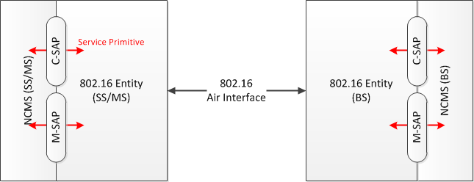
Figure 1 – conceptual IEEE 802.16 network architecure
The NCMS comprises different functional entities such as Service Flow management, Idle Mode management, LBS managemen, etc. These entities may be centrally located or distributed across the network. The exact functionality of these entities and their services is not defined in IEEE Std 802.16-2012 because it’s outside the scope of the standard.
The interface between NCSM and 802.16 entity consists of two SAP (Service Access Points) and service primitives exchanced through the SAPs. The M-SAP is used for less time sensitive Management plane primitives and the C-SAP is used for more time sensitive Control plane primitives that support handovers, security context management, radio resource management, and low power operations (such as idle mode and paging functions). The service primitives may be mapped to IEEE 802.16 MAC messages at air interface or protocol messages at the backhaul network. However, the specific mapping of service primitives to protocol messages in the backhaul network is out of scope of the standard.

Figure 2 shows an example of service primitives that involves in HO preperation between two BSs. 802.16 MAC control messages and protocol messages trigger activation of service primitives. The mapping of service primitives to 802.16 MAC control messages is cleary defined in the standard, while the mapping of service primitives to protocol messages is not defined.

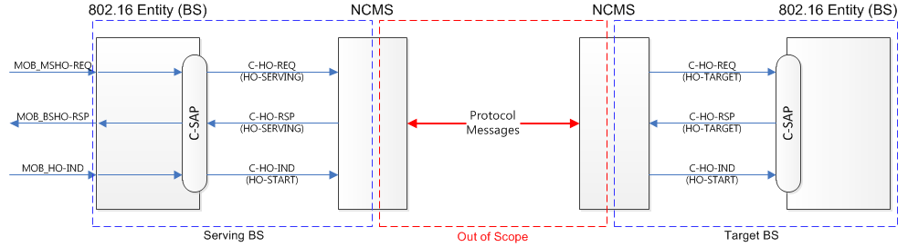
Figure 2 – Example of service primitives during HO preperation.

References
- IEEE Std 802.16-2012, “IEEE Standard for Air Interface for Broadband Wireless Access Systems”, 2012-08
- IEEE 802.16-12-0394-06-Gdoc, PAR and Five Criteria for P802.16q (Amendment to IEEE Std 802.16 for Multi-tier Networks), 2012-07

Proposed Texts
----------------- Start of the text proposal --------------------------------------------------------------------------------------
[Insert the following texts at the end of the document]

7 Annex: Reference Model
This annex provides information on the protocol architecture model and network reference model defined in IEEE Std 802.16-2012. Any management messaging defined in P802.16q to support management information exchanged among BSs shall be developed based on the archtecure model and network reference model defined in IEEE Std 802.16-2012.

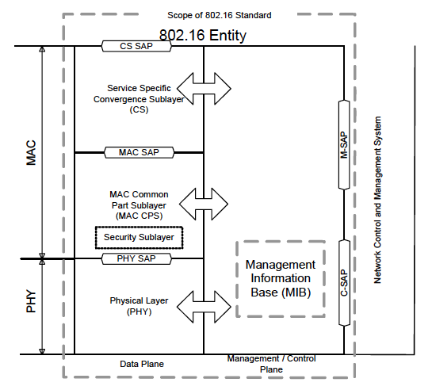
Figure 7-1 – IEEE Std 802.16 Protocol Archtecture Model

The 802.16 devices can include Subscriber Stations (SS) or Mobile Stations (MS), or Base Stations (BS). As the 802.16 devices may be part of a larger network and therefore would require interfacing with entities for management and control purposes, a Network Control and Management System (NCMS) abstraction has been introduced in IEEE Std 802.16-2012 as a "black box" containing these entities. The NCMS abstraction allows the PHY/MAC layers specified in 802.16 to be independent of the network architecture, the transport network, and the protocols used at the backend and therefore allows greater flexibility. NCMS logically exists at BS side and SS/MS side of the radio interface, termed NCMS(BS) and NCMS(SS/MS), respectively. Any necessary inter-BS coordination is handled through the NCMS(BS).
IEEE Std 802.16-2012 includes a Control SAP (C-SAP) and Management SAP (M-SAP) that expose control plane and management plane functions to upper layers. The M_SAP and C-SAP interfaces are described in 7.3.3 and 7.3.4, respectively. The NCMS uses the C-SAP and M-SAP to interface with the 802.16 entity. In order to provide correct MAC operation, NCMS shall be present within each SS/MS. The NCMS is a layer independent entity that may be viewed as a management entity or control entity. General system management entities can perform functions through NCMS and standard management protocols can be implemented in the NCMS.

7.1 802.16 entity
An 802.16 entity is defined as the logical entity in an SS/MS or BS that comprises the PHY and MAC layers of the Data Plane and the Management/Control Plane.

7.2 Network Control and Management System (NCMS)
This abstraction is detailed in Figure 7-2 to show the different functional entities that make up such a Network Control and Management System. These entities may be centrally located or distributed across the network. The exact functionality of these entities and their services is outside the scope of this document but shown here for illustration purposes and to better enable the description of the management and control procedures.

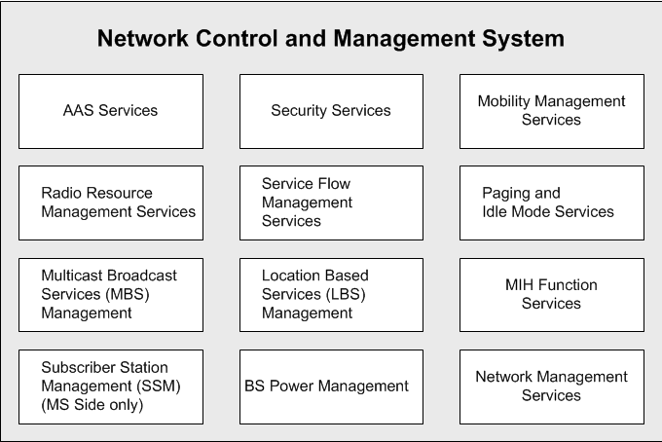
Figure 7-2 – Illustration of the Network Control and Management System (Informational)

NCMS protocols are not specified in IEEE Standard 802.16-2012, however information elements (IEs) and protocol primitives for these IEs are exposed using primitives via SAP. This includes MAC and PHY layer context information used by NCMS protocols to manage and control the air interface. NCMS service manifestations on the SS/MS and BS may have different configurations and functions.

7.3 Network reference model
Figure 7-3 describes a simplified network reference model. Multiple SS or MS may be attached to a BS. SS or MS communicate to the BS over the U interface using a Primary Management Connection, a Basic Connection or a Secondary Management Connection.

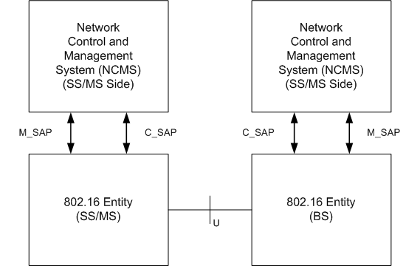
Figure 7-3 – 802.16 Network Reference Model

7.3.1 SS/MS and BS Interface
The correlation between MAC PDU and C-SAP/M-CAP are described in IEEE Std 802.16-2012 as follows:
- MAC management PDUs that are exchanged on the basic management connection trigger or are triggered by primitives that are exchanged over the C-SAP.
- MAC management PDUs that are exchanged on the primary management connection trigger or are triggered by primitives that are exchanged over either the C-SAP or the M-SAP depending on the particular management or control operation.
- Messages that are exchanged over the secondary management connection trigger or are triggered by primitives that are exchanged over the M-SAP.

7.3.2 802.16 entity to NCMS interface
This interface is a set of SAP between an 802.16 entity and NCMS and is represented in Figures 7-3. It is decomposed into two parts: the M-SAP is used for less time sensitive Management plane primitives and the C-SAP is used for more time sensitive Control plane primitives that support handovers, security context management, radio resource management, and low power operations (such as Idle mode and paging functions).

7.3.3 Management SAP (M-SAP)
The Management SAP may include, but is not limited to primitives related to:
- System configuration
- Monitoring Statistics
- Notifications/Triggers
- Multi-mode interface management

7.3.4 Control SAP (C-SAP)
The Control SAP may include, but is not limited to primitives related to:
- Handovers (e.g. notification of HO request from MS, etc.)
- Idle mode mobility management (e.g. Mobile entering idle mode)
- Subscriber and session management (e.g. Mobile requesting session setup)
- Radio resource management
- AAA server signaling (Eg. EAP payloads).
- Media Independent Handover Function Services
- Location detection reporting capability

----------------- Start of the text proposal --------------------------------------------------------------------------------------

