Project | IEEE 802.16 Broadband Wireless Access Working Group <http://ieee802.org/16>
Title | Clarification on base station function of HR-MS over IEEE 802.16.1a
Date Submitted | 2012-07-09
Source(s) | Won-Ik Kim, Eunkyung Kim, Miyoung Yun, Seokki Kim, Sungkyung Kim, Hyun Lee, Chulsik Yoon, Sungcheol Chang  ETRI  Seokjoo Shin  Chosun University | E-mail:  woniks@etri.re.kr  scchang@etri.re.kr  sjshin@chosun.ac.kr
Re: | “IEEE 802.16-12-400-00-Gdoc,” in response to Letter Ballot Recirc #38b on P802.16.1a/D3
Abstract | This provides AWD text proposals for clarification on base station function of HR-MS over IEEE 802.16.1a
Purpose | To discuss and adopt the proposed text in the draft amendment document on GRIDMAN
Notice | This document does not represent the agreed views of the IEEE 802.16 Working Group or any of its subgroups. It represents only the views of the participants listed in the “Source(s)” field above. It is offered as a basis for discussion. It is not binding on the contributor(s), who reserve(s) the right to add, amend or withdraw material contained herein.
Copyright Policy | The contributor is familiar with the IEEE-SA Copyright Policy <http://standards.ieee.org/IPR/copyrightpolicy.html>.
Patent Policy | The contributor is familiar with the IEEE-SA Patent Policy and Procedures:  <http://standards.ieee.org/guides/bylaws/sect6-7.html#6> and <http://standards.ieee.org/guides/opman/sect6.html#6.3>.  Further information is located at <http://standards.ieee.org/board/pat/pat-material.html> and <http://standards.ieee.org/board/pat>.
Clarification on base station function of HR-MS over IEEE 802.16.1a

Won-Ik Kim, Eunkyung Kim, Miyoung Yun, Seokki Kim, Sungkyung Kim, Hyun Lee, Chulsik Yoon, Sungcheol Chang
ETRI

Seokjoo Shin
Chosun University

Introduction
In this contribution, we suggest the modifications of the sentences in Section 6.12.1.3 Base station function for HR-MS over IEEE P802.16.1a/D3. The major suggestions are listed in below.

- Rewrite a paragraph in subsection
- Remove a few informative sentences
- Add additional information of control message
- Change figure

References
[1] IEEE P802.16nTM/D3, Air Interface for Broadband Wireless Access Systems - Draft Amendment: Higher Reliability Networks, June 2012.
[2] IEEE P802.16.1aTM/D3, WirelessMAN-Advanced Air Interface for Broadband Access Systems - Draft Amendment: Higher Reliability Networks, June 2012.
[3] EEE P802.16Rev3/D6, IEEE Draft Standard for Local and metropolitan area networks; Part 16: Air Interface for Fixed and Mobile Broadband Wireless Access Systems,” June 2012.
[4] IEEE P802.16.1TM/D6, IEEE Draft for WirelessMAN-Advanced Air Interface for Broadband Wireless Access Systems, June 2012.

Proposed Text for the 802.16.1a AWD
Note:
The text in BLACK color: the existing text in the 802.16.1a AWD
The text in RED color: the removal of existing 802.16.1a AWD
The text in BLUE color: the new text added to the 802.16.1a AWD

[-------------------------------------------------Start of Text Proposal---------------------------------------------------]

6.12 Support for HR-Networks

6.12.1 Multi-mode operation

…

6.12.1.3 Base station function for HR-MS

[Remedy1: Modify the sentences in Section 6.12.1.3 in IEEE P802.16.1a/D3.]
[Page# 117, Line# 2]

An HR-MS may operate as an HR-BS to provide connectivity for itself and other HR-MSs. During basic capability negotiation at network entry, an HR-MS that is capable of role change to HR-BS shall report such capability to the super-ordinate HR-BS/HR-RS.
While operating as an HR-BS, the station may maintain certain HR-MS functionalities.
The HR-MS may start operating as an HR-BS in a Proactive operation or a Reactive operation. For proactive operation, the mode switch is directed by the superordinate HR-BS of the HR-MS. In reactive operation, the mode switch is initiated by the HR-MS itself.

An HR-MS may operate as an HR-BS to provide connectivity for itself and other HR-MSs. The HR-MS starts operating as an HR-BS in a Proactive operation or a Reactive operation.
In proactive operation, the mode change is directed by a superordinate HR-BS of the HR-MS. During basic capability negotiation at network entry, an HR-MS that is capable of role change to HR-BS shall report such capability to the superordinate HR-BS/HR-RS.
In reactive operation, the mode change is initiated by the HR-MS itself.
While operating as an HR-BS, the station may maintain certain MS functionalities.

[Remedy2: Modify the sentences in Section 6.12.1.3.2 in IEEE P802.16.1a/D3.]
[Page# 117, Line# 35]

6.12.1.3.2 Reactive Operation

The HR-MSs which are capable of role changing to HR-BS may contend for operating at of BS mode when the superordinate HR-BS is under unforeseeable fails or when there is no infrastructure station within the range of HR-MS. The HR-MSs may initiate a mode switch to HR-BS after expiration of a random backoff timer to avoid potential collision among adjacent HR-MSs trying to perform a mode switch to HR-BS at the same time.

After completion of mode switch, While operating as HR-BS mode, the HR-MS acting as HR-BS may request mode change to one of its subordinate HR-MSs in order to hand HR-BS role over take over the role of HR-BS. In this case, it follows the procedure for Proactive operation as described in 6.12.1.3.1.

[Remedy3: Modify the sentences in Section 6.12.1.3.2.1 in IEEE P802.16.1a/D3.]
[Page# 118, Line# 2]

6.12.1.3.2.1 Collision resolution

When multiple HR-MSs try to change their mode to HR-BS, the collision in the sense of multiple BS operations in the same coverage area may occur. It causes serious interference to each other. When multiple HR-MSs try to change their mode to HR-BS in the same coverage area, the interference to each other may occur. In order to avoid this situation, the HR-MS who wants to perform BS operation tries to transmit PA preamble in a certain time period before changing the mode. In order to avoid it, an HR-MS who tries to perform BS mode operation should transmit PA preamble in a certain time period before changing the mode.

To resolve a collision occurred in preamble transmissions by multiple HR-MSs, HR-MS who can act as HR-BS changes its mode to HR-BS after going through 2 phases: initial access phase and collision resolution phase. Basic channel access mechanism is based on CSMA/CA (Carrier Sense Multiple Access/Collision Avoidance) protocol with backoff algorithm. Backoff slot time is defined 5ms which is identical to the frame size.

Initial access phase:
- HR-MS who can act as HR-BS calculates the value of backoff timer from a window [0, CW₁].
- If a preamble from other HR-MS is detected prior to expiration of the backoff timer, the HR-MS gives up its mode change.
- HR-MS transmits a preamble at the first OFDM symbol duration in 5ms frame once its backoff timer is expired.
- After transmitting a preamble, HR-MS goes into the collision resolution phase.

Collision resolution phase:
- HR-MS who has transmitted PA preamble successfully in the initial access phase selects the value of backoff timer from a window [0, CW₂] randomly in the manner of uniform distribution.
- If preamble from other HR-MS is detected prior to expiration of the backoff timer, the HR-MS gives up its mode change.
- Since its backoff timer is expired the HR-MS starts BS mode operation.

CW₁ and CW₂ may be predefined or regularly assigned by the previous serving HR-BS before corruption. The range of CW₁ and CW₂ is between 0 and 1024.

The conceptual description of the collision resolution method is illustrated in Figure 231.

[Remedy4: Change the Figure 231 in Section 6.12.1.3.2.1 in IEEE P802.16.1a/D3.]
[Page# 119, Line# 1]

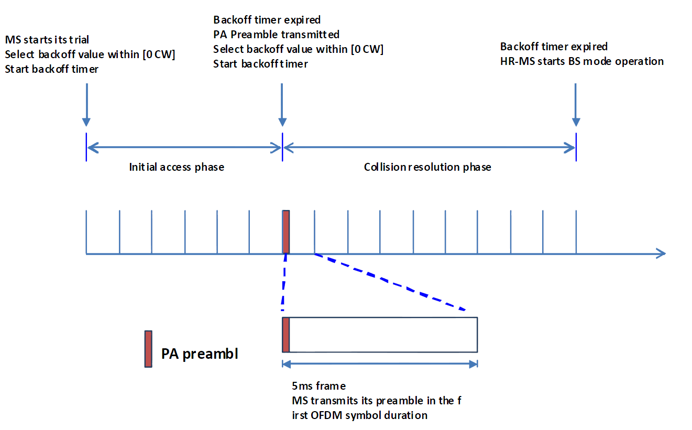

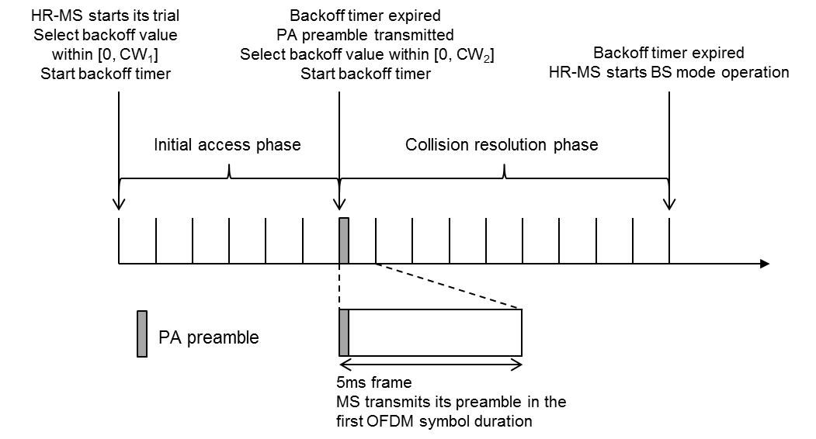
Figure 231 — Collision resolution method for HR-MS reactive operation

