IEEE P802.15
Wireless Personal Area Networks

Project | IEEE P802.15 Working Group for Wireless Personal Area Networks (WPANs)
Title | Proposed Comments Resolution on Sensing and AC IE`
Date Submitted | March 2024
Sources | Pooria Pakrooh (Qualcomm)
Re:
Abstract | Resolution to comments: 94, 97, 104, 156, 224, 410, 411, 432, 433, 553, 656, 663, 844, 846, 847, 859, 860, 861, 862, 881
Purpose | To propose comments resolution for “P802.15.4ab™/D (pre-ballot) C Draft Standard for Low-Rate Wireless Networks”
Notice | This document does not represent the agreed views of the IEEE 802.15 Working Group or IEEE 802.15.4ab Task Group. It represents only the views of the participants listed in the “Sources” field above. It is offered as a basis for discussion and is not binding on the contributing individuals. The material in this document is subject to change in form and content after further study. The contributors reserve the right to add, amend or withdraw material contained herein.

Comment Index #94 and #844 in 15-24-0010-16-04ab-cc-consolidated-comments
CID | Commenter | Sub-Clause | Page | Line | Comment | Proposed Change
94 | Pooria Pakrooh | 10.39.2 | 106 | 22 | Without CIR report, sensing task is incomplete. The CIR report is not necessarily sent OTA. Remove OTA from the sentence and make it mandatory. | Change to: “For the cases that the sensing initiator is the sensing transmitter, a sensing measurement report shall be sent by the sensing responder to provide the measurement report to the sensing initiator.”
844 | Carl Murray | 10.39.2 | 106 | 29 | Is the OTA qualification necessary here – does iot effectively limit the possible scenarios. | Delete “supporting scheduling of OTA CIR measurement reports from multiple responders”

Discussion:
1. The responder shall provide the CIR report to complete the sensing operation.
2. The CIR report is not necessarily sent OTA.
Resolution: Accepted
Proposed text changes on P802.15.4ab™/D (pre-ballot) C:
Change Line 21 on Page 106 as follows
For the cases that the sensing initiator is the sensing transmitter, a sensing measurement report shall be sent by the sensing responder to provide the measurement report to the sensing initiator.

Change Line 29 on Page 106 as follows
Multistatic sensing, where the initiator is the sensing transmitter, supporting scheduling of CIR measurement reports from multiple responders.

Comment Index #553 in 15-24-0010-16-04ab-cc-consolidated-comments
CID | Commenter | Sub-Clause | Page | Line | Comment | Proposed Change
553 | Youngwan So | 10.39.2 | 106 | 25-31 | Need to keep consistency.  1. In line #7 in page #106, it says only "Sensing may be in either monostatic or multistatic scenarios.".  2. In line #25~31 in page #106, it mentions even about 'bi-static mode' and 'Sensing by proxy mode' in addition to 'mono' and 'multi-static'.  3. In line #15 in page #117, here it also mentions all those four modes can be specified. (i.e. mono, bi, multi, SbP)  From above, clarification is needed whther all those four modes are possible or just only a part is allowed. | Make changes to below three parts appropriately so as to keep consistency.  1. In line #7 in page #106  2. In line #25~31 in page #106  3. In line #15 in page #117

Discussion:
There are four modes for sensing: Monostatic, bi-static, multi-static and SBP. The only change needed to address this comment is in line 7 of page 106, by removing sentence: " Sensing may be in either monostatic or multi-static scenarios".
Resolution: Revised
Proposed text changes on P802.15.4ab™/D (pre-ballot) C:
Change Line 7 on Page 106 as follows
Sensing measurements may enable various applications such as presence detection and environmental mapping.

Comment Index #656 in 15-24-0010-16-04ab-cc-consolidated-comments
CID | Commenter | Sub-Clause | Page | Line | Comment | Proposed Change
656 | Rojan Chitrakar | 10.39.4.3 | 108 | 5 | "The format of the sensing packets is defined within the PHY clause(s) of those PHYs capable of being SDEV."  What are these PHYs? | List out the relevant PHYs.

Discussion:
Agree with the commenter that a more accurate reference is needed.
Resolution: Revised
Proposed text changes on P802.15.4ab™/D (pre-ballot) C:
Change Line 5 on Page 108 as follows
In the sensing phase sensing packets are sent by the sensing initiator and/or sensing responders. The format of the sensing packets is defined in 16.2.1.

Comment Index #410 in 15-24-0010-16-04ab-cc-consolidated-comments
CID | Commenter | Sub-Clause | Page | Line | Comment | Proposed Change
410 | Bin Qian | 10.39.4.5.1 | 109 | 5 | What do other means refer to? OOB? | As in the comment

Discussion:
Using “OOB means” instated of “other means” makes this statement clearer.
Resolution: Revised
Proposed text changes on P802.15.4ab™/D (pre-ballot) C:
Change Line 5 on Page 109 as follows
The bitmap length and offset are negotiated and determined through OOB means, and they are fixed during sensing session.

Comment Indices #411 and #846 in 15-24-0010-16-04ab-cc-consolidated-comments
CID | Commenter | Sub-Clause | Page | Line | Comment | Proposed Change
411 | Bin Qian | 10.39.4.5.2 | 109 | 12 | The value of L is not clear. Is the latter number greater than the previous number by 16 or twice? | As in the comment
846 | Carl Murray | 10.39.4.5.2 | 109 | 12 | L= {16, …, M/2} as otherwise 32 is a length for M = 32 | Change  L= {16, 32, …, M/2}  To  L= {16, …, M/2}

Discussion:
Replace “=” with “belonging to the set” and specify “L” can take any power-of-2 value within the set.
Resolution: Revised
Proposed text changes on P802.15.4ab™/D (pre-ballot) C:
Change Line 12 on Page 109 as follows
To limit the test burden for the mandatory CIR report bitmap mode, an SDEV shall support for each bitmap
length M = {32, 64, 128, 256}, two strings of all ones, with equal length L, where L shall be an integer power of 2, belonging to the set {16, …, M/2}.

Comment Index #847 in 15-24-0010-16-04ab-cc-consolidated-comments
CID | Commenter | Sub-Clause | Page | Line | Comment | Proposed Change
847 | Carl Murray | 10.39.4.5.2 | 109 | 22 | This sentence does not make sense - in particular the "or" in "and/or"
Discussion:
Remove "and/or more than one SENS segment are used", as it does not add any useful information. When there is more than one segment, the sentence specifies that reports associated with all antennas per segment have a common reference tap.
Resolution: Revised
Proposed text changes on P802.15.4ab™/D (pre-ballot) C:
Change Line 7 on Page 106 as follows
For each segment, if more than one receiving antenna is used, a common reference tap shall be used for the CIR reports of all antennas . The common reference tap for each segment shall be earliest detected tap of antenna 0 for the segment.

Comment Index #663 in 15-24-0010-16-04ab-cc-consolidated-comments
CID | Commenter | Sub-Clause | Page | Line | Comment | Proposed Change
663 | Rojan Chitrakar | 10.39.4.6 | 110 | 11 | There is no termination phase in Figure 124. Does it happen in a different sensing round? | As in comment.

Discussion:
Sensing measurements happen in a sensing round, as shown in Figure 124. The session setup and session termination phases are done OOB and not detailed in the draft.

Resolution: Rejected

Comment Index #156 in 15-24-0010-16-04ab-cc-consolidated-comments
CID | Commenter | Sub-Clause | Page | Line | Comment | Proposed Change
156 | Benjamin Rolfe | 10.39.7.1 | 114 | 13 | " which should typically be used to report certain measurement information, " is incorrect use of "should" (see clause 1.3). | Change "should" to "would"

Resolution: Accepted

Comment Index #859 and #860 in 15-24-0010-16-04ab-cc-consolidated-comments
CID | Commenter | Sub-Clause | Page | Line | Comment | Proposed Change
859 | Carl Murray | 10.39.7.1 | 115 | 2 | Allow for a configuration of 32 - better than leaving reserved.
860 | Carl Murray | 10.39.7.1 | 115 | 6 | Allow for a configurations up to 32 - better than leaving reserved.
Discussion:
Maximum number of fragments is 16 for RSF and 8 for RIF. These numbers have been agreed before to limit the amount of time drift due to CFO error and to facilitate coherent combining across fragments.
Resolution: Rejected

Comment Index #861 and #862 in 15-24-0010-16-04ab-cc-consolidated-comments
CID | Commenter | Sub-Clause | Page | Line | Comment | Proposed Change
861 | Carl Murray | 10.39.7.1 | 116 | 2 | Allow for a configurations of 8 and 16 - better than leaving reserved configurations and allows for the new ETSI +10dB.
862 | Carl Murray | 10.39.7.1 | 115 | 6 | Allow for a configurations of 8 and 16 - better than leaving reserved configurations and allows for the new ETSI +10dB.

Discussion:
The minimum values for MSR and STS segment length have been set to 32, as reflected in DCN 100-23/r1. Similarly, minimum 15.4z STS segment length is 32. Decreasing these values to 8 and 16 requires higher Tx peak power, different from the range of consideration in 4z. Additionally, higher ETSI limits will make this peak power increase requirement more severe.
Resolution: Rejected
Comment Index #97, #104, #432 and #433 in 15-24-0010-16-04ab-cc-consolidated-comments
CID | Commenter | Sub-Clause | Page | Line | Comment | Proposed Change
97 | Pooria Pakrooh | 10.39.7.1 | 117 | 2 | One request bit would suffice for requesting CIR report for nonsesning packets. | Change bit 3 description to "CIR report request for nonsensing packet". Also, remove last field "Nonsensing CIR report parameters".
104 | Pooria Pakrooh | 10.39.7.1 | 123 | 20 | Only a request bit for nonsensing packet is enough. The packet identifier and source of report are not needed and cause confusion. | Remove all the content starting from line 3 to the line 13 (end of page 126".
432 | Bin Qian | 10.39.7.1 | 126 | 4 | Instead of the Transmission Packet Format Identifier field, a simpler way is to add one more bit in the Common Ranging Control field, MMS Ranging Control field, Data Comm Control field, respectively, to request CIR report | As in the comment
433 | Bin Qian | 10.39.7.1 | 126 | 4 | It seems that how to generate the CIR report is implementation specific, which is out the scope of 4ab. Thus, it is suggested to remove the Source of CIR Report field | As in the comment
Discussion:
Request of CIR report for nonsensing packets can be carried out by having one request bit in the AC IE. It is not necessary to introduce the details regarding transmission packet identifier and source of the report in the AC IE.
Resolution: Revised
Proposed text changes on P802.15.4ab™/D (pre-ballot) C:
- Line 2 on Page 117: Change bit 3 description to "CIR report request for nonsensing packet". Also, remove last field "Nonsensing CIR report parameters".
- Remove the following content from page 126:

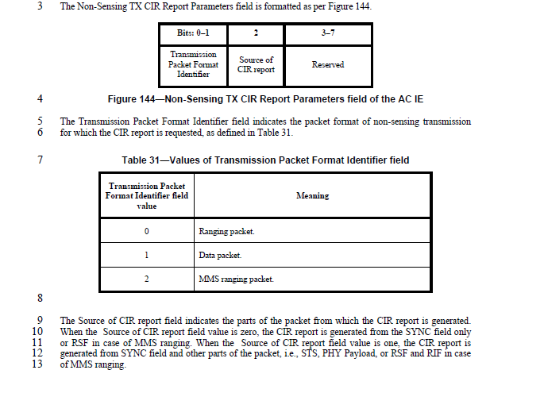

Comment Index #224 in 15-24-0010-16-04ab-cc-consolidated-comments
CID | Commenter | Sub-Clause | Page | Line | Comment | Proposed Change
224 | Billy Verso | 10.39.7.2 | 127 | 5 | In figure 145 field size of 36 for the Report Parameters Control, should be 35. | Change "36" to "35"
Discussion:
The maximum Report parameter Control number of in from Figure 145 should be 35.
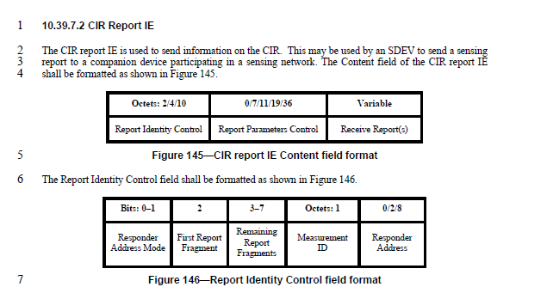
Resolution: Accepted
Comment Index #881 in 15-24-0010-16-04ab-cc-consolidated-comments
CID | Commenter | Sub-Clause | Page | Line | Comment | Proposed Change
881 | Carl Murray | 16.4.4 | 178 | 29 | This text is too broad -  "For any continuous set of values that contain …" | Change to -  "The requirement thus states that for some continuous set of values that contain …"

Discussion:
Agree with the commenter. Additionally, “magnitude” should be removed.

Resolution: Revised
Proposed text changes on P802.15.4ab™/D (pre-ballot) C:
Change Line 29 on Page 178 as follows
For some continuous set of values that contain the point τmax, it is required that | ϕ(τ) | is no less
30 than 0.92.

