IEEE P802.15
Wireless Personal Area Networks

Project | IEEE P802.15 Working Group for Wireless Personal Area Networks (WPANs)
Title | CIDs from DCN 24-103r6 ready for approval
Date Submitted | March 14, 2024
Sources | Alex Krebs (Apple)  krebs @ apple.com
Re:
Abstract
Purpose | To propose resolution for MMS related comments for “P802.15.4ab™/D (pre-ballot) C Draft Standard for Low-Rate Wireless Networks” .
Notice | This document does not represent the agreed views of the IEEE 802.15 Working Group or IEEE 802.15.4ab Task Group. It represents only the views of the participants listed in the “Sources” field above. It is offered as a basis for discussion and is not binding on the contributing individuals. The material in this document is subject to change in form and content after further study. The contributors reserve the right to add, amend or withdraw material contained herein.

Abstract
This submission contains the proposed comment resolutions for the CIDs 16, 30, 58, 63, 165, 209, 350, 515, 517, 697, 698, 705, 714, 726, 727, 728, 733, 737, 740, 746, 752, 836, 903, 904

R0: initial document

CID 697, 698, 705
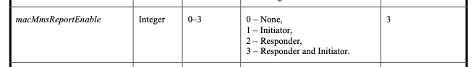
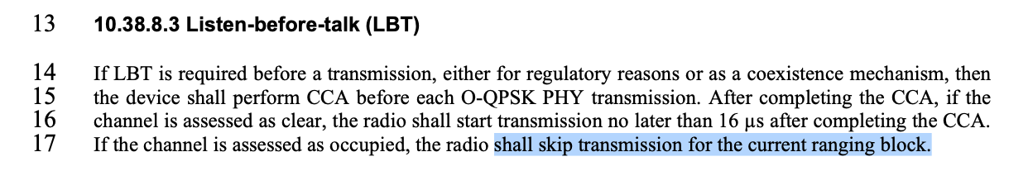
Name | Idx | Pg | L. | Comment | Proposed Change | Resolution
Carl Murray | 697 | 52 | 21 | macMmsReportEnable is a really bad name for a siugnal that has 4 states. What does it mean by "If it is enabled…" | Change name | Revise. Change all occurences of macMmsReportEnable to macMmsReportSender.
Carl Murray | 698 | 52 | 21 | What happens if macMmsReportEnable is set to 0 but either macMms1stReportNSlots or macMms2ndtReportNSlots is non zero |  | Reject. (Answer: Then there are defined report slot lengths that no transmitter uses. Should not affect or disturb anything.)
Carl Murray | 705 | 57 | 17 | Why skip the block, why not just the round? |  | Revise: change "block" to "round". (Discussion: The commenter clarified that the question's emphasis is on "block vs round" rather than generic on LBT retrials. The "block vs round" question has been resolved for #75 on page 51 in the Panama F2F in favor of "round". Advise to proceed consistent here.)
Discussion: ?

CID 209, 16, 58
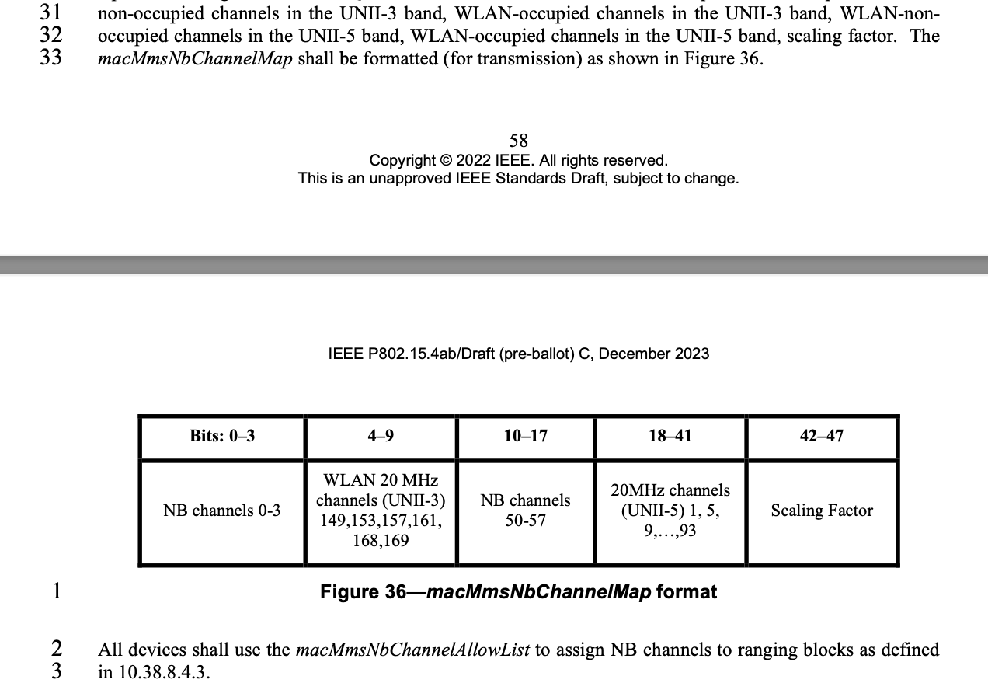
Name | Idx | Pg | L. | Comment | Proposed Change | Resolution
Billy Verso | 209 | 58 | 26 | The description here and Figure 43 seems to be duplicating what is in 10.38.10.3.7 The NB Channel Map field. Probably macMmsNbChannelMap is not needed; just macMmsNbChannelAllowList for each device, updated after over the air message exchange. | Delete paragraph and following paragraph, and the figure, and macMmsNbChannelMap attribute, over the air message can be used to update macMmsNbChannelAllowList configuration for each device. | Revise. Delete paragraph and following paragraph, and the figure 36, and macMmsNbChannelMap attribute, over the air message can be used to update macMmsNbChannelAllowList configuration for each device.
Li-Hsiang Sun | 16 | 58 | 30 | " The macMmsNbChannelMap contains five parts: WLAN-  non-occupied channels in the UNII-3 band, WLAN-occupied channels in the UNII-3 band, WLAN-non-  occupied channels in the UNII-5 band, WLAN-occupied channels in the UNII-5 band, scaling factor. The  macMmsNbChannelMap shall be formatted (for transmission) as shown in Figure 36." | the macMmsNbChannelMap should be updated to be the same as NB channel Map field used in messages and in Fig 43 | Revise (see #209)
Alex Krebs | 58 | 58, 59 | 32ff | incorrect channel map | remove last sentence of p.58 and Figure 36. | Revise (see #209)
Discussion:
I think this whole part is a left over of incomplete editing of DraftB and the accepted "Revise NB channel map" CID resolutions from DCN 23-575r2. Therefore I had marked CID 58 as editorial and assume it's resolved already.

CID 714
Name | Idx | Pg | L. | Comment | Proposed Change | Resolution
Carl Murray | 714 | 65 | 29 | This suggests that there are Compact frames without an FCS. Is this is not correct then it introduces unnecessary ambiguity? Pg64, line 5 states that each PSDU ends with a 2-octet FCS | Reconcile the 2 statements | Revised. (resolved through #627 by Rojan in DCN 23-20 in Panama F2F)

CID 726, 727
Name | Idx | Pg | L. | Comment | Proposed Change | Resolution
Carl Murray | 726 | 69 | 23 | The range of 8.6 seconds for the time offset field seems excessive | Should discuss if we want the full range supported | Revise. Add the following text after line 25: "The maximum value of this field shall be limited to 1 second."
Carl Murray | 727 | 69 | 27 | The range of 8.6 seconds for the time offset field seems excessive | Should discuss if we want the full range supported | Reject. (Full range is useful for ADV-CONF coordination packet search.)
Discussion: 3 bytes seems too short (~34ms), especially for ADV_CONF (#727), and there is not really any benefit in optimizing length here, since it 1-time use field in SOR/ADV-CONF prior to the ranging session.

CID 728, 733
Name | Idx | Pg | L. | Comment | Proposed Change | Resolution
Carl Murray | 728 | 70 | 2 | This needs to be rewritten referencing 10.38.8.4.3 and macMmsPrngSeed |  | Revise. Change lines 2-3 to:  This is a single octet field that carries the value macMmsPrngSeed used in the channel switching function as defined in 10.38.8.4.3.
Carl Murray | 733 | 71 | 10 | Is this correct? Can it not be changed in other compact frames, eg the SOR |  | Reject. (Yes. RPA prand is conveyed in ADV-POLL and POLL messages only. No need to send a new randomization every packet since all packets per discovery/round are sent in sequence on the same channel anyways, so easy to conjure for a tracker that they belong together even if addresses were rotated.)
Discussion: None.

CID 752

Name | Idx | Pg | L. | Comment | Proposed Change | Resolution
Carl Murray | 752 | 78 | 13 | It may be desirable to have a report compact frame without pass through data | Should consider adding | Revise as shown below.
Discussion: Agreement on the idea that it's cleaner to define a new field that is composed of PT Data and PT Data Length that can be referred to by different messages to be included as a whole.

Instructions to the editor: add a subsection "The Passthrough field" before 10.38.10.3.5 on p.65 l.31 as shown below:

10.38.10.3.X The Passthrough field
This is a variable length field that is used to pass arbitrary data to the next higher layer. It is formated as shown in Figure XXX.
Octets: 1 | variable
PT Data Length | PT Data
Figure XXX -- The Passthrough field structure

The value of PT Data Length is the number of octets contained in the PT Data field.
The PT Data field contains PT Data Length number of octets to be passed through to the next higher layer. The content of PT Data is out of scope of this specification.

Instructions to the editor: on p.78 change Figure 69 as shown below:
Octets: 5 | 0/variable
Round-trip Time | Passthrough
Figure 69—Format of the Message Content field in the One-to-one Initiator Report Compact frame (with Message Control field value 0x00)

Instructions to the editor: on p.78 change l.23-24 as shown below:
The Pass-through field is defined in 10.38.10.3.X. Its presence is determined by Frame Length (13.1.3.2) [13.1.3.2 is reference to 4me-D01].

Instructions to the editor: on p.79 change Figure 71 as shown below:
Octets: 5 | 0/variable
Reply Time | Passthrough
Figure 71—Format of the Message Content field in the One-to-one Responder Report Compact frame when the Message Control field value is 0x00

Instructions to the editor: on p.79 add the following text after l.11:
The Pass-through field is defined in 10.38.10.3.X. Its presence is determined by Frame Length (13.1.3.2) [13.1.3.2 is reference to 4me-D01].

Note: there are multiple other occurences and variants of PT Data and PT Data Length in frames with MessageControl >0x00. I'd recommend Rojan and Bin to take a look at those and propose how they want to proceed with those.

CID 30 and duplicates

Name | Idx | Pg | L. | Comment | Proposed Change | Resolution
Li-Hsiang Sun | 30 | 102 | 18 | There should be a default value of ranging slot (called slots) in Table 9 because it is configurable via management MAC config. | as in comment | Revise. (as described in Discussion)
Carl Murray | 836 | 102 | 18 | Is this table complete - for example where is the ranging slot duration defined |  | Revise. (see #30)
Discussion: TE: Was this lost from DraftB (see Table-9 below)? If yes, then just reinsert and add names: macMmsRangingSlotDuration, macMmsRangingRoundDuration, macMmsRangingBlockDuration.
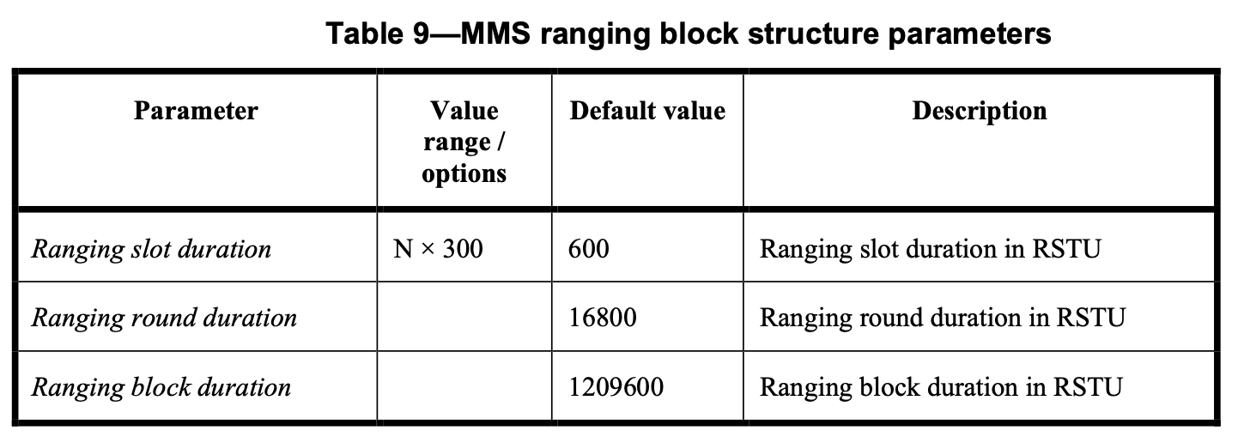

CID 34, 63 and duplicates

Name | Idx | Pg | L. | Comment | Proposed Change | Resolution
Alex Krebs | 63 | 71,72,74 | 19,5,5,12 | SMC_TLVs description missing | see external document DCN ??? | Revise. (See instruction below this table.)
Tero Kivinen | 515 | 71 | 19 | Line seems to be incomplete. | Complete it. | Revise. (see #63)
Carl Murray | 737 | 71 | 19 | Field description missing | Add field description | Revise. (see #63)
Mickael Maman | 903 | 71 | 19 | The SMC TLVs field is ….??? | "The SMC TLVs field is a sequence of structure which shall have Type, Length and Value (TLV). | Revise. (see #63)
Tero Kivinen | 517 | 72 | 5 | Line seems to be incomplete. | Complete it. | Revise. (see #63)
Carl Murray | 740 | 72 | 5 | Field description missing | Add field description | Revise. (see #63)
Mickael Maman | 904 | 72 | 5 | The SMC TLVs field is the list of supported message control commands. This is … | complete the sentence as previously #13 | Revise. (see #63)
Bin Qian | 350 | 74 | 5 | The number of occupied octets of SMC TLVs is missing | As in the comment | Revise. (see #63)
Benjamin Rolfe | 165 | 74 | 7 | Incomplete specification (TBD): SMC TLVs. | Complete definition or delete the fields that are not needed | Revise. (see #63)
Carl Murray | 746 | 74 | 12 | Incomplete description | Complete description | Revise. (see #63)

Instructions to the editor: add a subsection "Supported Message Control Tag Length Values field" to 10.38.10.3 as shown below:

10.38.10.3.x Supported Message Control Tag Length Values field
This is a variable length field that contains zero or more Supported Message Control Tag Length Value (SMC_TLV) structures. The SMC_TLV structure is formated as shown in Figure XXX.

Octets: 1 | 1 | variable
SMC_Tag | SMC_Length | SMC_Values
Figure XXX -- The Supported Message Control Tag Length Value structure

The value of SMC_Tag refers to a Compact Frame ID value as shown in Table-1.
The value of SMC_Length is the number of octets of the SMC_Values field.
The value of SMC_Values is an array of SMC_Length octets, where the value of each contained octet signals support of a Message Control field (10.38.10.3.2) value of the Compact frame with ID SMC_Tag.

Instructions to the editor: continue the sentence p.71 l.19 and p.72 l.5 as shown below:

The SMC TLVs field is the list of supported message control commands as defined in 10.38.10.3.x. This is used by the iniator to signal to responders which compact frames and which message control values it supports.

Instructions to the editor: continue the sentence p.74 l.12 as shown below:

The SMC TLVs field is the list of supported message control commands as defined in 10.38.10.3.x. This is used by the responder to signal to the initiator which compact frames and which message control values it supports.

