IEEE P802.15
Wireless Personal Area Networks

Project | IEEE P802.15 Working Group for Wireless Personal Area Networks (WPANs)
Title | Proposed Comments Resolution on 739 and 747
Date Submitted | March 2024
Sources | Carl Murray (Qorvo)
Re:
Abstract
Purpose | To propose comments resolution for “P802.15.4ab™/D (pre-ballot) C Draft Standard for Low-Rate Wireless Networks”
Notice | This document does not represent the agreed views of the IEEE 802.15 Working Group or IEEE 802.15.4ab Task Group. It represents only the views of the participants listed in the “Sources” field above. It is offered as a basis for discussion and is not binding on the contributing individuals. The material in this document is subject to change in form and content after further study. The contributors reserve the right to add, amend or withdraw material contained herein.

Comments 739 & 747
Index # | Commenter | Sub-Clause | Page | Line | Comment | Proposed Change
739 | Carl Murray | 10.38.10.4 | 72 | 3 | Would it be better to put the variable field at the end? | Should discuss
747 | Carl Murray | 10.38.10.5 | 74 | 10 | Would it be better to put the variable field at the end? | Should discuss

Proposed resolution to 739 (Revised)
Current Figure 52 in Draft C:
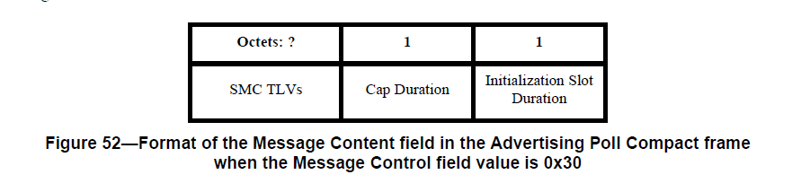
Change Figure 52 to:
Octets: 1 | 1 | variable
Cap Duration | Initialization Slot Duration | SMC TLVs

Notes to Editor:
- CID 738 (status = done) has already changed ‘?’ to ‘variable’
- The description order for the fields following the figure should also change to place the SMC TLVs at the end. This is not done here as the descriptions are missing and are covered by another CID.

Proposed resolution to 747 (Revised)
Current Figure 58 in Draft C:
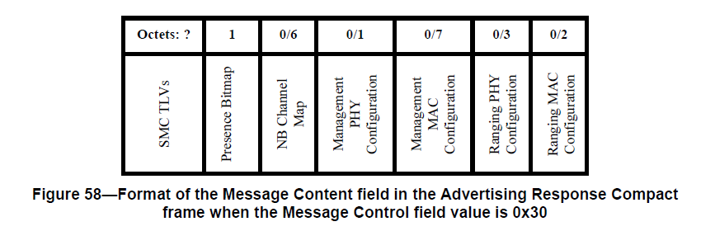
Change Figure 58 to:
Octets: 1 | 0/6 | 0/1 | 0/7 | 0/3 | 0/2 | variable
Presence Bitmap | NB Channel Map | Management PHY Configuration | Management MAC Configuration | Ranging PHY Configuration | Ranging MAC Configuration | SMC TLVs

Also change lines 14 and 15 on page 74 as indicated below -
The encoding/meanings of the Presence Bitmap, the NB Channel Map, the Management PHY Configuration, the Ranging PHY Configuration and the Ranging MAC Configuration fields in the message content are identical to that for the Message Control field values in 0x10 described above.
Notes to Editor:
- CID 744 (status = done) has already changed ‘?’ to ‘variable’.
- The description order for the fields following the figure should also change to place the SMC TLVs at the end. This is not done here as the description is missing and is covered by another CID.

