IEEE P802.15
Wireless Personal Area Networks

Project | IEEE P802.15 Working Group for Wireless Personal Area Networks (WPANs)
Title | Proposed resolution for RSS related comment IDs 503 and 926
Date Submitted | March 2024
Sources | Mickael Maman (STMicroelectronics), Sven Zeisberg (Zigpos)
Re:
Abstract
Purpose | To propose comments resolution for “P802.15.4ab™/D (pre-ballot) C Draft Standard for Low-Rate Wireless Networks”
Notice | This document does not represent the agreed views of the IEEE 802.15 Working Group or IEEE 802.15.4ab Task Group. It represents only the views of the participants listed in the “Sources” field above. It is offered as a basis for discussion and is not binding on the contributing individuals. The material in this document is subject to change in form and content after further study. The contributors reserve the right to add, amend or withdraw material contained herein.

Comment Index #926 in 15-24-0010-03-04ab-consolidated-comments-draft-c
Commenter | Index # | page | Sub-Clause | Line | Comment | Proposed Change
Zhenzhen Ye | 926 | 40 | 10.37.1 | 18 | Is this RSS only used with O-QPSK PHY? Should the name be changed to "RSS with O-QPSK" if it is the case? Can this not operate with any companions PHY? | Change to "The optional RSS part of this standard is designed to define a network infrastructure and portable device rules, based use of a narrow band PHY such as the O-QPSK PHY with a UWB PHY, with associated MAC features,

Discussion of comment ID 926:
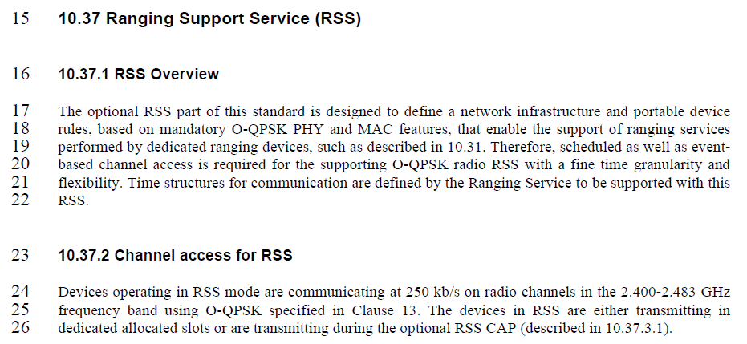
The commenter is asking if the RSS is intended to be used only with the O-QPSK PHY. The answer is yes, as described in section 10.37.2. However, renaming the section is not required. First, there is no need to put many details in a section name and second, keeping the name as it is would allow for possible future extensions without changing section name
Moreover, the commenter is asking, if the proposed scheme could not operate with any companion PHY. The answer is, that a generic RSS scheme may be able in principle to operate with other than the mentioned PHY. However, in the present approved update proposal, the RSS is deploying O-QPSK as described in section 10.37.2.
Proposed resolution:
revised
Proposed text changes on P802.15.4ab™/D (pre-ballot) C for comment ID 926:
10.37.1 RSS Overview
The optional RSS part of this standard is designed to define a network infrastructure and portable device rules, based on mandatory O-QPSK PHY and MAC features, that enable the support of ranging services performed by dedicated ranging devices, such as described in 10.32. Therefore, scheduled as well as event-based channel access is required for the supporting O-QPSK radio RSS with a fine time granularity and flexibility. Time structures for communication are defined by the Ranging Service to be supported with this RSS.
10.37.2 Channel access for RSS with O-QPSK
Devices operating in RSS mode with O-QPSK are communicating at 250 kb/s on radio channels in the 2.400-2.483 GHz frequency band using O-QPSK specified in Clause 13. The devices in RSS are either transmitting in dedicated allocated slots or are transmitting during the optional RSS CAP (described in 10.37.3.1).

Comment Index #503 in 15-24-0010-03-04ab-consolidated-comments-draft-c
Commenter | Index # | page | Sub-Clause | Line | Comment | Proposed Change
Tero Kivinen | 503 | 41 | 10.37.3.2 | 20 | I have now idea what the txt saying that ASN may be optionally used in the RSS slotframe? How it is used? ASN has complectly different properties than RSS slotframe etc has. Also "may optionally" is just may. | Remove ASN text.

Discussion for comment ID 503:
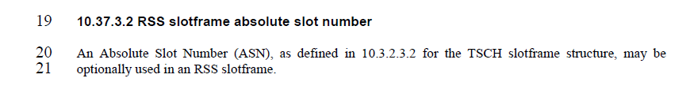
ASN is optionally used by the network infrastructure for slot-level synchronization of the RSS slotframe
Proposed resolution for comment ID 503:
revised
Pro Proposed text changes on P802.15.4ab™/D (pre-ballot) C for comment ID 503:
TBD

