IEEE P802.15
Wireless Personal Area Networks

Project | IEEE P802.15 Working Group for Wireless Personal Area Networks (WPANs)
Title | Proposed Comments Resolution on NB PHY
Date Submitted | March 2024
Sources | Bin Qian, Lei Huang, Rojan Chitrakar, David Xun Yang (Huawei)
Re:
Abstract
Purpose | To propose comments resolution for “P802.15.4ab™/D (pre-ballot) C Draft Standard for Low-Rate Wireless Networks”
Notice | This document does not represent the agreed views of the IEEE 802.15 Working Group or IEEE 802.15.4ab Task Group. It represents only the views of the participants listed in the “Sources” field above. It is offered as a basis for discussion and is not binding on the contributing individuals. The material in this document is subject to change in form and content after further study. The contributors reserve the right to add, amend or withdraw material contained herein.

Comment Index #459 in 15-24-0010-16-04ab-cc-consolidated-comments
CID | Commenter | Sub-Clause | Page | Line | Comment | Proposed Change
459 | Bin Qian | 13.2.5 | 154 | 2 | According to the figure, there are four symbols. Thus, change the figure description as "Mapping of chip sequences for four symbols starting with even-indexed symbols " | As in the comment

Discussion:
The original text is as follows
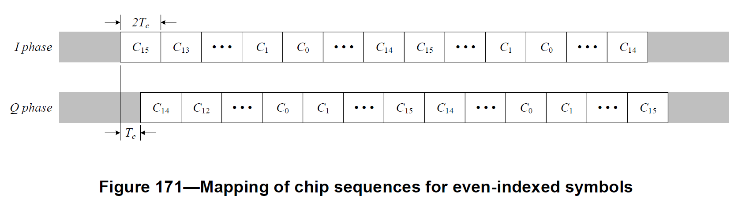
The figure has four symbols including even-indexed symbols and odd-indexed symbol.
Resolution: Revised
Proposed text changes on P802.15.4ab™/D (pre-ballot) C:
13.2.5 Symbol-to-chip mapping
Change Line 2 on Page 130 as follows
Figure 171—Mapping of chip sequences of four symbols starting with an even-indexed symbol

-------------------------------------------------------------------------------------------------------------------------------
Comment Index #163, 477, 238, 292, 460# in 15-24-0010-16-04ab-cc-consolidated-comments
CID | Commenter | Sub-Clause | Page | Line | Comment | Proposed Change
163 | Benjamin Rolfe | 13.3.2 | 154 | 14 | Incomplete specification (TBD) | Provide the PSD mask values or delete the clause
477 | Xiliang Luo | 13.3.2 | 154 | 14 | Table 48 should reuse Table 13-4 from P802.15.4me | Change ??? to: |f-fc|>3.5MHz, -20dB, -30dB
238 | Billy Verso | 13.3.2 | 154 | 15 | Missing numbers in Table 48—O-QPSK transmit PSD limits for the 5800 MHz and 6200 MHz bands | Fill in correct values.
292 | Carlos Aldana | 13.3.2 | 154 | 15 | The PSD limits in Table 48 of O-QPSK signals has not been properly defined | Please define the "??" values
460 | Bin Qian | 13.3.2 | 154 | 15 | The details of the PSD limits are missing | As in the comment

Discussion:
Regarding the frequency and relative limit, it is suggested to re-use the values in Table 13-4. The absolute limit shall comply with the local regulations
Resolution: Revised
Proposed text changes on P802.15.4ab™/D (pre-ballot) C:
13.3.2 Transmit power spectral density (PSD) mask
Change Line 10-15 on Page 130 as follows
When operating in the 5800 MHz or 6200 MHz band, the transmitted spectral products shall be less than the limits specified in Table 48. The absolute limit of Q-QPSK transmit PSD shall comply with the local regulations. For both relative and absolute limits, average spectral power shall be measured using a 100 kHz resolution bandwidth. For the relative limit, the reference level shall be the highest average spectral power measured within ± 1 MHz of the carrier frequency.
Table 48—O-QPSK transmit PSD limits for the 5800 MHz and 6200 MHz bands
Frequency | Relative limit
f-fC>???3.5 MHz | -20 dB

