IEEE P802.15
Wireless Personal Area Networks

Project | IEEE P802.15 Working Group for Wireless Personal Area Networks (WPANs)
Title | <802.15 TG4ab (NG-UWB) Conf. Call Mins. Jan. to Mar. 2024>
Date Submitted | [7 Mar, 2024]
Source | [David Xun Yang]  [Huawei]  [Bantian, Shenzhen, China] | Voice: [+86.159.1411.7462]  Fax: [--]  E-mail: [david.yangxun@huawei.com]
Re: | [802.15 TG4ab Conf. Call Mins]
Abstract | [Official Minutes of the Call]
Purpose | [Record the main points of the call]
Notice | This document has been prepared to assist the IEEE P802.15. It is offered as a basis for discussion and is not binding on the contributing individual(s) or organization(s). The material in this document is subject to change in form and content after further study. The contributor(s) reserve(s) the right to add, amend or withdraw material contained herein.
Release | The contributor acknowledges and accepts that this contribution becomes the property of IEEE and may be made publicly available by P802.15.

802.15 TG4ab (NG-UWB) Conf. Call Minutes
between Jan. and Mar. 2024 Mtgs.

Tuesday, 30 Jan 2024

Opening
9:03 AM ET 802.15 TG4ab Chair, Ben Rolfe (BCA), called the meeting to order.

Minutes
>25 participants were noted during the duration of the call

Utilizing the meeting and agenda doc. # 15-24-0105-00, the Chair conducted the following business:
- Opening
- Reviewed IEEE Patent Policy
  - Made call for claims with no responses
- Reviewed IEEE SA Participation Policy
- Reviewed IEEE SA Copyright Policy
- Reviewed 802 Rules

Announcement
Chair reviewed the proposed agenda (doc. # 15-24-0102-01). There was some discussion on the agenda for this morning. There was no objection to the updated agenda. It was approved with unanimous consent.

Clint Chaplin (SRA) shared “Consolidated Comments Draft C” (doc. # 15-24-0010-07). Billy Verso (Qorvo) discussed the comments assigned to the editor.

Alex Krebs (Apple) presented “DraftC comment resolution 1/30/2024”
(doc. # 15-24-0103-00)
This presentation is to resolve comments related to MMS – Synchronized Responders related comments.
Alex was going to continue the presentation in the afternoon session.

Chair asked if there is any other business to discuss. No request heard.

Chair recessed the call @10:03am ET until 6pm ET.

Tuesday, 30 Jan 2024

Opening
6:03 PM ET 802.15 TG4ab Chair, Ben Rolfe (BCA), called the meeting to order

Minutes
>25 participants were noted during the duration of the call

Alex Krebs (Apple) continued his presentation “DraftC comment resolution 1/30/2024”
(doc. # 15-24-0103-00)
This presentation is to resolve comments related to MMS – Synchronized Responders related comments.

Bin Qian (Huawei) presented “Proposed Comments Resolution on Compact Frame – Follow Up”
(doc. # 15-24-0104-00)
This presentation is to resolve comments on compact frame.

Chair asked if there is any other business to discuss. No request heard.

Chair recessed the call @7:05am ET until 9am, 6 Feb, ET.

Tuesday, 6 Feb 2024

Opening
9:03 AM ET 802.15 TG4ab Chair, Ben Rolfe (BCA), called the meeting to order

Minutes
>25 participants were noted during the duration of the call

Utilizing the meeting and agenda doc. # 15-24-0105-01, the Chair conducted the following business:
- Opening
- Reviewed IEEE Patent Policy
  - Made call for claims with no responses
- Reviewed IEEE SA Participation Policy
- Reviewed IEEE SA Copyright Policy
- Reviewed 802 Rules

Announcement
Chair reviewed the proposed agenda (doc. # 15-24-0102-04). There was some discussion on the agenda. It was approved with unanimous consent.

Bin Qian (Huawei) presented “Proposed Comments Resolution on Compact Frame – Follow Up”
(doc. # 15-24-0104-01)
This presentation is to resolve comments on compact frame.
There was no objection to the comment resolutions as in doc. # 15-24-0104-01.

Alex Krebs (Apple) presented “DraftC comment resolution 1/30/2024”
(doc. # 15-24-0103-02)
This presentation is to resolve comments related to MMS – Synchronized Responders related comments.

Chair emphasized that email reflector is available.

There were requests to amend the agenda.

Chair recessed the call @10:01am ET until 6pm ET.

Tuesday, 6 Feb 2024

Opening
6:03 PM ET 802.15 TG4ab Chair, Ben Rolfe (BCA), called the meeting to order

Minutes
>20 participants were noted during the duration of the call

Utilizing the meeting and agenda doc. # 15-24-0105-01, the Chair conducted the following business:
- Opening
- Reviewed IEEE Patent Policy
  - Made call for claims with no responses
- Reviewed IEEE SA Participation Policy
- Reviewed IEEE SA Copyright Policy
- Reviewed 802 Rules

Announcement
Chair reviewed the proposed agenda (doc. # 15-24-0102-05). There was some discussion on the agenda. It was approved with unanimous consent.

Bin Qian (Huawei) presented “Proposed Comments Resolution on time efficient one-to-many ranging”
(doc. # 15-24-0109-00)
This presentation is to resolve comments on one-to-many ranging.

Rojan Chitrakar (Huawei) presented “Proposed Resolution for MMS short term operating parameters”
(doc. # 15-24-0110-00)
This presentation is to resolve comments on MMS short term operating parameters.

Hongwon Lee (LG) presented “Resolution proposal regarding MMS MAC-public part 1 for P802.15.4ab™/Draft (pre-ballot) C”
(doc. # 15-24-0108-02)
This presentation is to resolve comments on MMS MAC.

There were requests to use the slots on Feb 13 for ad hoc discussion.

Chair recessed the call @7:03pm ET until 9am Feb 20, ET.

Tuesday, 20 Feb 2024

Opening
9:03 AM ET 802.15 TG4ab Chair, Ben Rolfe (BCA), called the meeting to order

Minutes
>20 participants were noted during the duration of the call

Utilizing the meeting and agenda doc. # 15-24-0105-04, the Chair conducted the following business:
- Opening
- Reviewed IEEE Patent Policy
  - Made call for claims with no responses
- Reviewed IEEE SA Participation Policy
- Reviewed IEEE SA Copyright Policy
- Reviewed 802 Rules

Announcement
Chair reviewed the proposed agenda (doc. # 15-24-0102-08). There were some discussions on the agenda.

Editor Billy Verso (Qorvo) introduced the progress of editorial comment resolutions and resolved comments # 493, 494 and 495 based on doc. # 15-24-0010-11.

Alex Krebs (Apple) presented “Discussion on RPA_hash collisions”
(doc. # 15-24-0126-00)
This presentation is to discuss the questions/claims raised in DCN 24-85r0 on what is the probability and impact of collisions in NBA-UWB MMS using compact frames and RPA_hash addresses.
There were lots of discussions.

Vice chair Clint Chaplin (SRA) introduced the progress of comment resolutions.

Chair recessed the call @10:02am ET until 6pm ET.

Tuesday, 20 Feb 2024

Opening
6:03 PM ET 802.15 TG4ab Chair, Ben Rolfe (BCA), called the meeting to order.

Minutes
>30 participants were noted during the duration of the call

Utilizing the meeting and agenda doc. # 15-24-0105-04, the Chair conducted the following business:
- Opening
- Reviewed IEEE Patent Policy
  - Made call for claims with no responses
- Reviewed IEEE SA Participation Policy
- Reviewed IEEE SA Copyright Policy
- Reviewed 802 Rules

Announcement
Chair reviewed the proposed agenda (doc. # 15-24-0102-08). There were some discussions on the agenda.

Rojan Chitrakar (Huawei) presented “Proposed resolution for Hyperblock security”
(doc. # 15-24-0112-00)
This presentation proposes resolutions to comments on Hyperblock security.

Rojan Chitrakar (Huawei) presented “Proposed resolution for Hyperblock block-assignment”
(doc. # 15-24-0111-00)
This presentation proposes resolutions to comments on Hyperblock assignment.

Vice chair Clint Chaplin (SRA) checked the status of resolved comments with assignees. (doc. # 15-24-0010-12)

Chair recessed the call @7:03pm ET until 9am Feb 27, ET.

Tuesday, 27 Feb 2024

Opening
9:03 AM ET 802.15 TG4ab Chair, Ben Rolfe (BCA), called the meeting to order as a joint meeting of the TG and 802.11 CoEx SC with co-chair Marc Emmelmann (Self).

Minutes
>20 participants were noted during the duration of the call

Utilizing the meeting and agenda doc. # 15-24-0105-04, the Chair conducted the following business:
- Opening
- Reviewed IEEE Patent Policy
  - Made call for claims with no responses
- Reviewed IEEE SA Participation Policy
- Reviewed IEEE SA Copyright Policy
- Reviewed 802 Rules

Announcement
Chair reviewed the proposed agenda (doc. # 15-24-0102-10). Chair added something for this afternoon (tomorrow morning) for editor's review of comments (doc. # 15-24-0102-11). There was no further discussion on agenda, approved without objection.

Carlos Aldana (Meta) presented “CCA Modes in 802.15.4”
(doc. # 11-24-0360-00)
This presentation provides a background on 802.15.4ab NB modes, reviews the CCA Modes in 802.15.4me Draft 3, and deferred comments.
There are lots of discussions on the existing text and resolutions to deferred comments.
Discussions will continue in Mar F2F.

Chair recessed the call @10:01pm ET until 6pm Feb 27, ET.

Tuesday, 27 Feb 2024

Opening
6:02 PM ET 802.15 TG4ab Chair, Ben Rolfe (BCA), called the meeting to order

Minutes
>20 participants were noted during the duration of the call

Utilizing the meeting and agenda doc. # 15-24-0105-04, the Chair conducted the following business:
- Opening
- Reviewed IEEE Patent Policy
  - Made call for claims with no responses
- Reviewed IEEE SA Participation Policy
- Reviewed IEEE SA Copyright Policy
- Reviewed 802 Rules

Announcement
Chair reviewed the proposed agenda (doc. # 15-24-0102-10). There were some discussions on the agenda.

Vice chair Clint Chaplin (SRA) checked the status of resolved comments with assignees. (doc. # 15-24-0010-14)

Bin Qian (Huawei) presented “Proposed Comments Resolution on time efficient one-to-many ranging”
(doc. # 15-24-0115-01)
This presentation is to resolve comments on the time efficiency of one-to-many ranging.
There were several discussions. The contribution will be updated to r2 accordingly.
There was no objection to the comment resolutions as in doc. # 15-24-0115-02.

Chair reviewed the call schedule and related agenda for the next week. There was a new request for the next call.

Chair introduced the progress of comment resolutions. Letter ballot may be launched after Mar meeting.
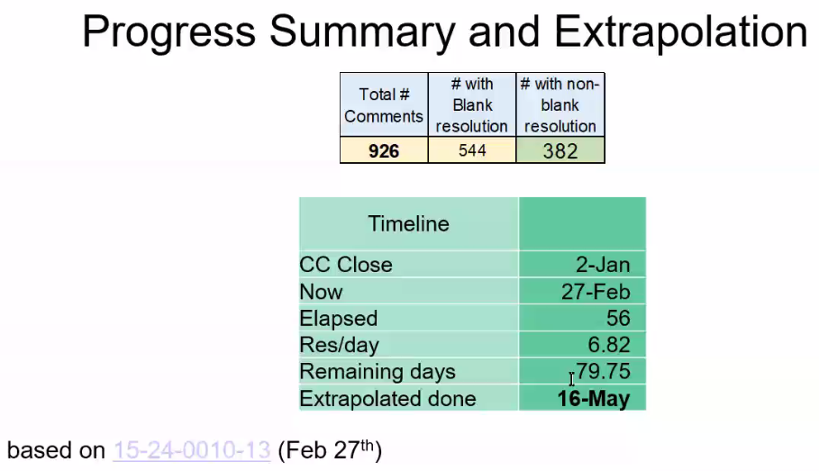

Chair recessed the call @6:56pm ET until 9am Mar 5, ET.

Tuesday, 5 Mar 2024

Opening
9:02 AM ET 802.15 TG4ab Chair, Ben Rolfe (BCA), called the meeting to order.

Minutes
>20 participants were noted during the duration of the call

Utilizing the meeting and agenda doc. # 15-24-0105-06, the Chair conducted the following business:
- Opening
- Reviewed IEEE Patent Policy
  - Made call for claims with no responses
- Reviewed IEEE SA Participation Policy
- Reviewed IEEE SA Copyright Policy
- Reviewed 802 Rules

Announcement
Chair reviewed the updated agenda (doc. # 15-24-0102-13). There was no further discussion on agenda, approved without objection.

Carl Murray (Qorvo) presented “Consensus before resolving ‘non-NBA’ MMS ranging CIDs”
(doc. # 15-24-0120-00)
Riku Pirhonen (NXP) presented “UWB control and ranging phase discussions”
(doc. # 15-24-0133-00)
There were lots of discussions on options.

Chair recessed the call @10:00pm ET until 6pm Mar 5, ET.

Tuesday, 5 Mar 2024

Opening
6:06 PM ET 802.15 TG4ab Chair, Ben Rolfe (BCA), called the meeting to order.

Minutes
>20 participants were noted during the duration of the call

Utilizing the meeting and agenda doc. # 15-24-0105-07, the Chair conducted the following business:
- Opening
- Reviewed IEEE Patent Policy
  - Made call for claims with no responses
- Reviewed IEEE SA Participation Policy
- Reviewed IEEE SA Copyright Policy
- Reviewed 802 Rules

Announcement
Chair reviewed the agenda (doc. # 15-24-0102-13). There was no discussion on agenda, approved without objection.

Rojan Chitrakar (Huawei) presented “Clarifications for Initialization and setup for O2M MMS Ranging”
(doc. #15-24-0124-00)
This presentation proposes to make the Initialization and Setup phase for one-to-many MMS ranging more clear.

Rojan Chitrakar (Huawei) presented “Proposed resolutions for mms Initialization and Setup for O2M ranging”
(doc. #15-24-0125-00)
This presentation proposes resolutions for comments on MMS initialization and setup for one-to-many ranging.

Billy Verso (Qorvo) presented “Draft C comment assignments – Resolutions I”
(doc. #15-24-0107-00)
This presentation proposes resolutions for selected comments.
There was no objection to the comment resolutions as in doc. # 15-24-0107-00.

Vice chair Clint Chaplin (SRA) assigned several comments as in “Consolidated Comments Draft c” (doc. #15-24-0010-16).

Chair reviewed the progress of comment resolutions.
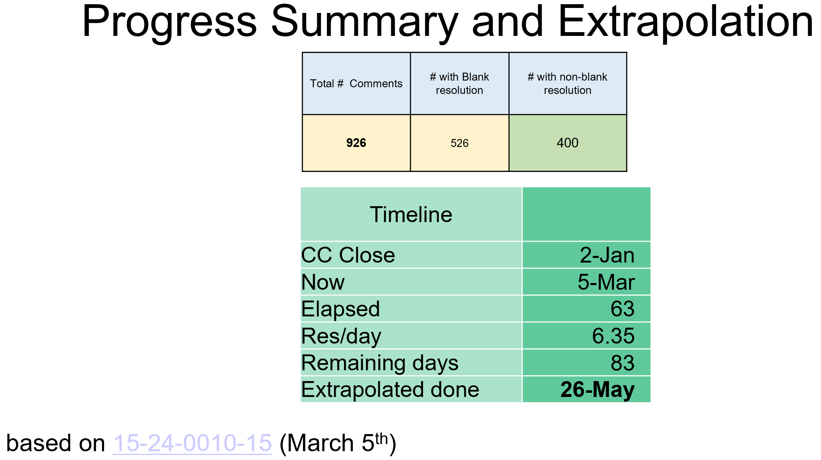

Chair adjourned the call @7:06pm ET.

