IEEE P802.15
Wireless Personal Area Networks

Project | IEEE P802.15 Working Group for Wireless Personal Area Networks (WPANs)
Title | Proposed Resolution for MMS – Initialization and Setup for One-to-many
Date Submitted | February 2024
Sources | Rojan Chitrakar, Lei Huang (Huawei)  rojan.chitrakar@huawei.com
Re:
Abstract
Purpose | To propose resolution for MMS – Synchronized Responders related comments for “P802.15.4ab™/D (pre-ballot) C Draft Standard for Low-Rate Wireless Networks” .
Notice | This document does not represent the agreed views of the IEEE 802.15 Working Group or IEEE 802.15.4ab Task Group. It represents only the views of the participants listed in the “Sources” field above. It is offered as a basis for discussion and is not binding on the contributing individuals. The material in this document is subject to change in form and content after further study. The contributors reserve the right to add, amend or withdraw material contained herein.

Rev 0: Initial version.

Comment Indices in 15-24-0010-00-04ab-consolidated-comments-draft-c:
Name | Index# | Pg | Sub-Clause | Ln | Comment | Proposed Change | Disposition
Rojan Chitrakar | 606 | 45 | 10.38.3.3 | 17 | Not all Advertising Poll Compact frame carry the CapDuration field that is need for contention; only those with message control 0x20 and 0x30 carry the field. | Rephrase as:  "…, the initiator sends an AAdvertising Poll Compact frame with the Message Control field set to 0x20 or 0x30 ..." | Revised
Rojan Chitrakar | 607 | 46 | 10.38.3.3 | 14 | Does this mean that if two or more responders are selected, coordination is mandatory? Else, the procedure for one-to-many when coordination is not active should also be described. | Describe the procedure for one-to-many when coordination is not active. | Revised
Carl Murray | 687 | 45 | 10.38.3.3 | 14 | The one-to-many without cordination is not handled and may be quite useful as it has less overhead. | Include one-to-many without cordination | Revised

Discussion: See DCN xxxx Clarifications for One-to-many MMS Ranging
Disposition Detail:
Proposed text changes on P802.15.4ab™/D (pre-ballot) C:
10.38.3.2.2 Initialization setup handshake for one-to-one ranging
Note to editor: Title of 10.38.3.4 is already changed by #690
…
10.38.3.2.3 Contention based initialization setup handshake (#11, #606, #607, #687)
Change the subfield as follows (Track changes ON)
Contention based initialization and setup may be used for one-to-one ranging or one-to-many ranging. In the contention-based initialization and setup phase, the initiator sends an Advertising Poll Compact frame carrying the Cap Duration field and the Initialization Slot Duration field to one or more intended responders opportunistically at times and intervals as deemed suitable for the higher layer functionality to be supported.
…
If only a single responder is selected for one-to-one ranging and the coordination is inactive, the initiator shall send a Start of Ranging Compact frame to the selected responder in the initialization slot following the CAP. The Start of Ranging Compact frame indicates the corresponding ranging configurations and the time offset between the start of the Start of Ranging Compact frame and the start of the first ranging block. Figure 25 shows the contention-based initialization and setup process for one-to-one ranging when coordination is inactive.
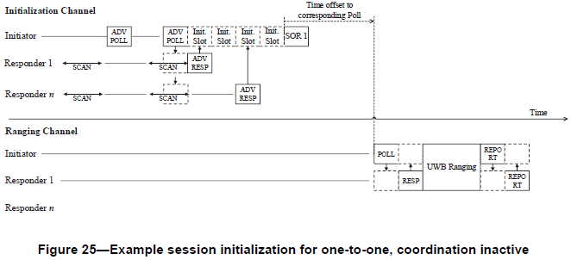
Change SOR 1 to SOR in Figure 25
If only a single responder is selected for one-to-one ranging and the coordination is active, the initiator should send an Advertising Confirmation Compact frame to the selected responder in the initialization slot following the CAP to indicate the time offset between the start of the Advertising Confirmation Compact frame and the start of a following Start of Ranging Compact frame, during which the initiator may attempt to capture the acquisition packets transmitted by other initiators on the initialization channel in NB and/or the default channel in UWB. Then the initiator should send the Start of Ranging Compact frame to the selected responder at the time indicated in the preceding Advertising Confirmation Compact frame. The Start of Ranging Compact frame specifies the corresponding ranging configurations and the time offset between the start of the Start of Ranging Compact frame and the start of the first ranging block. Figure 26 shows an example contention-based initialization and setup process for one-to-one ranging when coordination is active.
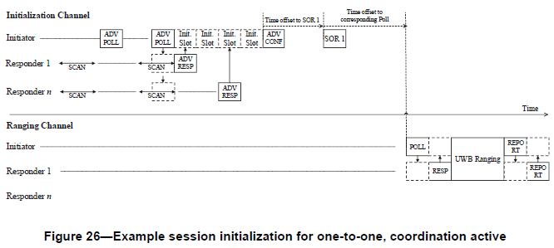
Change SOR 1 to SOR in Figure 26
If two or more responders are selected, the initiator shall send an Advertising Confirmation Compact frame indicating the selected responders and the time offset between the start of the Advertising Confirmation Compact frame and the start of the separate Start of Ranging Compact frame that will be sent to each of the selected responders. If coordination is active, during the minimum of all the time offsets, the initiator may attempt to capture the acquisition packets transmitted by other initiators on the initialization channel in NB and/or the default channel in UWB. Then the initiator should send Start of Ranging Compact frames to the selected responders individually at the respective times indicated in the preceding Advertising Confirmation Compact frame. If the initiator intends to perform multiple one-to-one ranging with the selected responders, each Start of Ranging Compact frame specifies the corresponding ranging configurations and the time offset between the first symbol of the Start of Ranging Compact frame and the first symbol of the One-to-one Poll Compact frame addressed to the corresponding responders. Figure 27 shows an example contention-based initialization and setup process for multiple one-to-one ranging.
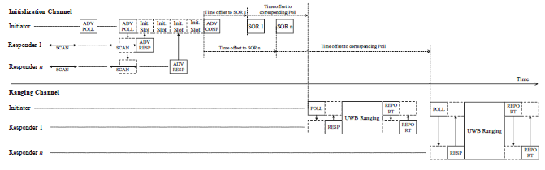
Figure 27 – Example session initialization for multiple one-to-one
If two or more responders are selected and the initiator intends to perform one-to-many ranging with the selected responders, each Start of Ranging Compact frame specifies the corresponding ranging configurations and the time offset between the first symbol of the Start of Ranging Compact frame and the first symbol of the first One-to-many Poll Compact frame addressed to all the selected responders in the first ranging block. Figure 27A shows an example contention-based initialization and setup process for one-to-many ranging.
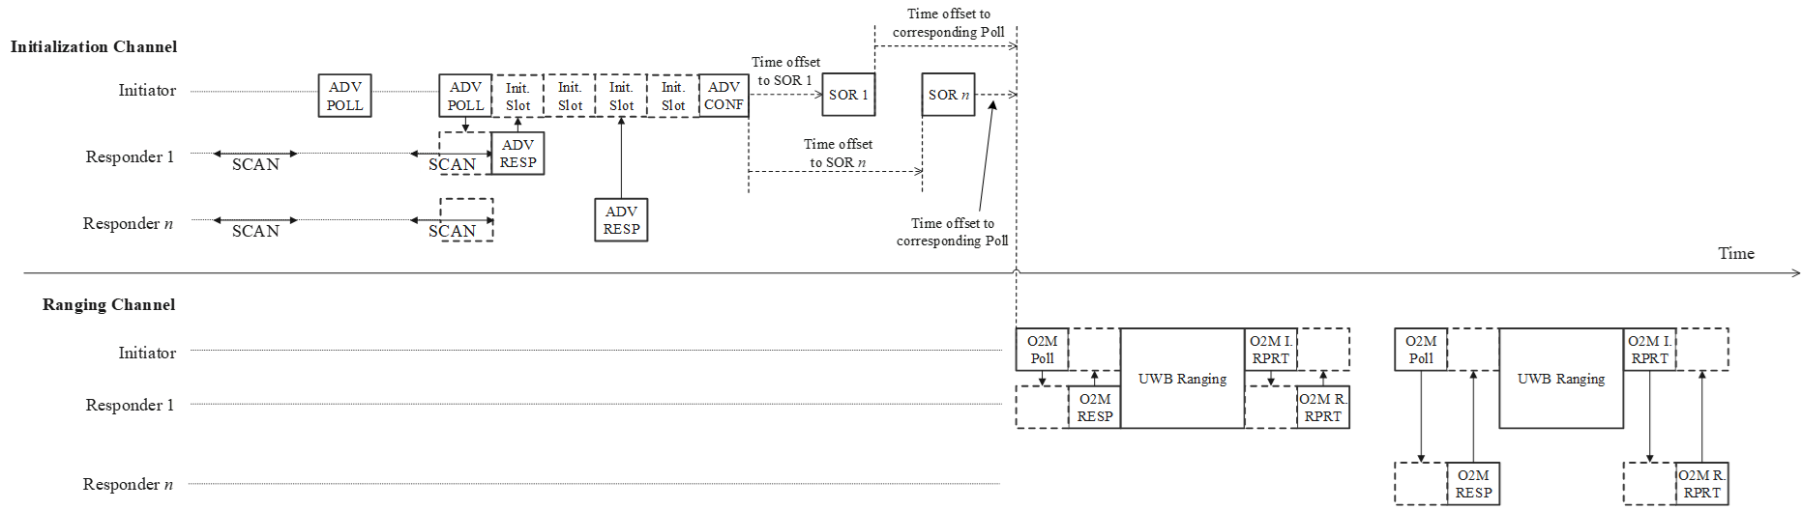
Figure 27A – Example session initialization for one-to-many
Upon receipt of the Advertising Confirmation Compact frame in the CAP, each of the selected responders shall listen for its incoming Start of Ranging Compact frame at the corresponding time specified in the Advertising Confirmation Compact frame.
After transmitting the Start of Ranging Compact frame, the initiator shall enter the control phase. After receiving the Start of Ranging Compact frame, the responder shall enter the control phase. After the initiator has confirmed receipt of the RESP Compact frame from the responder during the control phase, and unless initialization of further devices is required, the initiator shall discontinue ranging initialization and cease the transmission of Advertising Poll Compact frame.

10.38.3.3 UWB MMS ranging session initialization using public addresses

…

