IEEE P802.15
Wireless Personal Area Networks

Project | IEEE P802.15 Working Group for Wireless Personal Area Networks (WPANs)
Title | Proposed Resolution for CIR Report IE format
Date Submitted | February 2024
Sources | Rojan Chitrakar, Lei Huang (Huawei)  rojan.chitrakar@huawei.com
Re:
Abstract
Purpose | To propose resolution for CIR Report IE related comments for “P802.15.4ab™/D (pre-ballot) C Draft Standard for Low-Rate Wireless Networks” .
Notice | This document does not represent the agreed views of the IEEE 802.15 Working Group or IEEE 802.15.4ab Task Group. It represents only the views of the participants listed in the “Sources” field above. It is offered as a basis for discussion and is not binding on the contributing individuals. The material in this document is subject to change in form and content after further study. The contributors reserve the right to add, amend or withdraw material contained herein.

Rev 0: Initial version.
Rev 1: Minor editorial fixes
Rev 2: Fixed Figures XX-1 and XX-2 based on feedback.

Part-1 - Comment Indices in 15-24-0010-00-04ab-consolidated-comments-draft-c:
Name | Index# | Pg | Sub-Clause | Ln | Comment | Proposed Change | Disposition
Rojan Chitrakar | 669 | 127 | 10.39.7.2 | 16 | "The Measurement ID field carries a unique ID that identifies a particular sensing measurement instance."  If the report is fragmented, the Measurement ID field shall carry the same value in all fragments. | Add after the cited sentence (at line 17):  "If the report is fragmented, the Measurement ID field shall be set to the same value in all report fragments corresponding to the same measurement instance." | Revised  Behavioral sub-clause is added to describe the fragmenation method
Rojan Chitrakar | 671 | 128 | 10.39.7.2 | 22 | When compression is enabled, the length of the compressed receive report(s) may not be known to the receiver of the report and hence the length of the field should be included. | When compression is enabled, include a length field in the Receive Report. | Revised  Agree that a length of the CIR Taps field is needed in all fragments (with or without compression) to make each fragment self-contained.
Pooria Pakrooh | 105 | 128 | 10.39.7.2 | 23 | In the noncompressed case, a fragment may contain report for the second part of a segment/antenna. Therefore, the antenna and segment IDs missing, and the report fragment would not be self contained in this case. Clarify the behavior in such scenarios. | In the noncompressed case, a fragment may contain report for the second part of a segment/antenna. Therefore, the antenna and segment IDs missing, and the report fragment would not be self contained in this case. Clarify the behavior in such scenarios. | Revised  Agree that the Rx Ant Id and Segment ID are needed in all fragments to make each fragment self-contained.
Pooria Pakrooh | 108 | 129 | 10.39.7.2 | 7 | Even for nonfragmented report, the Rx and Segment ID are needed. | Remove "If the report is fragmented". | Revised  Agree that even for nonfragmented report, the Rx and Segment ID are useful.
Pooria Pakrooh | 109 | 129 | 10.39.7.2 | 9 | Even for nonfragmented report, the Rx and Segment ID are needed. | Remove "If the report is fragmented". | Revised  Agree that even for nonfragmented report, the Rx and Segment ID are useful.
Rojan Chitrakar | 672 | 128 | 10.39.7.2 | 22 | When frequency stitching is used with more than 4 sensing fragments (e.g., across 3 or more channels with a SENS PPDU with more than one segment each), the 2 bits Segment ID is not enough to identify the sensing fragments corresponding to the CIR report. While increasing the number of bits for the Segment ID field could also work, a better approach would be signaling the channel corresponding to the sensing fragment to avoid any ambiguity. | Add a channel ID field in the Receive Report field to identify the channel corresponding to the sensing fragment. The field shall be present when frequency stitching is used. | Revised  See discussion

Discussion：
Example 1 with no compression:
A length of the CIR Taps field is added in all fragments (with or without compression) to make each fragment self-contained. Rx Ant ID, Seg ID is also present in the second part of the receive report when split into 2.

Example 2 with compression:
When compression is enabled, the CIR Taps field of each receive report is compressed independently. The length of the compressed CIR Taps field is not known to the receiver. A length of the CIR Taps field is needed (with or without fragmentation) for the receiver to correctly recover the compressed CIR Taps.
Example 3 with frequency stitching:
When frequency stitching is enabled and SENS PPDUs are transmitted on different channels, the Rx Ant ID and Segment ID in the Receive Reports will get repeated. To identify the reports, channel id field is added. The channel id field is reserved for non-frequency stitching cases.

Summary of the CIR Report IE format (newly added fields highlighted in red):
Disposition: Revised
Disposition Detail:
Proposed text changes on P802.15.4ab™/D (pre-ballot) C:

10.39.7.2 CIR Report IE (#)
Change the subfield as follows (Track changes ON)
…
The Report Parameters Control field shall be formatted as shown in 21 Figure 147.
…
Each receiver report in the Receive Report(s) field shall be formatted as shown in Figure 149.

Octets: 0 or 3 | 1 or 3 | Variable
Receive Report Description | Receive Report Control | CIR Taps
Figure 149 - Format of each Receive Report in the Receive Report field(s) of the CIR report IE
The Receive Report Description field shall be formatted as shown in Figure 149B.
Bits: 0-5 | 6-9 | 10-15 | Octets: 1
Timing Offset | Normalization Factor | Reserved | RSSI
Figure 149B - Receive Report Description field format
The Timing Offset field value reports the timing offset between the reference tap and the CIR report timing …
…

The RSSI field is a measure of the received signal strength at the antenna for the received sequence used to …
The Receive Report Control field shall be formatted as shown in Figure 149C.

Bits: 0-1 | 2-3 | 4-7 | Octets: 0 or 2
Rx Antenna ID | Segment ID | Channel ID | CIR Taps Length
Figure 149C - Receive Report Control field format
The Rx Antenna ID field identifies the receive antenna corresponding to the CIR taps.
The Segment ID field identifies the Sensing PPDU SENS segment corresponding to the CIR taps.
The Channel ID field indicates the channel corresponding to the CIR taps when frequency stitching is enabled. The Channel ID field is reserved when frequency stitching is not enabled.
The CIR Taps Length field indicates the length of the CIR Taps field and shall be present only if the report is fragmented or if the report is compressed.
NOTE 1 – The maximum length of the CIR Taps field is restricted by the Frame Length field of the PHR field.
NOTE 2 – If the First Report Fragment field in the Report Identity Control field is equal to 1 and the Remaining Report Fragments field in the Report Identity Control field is equal to 0, it indicates that the report is not fragmented. Any other values of the First Report Fragment field and the Remaining Report Fragments field indicate that the report is fragmented.

10.39.4.5 Window-based CIR measurement report
Add the following new sub-clause at the end of 10.39.4.5
10.39.4.5.3 CIR measurement report Fragmentation
The CIR Report IE as described in 10.39.7.2 is used to carry the CIR measurement report. If the size of the CIR Report IE exceeds the available space in the Payload field of the host frame, the Receive Report(s) field of the CIR Report IE shall be divided into up to 32 fragments. All fragments, with the exception of the final fragment, should fill the available space in the Payload field of the host frame.
Each fragment shall be carried in a separate CIR Report IE and the fields of each CIR Report IE are included as follows:
— The Report Identity Control field shall be present in all CIR Report IE. Except the First Report Fragment field and the Remaining Report Fragments field, each of the rest of the fields of the Report Control field shall be set to the same value in all fragments. The Measurement ID field helps to identify all the fragments that belong to the same CIR measurement report. The First Report Fragment field and the Remaining Report Fragments field is used to keep track of the fragment order and is set as described in 10.39.7.2.
— The Report Parameters Control field shall be present only if the First Report Fragment field value (in the Report Identity Control field) is one and is not present otherwise.
— The Receive Report(s) field carry one or more receive reports that are arranged as described in 10.39.7.2. Even when the receive reports are carried in multiple CIR Report IEs, the reports shall follow the order described in 10.39.7.2 across all the fragments. The sub-fields of each receive report are included as follows:
- When a receive report is divided into two parts and carried in two different CIR Report IEs, the Receive Report Description field shall only be present in the first part of the receive report and not present in the second part.
- The Receive Report Control field shall be present in all receive reports. If a report is fragmented or if the report is compressed, the CIR Taps Length field shall be present in all receive reports. When a receive report is divided into two parts and carried in two different CIR Report IEs, the Receive Report Control field (including the CIR Taps Length field) shall be present in each part of the receive report in its entirety. In other words, the Receive Report Control field shall not be split across two CIR Report IEs.
NOTE 1 - The CIR Taps Length field may be omitted when the CIR measurement report is not fragmented or the receive report is not compressed.
NOTE 2 – To avoid the Receive Report Control field being split across two CIR Report IEs, some of the available space in the Payload field of the host frame may be left unused.
- The CIR Taps field shall be present in all receive reports.
An example fragmentation procedure when compression is not enabled is illustrated in Figure XX-1.
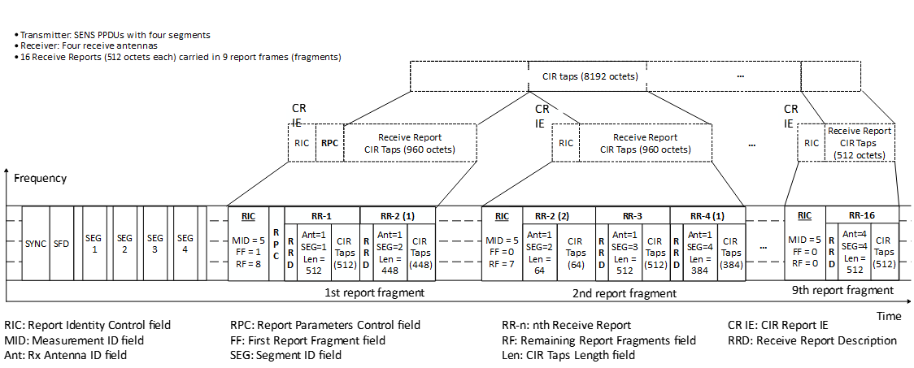
Figure xx-1—Example CIR measurement report fragmentation when compression is disabled
If compression is enabled (as indicated by the Compression field in the Report Parameters Control field of the CIR Report IE), the CIR Taps field of each receive report shall be DEFLATE compressed individually. If the size of the CIR Report IE still exceeds the available space in the Payload field of the host frame, the Receive Report(s) field is fragmented as described above. An example fragmentation procedure when compression is enabled is illustrated in Figure XX-2.
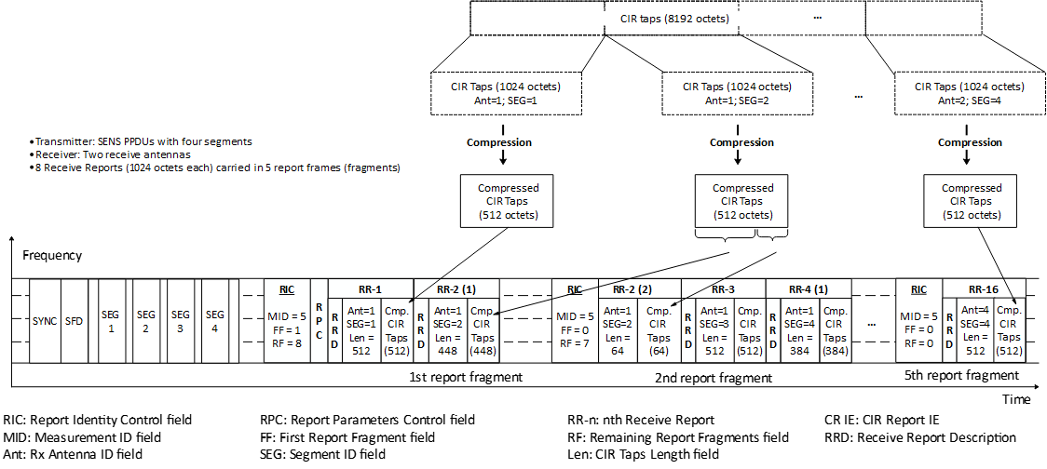
Figure xx-2—Example CIR measurement report fragmentation when compression is enabled
An example fragmentation procedure when frequency stitching is used is illustrated in Figure XX-3.

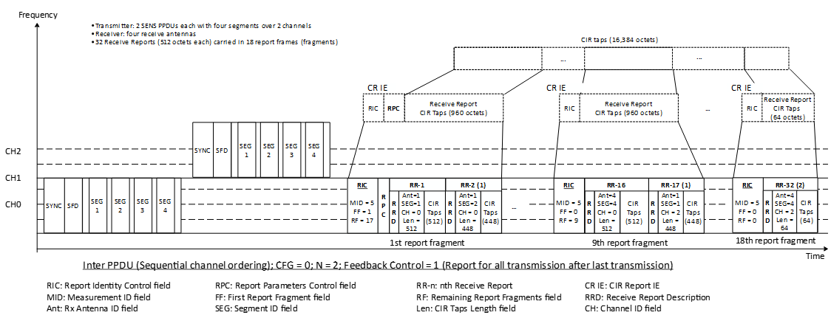
Figure xx-3—Example CIR measurement report fragmentation with frequency stitching

