IEEE P802.15
Wireless Personal Area Networks

Project | IEEE P802.15 Working Group for Wireless Personal Area Networks (WPANs)
Title | Proposed Resolution for MMS short term operating parameters
Date Submitted | February 2024
Sources | Rojan Chitrakar, Lei Huang (Huawei)  rojan.chitrakar@huawei.com
Re:
Abstract
Purpose | To propose resolution for MMS short term operating parameters related comments for “P802.15.4ab™/D (pre-ballot) C Draft Standard for Low-Rate Wireless Networks” .
Notice | This document does not represent the agreed views of the IEEE 802.15 Working Group or IEEE 802.15.4ab Task Group. It represents only the views of the participants listed in the “Sources” field above. It is offered as a basis for discussion and is not binding on the contributing individuals. The material in this document is subject to change in form and content after further study. The contributors reserve the right to add, amend or withdraw material contained herein.

Rev 0: Initial version.

Comment Indices in 15-24-0010-00-04ab-consolidated-comments-draft-c:
Name | Index# | Pg | Sub-Clause | Ln | Comment | Proposed Change | Disposition
Li-Hsiang Sun | 13 | 50 | 10.38.4.1 | 34 | "If the responder receives a poll Compact frame from the initiator with a request to suggest short-term operating parameters and is not intending to send any measurement report in the current ranging round, then the response Compact frame transmitted by the responder shall include the  suggested short-term operating parameters. "  Responder may need some time to ccome up with the suggested short term parameters such as NB Channel Map | change shall to may in this paragraph and in p53L10 | Revised  Shall is changed to should (instead of may)
Carl Murray | 692 | 50 | 10.38.4.1 | 36 | Recommend changing "shall" to "may" as there is no good reason to force the responder to propose short term parameters if it has no suggestions to make. It will just end up sending back the long-term parameters. | Change "shall" to "may" | Revised  Shall is changed to should (instead of may)

Discussion：
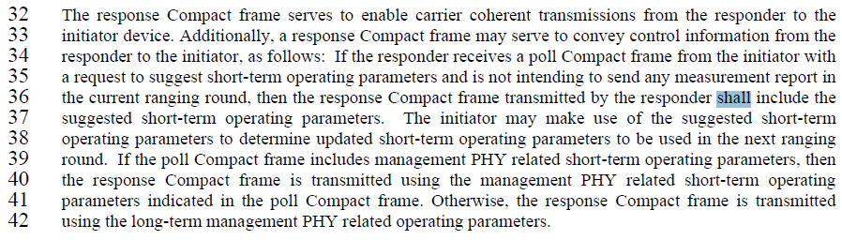
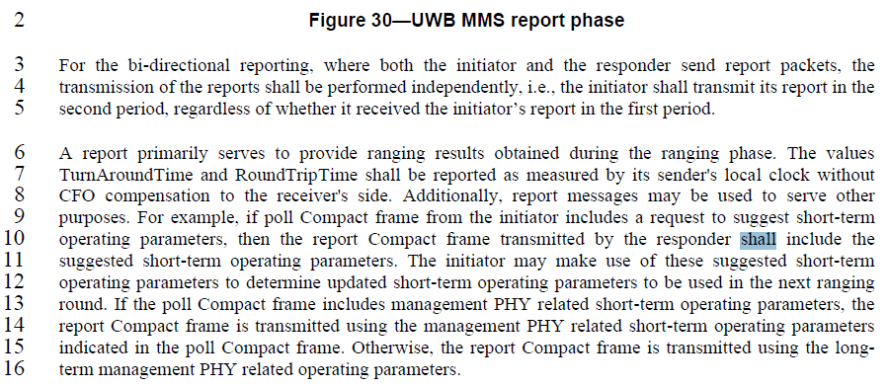

Comment Indices in 15-24-0010-00-04ab-consolidated-comments-draft-c:
Name | Index# | Pg | Sub-Clause | Ln | Comment | Proposed Change | Disposition
Carl Murray | 693 | 50 | 10.38.4.1 | 39 | Although this is meant to be a clarifying statement it introduces potential ambiguity. The purpose of the short term parameters is already well defined.This statement repeats the purpose but only partially and therefore is potentially ambiguous. For instance what happens to the Report compact frame? |  | Revised

Discussion
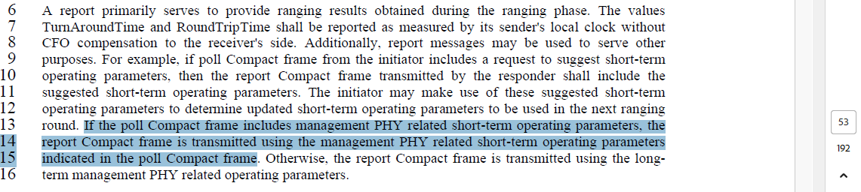
Disposition: Revised
Disposition Detail:
10.38.4.1 General
…
The poll Compact frame (10.38.10.7) serves to enable carrier coherent transmissions from the initiator to the responder device. Additionally, the poll Compact frame may indicate short-term operating parameters for the current ranging round and optionally request that the responder suggests short-term operating parameters for the next ranging round. The poll Compact frame is transmitted at long-term management PHY configuration. After receiving the poll Compact frame including short-term operating parameters, the responder shall update the short-term operating parameters accordingly. The updated short-term operating parameters take effect at the end of the poll Compact frame and are only applicable to the current ranging round. All subsequent transmissions in the current ranging round shall use the updated operating parameters. All parameters revert to the long-term operating parameter in the next ranging round.
The response Compact frame serves to enable carrier coherent transmissions from the responder to the initiator device. Additionally, a response Compact frame may serve to convey control information from the responder to the initiator, as follows: If the responder receives a poll Compact frame from the initiator with a request to suggest short-term operating parameters and is not intending to send any measurement report in the current ranging round, then the response Compact frame transmitted by the responder should include the suggested short-term operating parameters. The initiator may make use of the suggested short-term operating parameters to determine updated short-term operating parameters to be used in the next ranging round.
10.38.6 UWB MMS report phase
…
A report primarily serves to provide ranging results obtained during the ranging phase. The valuesTurnAroundTime and RoundTripTime shall be reported as measured by its sender's local clock without CFO compensation to the receiver's side. Additionally, report messages may be used to serve other purposes. For example, if poll Compact frame from the initiator includes a request to suggest short-term operating parameters, then the report Compact frame transmitted by the responder should include the suggested short-term operating parameters. The initiator may make use of these suggested short-term operating parameters to determine updated short-term operating parameters to be used in the next ranging round.

Comment Indices in 15-24-0010-00-04ab-consolidated-comments-draft-c:
Name | Index# | Pg | Sub-Clause | Ln | Comment | Proposed Change | Disposition
Pooria Pakrooh | 77 | 58 | 10.38.8.4.2 | 19 | If all channels are blocked, devices shall not transmit. | Change "devices should not engage in an MMS ranging session." to "device shall quit the ranging session." | Rejected
Carl Murray | 709 | 58 | 10.38.8.4.2 | 23 | This looks like a very bad way to update the allowed channel list. You would think that the change should be permanent until changed again. | Should discuss if this was really the intention | Rejected

Discussion：
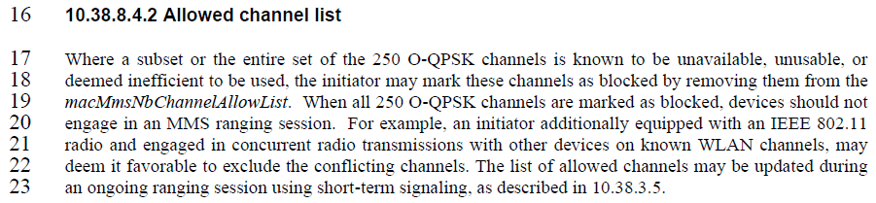
Comment #77
Disposition: Rejected
Disposition Detail:
It is not necessary to mandate that devices quit an existing ranging session. Implementation can decide whether a device chooses to wait out the channel outage event or quit the ranging session.
Comment #709
Disposition: Rejected
Disposition Detail:
Allowing the list of allowed channels to be updated using short-term signalling was a deliberate design choice to overcome temporary channel outage events etc. Long term parameter update may be performed in other ways e.g., via OOB.

Comment Indices in 15-24-0010-00-04ab-consolidated-comments-draft-c:
Name | Index# | Pg | Sub-Clause | Ln | Comment | Proposed Change | Disposition
Bin Qian | 343 | 69 | 10.38.10.3.11 | 9 | It seems that the One-to-many Initiator Report is not a response Compact frames | As in the comment | Revised

Discussion：

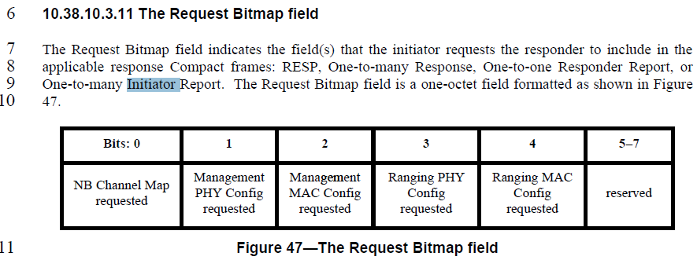
Disposition: Revised
Disposition Detail:
Proposed text changes on P802.15.4ab™/D (pre-ballot) C:

10.38.10.3.11 The Request Bitmap field (#343)
Change the subfield as follows (Track changes ON)
The Request Bitmap field indicates the field(s) that the initiator requests the responder to include in the applicable response Compact frames: RESP, One-to-many Response, One-to-one Responder Report, or One-to-many Responder Report. The Request Bitmap field is a one-octet field formatted as shown in Figure 9.

