IEEE P802.15
Wireless Personal Area Networks

Project | IEEE P802.15 Working Group for Wireless Personal Area Networks (WPANs)
Title | Proposed Comments Resolution on One-to-many Ranging
Date Submitted | Feb. 2024
Sources | Bin Qian, Lei Huang, Rojan Chitrakar, David Xun Yang (Huawei)
Re:
Abstract
Purpose | To propose comments resolution for “P802.15.4ab™/D (pre-ballot) C Draft Standard for Low-Rate Wireless Networks”
Notice | This document does not represent the agreed views of the IEEE 802.15 Working Group or IEEE 802.15.4ab Task Group. It represents only the views of the participants listed in the “Sources” field above. It is offered as a basis for discussion and is not binding on the contributing individuals. The material in this document is subject to change in form and content after further study. The contributors reserve the right to add, amend or withdraw material contained herein.

Comment Index #775 in 15-24-0010-09-04ab-cc-consolidated-comments
Index # | Commenter | Sub-Clause | Page | Line | Comment | Proposed Change
775 | Carl Murray | 10.38.10.12 | 84 | 8 | Field description missing | Add field description

Discussion:
The original text of Draft C is as follows
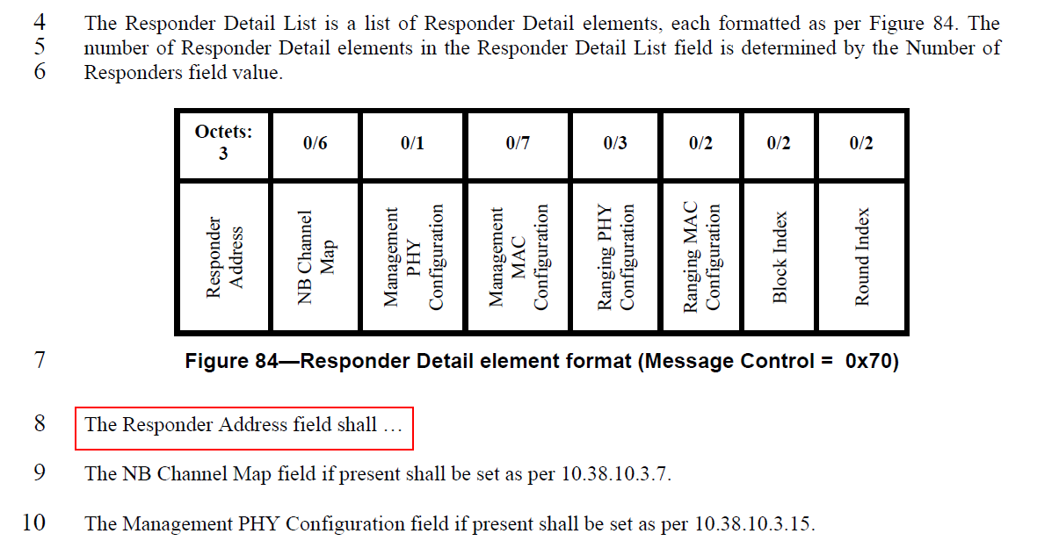
Resolution: Revised
Proposed text changes on P802.15.4ab™/D (pre-ballot) C:
10.38.10.12 One-to-many Poll Compact frame
Change Line 8 on Page 84 as follows
The Responder Address field identifies a responder participating in the current one-to-many ranging. The Responder Address field value shall contain an eligible responder’s RPA hash generated using the initiator’s RPA_prand in the one-to-many Poll Compact frame along with the responder’s IRK.

-------------------------------------------------------------------------------------------------------------------------------
Comment Index #370, #776 in 15-24-0010-09-04ab-cc-consolidated-comments
Index # | Commenter | Sub-Clause | Page | Line | Comment | Proposed Change
370 | Bin Qian | 10.38.10.12 | 84 | 20 | The description is not complete | As in the comment
776 | Carl Murray | 10.38.10.12 | 84 | 20 | Field description missing | Add field description

Discussion:
The original text of Draft C is as follows
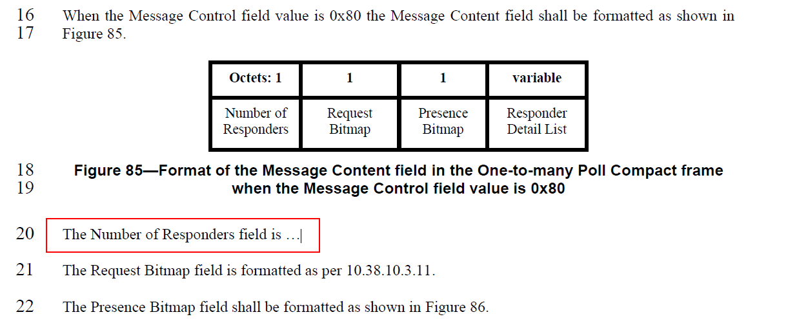
Resolution: Revised
Proposed text changes on P802.15.4ab™/D (pre-ballot) C:
10.38.10.12 One-to-many Poll Compact frame
Change Line 20 on Page 84 as follows
The Number of Responders field indicates the number of responders to be involved in the current ranging session and determines the length of the Responder Detail List field.

-------------------------------------------------------------------------------------------------------------------------------
Comment Index #781 in 15-24-0010-09-04ab-cc-consolidated-comments
Index # | Commenter | Sub-Clause | Page | Line | Comment | Proposed Change
781 | Carl Murray | 10.38.10.12 | 85 | 26 | Field description missing | Add field description

Discussion:
The original text of Draft C is as follows
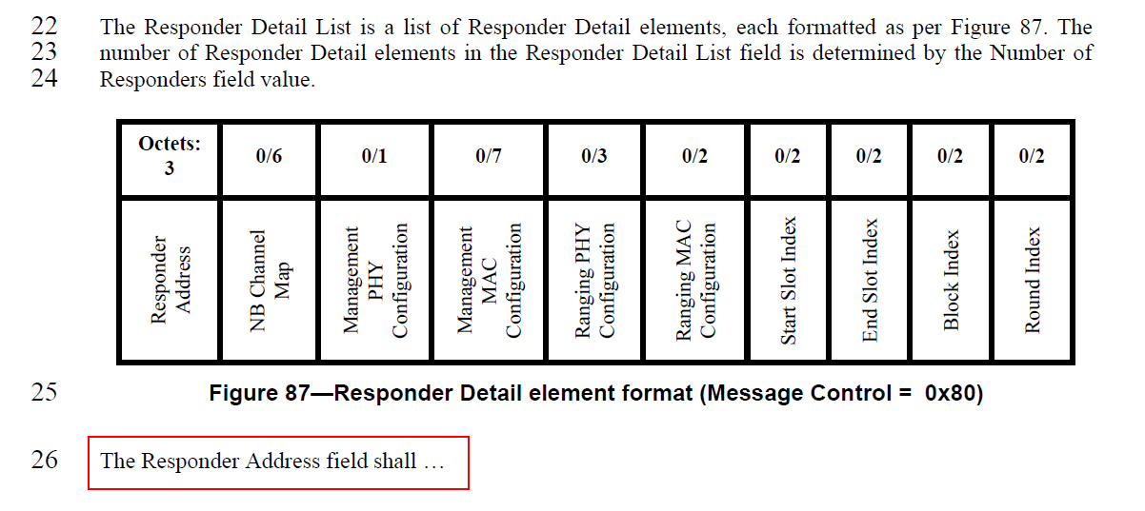
Resolution: Revised
Proposed text changes on P802.15.4ab™/D (pre-ballot) C:
10.38.10.12 One-to-many Poll Compact frame
Change Line 26 on Page 85 as follows
The Responder Address field identifies a responder participating in the current one-to-many ranging. The Responder Address field value shall contain an eligible responder’s RPA hash generated using the initiator’s RPA_prand in the one-to-many Poll Compact frame along with the responder’s IRK.

-------------------------------------------------------------------------------------------------------------------------------
Comment Index #372 in 15-24-0010-09-04ab-cc-consolidated-comments
Index # | Commenter | Sub-Clause | Page | Line | Comment | Proposed Change
372 | Bin Qian | 10.38.10.12 | 85 | 16-18 | The paragraph is contradictory | As in the comment

Discussion:
The original text of Draft C is as follows
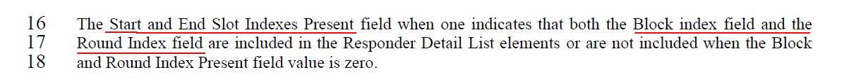
Resolution: Revised
Proposed text changes on P802.15.4ab™/D (pre-ballot) C:
10.38.10.12 One-to-many Poll Compact frame
Change Line 16-18 on Page 85 as follows
The Start and End Slot Indexes Present field when one indicates that both the Start Slot index field and the End Slot Index field are included in the Responder Detail List elements or are not included when the Start and End Slot Indexes Present field value is zero.

Comment Index #785, #786, #374 in 15-24-0010-09-04ab-cc-consolidated-comments
Index # | Commenter | Sub-Clause | Page | Line | Comment | Proposed Change
785 | Carl Murray | 10.38.10.12 | 86 | 18 | Field description missing | Add field description
786 | Carl Murray | 10.38.10.12 | 86 | 19 | Field description missing | Add field description
374 | Bin Qian | 10.38.10.12 | 86 | 18, 19, 20 | The description is not complete | As in the comment

Discussion:
The original text of Draft C is as follows
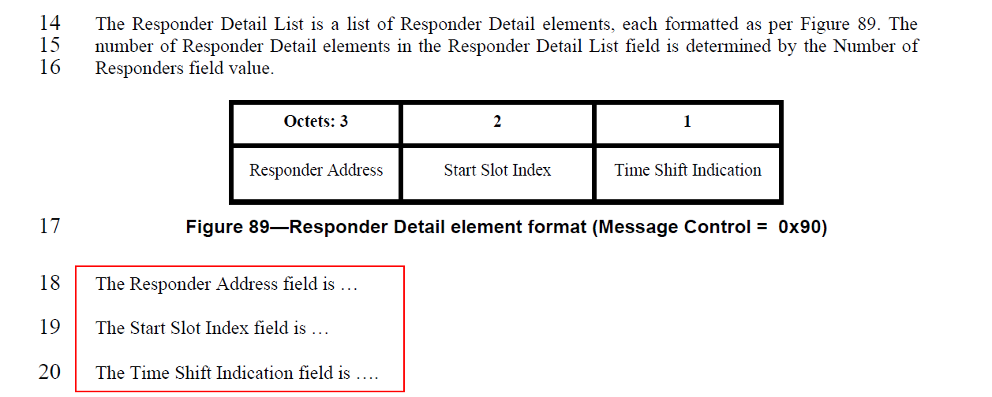
Resolution: Revised
Proposed text changes on P802.15.4ab™/D (pre-ballot) C:
10.38.10.12 One-to-many Poll Compact frame
Change Line 18-20 on Page 86 as follows
The Responder Address field identifies a responder participating in the current one-to-many ranging.The Responder Address field value shall contain an eligible responder’s RPA hash generated using the initiator’s RPA_prand in the one-to-many Poll Compact frame along with the responder’s IRK.
The Start Slot Index field is a 16-bit index of the first ranging slot of a ranging sub-round.
The Time Shift Indication field when zero indicates the corresponding responder transmits the first fragment at RpRsfOffset/RpRifOffset + 400 RSTU into the ranging phase, and when one indicates the corresponding responder transmits the first fragment at RpRsfOffset/RpRifOffset + 800 RSTU into the ranging phase.

