IEEE P802.15
Wireless Personal Area Networks

Project | IEEE P802.15 Working Group for Wireless Personal Area Networks (WPANs)
Title | Proposed Comments Resolution on Compact Frame – Follow Up
Date Submitted | Jan. 2024
Sources | Bin Qian, Lei Huang, Rojan Chitrakar, David Yun Yang (Huawei)
Re:
Abstract
Purpose | To propose comments resolution for “P802.15.4ab™/D (pre-ballot) C Draft Standard for Low-Rate Wireless Networks”
Notice | This document does not represent the agreed views of the IEEE 802.15 Working Group or IEEE 802.15.4ab Task Group. It represents only the views of the participants listed in the “Sources” field above. It is offered as a basis for discussion and is not binding on the contributing individuals. The material in this document is subject to change in form and content after further study. The contributors reserve the right to add, amend or withdraw material contained herein.

Comment Index #637 in 15-24-0010-05-04ab-cc-consolidated-comments
Index # | Commenter | Sub-Clause | Page | Line | Comment | Proposed Change
637 | Benjamin Rolfe | 10.38.10.4 | 72 | 6 | CapDuration[], InitializationSlotDuration[] are not defined. | Define CapDuration[], nitializationSlotDuration[]

Discussion:
The field description of CapDuration and InitializationSlotDuration have been completed in 15-24-0024-00-04ab-proposed-comments-resolution-on-compact-frame.docx.
Resolution: Revised
Proposed text changes on P802.15.4ab™/D (pre-ballot) C:
Refer to 15-24-0024-00-04ab-proposed-comments-resolution-on-compact-frame.docx.

-------------------------------------------------------------------------------------------------------------------------------
Comment Index #355 in 15-24-0010-05-04ab-cc-consolidated-comments
Index # | Commenter | Sub-Clause | Page | Line | Comment | Proposed Change
355 | Bin Qian | 10.38.10.8 | 77 | 23 | It is possible that the Message Content field consists of more than 5 octets. And the value may not be zero | As in the comment

Discussion:
The original text of Draft C is as follows
When the Message Control field value is 0x10 the Message Content field shall consist of five octets with the value of zero as shown in Figure 67.
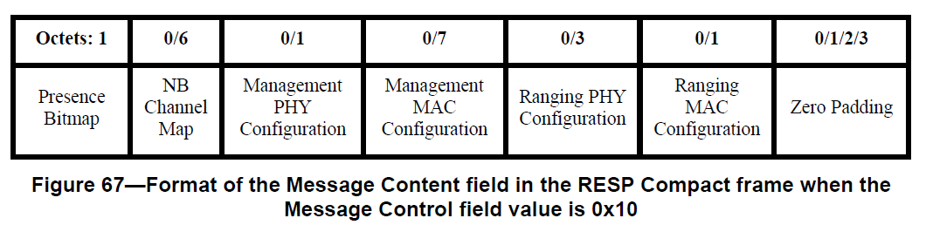

It is obvious that above message content field may consist of more than 5 octets with non-zero value.

Resolution: Revised
Proposed text changes on P802.15.4ab™/D (pre-ballot) C:
10.38.10.8 RESP Compact frame
Change Line 23-24 on Page 77 as follows
When the Message Control field value is 0x10 the Message Content field shall be formatted as shown in Figure 67.

-------------------------------------------------------------------------------------------------------------------------------
Comment Index #751 in 15-24-0010-05-04ab-cc-consolidated-comments
Index # | Commenter | Sub-Clause | Page | Line | Comment | Proposed Change
751 | Carl Murray | 10.38.10.8 | 78 | 7 | Zero padding by 2 octets can never happen - also impacts figure 67

Discussion:
The original text of Draft C is as follows
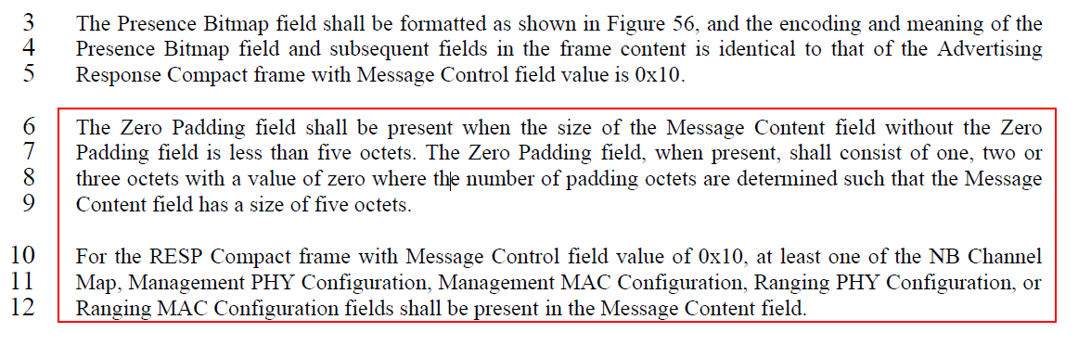
When the Presence Bitmap field only indicates the presence of the Management PHY Configuration field and the Ranging MAC Configuration field, the Zero Padding field shall consist of two octets with a value of zero such that the Message Content field has a size of five octets. Note that the Presence Bitmap field always occupy one octet.

Resolution: Reject

-------------------------------------------------------------------------------------------------------------------------------
Comment Index #790 in 15-24-0010-05-04ab-cc-consolidated-comments
Index # | Commenter | Sub-Clause | Page | Line | Comment | Proposed Change
790 | Carl Murray | 10.38.10.13 | 87 | 16 | The Zero Padding header is incorrect for 2 reasons | Change "0/1/2/3" to "0/2/3/4"

Discussion:
The original text of Draft C is as follows
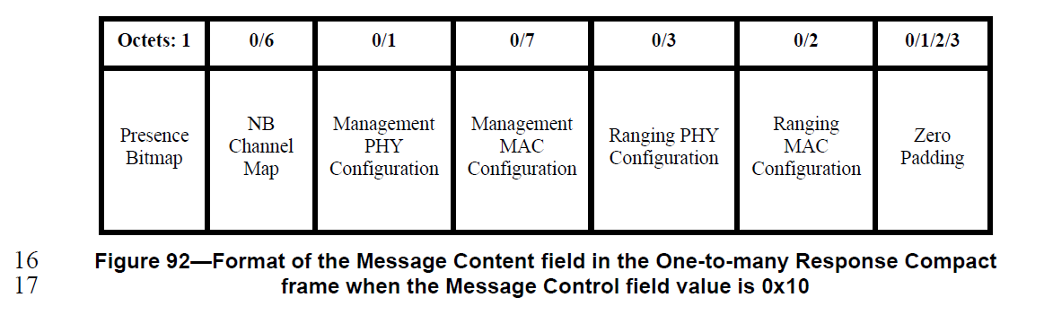
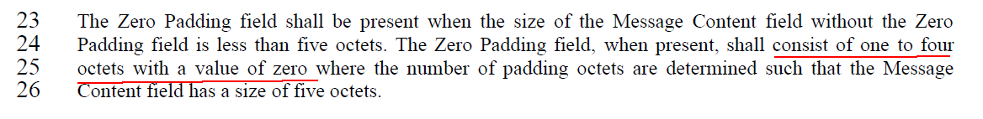
The comment has two points:
- Is it possible the Zero Padding field has one octet
- Is it possible the Zero Padding field has four octets
When the Presence Bitmap field only indicates the presence of the Ranging PHY Configuration, the Zero Padding field shall consist of one octet with a value of zero such that the Message Content field has a size of five octets.
Since at least one of the fields NB Channel Map, Management PHY Config, Management MAC Config, Ranging PHY Config and Ranging MAC Config fields shall be present, and the Presence Bitmap field always occupy one octet, the Zero Padding field with four octets cannot happen.

Resolution: Reject, the existing text is correct

-------------------------------------------------------------------------------------------------------------------------------
Comment Index #796 in 15-24-0010-05-04ab-cc-consolidated-comments
Index # | Commenter | Sub-Clause | Page | Line | Comment | Proposed Change
796 | Carl Murray | 10.38.10.13 | 88 | 25 | A zero padding with 1 octet is not possible | Change  … shall consist of one to four octets with a value of zero where …  To  … shall consist of two to four octets with a value of zero where
Discussion:
The analysis is same as that for CID #790 as above.

Resolution: Revised
Proposed text changes on P802.15.4ab™/D (pre-ballot) C:
10.38.10.13 One-to-many Response Compact frame
Change Line 23-26 on Page 88 as follows
The Zero Padding field shall be present when the size of the Message Content field without the Zero Padding field is less than five octets. The Zero Padding field, when present, shall consist of one to three octets with a value of zero where the number of padding octets are determined such that the Message Content field has a size of five octets.

