IEEE P802.15
Wireless Personal Area Networks

Project | IEEE P802.15 Working Group for Wireless Personal Area Networks (WPANs)
Title | DraftC comment resolution 1/30/2024
Date Submitted | March 13, 2024
Sources | Alex Krebs (Apple)  krebs @ apple.com
Re:
Abstract
Purpose | To propose resolution for MMS related comments for “P802.15.4ab™/D (pre-ballot) C Draft Standard for Low-Rate Wireless Networks” .
Notice | This document does not represent the agreed views of the IEEE 802.15 Working Group or IEEE 802.15.4ab Task Group. It represents only the views of the participants listed in the “Sources” field above. It is offered as a basis for discussion and is not binding on the contributing individuals. The material in this document is subject to change in form and content after further study. The contributors reserve the right to add, amend or withdraw material contained herein.

Abstract
This submission contains the proposed comment resolutions for the CIDs 16, 30, 34, 58, 62, 63, 66, 67, 79, 164, 165, 209, 237, 346, 348, 350, 512, 513, 515, 517, 629, 636, 639, 646, 697, 698, 705, 714, 718, 721-728, 733, 737, 740, 743, 746, 752, 753, 754, 799, 800, 825, 827, 829, 831, 833, 835, 836, 903, 904, 912, 917, 918, 919, 920, 921, 922, 923, and 924.

R0: initial document

CIDs ready:
R1: 697, 698
R2: 705, 209, 16, 58, 714
R3: 726, 727, 728, 733
R4:

CID 697, 698, 705
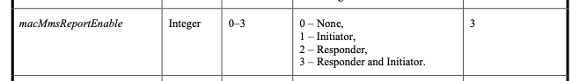
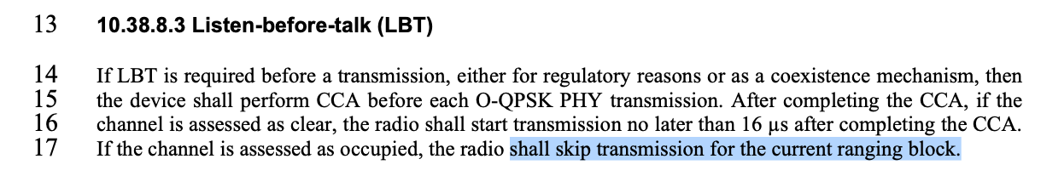
Name | Idx | Pg | L. | Comment | Proposed Change | Resolution
Carl Murray | 697 | 52 | 21 | macMmsReportEnable is a really bad name for a siugnal that has 4 states. What does it mean by "If it is enabled…" | Change name | Revise. Change all occurences of macMmsReportEnable to macMmsReportSender.
Carl Murray | 698 | 52 | 21 | What happens if macMmsReportEnable is set to 0 but either macMms1stReportNSlots or macMms2ndtReportNSlots is non zero |  | Reject. (Answer: Then there are defined report slot lengths that no transmitter uses. Should not affect or disturb anything.)
Carl Murray | 705 | 57 | 17 | Why skip the block, why not just the round? |  | Revise: change "block" to "round". (Discussion: The commenter clarified that the question's emphasis is on "block vs round" rather than generic on LBT retrials. The "block vs round" question has been resolved for #75 on page 51 in the Panama F2F in favor of "round". Advise to proceed consistent here.)
Discussion: ?

CID 209, 16, 58
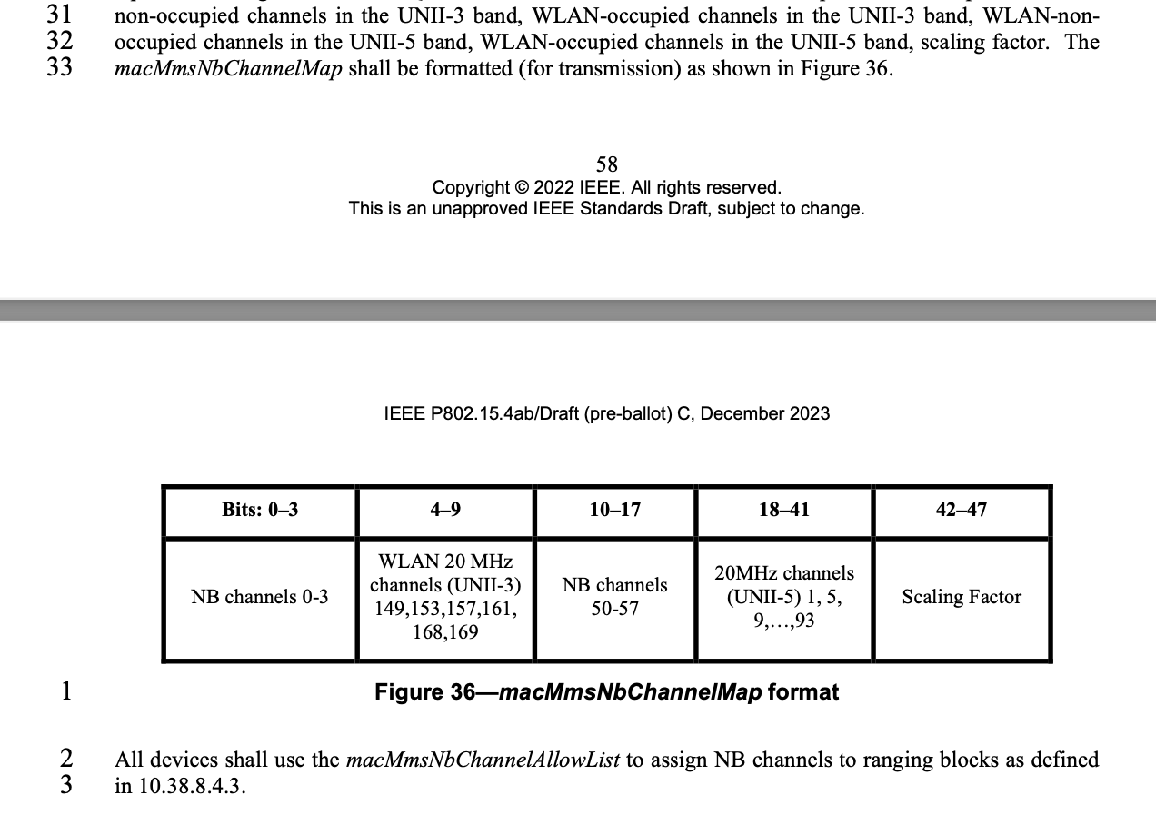
Name | Idx | Pg | L. | Comment | Proposed Change | Resolution
Billy Verso | 209 | 58 | 26 | The description here and Figure 43 seems to be duplicating what is in 10.38.10.3.7 The NB Channel Map field. Probably macMmsNbChannelMap is not needed; just macMmsNbChannelAllowList for each device, updated after over the air message exchange. | Delete paragraph and following paragraph, and the figure, and macMmsNbChannelMap attribute, over the air message can be used to update macMmsNbChannelAllowList configuration for each device. | Revise. Delete paragraph and following paragraph, and the figure 36, and macMmsNbChannelMap attribute, over the air message can be used to update macMmsNbChannelAllowList configuration for each device.
Li-Hsiang Sun | 16 | 58 | 30 | " The macMmsNbChannelMap contains five parts: WLAN-  non-occupied channels in the UNII-3 band, WLAN-occupied channels in the UNII-3 band, WLAN-non-  occupied channels in the UNII-5 band, WLAN-occupied channels in the UNII-5 band, scaling factor. The  macMmsNbChannelMap shall be formatted (for transmission) as shown in Figure 36." | the macMmsNbChannelMap should be updated to be the same as NB channel Map field used in messages and in Fig 43 | Revise (see #209)
Alex Krebs | 58 | 58, 59 | 32ff | incorrect channel map | remove last sentence of p.58 and Figure 36. | Revise (see #209)
Discussion:
I think this whole part is a left over of incomplete editing of DraftB and the accepted "Revise NB channel map" CID resolutions from DCN 23-575r2. Therefore I had marked CID 58 as editorial and assume it's resolved already.

CID 512
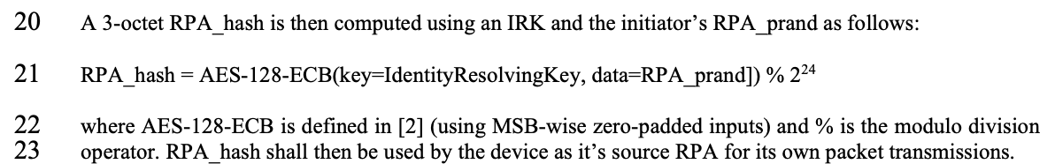

Name | Idx | Pg | L. | Comment | Proposed Change | Resolution
Rojan Chitakrar | 629 | 64 | 22 | What is reference [2] and is it a normative reference? If so should be listed in clause 2 (Normative references). AES is widely used in IEEE, please check if the normative reference FIPS Pub 197 included in 802.15.4-2020 already covers the AES-128-ECB. | Please check if the normative reference FIPS Pub 197 already covers the AES-128-ECB, else add the relevant reference in the subclause 2. | Revise. (see #512)
Tero Kivinen | 512 | 64 | 21 | The output of the AES-128-ECB is not a integer number, thus you can't take module function out of it. The output of the encryption is the 128-bit bitstring. You most likely want to say something like that RPA_hash will be rightmost 24 bits of the output of the encryption function. | Define calculations using bit strings. | Revise. Change lines 20-22:  An RPA_hash is then given by bits 0 to 23 of h(key=IdentityResolvingKey, data=RPA_prand) where h is the block cipher referred to by AES-128 [B.2.2-4meD01] with an IRK and the initiator's RPA_prand as input.
Discussion: Clause 9.3.1? Removed integer representation language, as it is irrelevant for how the bits are sent over the air. Discussion over reflector suggested there is no consensus on the proposed solution yet.

CID 714
Name | Idx | Pg | L. | Comment | Proposed Change | Resolution
Carl Murray | 714 | 65 | 29 | This suggests that there are Compact frames without an FCS. Is this is not correct then it introduces unnecessary ambiguity? Pg64, line 5 states that each PSDU ends with a 2-octet FCS | Reconcile the 2 statements | Revised. (resolved through #627 by Rojan in DCN 23-20 in Panama F2F)
Rojan Chitrakar | 627 | 64 | 5 | "each PSDU ends with a 2-octet FCS, which …"  Secure compact frames do not carry FCS, they carry MIC instead. | Change the sentence as:  " each PSDU either ends with a 2-octet FCS, which shall be …., or ends with a MIC field as described in 10.38.10.3.16. | Revised.

CID 718
Name | Idx | Pg | L. | Comment | Proposed Change | Resolution
Carl Murray | 718 | 66 | 24 | "channels 1 to 93" doesn't appear to be right |  | Revise. Replace "channels 1 to 93" by "channels 1,5,9,...,93" in line 24, and replace "4" by "41" in line 22 (see DCN 23-575r2).
Discussion: Fix line 22: 18<=N<=41. Also consider referencing 802.11 REVme ax,be.

CID 721-725
Name | Idx | Pg | L. | Comment | Proposed Change | Resolution
Carl Murray | 721 | 68 | 23 | RcpPollSlots and macMmsRcpPollNSlots have incompatible ranges | resolve | Revise. On p.103, change range of macMmsRcpPollNSlots to 0-15.
Carl Murray | 722 | 68 | 25 | RcpResponseSlots and macMmsRcpRespNSlots have incompatible ranges | resolve | Revise. On p.103, change range of macMmsRcpRespNSlots to 0-15.
Carl Murray | 723 | 68 | 27 | Should RpDuration be linked to macMmsRpDuration (note they have incompatible ranges) | resolve | Defer. This is needs to be resolved jointly with #207 ("make RpDuration relative" as discussed during January F2F)
Carl Murray | 724 | 69 | 1 | RcpResponseSlots and macMms1stReportNSlots have incompatible ranges | resolve | Revise. On p.103, change range of macMms1stReportNSlots to 0-15.
Carl Murray | 725 | 69 | 4 | MrpSecondSlots and macMms2ndtReportNSlots have incompatible ranges | resolve | Revise. On p.103, change range of macMms2ndReportNSlots to 0-15.
Alex Krebs | 61 | 103 | 1 | The value ranges are incorrect for some fields. | Change Range values as specified in 10.38.10.3.10 | Revised (by #721-#725)
Discussion: The technical change of section 10.38.10.3.10 had been accepted for DraftB #99 in DCN 23-575r2. Therefore #912 was marked editorial before.

CID 726, 727
Name | Idx | Pg | L. | Comment | Proposed Change | Resolution
Carl Murray | 726 | 69 | 23 | The range of 8.6 seconds for the time offset field seems excessive | Should discuss if we want the full range supported | Revise. Add the following text after line 25: "The maximum value of this field shall be limited to 1 second."
Carl Murray | 727 | 69 | 27 | The range of 8.6 seconds for the time offset field seems excessive | Should discuss if we want the full range supported | Reject. (Full range is useful for ADV-CONF coordination packet search.)
Discussion: 3 bytes seems too short (~34ms), especially for ADV_CONF (#727), and there is not really any benefit in optimizing length here, since it 1-time use field in SOR/ADV-CONF prior to the ranging session.

CID 728, 733
Name | Idx | Pg | L. | Comment | Proposed Change | Resolution
Carl Murray | 728 | 70 | 2 | This needs to be rewritten referencing 10.38.8.4.3 and macMmsPrngSeed |  | Revise. Change lines 2-3 to:  This is a single octet field that carries the value macMmsPrngSeed used in the channel switching function as defined in 10.38.8.4.3.
Carl Murray | 733 | 71 | 10 | Is this correct? Can it not be changed in other compact frames, eg the SOR |  | Reject. (Yes. RPA prand is conveyed in ADV-POLL and POLL messages only. No need to send a new randomization every packet since all packets per discovery/round are sent in sequence on the same channel anyways, so easy to conjure for a tracker that they belong together even if addresses were rotated.)
Discussion: None.

CID 513, 346, 636, 912
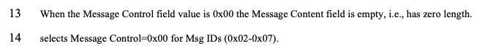

Name | Idx | Pg | L. | Comment | Proposed Change | Resolution
Tero Kivinen | 513 | 71 | 14 | Line seems to be incomplete. | Complete it. | Revise. (see #912)
Bin Qian | 346 | 71 | 14 | It seems the sentence is not complete | As in the comment | Revise. (see #912)
Rojan Chitrakar | 636 | 71 | 18 | "...selects MessageControl=0x00 for MsgIDs (0x02-0x07)." | Clarify what this means, else delete it. | Revise. (see #912)
Alex Krebs | 912 | 71 | 13-14 | Improve language by replacing lines with: | A Message Control field value of 0x00 signals baseline support by the initiator for MMS messages. Baseline MMS messages are compact messages with Frame ID values 0x02 to 0x06 with Message Control 0x00 (Table 1). | Revise. A Message Control field value of 0x00 signals support by the initiator for MMS messages with Compact Frame ID values 0x01 to 0x06 with Message Control 0x00 (Table 1).
Discussion: We have to think about if 0x01 is included or not. Answer: yes, it's included. We changed the counting to start at 0 instead of 1 when migrating from "Compressed Frame" to "Compact Frame" as documented in the approved Document DCN 23-481r1 slide 8. Therefore in the resolution proposal, the range is adjusted from "0x02-0x07" to "0x01-0x06".

CID 639, 743, 79

Name | Idx | Pg | L. | Comment | Proposed Change | Resolution
Carl Murray | 743 | 72 | 15 | Would it be better to get rid of message control 0x00 as 0x01 provides the same functionality but is more flexible at the cost of 1 octet | Should discuss | Defered for offline discussion/work.
Rojan Chitrakar | 639 | 72 | 15 | The 3 message control version are almost the same and can be easily unified by adopting the presence bitmap in all versions. | Unify the 3 message control versions by adopting the presence bitmap field in all versions. | Defered for offline discussion/work.
Pooria Pakrooh | 79 | 66 | 9 | For airtime efficiency, it is good to have the option for signaling the UNII-3 and UNII-5 bitmaps, separately. | Add two tables, under Figure 43, with the following contents:  "Figure 44: The NB Channel Map field for UNII-3--> Contents: NB Channels 0-3 (bits 0-3) / WLAN channel bitmask (UNII-3) (bits 4-9) /NB Channel start (bits 10-12) /NB Channel step (bits 13-14)/ Reserved (bit 15)"  AND  "Figure 45: The NB Channel Map field for UNII-5--> Contents: NB Channels 50-57 (bits 0-7) / WLAN channel bitmask (UNII-5) (bits 8-31) /NB Channel start (bits 32-34) /NB Channel step (bits 35-36)/ reserved (bits (37-39)" | Defered for offline discussion/work.
Discussion: Merging 0x10 to 0x30 with assigning SMC_TLVs one of the remaining PresenceBitmap bits sounds like a good idea. However, we should keep this aligned with #79, which will need an additional bit for UNII-3/UNII-5 separation, and it won't be a simple bitmap then anymore. However I would like to keep 0x00 clean without any variable frame part processing as it is not a question of one less/more byte (#743), but more of implementation complexity (e.g. what happens if there is disjoint field presence in ADV-RESP/SOR?). Can we defer and do a joint document to solve these CIDs together (Pooria, Bin, Alex, ?).

CID 752

Name | Idx | Pg | L. | Comment | Proposed Change | Resolution
Carl Murray | 752 | 78 | 13 | It may be desirable to have a report compact frame without pass through data | Should consider adding | Revise as shown below.
Discussion: Agreement on the idea that it's cleaner to define a new field that is composed of PT Data and PT Data Length that can be referred to by different messages to be included as a whole.

Instructions to the editor: add a subsection "The Passthrough field" before 10.38.10.3.5 on p.65 l.31 as shown below:

10.38.10.3.X The Passthrough field
This is a variable length field that is used to pass arbitrary data to the next higher layer. It is formated as shown in Figure XXX.
Octets: 1 | variable
PT Data Length | PT Data
Figure XXX -- The Passthrough field structure

The value of PT Data Length is the number of octets contained in the PT Data field.
The PT Data field contains PT Data Length number of octets to be passed through to the next higher layer. The content of PT Data is out of scope of this specification.

Instructions to the editor: on p.78 change Figure 69 as shown below:
Octets: 5 | 0/variable
Round-trip Time | Passthrough
Figure 69—Format of the Message Content field in the One-to-one Initiator Report Compact frame (with Message Control field value 0x00)

Instructions to the editor: on p.78 change l.23-24 as shown below:
The Pass-through field is defined in 10.38.10.3.X. Its presence is determined by Frame Length (13.1.3.2) [13.1.3.2 is reference to 4me-D01].

Instructions to the editor: on p.79 change Figure 71 as shown below:
Octets: 5 | 0/variable
Reply Time | Passthrough
Figure 71—Format of the Message Content field in the One-to-one Responder Report Compact frame when the Message Control field value is 0x00

Instructions to the editor: on p.79 add the following text after l.11:
The Pass-through field is defined in 10.38.10.3.X. Its presence is determined by Frame Length (13.1.3.2) [13.1.3.2 is reference to 4me-D01].

Note: there are multiple other occurences and variants of PT Data and PT Data Length in frames with MessageControl >0x00. I'd recommend Rojan and Bin to take a look at those and propose how they want to proceed with those.

CID 66, 67 and duplicates

Name | Idx | Pg | L. | Comment | Proposed Change | Resolution
Alex Krebs | 66 | 78 | 22 | Rounttriptime description missing | Change line to "The Round-trip Time field is the the time difference between the RMARKERs of the POLL and the RESP MMS fragments measured at the initiator side in 1/499.2MHz resolution." | Revise. The Round-trip Time field is the the time difference between the RMARKERs of the POLL and the RESP MMS fragments measured at the initiator side in 1ps resolution.
Alex Krebs | 67 | 79 | 16 | Reply-time description missing | Change the line to "The Round-trip Time field is the the time difference between the RMARKERs of the POLL and the RESP MMS fragments measured at the responder side in 1/499.2MHz resolution." | Revise. Change the line to "The Reply Time" field is the the time difference between the RMARKERs of the POLL and the RESP MMS fragments measured at the responder side in 1ps resolution."
Rojan Chitrakar | 646 | 78 | 22 | Contents are missing. | Add the contents | Revise. (see #66)
Carl Murray | 753 | 78 | 22 | Field description missing | Add field description | Revise. (see #66)
Carl Murray | 754 | 79 | 16 | Field description missing | Add field description | Revise. (see #67)
Carl Murray | 833 | 101 | 17 | Field description missing | Add field description | Revise. (see #67)
Carl Murray | 835 | 102 | 13 | Field description missing | Add field description | Revise. (see #67)
Alex Krebs | 917 | 89 | 13 | Reply-time description missing | see #67 | Revise. (see #67)
Alex Krebs | 922 | 90 | 10 | Rounttriptime description missing | see #66 | Revise. (see #66)
Alex Krebs | 923 | 98 | 21 | Rounttriptime description missing | see #66 | Revise. (see #66)
Alex Krebs | 918 | 99 | 13 | Reply-time description missing | see #67 | Revise. (see #67)
Alex Krebs | 919 | 100 | 5 | Reply-time description missing | see #67 | Revise. (see #67)
Alex Krebs | 924 | 100 | 24 | Rounttriptime description missing | see #66 | Revise. (see #66)
Alex Krebs | 920 | 101 | 17 | Reply-time description missing | see #67 | Revise. (see #67)
Alex Krebs | 921 | 102 | 13 | Reply-time description missing | see #67 | Revise. (see #67)
Carl Murray | 799 | 89 | 13 | Field description missing | Add field description | Revise. (see #67)
Carl Murray | 800 | 90 | 10 | Field description missing | Add field description | Revise. (see #66)
Carl Murray | 825 | 98 | 21 | Field description missing | Add field description | Revise. (see #66)
Carl Murray | 827 | 99 | 13 | Field description missing | Add field description | Revise. (see #67)
Carl Murray | 829 | 100 | 5 | Field description missing | Add field description | Revise. (see #67)
Carl Murray | 831 | 100 | 24 | Field description missing | Add field description | Revise. (see #66)

CID 30 and duplicates

Name | Idx | Pg | L. | Comment | Proposed Change | Resolution
Li-Hsiang Sun | 30 | 102 | 18 | There should be a default value of ranging slot (called slots) in Table 9 because it is configurable via management MAC config. | as in comment | tbd.
Carl Murray | 836 | 102 | 18 | Is this table complete - for example where is the ranging slot duration defined |  | dup 30
Discussion: TE: Was this lost from DraftB (see Table-9 below)? If yes, then just reinsert and add names: macMmsRangingSlotDuration, macMmsRangingRoundDuration, macMmsRangingBlockDuration.
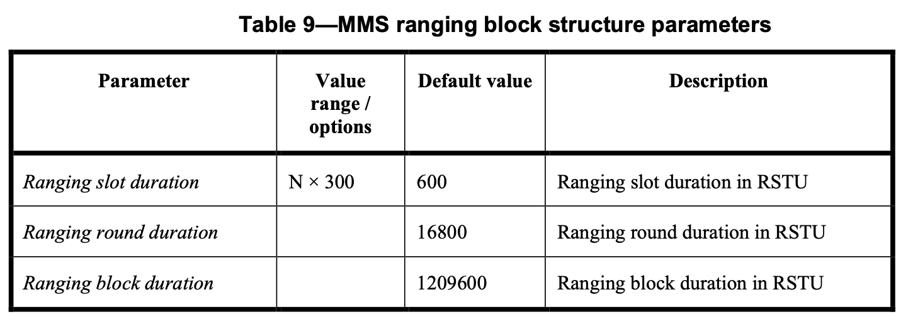

CID 237

Name | Idx | Pg | L. | Comment | Proposed Change | Resolution
Billy Verso | 237 | ## | 6 | The channel assignment clause for the HRP UWB PHY, was not updated however we have an new definition in 16.4.1.2 covering an (optional) extended set of channels. Being able to select these individually is needed for instance to do frequency stitched sensing with individual frame TX on the different frequencies, (as an alternative to the automatic stepped case). Would also allow for future regulatory changes without further UWB text update. | Add in coverage for extended range. And, revisit all places UWB channel number is signaled, especially in new 4ab messages. To ensure the UWB channel number field size is sufficient to signal the extern range. | tbd.
Discussion: Not clear what the benefit would be to send longer NB message fields covering overlapping channels 0-97? What is the general idea here regarding the channel number conflict between the legacy 15.4a channels 0-15 (Table-16-27 [4me-D01]?

CID 34, 63 and duplicates

Name | Idx | Pg | L. | Comment | Proposed Change | Resolution
Alex Krebs | 63 | 71,72,74 | 19,5,5,12 | SMC_TLVs description missing | see external document DCN ??? | Revise. (See instruction below this table.)
Li-Hsiang Sun | 34 | 71 | 15 | It is not clear whether SMC TLV are related to:  1) the receiving capability to understand msg ID and ctrl from the peer, or  2) in additionally to receving capability it also indicates that the sender of this field requires the peer to understand msg id and ctrl indicated in SMC TLV from the sender | when SMC TLV in ADV_POLL, it is case 2), when SMC TLV in ADV_RESP, it is case 1) | Reassign to Rojan. (Discussed idea: status code delivery in MsgCtrl=0xF0)
Benjamin Rolfe | 164 | 71 | 19 | Incomplete specification (TBD): Multiple fields lack definitions (SMC TLVs, CAP duration field, Initialization Slot Duration field). Note that I can not find this field used in any part of this draft other than frame definitions. Maybe we don't need it? | Complete definition or delete the fields that are not needed | partially solved as per below, other issues --> reassign please
Tero Kivinen | 515 | 71 | 19 | Line seems to be incomplete. | Complete it. | Revise. (see #63)
Carl Murray | 737 | 71 | 19 | Field description missing | Add field description | Revise. (see #63)
Mickael Maman | 903 | 71 | 19 | The SMC TLVs field is ….??? | "The SMC TLVs field is a sequence of structure which shall have Type, Length and Value (TLV). | Revise. (see #63)
Tero Kivinen | 517 | 72 | 5 | Line seems to be incomplete. | Complete it. | Revise. (see #63)
Carl Murray | 740 | 72 | 5 | Field description missing | Add field description | Revise. (see #63)
Mickael Maman | 904 | 72 | 5 | The SMC TLVs field is the list of supported message control commands. This is … | complete the sentence as previously #13 | Revise. (see #63)
Bin Qian | 348 | 72 | 5-7 | The descriptions of the SMC TLVs field, CAP Duration field, Initialization Slot Duration field are missing | As in the comment | partially solved as per below, other issues --> reassign please
Bin Qian | 350 | 74 | 5 | The number of occupied octets of SMC TLVs is missing | As in the comment | Revise. (see #63)
Benjamin Rolfe | 165 | 74 | 7 | Incomplete specification (TBD): SMC TLVs. | Complete definition or delete the fields that are not needed | Revise. (see #63)
Carl Murray | 746 | 74 | 12 | Incomplete description | Complete description | Revise. (see #63)
Alex Krebs | 62 | 71,72,74 | 17,3,5 | ? needs to be defined | change "?" to "variable" | Revise. Change "?" to "0/variable".

Instructions to the editor: add a subsection "Supported Message Control Tag Length Values field" to 10.38.10.3 as shown below:

10.38.10.3.x Supported Message Control Tag Length Values field
This is a variable length field that contains zero or more Supported Message Control Tag Length Value (SMC_TLV) structures. The SMC_TLV structure is formated as shown in Figure XXX.

Octets: 1 | 1 | variable
SMC_Tag | SMC_Length | SMC_Values
Figure XXX -- The Supported Message Control Tag Length Value structure

The value of SMC_Tag refers to a Compact Frame ID value as shown in Table-1.
The value of SMC_Length is the number of octets of the SMC_Values field.
The value of SMC_Values is an array of SMC_Length octets, where the value of each contained octet signals support of a Message Control field (10.38.10.3.2) value of the Compact frame with ID SMC_Tag.

Instructions to the editor: continue the sentence p.71 l.19 and p.72 l.5 as shown below:

The SMC TLVs field is the list of supported message control commands as defined in 10.38.10.3.x. This is used by the iniator to signal to responders which compact frames and which message control values it supports.

Instructions to the editor: continue the sentence p.74 l.12 as shown below:

The SMC TLVs field is the list of supported message control commands as defined in 10.38.10.3.x. This is used by the responder to signal to the initiator which compact frames and which message control values it supports.

