IEEE P802.15
Wireless Personal Area Networks

Project | IEEE P802.15 Working Group for Wireless Personal Area Networks (WPANs)
Title | Proposed Resolution on Sensing Comments Part 1
Date Submitted | Jan. 2024
Sources | Bin Qian, Lei Huang, Rojan Chitrakar (Huawei)
Re:
Abstract
Purpose | To propose comments resolution for “P802.15.4ab™/D (pre-ballot) C Draft Standard for Low-Rate Wireless Networks”
Notice | This document does not represent the agreed views of the IEEE 802.15 Working Group or IEEE 802.15.4ab Task Group. It represents only the views of the participants listed in the “Sources” field above. It is offered as a basis for discussion and is not binding on the contributing individuals. The material in this document is subject to change in form and content after further study. The contributors reserve the right to add, amend or withdraw material contained herein.

Comment Index #419 in 15-24-0010-01-04ab-cc-consolidated-comment
Index # | Commenter | Sub-Clause | Page | Line | Comment | Proposed Change
419 | Bin Qian | 10.39.7.1 | 114 | 20, 21 | The description of the Preamble Code Configuration field is missing | As in the comment

Discussion:
The preamble code configuration of MMS ranging has been defined in the MMS Ranging Configuration field. Thus, the Preamble Code Configuration here is used to specify the preamble code in the legacy ranging applications, which has been defined by the Ranging Channel and Preamble Code Selection IE (RCPCS IE) in 10.26.8.5.

Resolution: Revised
Proposed text changes on P802.15.4ab™/D (pre-ballot) C:
10.39.7.1 Application Control IE (AC IE)
Change Line 20-21 on Page 114 as follows
The Preamble Code Configuration field if present specifies the preamble code that will be used in the forthcoming ranging exchange, and shall be formatted as shown in Figure a.
Bits: 0 | 1 | 2 | 3-7 | Octets: 0/4 | 0/3 | 0/1 | 0/1 | 0/2
CCIP | DDP | PSP | Channel Number | CCI | DPS Duration | TX Preamble Code | RX Preamble Code | PSR
Figure a – Preamble Code Configuration field of the AC IE
The CCIP field when one indicates the presence of the CCI field, or when zero that it is not present.

The DDP field when one indicates the presence of the DPS Duration field, or when zero that it is not present.

The PSP field when one indicates the presence of the preamble sequence selection fields, that is the TX Preamble Code field, the RX Preamble Code field and the PSR field.

The Channel Number field indicates the UWB channel number, that is as per 11.1.3.5 for the HRP UWB PHY and 11.1.3.8 for the LRP UWB PHY, for the forthcoming ranging exchange.

The CCI field specifies the channel configuration interval, which is the time in RSTU (as defined in
10.26.1.5) between the sending of this IE and reconfiguration to the specified channel.

The DPS Duration field specifies the effective time duration of the dynamic channel and preamble code selection, in units of RSTU for the ERDEV and symbols for non-ERDEV.

The TX Preamble Code field indicates the DPS preamble code that the IE sender will use for transmission during the forthcoming ranging exchange.

The RX Preamble Code field indicates the DPS preamble code that the IE sender will use for reception during the forthcoming ranging exchange.

Both these preamble codes shall be selected from Table 16-8, or both from Table 16-9.

The PSR field indicates the number of preamble symbol repetitions (PSR) to be used for the SYNC of each RFRAME of the forthcoming ranging exchange. This shall be one of the SYNC lengths specified in 15.2.6.2, or zero indicating no change in SYNC length is required.

-------------------------------------------------------------------------------------------------------------------------------
Comment Index #421 in 15-24-0010-01-04ab-cc-consolidated-comment
Index # | Commenter | Sub-Clause | Page | Line | Comment | Proposed Change
421 | Bin Qian | 10.39.7.1 | 115 | 7, 8 | The description of the Preamble Code Index field is missing | As in the comment

Discussion:
The definition of the Preamble Code Index is same as the Sequence Code Index field defined in 10.38.10.3.8
Resolution: Revised
Proposed text changes on P802.15.4ab™/D (pre-ballot) C:
10.39.7.1 Application Control IE (AC IE)
Change Line 7 on Page 115 as follows
The Preamble Code Index field indicates the preamble code that will be used by the RSF in the forthcoming ranging exchange, where the Preamble Code Index field values 9 to 24 select length-127 ternary codes from Table 16-8, the Preamble Code Index field values 25 to 32 select length-91 ternary codes from Table 16-9, and the Preamble Code Index field values 33 to 48 select length-128 sequences from Table 50, and other values are reserved

-------------------------------------------------------------------------------------------------------------------------------
Comment Index #657, #68, #95, #162, #219, #409, #558 in 15-24-0010-01-04ab-cc-consolidated-comment
Index # | Commenter | Sub-Clause | Page | Line | Comment | Proposed Change
657 | Rojan Chitrakar | 10.39.4.4 | 108 | 12 | "The definition of computation methods is TBD."  What computation method? To generate range/AOA? | Resolve the TBD.
68 | Alex Krebs | 10.39.4.4 | 108 | 12 | The report format is assumably independent of the computation method for the value. | Remove sentence with the TBD.
95 | Pooria Pakrooh | 10.39.4.4 | 108 | 12 | The details of processed target report are in subclause 10.39.7.6 | Remove "The definition of computation methods is TBD". Add the sentence: "The details of processed target report are illustrated in 10.39.7.6."
162 | Benjamin Rolfe | 10.39.4.4 | 108 | 12 | Incomplete specification (TBD) | Replace with: The method of computation is out of scope of this standard
219 | Billy Verso | 10.39.4.4 | 108 | 12 | There is a “TBD” on this line | Replace this with something.
409 | Bin Qian | 10.39.4.4 | 108 | 12 | The definition of computation method is implementation specific, which is out the scope of the 4ab standard | Delete the last sentence
558 | Youngwan So | 10.39.4.4 | 108 | 12 | There still is "TBD" | Remove the sentence or fill TBD part with appropriate technical details

Discussion:
The original text of Draft C is as follows
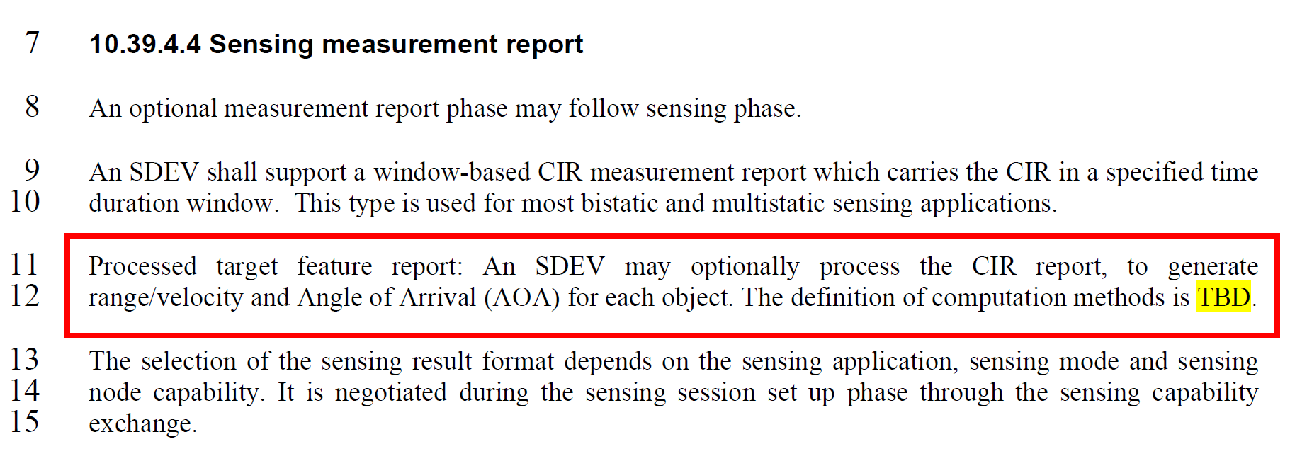
The computation method is out the scope of 4ab. The details of processed target feature report are defined in 10.39.7.6.

Resolution: Revised
Proposed text changes on P802.15.4ab™/D (pre-ballot) C:
Change 10.39.4.4 as follows
10.39.4.4 Sensing measurement report
An optional measurement report phase may follow sensing phase.

An SDEV shall support a window-based CIR measurement report which carries the CIR in a specified time duration window. This type is used for most bistatic and multistatic sensing applications. The details of the CIR measurement report are illustrated in 10.39.7.2.

An SDEV may optionally process the CIR report, to generate the processed target feature report, which includes range/velocity and Angle of Arrival (AOA) for each object. The details of the processed target feature report are illustrated in 10.39.7.6.

The selection of the sensing result format depends on the sensing application, sensing mode and sensing node capability. It is negotiated during the sensing session set up phase through the sensing capability exchange.

