IEEE P802.15
Wireless Personal Area Networks

Project | IEEE P802.15 Working Group for Wireless Personal Area Networks (WPANs)
Title | Proposed Resolution for MMS – Synchronized Responders
Date Submitted | January 2024
Sources | Rojan Chitrakar, Lei Huang (Huawei)  rojan.chitrakar@huawei.com
Re:
Abstract
Purpose | To propose resolution for MMS – Synchronized Responders related comments for “P802.15.4ab™/D (pre-ballot) C Draft Standard for Low-Rate Wireless Networks” .
Notice | This document does not represent the agreed views of the IEEE 802.15 Working Group or IEEE 802.15.4ab Task Group. It represents only the views of the participants listed in the “Sources” field above. It is offered as a basis for discussion and is not binding on the contributing individuals. The material in this document is subject to change in form and content after further study. The contributors reserve the right to add, amend or withdraw material contained herein.

Rev 0: Initial version. Addresses the following comments:

Part 1: Comment Indices in 15-24-0010-00-04ab-consolidated-comments-draft-c:
Name | Index# | Pg | Sub-Clause | Ln | Comment | Proposed Change | Disposition
Rojan Chitrakar | 640 | 73 | 10.38.10.5 | 5 | It is beneficial to also include a field (e.g., Number Of Responders) to indicate that the Advertising Response Compact frame is requesting for one-to-many ranging from a group of connected responders, in which case the field can also indicate how many responders will particate in the subsequent ranging phase. This was presented in 23/337r0 (Proposal-1). | Add a field (Number Of Responders (N)) to the "Advertising Response Compact frame when the Message Control field value is 0x10" to indicate that the the Advertising Response Compact frame is requesting one-to-many ranging from a group of N connected responders. Also add the corresponding bit in the Presence Bitmap field. | Revised
Rojan Chitrakar | 642 | 75 | 10.38.10.6 | 2 | For the one-to-many ranging with a group of connected responders, it is beneficial to also include a field (e.g., Number Of Responders) in the Start of Ranging Compact frame to indicate how many responders are accepted to particate in the subsequent ranging phase. This was presented in 23/337r0 (Proposal-1). | Include an option field (e.g., Number Of Responders) in the Start of Ranging Compact frame to indicate the number of responders accepted to particate in the subsequent ranging phase. | Revised
Rojan Chitrakar | 648 | 81 | 10.38.10.12 | 19 | For one-to-many ranging with a group of connected responders,the initiator need not schedule the responders in the ranging phase and hence the O2M POLL can be a simplified version of Message Control field value= 0x10 without Responder Address List field. | Add a variant of the O2M POLL for the one-to-many ranging with a group of connected responders,which is a simplified version of Message Control field value= 0x10 but without the Responder Address List field. | Revised
Rojan Chitrakar | 651 | 92 | 10.38.10.17 | 9 | It is beneficial to also include a field (e.g., Number Of Responders) to indicate that the Public Advertising Response Compact frame is requesting for one-to-many ranging from a group of connected responders, in which case the field can also indicate how many responders will particate in the subsequent ranging phase. This was presented in 23/337r0 (Proposal-1). | Add a field (Number Of Responders (N)) to the "Public Advertising Response Compact frame when the Message Control field value is 0x00" to indicate that the the Advertising Response Compact frame is requesting one-to-many ranging from a group of N connected responders. Also add the corresponding bit in the Presence Bitmap field. | Revised  651 is automatically resolved by the changes made for #640 since the content of the public Advertising Response Compact frame is the same as the Advertising Response Compact frame.
Rojan Chitrakar | 653 | 92 | 10.38.10.18 | 21 | For the one-to-many ranging with a group of connected responders, it is beneficial to also include a field (e.g., Number Of Responders) in the Public Start of Ranging Compact frame to indicate how many responders are accepted to particate in the subsequent ranging phase. This was presented in 23/337r0 (Proposal-1). | Include an option field (e.g., Number Of Responders) in the Public Start of Ranging Compact frame to indicate the number of responders accepted to particate in the subsequent ranging phase. | Revised

Discussion：
This was presented in 23/337r0 (Proposal-1):
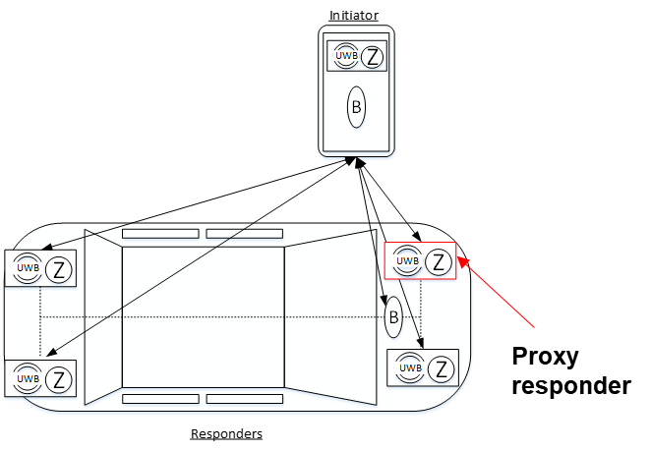
- One-to-many NBA-UWB MMS ranging (synchronized responders):
  - One of the responders (in the group of responders) acts as a proxy responder (or group leader).
  - During the Initialization and Setup phase, only the proxy responder transmit the ADV-RESP frames upon receiving the ADV-POLL frame from the initiator.
    - The ADV-RESP frame indicates the number of responders (n) that will participate in the MMS ranging.
  - Upon receiving the ADV-RESP frame, the initiator transmits the SOR frame.
    - The SOR frame confirms the number of responders (m <= n) that will participate in the MMS ranging.

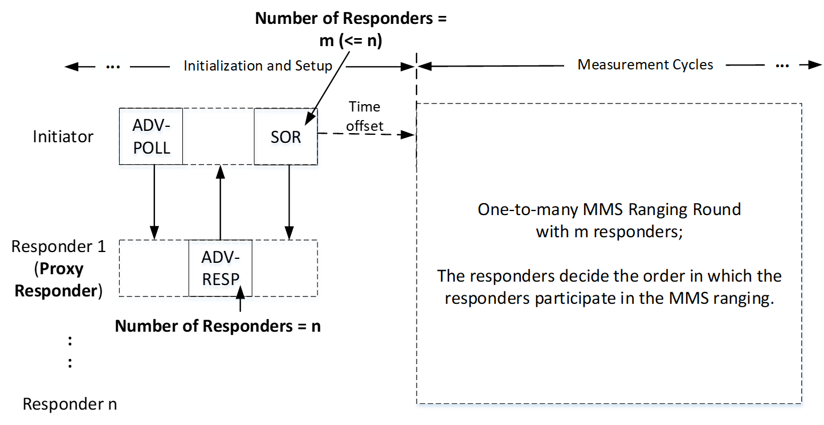
We also noted an error: Ranging MAC Configuration field should be 1 octet and not 2.
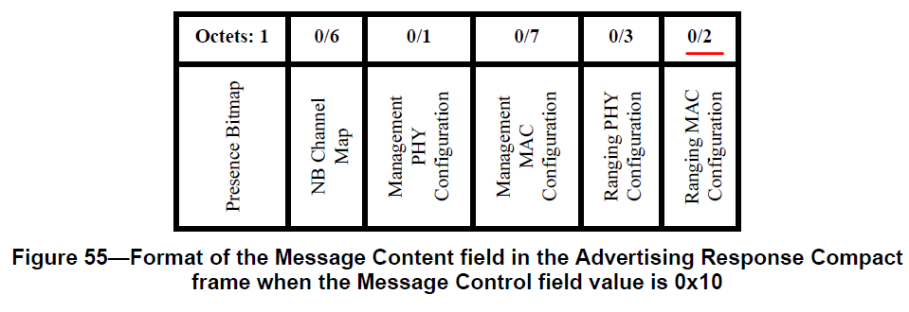
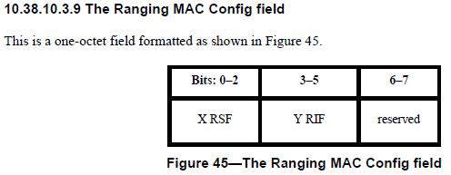
Disposition: Revised
Disposition Detail:
Proposed text changes on P802.15.4ab™/D (pre-ballot) C:

10.38.10.5 Advertising Response Compact frame (#640)
Change the subfield as follows (Track changes ON)
Also change the Ranging MAC Configuration field size from 0/2 to 0/1, or from 2 to 1 as appropriate in P72L17, P74L10, P75L3, P76L5, P79L14, P84L7, P85L25, P87L16, P89L11, P99L17, P102L1
…
Octets: 1 | 0/6 | 0/1 | 0/7 | 0/1 | 0/1 | 0/1
Presence Bitmap | NB Channel Map | Management PHY Configuration | Management MAC Configuration | Ranging PHY Configuration | Ranging MAC Configuration | Number Of Responders
Figure 55—Format of the Message Content field in the Advertising Response Compact frame when the Message Control field value is 0x10
The Presence Bitmap field shall be formatted as shown in Figure 56.
Bits: 0 | 1 | 2 | 3 | 4 | 5 | 6-7
NB Channel Map Present | Management PHY Configuration Present | Management MAC Configuration Present | Ranging PHY Configuration Present | Ranging MAC Configuration Present | Number Of Responders Present | Reserved
Figure 56—Presence Bitmap field format
…
The Ranging MAC Configuration Present field when one indicates that the Ranging MAC Configuration field is included in the Message Content field or is not included when the Ranging MAC Configuration Present field value is zero.
The Number Of Responders Present field when one indicates that the Number Of Responders field is included in the Message Content field or is not included when the Number Of Responders Present field value is zero.
The NB Channel Map field if present shall be set as per 10.38.10.3.7
…
The Management MAC Configuration field if present shall be set as per 10.38.10.3.10
The Number Of Responders field if present indicates the number of responders that are requested to participate in the subsequent ranging phase. The Number Of Responders field when set to N (N > 0) indicates that the Advertising Response Compact frame is requesting one-to-many ranging from a group of N+1 connected responders. The field value of 0 is reserved.
When the Message Control field value is 0x20 the Message Content field shall be formatted as shown in Figure 57.

10.38.10.6 Start of Ranging Compact frame (#642)
Change the subfield as follows (Track changes ON)
…
The Message Control field value shall be either 0x00 or 0x10. This value determines the formatting of the Message Content field.
When the Message Control field value is 0x10 the Message Content field shall be formatted as shown in Figure 60.
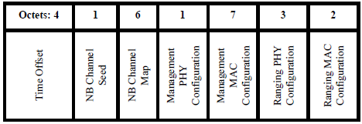
Figure 60—Format of the Message Content field in the Start of Ranging Compact frame when the Message Control field value is 0x00
…
The Ranging MAC Configuration field shall be set as per 10.38.10.3.9
When the Message Control field value is 0x10 the Message Content field shall be formatted as shown in Figure 60A.
Octets: 1 | 4 | 1 | 6 | 1 | 7 | 3 | 2 | 0/1
Presence Bitmap | Time Offset | NB Channel Seed | NB Channel Map | Management PHY Configuration | Management MAC Configuration | Ranging PHY Configuration | Ranging MAC Configuration | Number Of Responders
Figure 60A—Format of the Message Content field in the Start of Ranging Compact frame when the Message Control field value is 0x10
The Presence Bitmap field shall be formatted as shown in Figure 60B.
Bits: 0 | 1-7
Number Of Responders Present | Reserved
Figure 60B—Presence Bitmap field format
The Number Of Responders Present field when one indicates that the Number Of Responders field is included in the Message Content field or is not included when the Number Of Responders Present field value is zero.
The encoding/meaning of the subsequent fields in the message content except the Number Of Responders field is identical to that for Message Control field value is 0x00 described above.
The Number Of Responders field if present indicates the number of responders that are accepted to participate in the subsequent ranging phase. The Number Of Responders field when set to M (M > 0) indicates that the initiator will perform one-to-many ranging with a group of M+1 connected responders. The field value of 0 is reserved.
10.38.10.12 One-to-many Poll Compact frame (#648)
Change the subfield as follows (Track changes ON)
…
The Message Control field value shall be one of the values: 0x00, 0x10, 0x20, 0x30, 0x40, 0x50, 0x60, 0x70, 0x80, 0x90, 0xA0 or 0xB0. This value determines the formatting of the Message Content field.
…
When the Message Control field value is 0xA0 the Message Content is the same as for Message Control field value is 0x90, except this one-to-many poll Compact frame is signaling that both initiator and responder devices are to send a measurement report.
When the Message Control field value is 0xB0 the Message Content field shall be formatted as shown in Figure 89A.
Octets: 1 | 1
Number Of Responders | Slots Per Responder
Figure 89A—Format of the Message Content field in the One-to-many Poll Compact frame when the Message Control field value is 0xB0
The Number Of Responders field indicates the number of responders that are allocated slots in the ranging phase. The Number Of Responders field when set to M (M > 0) indicates that the initiator will perform one-to-many ranging with a group of M+1 connected responders. The field value of 0 is reserved.
The encoding/meaning of Slots Per Responder field is the same as for Message Control field value is 0x90
10.38.10.18 Public Start of Ranging Compact frame (#653)
Change the subfield as follows (Track changes ON)
…
The Message Control field value shall be one of 0x00 or 0x10. This value determines the formatting of the Message Content field.
When the Message Control field value is 0x00 the Message Content field shall be formatted the same as for the Start of Ranging Compact frame Message Content field shown in Figure 60, with the same function and meaning for each of the fields.
When the Message Control field value is 0x10 the Message Content field shall be formatted the same as for the Start of Ranging Compact frame Message Content field frame when the Message Control field value is 0x10, as shown in Figure 60A, with the same function and meaning for each of the fields.

10.38.9 Procedures for one-to-many MMS ranging
Add the following new subclause at the end of 10.38.9
10.38.9.5 Synchronized one-to-many ranging (#648)
Synchronized one-to-many ranging is used when two or responders are connected with each (e.g., with wired connections) and are capable of coordinating their actions.
During the Initialization phase, one of the responders (in the group of connected responders) acts as a proxy responder (or group leader) and responds to the initiator’s Advertising Poll Compact frame with an Advertising Response Compact frame with the Message Control field value set to 0x10 and carrying the Number Of Responders field set to N (N > 0). This indicates that the responder is requesting one-to-many ranging for a group of N+1 connected responders. The rest of the responders in the group shall not respond to the Advertising Response Compact frame. Upon receiving an Advertising Response Compact frame with the Message Control field value set to 0x10 and carrying the Number Of Responders field set to N, the initiator transmits the Start of Ranging Compact frame with the Message Control field value set to 0x10 and carrying the Number Of Responders field set to M (M <= N) confirming that the initiator will perform ranging with M+1 responders.
The ranging phase for the Synchronized one-to-may ranging is the same as described in 10.38.9.1, except that:
- The ranging initiation message transmitted by the initiator at the beginning of the ranging round only indicates the maximum number of responders (M) that will participate in the one-to-many ranging, but it does not schedule the ranging slots for the responders.
- M responders participates in the one-to-many ranging. In each ranging sub-round, the ranging control phase, the ranging phase and the measurement report phase are the same as the one-to-one ranging case except that the order in which the ranging is performed is decided by the responders.
Part 2: Comment Indices in 15-24-0010-00-04ab-consolidated-comments-draft-c:
Name | Index# | Pg | Sub-Clause | Ln | Comment | Proposed Change | Disposition
Rojan Chitrakar | 641 | 75 | 10.38.10.6 | 2 | It is beneficial to include a Status field in the Start of Ranging Compact frame to indicate whether or not the initiator can fulfill the ranging parameters requested by the responder(s) (in the Advertising Response Compact frame). | Include a Status field in the Start of Ranging Compact frame to indicate whether or not the initiator can fulfill the ranging parameters requested by the responder(s). When the Status is not SUCCESS, the rest of the fields in the Start of Ranging Compact frame can be omitted and the initiator will not proceed to the ranging phase. | Revised
Rojan Chitrakar | 652 | 92 | 10.38.10.18 | 21 | It is beneficial to include a Status field in the Public Start of Ranging Compact frame to indicate whether or not the initiator can fulfill the ranging parameters requested by the responder(s) (in the Advertising Response Compact frame). | Include a Status field in the Public Start of Ranging Compact frame to indicate whether or not the initiator can fulfill the ranging parameters requested by the responder(s). When the Status is not SUCCESS, the rest of the fields in the Start of Ranging Compact frame can be omitted and the initiator will not proceed to the ranging phase. | Revised  #652 is automatically resolved by the changes made for #641 since the content of the public Start of Ranging Compact frame is the same as the Start of Ranging Compact frame.

Disposition: Revised
Disposition Detail:
Proposed text changes on P802.15.4ab™/D (pre-ballot) C:
10.38.10.6 Start of Ranging Compact frame (#641)
Change the subfield as follows (Track changes ON)
…
Octets: 4 | 1 | 6 | 1 | 7 | 3 | 2 | 1
Time Offset | NB Channel Seed | NB Channel Map | Management PHY Configuration | Management MAC Configuration | Ranging PHY Configuration | Ranging MAC Configuration | Status
Figure 60—Format of the Message Content field in the Start of Ranging Compact frame when the Message Control field value is 0x00
The Status field indicates whether the initiator can fulfil the ranging parameters requested by the responder(s). When the Status is not SUCCESS, the rest of the fields in the Start of Ranging Compact frame is ignored and the initiator will not proceed to the ranging phase.

