IEEE P802.15
Wireless Personal Area Networks

Project | IEEE P802.15 Working Group for Wireless Personal Area Networks (WPANs)
Title | Proposed change regarding the comment of RR IE signaling in hyper block mode for P802.15.4ab™/Draft (pre-ballot) C
Date Submitted | Jan 2024
Sources | Hong Won Lee, Insun Jang, Jinsoo Choi, HanGyu Cho (LG Electronics)
Re:
Abstract
Purpose | To propose comments and proposed changes to “P802.15.4ab™/ Draft (pre-ballot) C Draft Standard for Low-Rate Wireless Networks”.
Notice | This document does not represent the agreed views of the IEEE 802.15 Working Group or IEEE 802.15.4ab Task Group. It represents only the views of the participants listed in the “Sources” field above. It is offered as a basis for discussion and is not binding on the contributing individuals. The material in this document is subject to change in form and content after further study. The contributors reserve the right to add, amend or withdraw material contained herein.

This document aims to propose a resolution proposal regarding the RR IE comment for P802.15.4ab™/ Draft (pre-ballot) C Draft Standard
Comment in 15-24-0002-00-04ab-tg4ab-preballot-comments-hongwon.xlsx
Category | Page | Sub-clause | Line # | Comment | Proposed Change
Technical | 32 | 10.31.9.3 | 29-30 | RR IE signalling rule is not described for hyper block mode | RR IE signalling method should be additionally described for the hyper block mode

Discussion:
The signalling behaviour for the RR IE in hyper block mode may need to be clarified. In case of hyper block mode, the signalling behaviour for the RR IE is mostly the same as described in section 10.31.9.3. However, the signalling behaviour for the RR IE, as described in section 10.31.9.3, may need further clarification for hyper block mode. In the description to signal the RR IE on page #47, lines 7-18 in IEEE Std 802.15.4z-2020, signalling behaviour explains only how RR IE is signalled for block-based mode. The signalling information for the next ranging round between block-based mode and hyper block mode is different, and this difference should be additionally explained for the hyper block mode.
Resolution: Revised
Proposed text change on P802.15.4ab™/Draft (pre-ballot) C:
10.31.9.3 Ranging Round IE (RR IE)
- Original Text
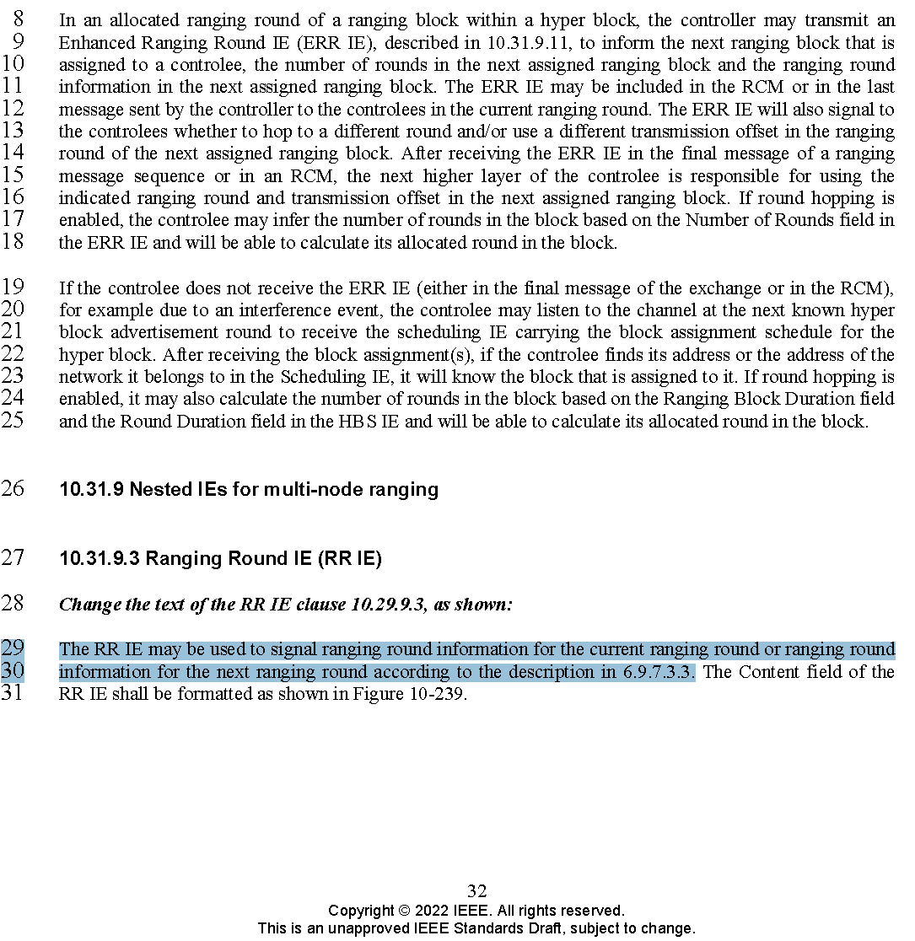
- Proposed change
Revise the sub-clause 10.31.9.3 Ranging Round IE (RR IE) in IEEE P802.15.4ab/Draft (pre-ballot) C as follows:
--------------------------------------------------------------------------------------------------------------------------------
10.31.9.3 Ranging Round IE (RR IE)

(pp. 32 line #29)
The RR IE may be used to signal ranging round information for the current ranging round or ranging round information for the next ranging round both in block-based mode and hyper block mode according to the description in section 6.9.7.3.3, except that in case of hyper block mode, the "next ranging block" or “ranging block i+1” mentioned in section 6.9.7.3.3 does not specify the next ranging block in the current hyper block (k), but rather specifies the ranging block in the next hyper block with the same index as the current ranging block (i.e., ranging block i in hyper block k+1).
…
--------------------------------------------------------------------------------------------------------------------------------

