IEEE P802.15
Wireless Personal Area Networks

Project | IEEE P802.15 Working Group for Wireless Personal Area Networks (WPANs)
Title | Proposed Resolution on MMS MAC Comments
Date Submitted | October 2023
Sources | Rojan Chitrakar, Lei Huang (Huawei)  rojan.chitrakar@huawei.com
Re:
Abstract
Purpose | To propose resolution to MMS MAC comments for “P802.15.4ab™/D (pre-ballot) B Draft Standard for Low-Rate Wireless Networks” .
Notice | This document does not represent the agreed views of the IEEE 802.15 Working Group or IEEE 802.15.4ab Task Group. It represents only the views of the participants listed in the “Sources” field above. It is offered as a basis for discussion and is not binding on the contributing individuals. The material in this document is subject to change in form and content after further study. The contributors reserve the right to add, amend or withdraw material contained herein.

Rev 0: Initial version. Addresses the following comments:
17, 119, 237, 238
Rev 1: Made changes based on feedback. Changes in CYAN.

Comment Index #17 in 15-23-0475-13-04ab-cc-consolidated-comments
Name | Sub-Clause | Page.Line | Comment | Proposed Change
Li-Hsiang Sun | 10.35.4 | 39.40 | " The poll message is transmitted at long-term NB PHY configuration." however, it is not clear if NB Channel select is included in the previous REPORT message from responder, is it counted as short term config?  It is not clear what is the protocol to change Allowed channel list in the middle of the session | NB channel select is not counted as short term operating parameters because it cannot be applied to the next round just for messages other than POLL  There should be a protocol that based on suggested NB channel select to update allowed channel list. However, initiator may need to stay on the channels for additional rounds based on the current alowed list if it does not receive a responding message to resend the new list.

Discussion：
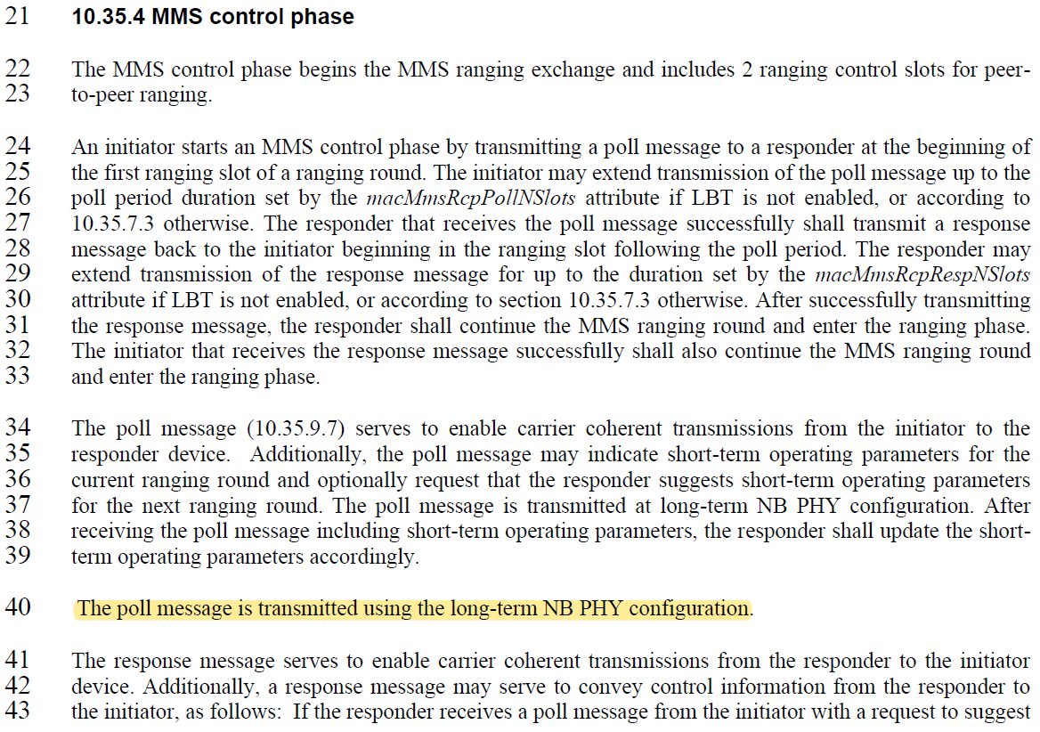

When the available channel list is included in the POLL message, it is regarded as short-term operating parameter and the channel information is updated in the same round. While this behaviour is already captured in Draft 0 (B), we agree with the comment that further detail to improve the clarity of the text is helpful.
In addition, based on page 21 of the approved document 23-0412-00, bit 0 of the Presence Bitmap field is used to indicate the presence of the NB Channel Select field or NB Channel Map field. When the Presence Bitmap field is included in the initialization phase in the ADV-RESP message, bit 0 of the Presence Bitmap field is used to indicate the presence of the NB Channel Select field. When the Presence Bitmap field is included in the POLL, RESP or REPORT message of the MMS control and report phases, bit 0 of the Presence Bitmap field is used to indicate the presence of the NB Channel Map field (instead of the NB Channel Select field). It should be noted that the NB Channel Map field has the same format as macMmsNbChannelMap defined in Figure 29. While this is captured in the consensus document 23/412r0, the field was wrongly named as NB Channel Select in the messages. This is also corrected in this disposition and replaced as NB Channel Map field. For consistency, the NbaChannelMap field is also globally replaced as NB Channel Map field.
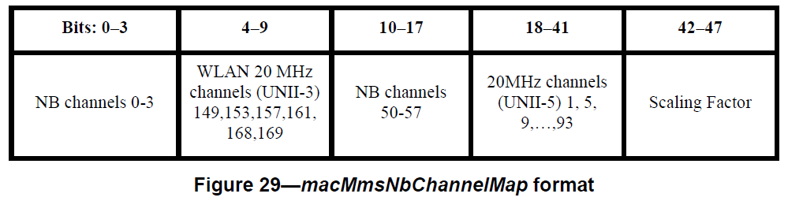
Disposition: Revised
Disposition Detail:
Proposed text changes on P802.15.4ab™/D (pre-ballot) B:
10.35.4 MMS control phase
Make the following changes in the subclause (Track changes ON):
…
The poll message (10.35.9.7) serves to enable carrier coherent transmissions from the initiator to the responder device. Additionally, the poll message may indicate short-term operating parameters for the current ranging round and optionally request that the responder suggests short-term operating parameters for the next ranging round. The poll message is transmitted at long-term NB PHY configuration. After receiving the poll message including short-term operating parameters, the responder shall update the short-term operating parameters accordingly. The updated short-term operating parameters take effect at the end of the poll message and are only applicable to the current ranging round. All parameters revert to the long-term operating parameter in the next ranging round.

The response message serves to enable carrier coherent transmissions from the responder to the initiator device. Additionally, a response message may serve to convey control information from the responder to the initiator, as follows: If the responder receives a poll message from the initiator with a request to suggest short-term operating parameters and is not intending to send any measurement report in the current ranging round, then the response message transmitted by the responder shall include the suggested short-term operating parameters. The initiator may make use of the suggested short-term operating parameters to determine updated short-term operating parameters to be used in the next ranging round. If the poll message includes NB related short-term operating parameters, the response message is transmitted using the NB related short-term operating parameters indicated in the poll message. Otherwise, the response message is transmitted using the long-term NB related operating parameters.

10.35.6 MMS report phase
Make the following changes in the subclause (Track changes ON):
…
A report message primarily serves to provide ranging results obtained during the ranging phase. Additionally, report messages may be used to serve other purposes. For example, if poll message from the initiator includes a request to suggest short-term operating parameters, then the report message transmitted by the responder shall include the suggested short-term operating parameters. The initiator may make use of these suggested short-term operating parameters to determine updated short-term operating parameters to be used in the next ranging round. If the poll message includes NB related short-term operating parameters, the report message is transmitted using the NB related short-term operating parameters indicated in the poll message. Otherwise, the report message is transmitted using the long-termNB related operating parameters.

If a device fails to deliver a report during its assigned slot in the report phase, OOB mechanisms might be employed to deliver it during the remaining time of the current ranging block.
Change Figure 40 (The Request Bitmap field) at Page 53 as follows:
Bits: 0 | 1 | 2 | 3 | 4 | 5-7
NB Channel Map requested | NB PHY Configuration requested | NB MAC Configuration requested | UWB PHY Configuration requested | UWB MAC Configuration requested | Reserved

Change Figure 50 (Message Content field in POLL when message control is one) at Page 57 as follows:
Octets: 1 | 1 | 0/6 | 0/3 | 0/2 | 0/1 | 0/7
Request Bitmap | Presence Bitmap | NB Channel Map | NB PHY Configuration | NB MAC Configuration | UWB PHY Configuration | UWB MAC Configuration

Change Figure 51 (Presence Bitmap format) at Page 57 as follows:
Bits: 0 | 1 | 2 | 3 | 4 | 5-7
NB Channel Map Present | NB PHY Configuration Present | NB MAC Configuration Present | UWB PHY Configuration Present | UWB MAC Configuration Present | Reserved

Make the following changes at Line 19 at Page 58 REPORT (Responder):
If Bit 0 of Presence Bitmap == 1 then {NB Channel Map[6]},
Make the following changes at Line 24 at Page 58 REPORT (Responder):
where PTDataLength and PTData fields are optionally present and represent pass through data to higher layers; and at least one of NB Channel Map, NB PHY Config, NB MAC Config, UWB PHY Config and UWB MAC Config fields shall be present.
Make the following changes at Line 10 at Page 60 POLL (One-to-many):
If Bit 0 of Presence Bitmap == 1 then {NB Channel Map[6]},
Make the following changes at Line 19 at Page 60 POLL (One-to-many):
If Bit 0 of Presence Bitmap == 1 then {NB Channel Map[6]},
Make the following changes at Line 7 at Page 61 RESP (One-to-many):
If Bit 0 of Presence Bitmap == 1 then {NB Channel Map[6]},
Make the following changes at Line 13 at Page 61 RESP (One-to-many):
The number of padding octets is determined so that the MessageContent field has a minimum size of 5 octets; and at least one of the fileds NB Channel Map, NB PHY Config, NB MAC Config, UWB PHY Config and UWB MAC Config fields shall be present.
Make the following changes at Line 3 at Page 62 REPORT (from responder in one-to-many ranging):
If Bit 0 of Presence Bitmap == 1 then {NB Channel Map[6]},
Make the following changes at Line 8 at Page 62 REPORT (from responder in one-to-many ranging):
where at least one of NB Channel Map, NB PHY Config, NB MAC Config, UWB PHY Config and UWB MAC Config fields shall be present.
--------------------------------------------------------------------------------------------------------------------------------
Comment Index #119 in 15-23-0475-13-04ab-cc-consolidated-comments
Name | Sub-Clause | Page.Line | Comment | Proposed Change
Youngwan So | 10.35.9.8 | 58.4 | Seems typo or incomplete sentence | Revise appropriately if needed.

Discussion：
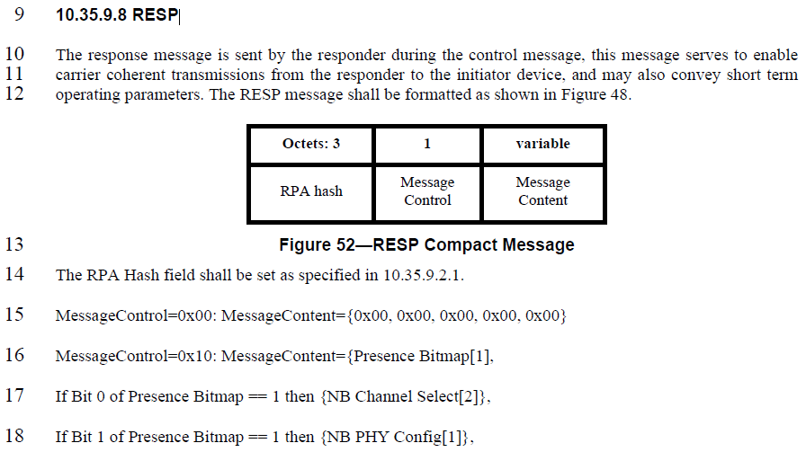
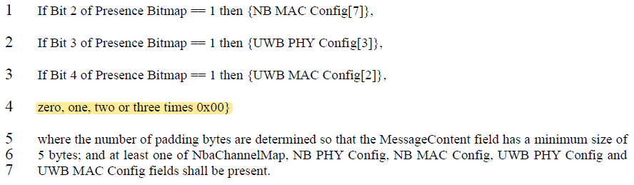
The purpose of the sentence on line 4 is explained in line 5, but we agree that the text can be improved for better clarity. We have rewritten the subclause 10.35.9.8 (RESP) similar to the style used for the POLL message.
Disposition: Revised
Disposition Detail:
Proposed text changes on P802.15.4ab™/D (pre-ballot) B:
10.35.9.8 RESP
Make the following changes in the subclause (Track changes ON):
…
The RPA Hash field shall be set as specified in 10.35.9.2.1.
The Message Control field value shall be either zero or one. This value determines the formatting of the Message Content field.

When the Message Control field value is zero the Message Content field shall consist of five octets with the value of zero as shown in Figure 52B.
Octets: 5
0x0000000000
Figure 52B—Message Content field in RESP when message control is zero

When the Message Control field value is one the Message Content field shall be formatted as shown in Figure 52C.
Octets: 1 | 0/6 | 0/3 | 0/2 | 0/1 | 0/7 | 0/1/2/3
Presence Bitmap | NB Channel Map | NB PHY Configuration | NB MAC Configuration | UWB PHY Configuration | UWB MAC Configuration | Zero Padding
Figure 52C—Message Content field in RESP when message control is one
The Presence Bitmap field shall be formatted as shown in Figure 51.
At least one of NB Channel Map, NB PHY Config, NB MAC Config, UWB PHY Config and UWB MAC Config fields shall be present in the Message Content field.
The Zero Padding field shall be present when the size of the Message Content field without the Zero Padding field is less than five octets. The Zero Padding field, present, shall consist of one, two or three octets with the value of zero where the number of padding octets are determined so that the Message Content field has a size of five octets.

--------------------------------------------------------------------------------------------------------------------------------

Comment Index #237 in 15-23-0475-13-04ab-cc-consolidated-comments
Name | Sub-Clause | Page.Line | Comment | Proposed Change
Carlos Aldana | 10.35.7.4.2 | 44.1 | What happens if all the channels are deemed unavailable or unusable? | Please specify expected behavior

Discussion：
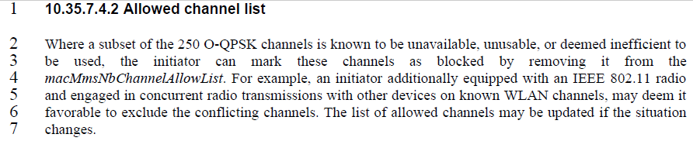
If all NB channels are deemed unavailable or unusable, the MMS ranging session won’t even be initialized and the allowed channel list is not communicated.
Disposition: Revised.
Disposition Detail:

Change the sentence in Page 44 Line 2 as follows (Track change ON):
10.35.7.4.2 Allowed channel list
Where a subset or the entire set of the 250 O-QPSK channels is known to be unavailable, unusable, or deemed inefficient to be used, the initiator can mark these channels as blocked by removing it from the macMmsNbChannelAllowList. When all 250 O-QPSK channels are marked as blocked, devices should not engage in an MMS ranging session. For example, an initiator additionally equipped with an IEEE 802.11 radio and engaged in concurrent radio transmissions with other devices on known WLAN channels, may deem it favorable to exclude the conflicting channels. The list of allowed channels may be updated if the situation changes.
--------------------------------------------------------------------------------------------------------------------------------
Comment Index #238 in 15-23-0475-13-04ab-cc-consolidated-comments
Name | Sub-Clause | Page.Line | Comment | Proposed Change
Carlos Aldana | 10.35.7.4.2 | 44.20 | When does the responder employ the list of available channels? Is it immediate, or after X ms? If X ms, what is X? | Please specify expected behavior

Discussion：
The comment is similar to #17. For short-term operating parameters update, the list of available channels take effect at the end of the poll message. This is addressed by the disposition of comment #17. We note that the reference subclause in D0 is wrong (points to the original subclause in 23/381r5), we have corrected the reference to point to 10.35.7.4.3 (channel switching protocol).
Disposition: Revised
Disposition Detail: This comment is addressed by the disposition of comment #17. No further changes required from the 4ab editor.

