IEEE P802.15
Wireless Personal Area Networks

Project | IEEE P802.15 Working Group for Wireless Personal Area Networks (WPANs)
Title | <802.15 TG4ab (NG-UWB) Conf. Call Mins. Jul. to Sep. 2023>
Date Submitted | [08 Sep, 2023]
Source | [David Xun Yang]  [Huawei]  [Bantian, Shenzhen, China] | Voice: [+86.159.1411.7462]  Fax: [--]  E-mail: [david.yangxun@huawei.com]
Re: | [802.15 TG4ab Conf. Call Mins]
Abstract | [Official Minutes of the Call]
Purpose | [Record the main points of the call]
Notice | This document has been prepared to assist the IEEE P802.15. It is offered as a basis for discussion and is not binding on the contributing individual(s) or organization(s). The material in this document is subject to change in form and content after further study. The contributor(s) reserve(s) the right to add, amend or withdraw material contained herein.
Release | The contributor acknowledges and accepts that this contribution becomes the property of IEEE and may be made publicly available by P802.15.

802.15 TG4ab (NG-UWB) Conf. Call Minutes
between Jul. and Sep. 2023 Mtgs.

Tuesday, 25 Jul 2023

Opening
9:02 AM ET 802.15 TG4ab Chair, Ben Rolfe (BCA), called the meeting to order

Minutes
<40 participants were noted during the duration of the call

Utilizing the meeting and agenda doc. # 15-23-0428-00, the Chair conducted the following business:
- Opening
- Reviewed IEEE Patent Policy
  - Made call for claims with no responses
- Reviewed IEEE SA Participation Policy
- Reviewed IEEE SA Copyright Policy
- Reviewed 802 Rules

Announcement
Chair reviewed the proposed agenda. There was no objection to the agenda. It passed with unanimous consent.

Chair reviewed the milestone schedule. No question/comment heard.

Editor Billy Verso (Qorvo) introduced the progress of draft preparing as in doc. # 15-23-0374-00:
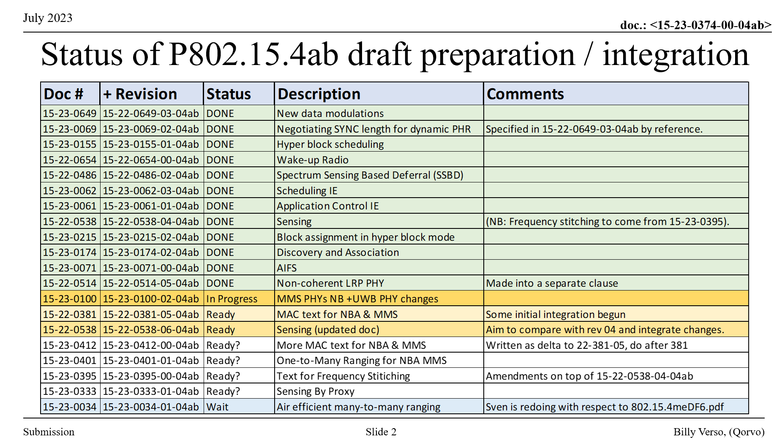
The draft is expected to be ready in the middle of August. Pooria Pakrooh (Qualcomm) clarified that “Text for Frequency Stitching” (doc.# 15-23-0395-00-04ab) and “Sensing by Proxy” (doc. 15-23-0331-01-04ab) had been incorporated in the document “Sensing (updated doc)” (doc.# 15-22-0538-06-04ab).

Chair reviewed the telecon schedule and reminded people to send requests few days before the next call.

Chair reminded people to register Sep interim meeting before the deadline for early bird.

Chair asked if there is any other business to discuss. No request heard.

Chair adjourned the call @9:42am ET.

Tuesday, 1 Aug 2023

Opening
10:05 PM PT 802.15 TG4ab Chair, Ben Rolfe (BCA), called the ad-hoc meeting to order

Minutes
>30 participants were noted during the duration of the call

Utilizing the meeting and agenda doc. # 15-23-0428-01, the vice chair conducted the following business:
- Opening
- Reviewed IEEE Patent Policy
  - Made call for claims with no responses
- Reviewed IEEE SA Participation Policy
- Reviewed IEEE SA Copyright Policy
- Reviewed 802 Rules

Announcement
Chair reviewed the proposed agenda. There was no objection to the agenda. It passed with unanimous consent.

Chair reviewed the milestone schedule. No question/comment heard.

Aniruddh Rao Kabbinale (Samsung) presented “Updates for using non-sensing transmissions for sensing”
(doc. # 15-23-0437-00)
This presentation is an update to discussion on use of non-sensing transmission for sensing. It provides updates to control message to enable use of non-sensing transmissions for sensing.
Questions/comments raised include details of sensing control field.

Carl Murray (Qorvo) presented “MMS ranging messaging”
(doc. # 15-23-0435-00)
This presentation introduces the recommended approach for MMS ranging messaging.

Editor Billy Verso (Qorvo) presented “Status of Draft” (doc. # 15-23-0374-01). The current progress was shown as follows:
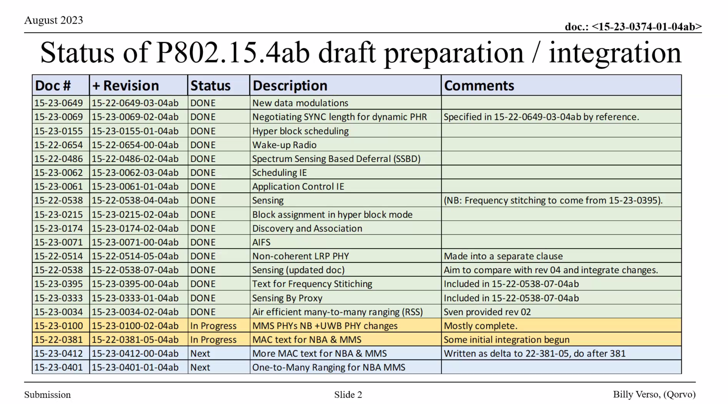

Chair introduced “Draft Development Process” on page 26 and 27 as in doc. # 15-23-0428-01.

Chair reviewed the telecon schedule and reminded people to send requests a few days before the next call.

Chair reminded people to register Sep interim meeting even though the deadline for early bird was past.

Chair asked if there is any other business to discuss. No request heard.

Chair adjourned the call @10:55pm PT.

Tuesday, 8 Aug 2023

Opening
9:03 AM ET 802.15 TG4ab Chair, Ben Rolfe (BCA), called the meeting to order.

Minutes
~35 participants were noted during the duration of the call

Utilizing the meeting and agenda doc. # 15-23-0428-02, the Chair conducted the following business:
- Opening
- Reviewed IEEE Patent Policy
  - Made call for claims with no responses
- Reviewed IEEE SA Participation Policy
- Reviewed IEEE SA Copyright Policy
- Reviewed 802 Rules

Announcement
Chair reviewed the proposed agenda. There was no objection to the agenda. It passed with unanimous consent.

Chair reviewed the schedule major milestones.

Bin Qian (Huawei) presented “Considerations on CIR report for non-sensing transmission”
(doc. # 15-23-0440-01)
This presentation proposes not to apply the dynamic data packet to perform sensing and not to generate the CIR report from PHY payload.
Questions/comments raised include the motivation of considering non-sensing PPDU, and possibility to generate CIR report by using different type of fields.

Editor Billy Verso (Qorvo) presented “Status of Draft” (doc. # 15-23-0374-02). The current progress was shown as follows:
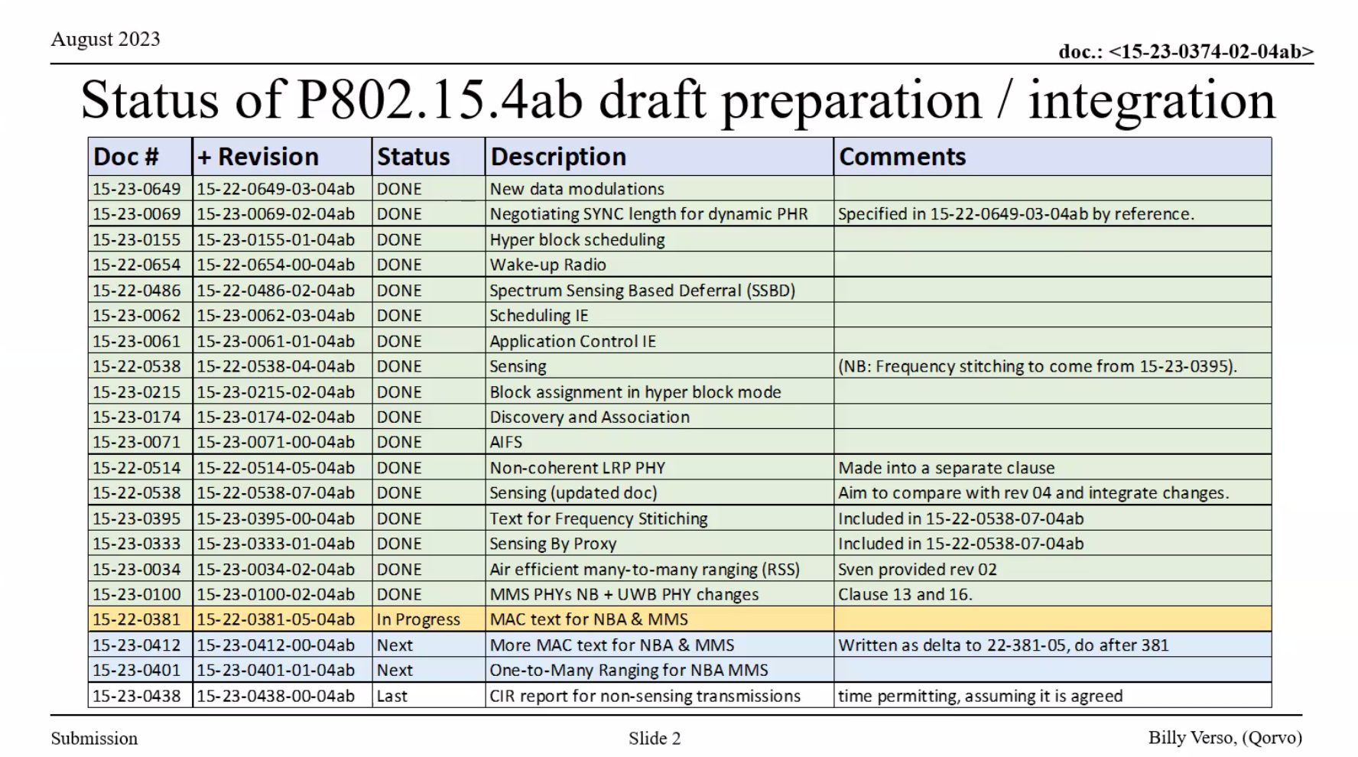
There was a question on how to guarantee 30 days before Sep F2F meeting for people to review. Chair explained there were several reasons that 30 days cannot be met. The duration can be reduced in this case. Comments will be collected by vice chair Clint Chaplin (SRA) efficiently.

Chair reviewed the telecon schedule and reminded people to send requests a few days before the next call.

Chair asked if there is any other business to discuss. No request heard.

Chair adjourned the call @9:52am ET.

Tuesday, 15 Aug 2023

Opening
10:01 PM PT 802.15 TG4ab Chair, Ben Rolfe (BCA), called the meeting to order.

Minutes
~30 participants were noted during the duration of the call

Utilizing the meeting and agenda doc. # 15-23-0428-03, the Chair conducted the following business:
- Opening
- Reviewed IEEE Patent Policy
  - Made call for claims with no responses
- Reviewed IEEE SA Participation Policy
- Reviewed IEEE SA Copyright Policy
- Reviewed 802 Rules

Announcement
Chair reviewed the proposed agenda. There was no objection to the agenda. It passed with unanimous consent.

Chair reviewed the schedule major milestones and emphasized that the draft was available.

Chair presented “Status of Draft” (doc. # 15-23-0374-03). The current progress was shown as follows:
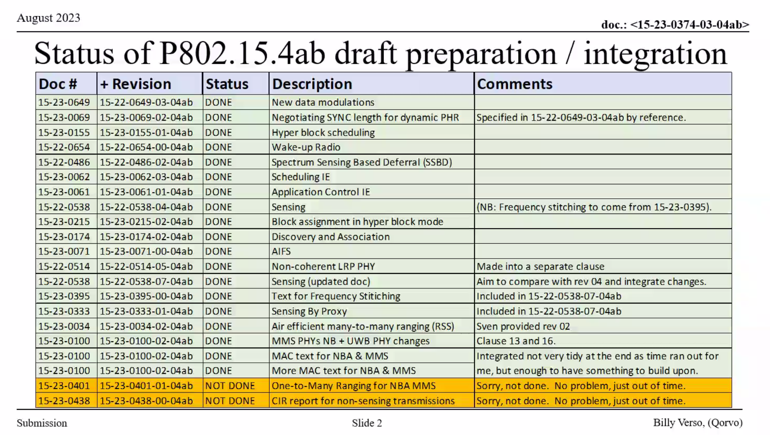
No question heard about the current status.

Chair further introduced the draft development process and comment process (doc. # 15-23-0428-03). Chair announced that vice chair Clint Chaplin (SRA) is responsible for comment management. There are several questions on the details of comment submission. Chair further introduced how to handle the missing documents. Both the draft and the missing documents are commentable.

Chair introduced the need of Coexistence Assessment Document. Chair was looking for volunteers to prepare this document. Carlos Aldana (Meta) was interested in contributing the technical part.

Chair reviewed the telecon schedule and reminded people to send requests a few days before the next call.

Chair asked if there is any other business to discuss. No request heard.

Chair adjourned the call @10:58pm PT.

Tuesday, 29 Aug 2023

Opening
10:02 PM PT 802.15 TG4ab Chair, Ben Rolfe (BCA), called the meeting to order.

Minutes
>20 participants were noted during the duration of the call

Utilizing the meeting and agenda doc. # 15-23-0428-04, the Chair conducted the following business:
- Opening
- Reviewed IEEE Patent Policy
  - Made call for claims with no responses
- Reviewed IEEE SA Participation Policy
- Reviewed IEEE SA Copyright Policy
- Reviewed 802 Rules

Announcement
Chair reviewed the proposed agenda. There was no objection to the agenda. It passed with unanimous consent.

Chair reviewed the updated schedule major milestones.

Chair Benjamin Rolfe (BCA) presented “Coexistence Document for IEEE 802.15.4ab (proposed outline)”
(doc. # 15-23-0452-00)
This presentation introduced the outline of coexistence analysis of 802.15.4z and other 802 wireless systems.
Alex Krebs (Apple), Carlos Aldana (Meta) and Larry Zakaib (Spark) volunteered for the work on coexistence.

Chair introduced his plan and schedule on the draft. There were several questions on the missing documents, missing parts and pre-mature content. People also suggested to leave one more week for the editor after Sep meeting.

Chair reviewed the telecon schedule and reminded people to send requests a few days before the next call.

Chair asked if there is any other business to discuss. No request heard.

Chair adjourned the call @10:58pm PT.

Tuesday, 5 Sep 2023

Opening
9:02 AM ET 802.15 TG4ab Chair, Ben Rolfe (BCA), called the meeting to order.

Minutes
~30 participants were noted during the duration of the call

Utilizing the meeting and agenda doc. # 15-23-0458-00, the Chair conducted the following business:
- Opening
- Reviewed IEEE Patent Policy
  - Made call for claims with no responses
- Reviewed IEEE SA Participation Policy
- Reviewed IEEE SA Copyright Policy
- Reviewed 802 Rules

Announcement
Chair reviewed the proposed agenda. There was no objection to the agenda. It passed with unanimous consent.

Chair reviewed the updated schedule major milestones.

Editor Billy Verso (Qorvo) introduced his new progress in draft 0 preparation (doc. # 15-23-0374-04). All the documents in the following table were in. Editor would generate the pdf version of draft 0 for people to review. Chair encouraged people to focus on the potential issues in Sep F2F meeting.

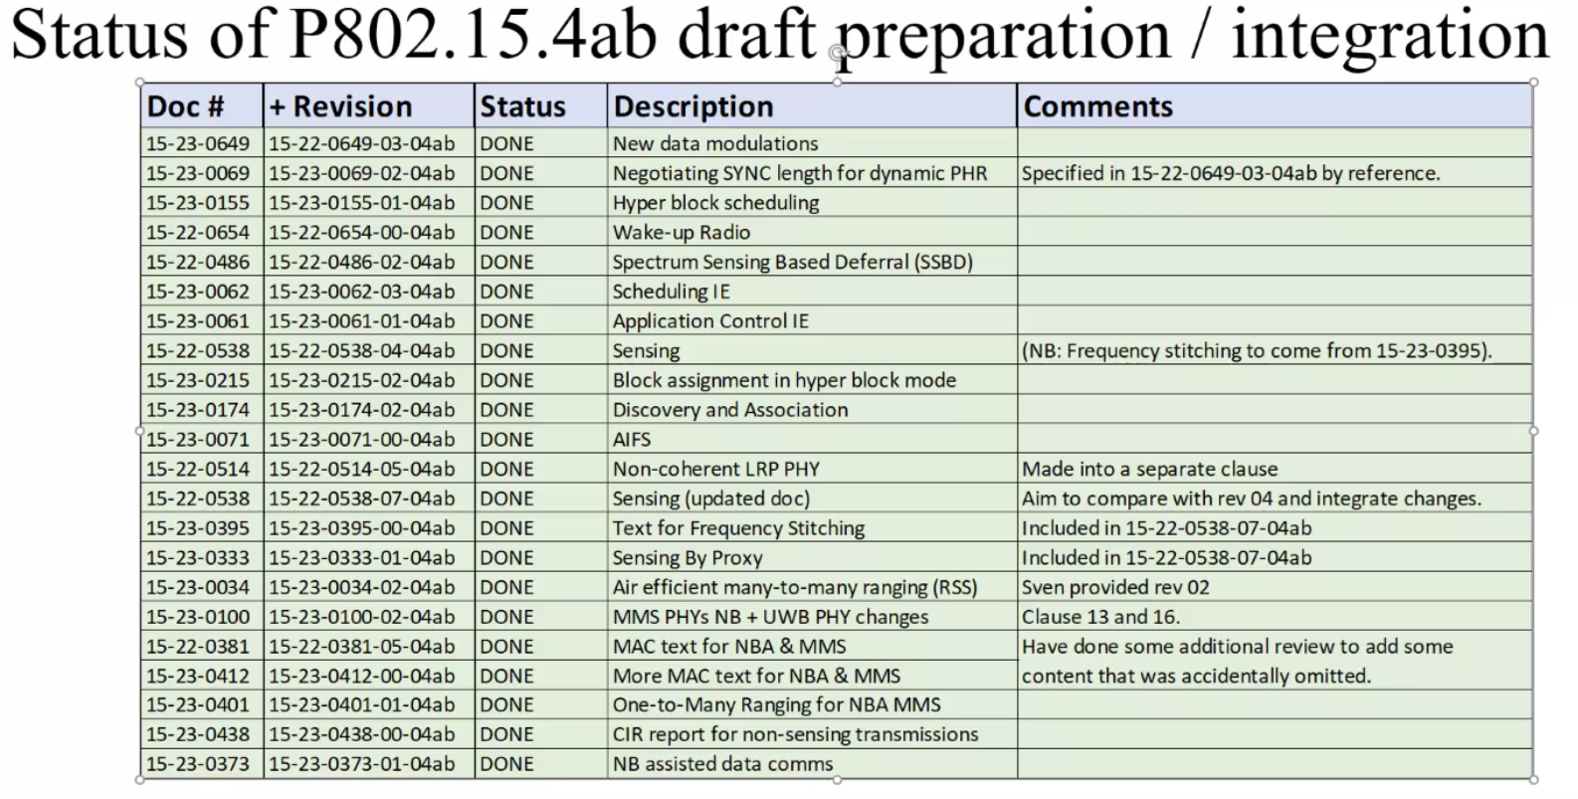

Chair introduced his plan and schedule on the draft in Sep meeting. There were several questions on details, e.g., how to operate “teams”, whether to have an updated draft after Sep meeting, etc. Chair further introduced the potential timeline for comment collection after Sep meeting.

Chair asked if there is any other business to discuss. There were two questions:
- Whether to send a notice for people to comment on the updated draft document by Billy
- Contributions need to focus on the draft in Sep meeting

Chair adjourned the call @9:53am ET.

