IEEE P802.15
Wireless Specialty Networks

Project | IEEE P802.15 Working Group for Wireless Specialty Networks (WSNs) – 802.15.6ma
Title | Proposed text for 6ma MAC – Frames and IEs for dependable BAN
Date Submitted | July 4, 2023
Source | Seong-Soon Joo (KPST) | E-mail: [ssjoo@etri.sci.kr]
Re: | Contribution to IEEE 802.15.6ma
Abstract | This document provides a text draft of 6ma MAC for specifying frames and information elements to support coexisting dependable BANs in clause 5.
Purpose | Support development of technical content for the draft
Notice | This document has been prepared to assist the IEEE P802.15. It is offered as a basis for discussion and is not binding on the contributing individual(s) or organization(s). The material in this document is subject to change in form and content after further study. The contributor(s) reserve(s) the right to add, amend or withdraw material contained herein.
Release | The contributor acknowledges and accepts that this contribution becomes the property of IEEE and may be made publicly available by P802.15.

Revise the sub-clause 5.2 as follows:

5.2.1.1.7 Frame Subtype
The Frame Subtype field is set to indicate the subtype of the current frame of a given type according to Table 3. The name of the frame subtype of a frame is used as the name of the frame throughout Clause 2 through Clause 7.
Table 3 ―Frame Type and Frame Subtype field encoding
Frame Type value b5 b4 | Frame Type name | Frame Subtype value b3 b2 b1 b0 | Frame Subtype name
00 | Management | 0000 | Beacon
00 | Management | 0001 | Reserved
00 | Management | 0010 | Security Association
00 | Management | 0011 | Security Disassociation
00 | Management | 0100 | PTK
00 | Management | 0101 | GTK
00 | Management | 0110–0111 | Reserved
00 | Management | 1000 | Connection Request
00 | Management | 1001 | Connection Assignment
00 | Management | 1010 | Disconnection
00 | Management | 1011 | D-Beacon
00 | Management | 1100–1110 | Reserved
00 | Management | 1111 | Command
01 | Control | 0000 | I-Ack
01 | Control | 0001 | B-Ack
01 | Control | 0010–0011 | Reserved
01 | Control | 0100 | I-Ack+Poll
01 | Control | 0101 | B-Ack+Poll
01 | Control | 0110 | Poll
01 | Control | 0111 | T-Poll
01 | Control | 1000–1101 | Reserved
01 | Control | 1110 | Wakeup
01 | Control | 1111 | B2
10 | Data | 0000 | User Priority 0 or Allocation Mapped Data Subtype
10 | Data | 0001 | User Priority 1 or Allocation Mapped Data Subtype
10 | Data | 0010 | User Priority 2 or Allocation Mapped Data Subtype
10 | Data | 0011 | User Priority 3 or Allocation Mapped Data Subtype
10 | Data | 0100 | User Priority 4 or Allocation Mapped Data Subtype
10 | Data | 0101 | User Priority 5 or Allocation Mapped Data Subtype
10 | Data | 0110 | User Priority 6 or Allocation Mapped Data Subtype
10 | Data | 0111 | Emergency
10 | Data | 1000–1111 | Allocation Mapped Data Subtype
11 | Reserved | 0000–1111 | Reserved

Revise the sub-clause 5.3 as follows:

5.3.10 Dependable BAN Beacon (D-Beacon)
A beacon frame contains a Frame Payload that is formatted as shown in Figure 1. It is locally broadcast by a hub of a dependable BAN in every beacon period (superframe).
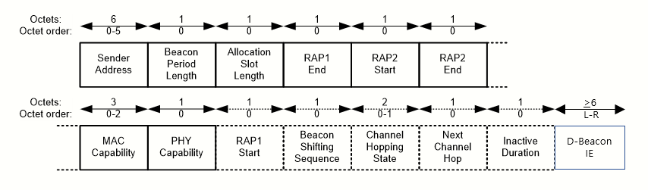
- ―Frame Payload format for D-Beacon frames

5.3.10.1 Sender Address
The Sender Address field is as defined in 5.3.1.1.
5.3.10.2 Beacon Period Length
The Beacon Period Length field is set to the length of the beacon period, in units of ten times of allocation slots.
5.3.10.3 Allocation Slot Length
The Allocation Slot Length field is set to 62 such that is equal to pAllocationSlotMin + 62 x pAllocationSlotResolution.
5.3.10.4 RAP1 Start
The RAP1 Start field is as defined in 5.3.1.4.
5.3.10.5 RAP1 End
The RAP1 End field is as defined in 5.3.1.5.
5.3.10.6 RAP2 Start
The RAP2 Start field is as defined in 5.3.1.6.
5.3.10.7 RAP2 End
The RAP2 End field is as defined in 5.3.1.7.
5.3.10.8 MAC Capability
The MAC Capability field is as defined in 5.3.1.8.
5.3.10.9 PHY Capability
The PHY Capability field is as defined in 5.3.1.9.
5.3.10.10 Beacon Shifting Sequence
The Beacon Shifting Sequence field is as defined in 5.3.1.10.
5.3.10.11 Channel Hopping State
The Channel Hopping State field is as defined in 5.3.1.11.
5.3.10.12 Next Channel Hop
The Next Channel Hop field is as defined in 5.3.1.12.
5.3.10.13 Inactive Duration
The Inactive Duration field is as defined in 5.3.1.13.
5.3.10.14 Dependable BAN Beacon IE
The Dependable BAN Beacon IE is as defined in 5.7.16.

Revise the sub-clause 5.7 as follows:

5.7 Information elements

Table 16—Information elements (continued)
Element ID  in decimal value | IE name | Description
9 | Bilink Assignment IE | Specifies allocation slot-based scheduled bilink allocation(s) assigned to a node in beacon or non-beacon mode with superframes
10 | Type-I Unscheduled Bilink Assignment IE | Specifies allocation slot-based unscheduled bilink allocation(s) assigned to a node in beacon or non-beacon mode with superframes
11 | Type-II Unscheduled Bilink Assignment IE | Specifies frame count-based unscheduled bilink allocation(s) assigned to a node in non-beacon mode without superframes
12 | Reserved | Reserved
13 | Nibble Encoded Channel Order IE | Specifies a list of 4-bit encoded channels in an operating band containing no more than 15 channels in the order of their selection by a hub as the operating channel
14 | Channel Hopping and Ordering IE | Specifies a subset of channels included in channel hopping in the operating frequency band and/or a list of 8-bit encoded channels in the operating band in the order of their selection by a hub as the operating channel
15 | Former Hub Address IE | Specifies the EUI-48 of the last hub with which the node was connected
16 | Dependable BAN Beacon IE | Specifies configuration of dependable BAN and dependable BAN group, and coordination information of maintaining a dependable BAN group
17–244 | Reserved | Reserved
255 | Application Specific IE | Provides user-defined application-specific information

5.7.16 Dependable BAN Beacon IE
The Dependable BAN Beacon IE is formatted as shown in Figure xx. It is optionally contained in dependable BAN beacon frames to convey the configuration of beacon period of a dependable BAN and the configuration of beacon access phase of a dependable BAN group, and the coordination commands between coordinator hub and leaf hub of a dependable BAN group.
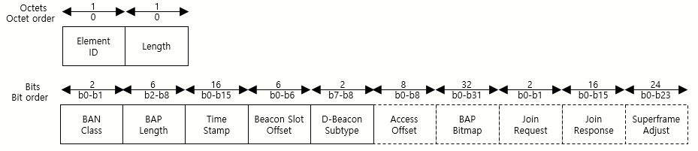
Figure xx —Dependable BAN Beacon IE format

5. 7.16.1 BAN Class
The BAN Class field is set according to Table xx to indicate the class of the services provided by the BAN.of the sender of the current frame.
- —BAN Class field encoding
Field value  in decimal | BAN services
0 | Reserved
1 | Class 1 services: 15 ms bounded latency, 99.9% probability of loss, 10ms update rate
2 | Class 2 services: 100 ms bounded latency, 99% probability of loss, 50ms update rate
3 | Class 3 services: 250 ms bounded latency, 95% probability of loss, 1s update rate

5.7.16.2 BAP Length
The BAP Length field is set to the number of reserved slots for transmitting a beacon in a dependable BAN group.
5.7.16.3 Time Stamp
The Time Stamp field is set to the slot counter of a hub transmitting beacon that is maintained from the start.
5.7.16.4 Beacon Slot Offset
The Beacon Slot Offset field is set to the slot number transmitting a beacon in beacon access phase, If set to zero, a coordinator hub broadcasts D-Beacon, Otherwise, a leaf hub broadcasts D-Beacon.
5.7.16.5 D-Beacon Subtype
The D-Beacon Subtype field is set as Table xx to indicate what fields are followed after this field.
- —D-Beacon Subtype field encoding
Field value  in decimal | BAN services
0 | For a coordinator hub, BAP Bitmap field is followed. For a leaf hub, Access Offset field is followed
1 | For a coordinator hub, Join Response field is followed. For a leaf hub, Access Offset field and Join Response field are followed
2 | For a coordinator hub, xxx field is followed. For a leaf hub, Superframe Adjust field is followed
3 | Reserved

5.7.16.6 Access Offset
The Access Offset field is set to the slot offset to start an access phase after BAP ends.
5.7.16.7 BAP Bitmap
The BAP Bitmap is set to indicate the assigned beacon slot that a coordinator hub assigns a beacon slot in BAP to a leaf hub and set 1 to the slot number of bitmap.
5.7.16.8 Join Request
The Join Request field is set to indicate whether a hub joins as a coordinator or a leaf hub. If it is set to zero, a hub challenges to become a coordinator hub. Otherwise, a hub requests to become a member of a dependable BAN group.
5.7.16.9 Join Response
The Join Response field is formatted as shown in Figure xx.
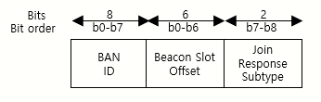
Figure xx —Dependable BAN Join Response format
5.7.16.9.1 BAN ID
The BAN ID field is set to the abbreviated address of the BAN which send a join request.
5.7.16.9.2 Beacon Slot Offset
The Beacon Slot Offset field is set to the slot number assigned to a leaf hub for transmitting a beacon in beacon access phase.
5.7.16.9.3 Join Response Subtype
The Join Response Subtype field is set as Table xx to indicate what fields are followed after this field.
- —Join Response Subtype field encoding
Field value  in decimal | BAN services
0 | End of Join Response field
1 | Join Response field is followed
2 | Coordinator challenge accepted and BAP Bitmap field is followed
3 | Reserved

5.7.16.10 Superframe Adjust
The Superframe Adjust field is formatted as shown in Figure xx.
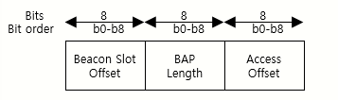
Figure xx —Superframe Adjust format
5.7.16.10.1 Beacon Slot Offset
The Beacon Slot Offset field is set to the beacon slot number that will be used from next superframe.
5.7.16.10.2 BAP Length
The BAP Length field is set to the number of reserved slots for transmitting a beacon in a dependable BAN group.
5.7.16.10.3 Access Offset
The Access Offset field is set to the slot offset to start an access phase after BAP ends that will be used from next superframe.

