**IEEE P802.15**

**Wireless Specialty Networks**

|  |  |
| --- | --- |
| Project | IEEE P802.15 Working Group for Wireless Specialty Networks (WSNs) |
| Title | 15.4 MAC evolution to support air time efficient multi-mode many-2-many ranging – based on Technical Specification Framework for 802.15.4ab |
| Date Submitted | 16th January 2023, original submission 31st July 2023, updated according to new baseline doc structure (802.15.4meDF6) |
| Source | [Sven Zeisberg, Erik Mademann, Frank Stephan, (Zigpos)] [Jean-Marie Andre, Mickael Maman, (ST microelectronics)]  [Vincent van der Locht, (SynchronitIT)]  [Franz Lehmann, (TRUMPF)]  [sven.zeisberg @ zigpos.com],[jean-marie.andre @ st.com] | |
| Re: | Developing technical content for 15.4-2020 MAC evolution to support air time efficient multi-mode many-2-many ranging |
| Abstract | This document provides inputs for editing the draft 4ab standard in order to enhance the 15.4(z) MAC enabling air time efficient multi-mode many-2-many ranging. Inputs are provided in a backward compatible evolutionary approach and are focused on (i) allowing interleaved multi-purpose time slots in scheduled multi-mode ranging mode as well as (ii) enabling free choice of responders while picking initiators in scheduled many-2-many ranging. Further, the existing TSCH slotframe approach is proposed to be applied also for another O-QPSK based additional special application space, which is introduced and which is called “NB Ranging Support Service”. |
| Purpose | Provide input for technical content for the draft 802.15.4ab |
| Notice | This document has been prepared to assist the IEEE P802.15 and is based on the Technical Specification Framework for 802.15.4ab provided by Ben Rolfe in document 15-21-0442-00-04ab-technical-specification-framework. It is offered as a basis for discussion and is not binding on the contributing individual(s) or organization(s). The material in this document is subject to change in form and content after further study. The contributor(s) reserve(s) the right to add, amend or withdraw material contained herein. |
| Release | The contributor acknowledges and accepts that this contribution becomes the property of IEEE and may be made publicly available by P802.15. |

Technical Specification Framework

For 802.15.4ab

# Overview

In this contribution a number of backward compatible MAC sublayer evolution proposals are described, which all target the same goal, to enhance air time efficiency in dense multi-mode ranging (MMR) scenarios with ranging infrastructure installations.

The document is split into two parts, first an explanatory part with sections 1-5 and second a detailed update proposal text part with sections 6-7.

In sections 1-5 the reasoning and background as well as references for better understanding of the proposed evolutionary changes are provided. In the subsequent sections 6 and 7 then the detailed text change proposals are provided referring to the existing standards document.

Revision 1 of this contribution was based on 802.15.4-2020 and 802.15.4z-2020, and the update proposals where approved by the 802.15 TG4ab excluding the original change proposal for the ARC IE.

Revision 2 of this contribution is an editorial rewritten version compared to revision 1 in order to:

* reflect the changed baseline document now being the merged and restructured 802.15.4meDF6 (instead of the previous 802.15.4-2020 and 802.15.4z-2020)
* remove the change proposal concerning the ARC IE from this document

# References

[0] IEEE 802.15.4-2020

[0b] IEEE 802.15.4z-2020

[0c] IEEE 802.15.4meDF6

[1] Jean-Marie André, Sven Zeisberg, Erik Mademann: Evolution of 4z enabling optimized many-to-many ranging for dense environments. IEEE 802.15-22-0471-00-04ab, 2022-09, IEEE 802.15 TG4ab

[2] Sven Zeisberg, Jean-Marie André: 802.15.4z upgrade requirements for larger industrial scenarios. IEEE 15-21-0066-00-04ab, 2021-01-20, IEEE 802.15 SG4ab

[3] Jean-Marie André, Sven Zeisberg: DL-TDOA positioning TDMA scheme. IEEE 15-21-0530-00-04ab, 2021-10-19, IEEE 802.15 TG4ab

[4] J.S. Hammerschmidt, Ersen Ekrem, Eren Sasoglu, Xiliang Luo: Narrowband assisted multi-millisecond UWB. IEEE 15-21-0409-00-04ab, 2021-07-20, IEEE 802.15 TG4ab

[5] Jean-Marie André (ST microelectronics), Sven Zeisberg (HTW), Vincent van der Locht (SynchronicIT), Frank Stephan (ZIGPOS), Andreas Schumacher (TRUMPF): TDMA scheme enabling industrial DL-TDoA and UL-TDoA scenarios. IEEE 15-22-0077-00-04ab, 2022-01-2, IEEE 802.15 TG4ab

# Definitions, acronyms, and abbreviations

## Definitions

Multi-Mode Ranging scenario: within a single ranging round the ranging anchor nodes support several different ranging modes at the same time.

## Acronyms and abbreviations

RSS Ranging Support Service

MMR Multi-Mode Ranging

DOP Dilution of precision

ATS Allocated Transmit Slot

# Format conventions

# General description

In this section four backward compatible MAC sublayer evolution proposals (A,B,C,D) are described, which all target the same goal to enhance air time efficiency in dense multi-mode ranging (MMR) scenarios with fixed ranging infrastructure installations. Selected proposals can be also beneficial deploying single-mode ranging scenarios. All of the proposals have been motivated in previous contributions [1,2,3,4,5] to the TG4ab group and are now in this contribution detailed and provided in a suitable format to support integration into the draft 4ab text document based on IEEE 802.15.4meDF6 [0c]. The original version of the document (revision 1) was written based on the assumption to update 802.15.4-2020 [0] and 802.15.4z-2020 [0b]. A change in the document structure of 802.15.4meDF6 [0c] compared to 802.15.4-2020 [0] and 802.15.4z-2020 [0b] required an update of the original version of this contribution to fit to the new structure of the baseline document.

.

First an example scenario description is provided, which provides a frame for motivating all the four proposed MAC evolution proposals. Afterwards the four proposed enhancements are explained based on this scenario description.

## Scenario description

In certain dense ranging environments, like manufacturing halls or logistics centers, many items (via attached tags at proximity) are to be tracked, and multiple location tracking solutions need to be implemented (e.g. DL-TDoA, UL-TDoA, TWR) at the same venue [1][2] running at the same time.

Multiple sequences of ranging procedures may be required simultaneously:

* Ranging between anchors in order to keep them synchronous, or to verify status etc.
* Ranging between anchors and diverse tags to run various location algorithms simultaneously (e.g. TWR, UL-TDoA, DL-TDoA, …)

The example environment can be dynamic in terms of shadowing/fading as well as in terms of interference, but a high robustness of the ranging procedures is still targeted to support important processes, such as professional/industrial production or logistics, in a reliable manner. Furthermore the scenario needs to be scalable to larger areas with several tens or several hundreds of anchor nodes.

The scenario foresees mainly scheduled channel access to minimize the probability of intra system collisions, but there is also contention based channel access possible during certain dedicated periods.

## Enhancement A: Optional single slot/message accommodation of control+init+resp or init+resp roles in many-2-many MMR

To accommodate as many as possible simultaneous ranging schemes, it is suggested to allow several messages of various types to be merged into one single UWB frame. This maximizes the use of available time slots [1].

In the example environment the deployment of several kinds of anchor nodes can be helpful supporting the MMR scenario in order to enable high user densities, a good air time efficiency and a good dilution of precision (DoP).

In such a scenario, within a single ranging round the ranging anchor nodes support several different ranging modes at the same time. The different ranging modes operate quasi-simultaneous and serve different purposes (i.e., different use-cases requiring specific performance/behavior characteristics) in parallel at a single area of coverage.

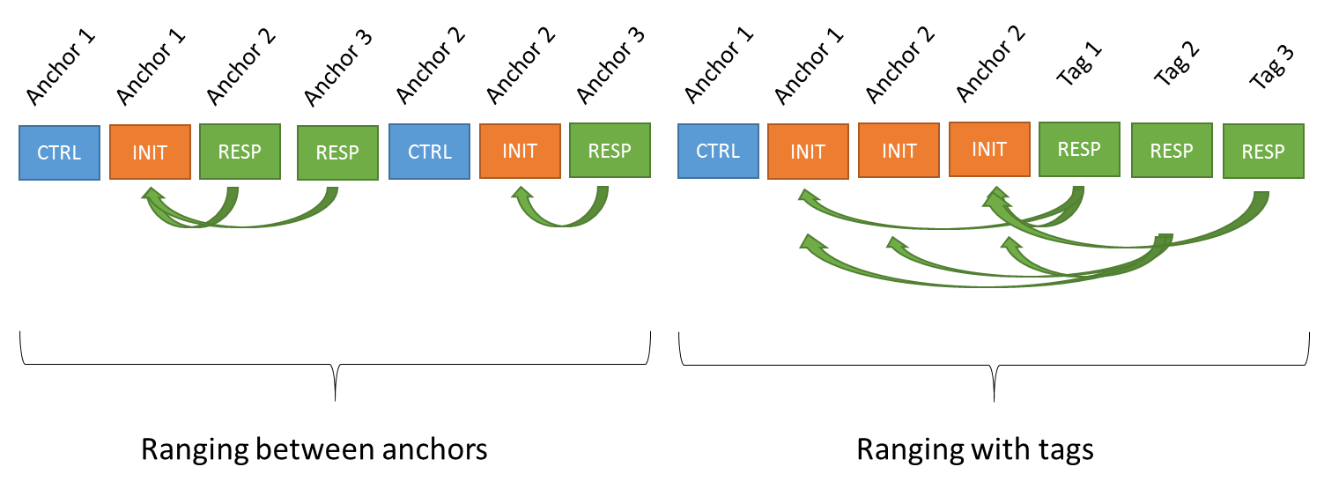

Figure 1: Multiple rangings scheduled sequentially.

As an example, this way, e.g., the time synchronization between ranging anchor nodes can be realized with a many-2-many TWR scheme, where at the same time the synchronization frames exchanged between the ranging anchor nodes can be utilized by some UWB receive-only tags to calculate their position based on down-link time difference of arrival algorithms.

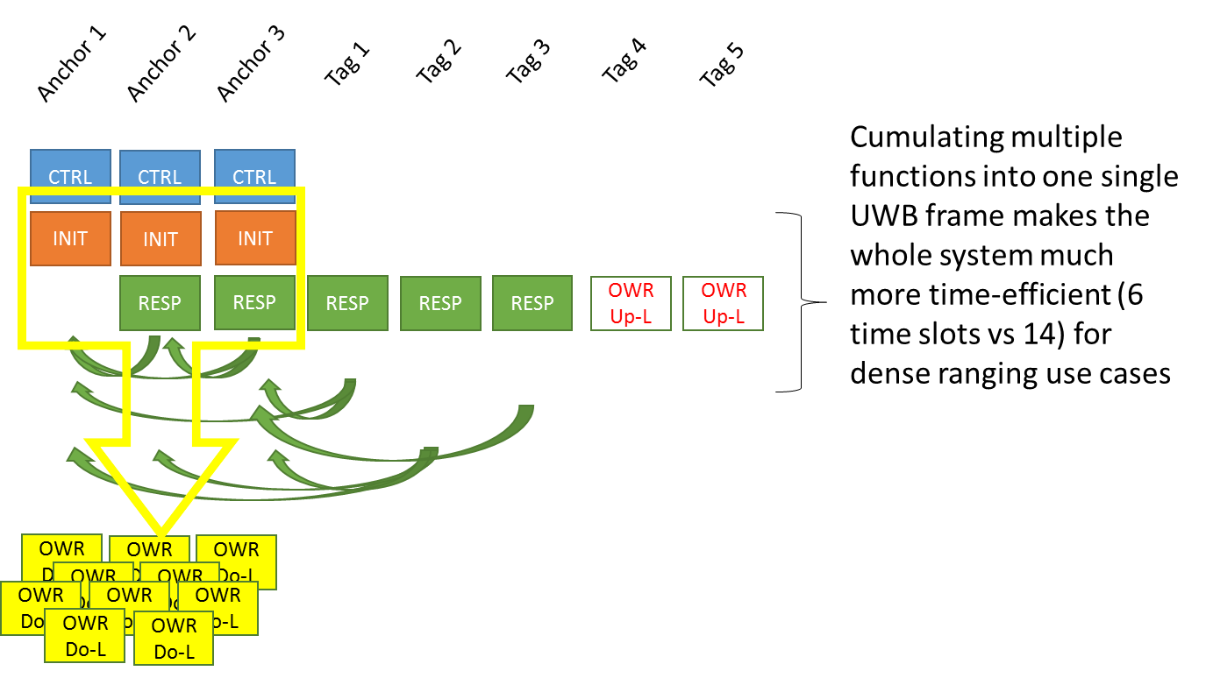

Figure 2: Multiple rangings organized simultaneously.

Furthermore, the frames exchanged for such purposes can be deployed also at the same time as command and initiator messages for starting a scheduled two way ranging with another type of tags in the same vicinity [Figure 2].

The example illustrated in Figure 1 and Figure 2 demonstrates the air time saving potential of such message merging. This has advantages in terms of air time efficiency, radio coexistence and fulfilling regulatory requirements in terms of duty cycle limitations and last but not least providing a better service quality to various diverse user requirements at a single service coverage area.

The existing IEEE 802.15.4z-2020 [0b] standard foresees already an implementation of the role merging principle for messages in a few selected occasions:

* Non-deferred reports: a single message carries the response to an initiation message as well as the report part
* RCM & Initiation roles can be merged into one single message in general
* DS-TWR realization with 3 messages: the 2nd message carries the role of responder and initiator

It can be concluded, that the concept of multiple roles for messages is already existing in IEEE 802.15.4z [0b] . There, in section 6.9.7.2. it is mentioned, that “…, each ranging round may be composed of an RCP, an RP, and an MRP, where each of these phases may consist of multiple slots. In practice, it may be possible to merge some phases.” However, the focus for explicit examples has been on merging Ranging Initiation Phase (RIP) with Ranging Control Phase (RCP) so far.

Currently the IEEE 802.15.4-2020 [0] standard only foresees for scheduled ranging to identify ranging phase time slots explicitly as either initiator or as response time slots. The existing standard foresees further, that there is only one single command, initiation and response phase each scheduled subsequently within a single ranging round. It is not yet explicitly described in the standard, that it is also possible to merge initiation and response time slots nor to merge command, initiate and response time slots in MMR scenarios.

It is proposed here to mention explicitly extending the already mentioned RCM/Initiation merging to a possible RCM/Initiation/Response merging in single slots.

In order to ensure backward compatibility the assignment of initiator or responder roles for slots still need to be in place for RDM IE, if not scheduled by a higher layer. Depending on the mandatory part of the message the slot shall have the role assignment either initiator or responder and may contain as optional component the other one functionality as well.

(These extensions/clarifications can be helpful for many-2-many MMR use cases, e.g., in dense DL-TDoA scenarios anchors message exchanges.)

## Enhancement B: Optional free selection of initiators in many-2-many responses

The example scenario forms a dynamic environment, therefore it can not be known beforehand, if a certain anchor can receive a message from another certain anchor in the vicinity. The receiving anchor (which could be any one anchor except of the transmitting anchor itself at a certain slot) will receive a number of initiation messages from selected surrounding anchors depending on the current shadowing and interference situation. Due to the many-2-many nature of the ranging round it may be sufficient if it picks only a subset from them and includes it’s time relations to each member of this subset into a single response message. In order to keep the UWB response frame payload reasonably short only a certain relevant subset should be picked. Besides the many-2-many condition there is also the second constraint of the scenario, which is the MMR nature. Here we are leveraging the fact, that the many-2-many TWR messages between the anchors can be processed at the same time as OWR messages for DL-TDoA devices. If there would be perfect time sync between anchors only the initiation messages of the TWR would be sufficient for the OWR of the DL-TDoA device. For the more general case of assuming certain non-ideal sync between anchors, it is important, that the DL-TDoA device can also receive the responses of the TWR anchor sync ranging procedure. And here it becomes now important that the responses subset should address most of the neighbor anchors, which can be received by a DL-TDoA device at a certain position.

Allowing the responder to pick its initiators, to which it will include responses in its message, allows the system to adapt to temporary link distortions and to keep the UWB frame still reasonably short.

## Enhancement C: Optional sending multiple RCM messages in a ranging round

Increase robustness and support scalability by optionally sending multiple “copies” of an RCM in a many-2-many ranging round. The challenging environment in the dynamic example scenario with temporary shadowing and interference can better be coped with by deploying a diversity strategy in terms of sending the RCM from several anchor nodes. The contents in terms of scheduling information etc. would be the same. Other anchors as well as tags may be able to receive only a subset of anchors on the vicinity.

This proposal constitutes a transmit diversity. We propose that each RCM can be combined with an initiation and with an anchor position information in a single UWB frame. This allows any other than the first slot user in the round to already insert a response information reacting to previously sent initiation messages in its own RCM+Init message.

## Enhancement D: Optional O-QPSK Ranging Support Service using slotframes

Slotframes have been introduces in 15.4 originally for TSCH operation as a more flexible option of organizing scheduled channel access than the rather rigid Superframe structure defined for the traditional beacon-enabled mode. The advantage of TSCH slotframes is the ability to freely define the number of slots per frame between 0 and 0xFFFF (64k) and to be able to freely define the size of a time slot in terms of micro seconds between 0 and 0xFFFFF (ca. 1s). There is no limitation to multiples of the power of 2. Furthermore, the transmission of a beacon for each slotframe is optional and alternatively the time organization is done by other means [0].

### Maximize battery time for scheduled UL-TDoA tags by enabling UWB TXonly by using loosely coupled O-QPSK for communication and rough time slot synchronization

An out of band communication with low resource consumption may avoid or reduce UWB reception at the portable tag device and providing at the same time a coarse time synchronization. Accuracy should be in the order of a few micro seconds for typical scheduled UWB UL-TDoA schemes. The coarse timing could be achieved by aligning UWB time slots and OOB transmission schedule. Therefore, an intra system contention free access without CSMA-CA is required for the OOB time synchronization messages.

### Optimize the Dilution of Precision (DoP) and diversity gain for the DL-TDoA tags by enabling battery powered anchor (BPA) nodes, which are basically UWB TXonly by using loosely coupled O-QPSK for communication and rough slot synchronization

An out of band communication with low resource consumption avoids UWB reception at the BPA device and providing at the same time a coarse time synchronization to schedule the UWB DL-TDoA initiation messages of the BPA. Accuracy should be in the order of a few micro seconds for typical UWB slot sizes in DL-TDoA schemes. See previous paragraph for OOB channel access for synchronization messages.

### Keep the UWB channel free for ranging frames/slots by off-loading of uncritical management/cmd&control communication from UWB to out-of-band communication deploying O-QPSK in order to keep the number of UWB communication/cmd&control frames low

Network maintenance, such as discovery, joining, resource allocation messages can be exchanged out-of-band (OOB), if sufficient OOB communication bandwidth is available. OOB coverage need to be at least equal to UWB coverage. No strict time or frequency synchronization is required between OOB and UWB for this purpose.

### Keep the UWB frames short by off-loading of uncritical management/cmd&control communication from UWB to out-of-band communication deploying O-QPSK

Ranging management, such as slot allocation, resource allocation requests, can be exchanged out-of-band, if sufficient OOB communication bandwidth is available. OOB coverage need to be at least equal to UWB coverage. No frequency synchronization is required between OOB and UWB subsystems for this purpose, but time-wise an alignment of the control phase of the scheduled UWB ranging round and the OOB is desirable.

# MAC Functional Description

Proposed detailed enhancements of existing standard(s), changes in this revision 2 are written compared to 802.15.4meDF6 [0c].

## ~~802.15.4~~, 802.15.4meFD6: add section “5.2.9: Ranging Support Service (RSS)” in section 5.2. Special application spaces

The RSS portions of this standard are designed to implement a network infrastructure and portable devices that enable the support of ranging services performed by dedicated ranging devices. Therefore scheduled as well as event based channel access is required with a fine time granularity and flexibility. Time structures for communication are defined by the Ranging Service to be supported.

## ~~802.15.4~~, 802.15.4meFD6: 5.7.1.3: Slotframes …change text in this section to make sure the slotframes concept can be used also in RSS but not necessarily with channel hopping

In a TSCH PAN and in a RSS PAN, the concept of the superframe is replaced with a slotframe. The slotframe also contains defined periods of communications between devices that are either CSMA-CA or guaranteed, but the slotframe automatically repeats based on the participating devices’ shared notion of time. Unlike the superframe, slotframes and a device’s assigned timeslot(s) within the slotframe can be initially communicated by beacon, but are typically configured by a higher layer as the device joins the network. Because all devices share common time and channel information, devices may hop over the entire channel space to minimize the negative effects of multipath fading and interference and do so in a slotted way to avoid collisions, minimizing the need for retransmissions. Both of these features are desirable for operation in a harsh industrial environment.

## ~~802.15.4, 6.2.6: rename the heading from “TSCH slotframe structure” to “Slotframe structure” and adapt to contents of section 6.2.6. so, that RSS and TSCH are appropriately reflecte~~d 802.15.4meFD6: Introduce a subsection “10.34. Ranging Support Service” in section 10 and refer to 10.3.2.3. of the TSCH slotframe structure

**10.34 Ranging Support Service (RSS)**

**10.34.1 RSS Overview**

The optional RSS part of this standard is designed to define a network infrastructure and portable devices rules, based on mandatory 15.4 narrowband O-QPSK PHY and MAC features, that enable the support of ranging services performed by dedicated ranging devices, such as described in section 10.29. of this document. Therefore scheduled as well as event based channel access is required for the supporting narrowband O-QPSK radio RSS with a fine time granularity and flexibility. Time structures for communication are defined by the Ranging Service to be supported with this RSS.

**10.34.2 Channel access for RSS**

Devices operating in RSS mode are communicating on radio channels in the 2.400-2.483 GHz frequency band using O-QPSK, as defined in this document (802.15.4meFD6, section 13, O-QPSK PHY) with 250kbit/s. The devices in RSS are either transmitting in dedicated allocated slots or are transmitting during the optional RSS CAP (see 10.34.3.1).

For devices transmitting in dedicated allocated slots, channel access is performed basically according to the procedure described in the TSCH subsection (section 10.3.2.1) with the difference that “link” has to be replaced by “Allocated Transmit Slot (ATS)” to cover in addition to a link also the case of transmitting a broadcast message in a ATS. For RSS, the CCA is Off in this case.

In RSS slotframe slots, which have not been allocated to become ATS or to carry links, a contention based access to the channel without any prior channel allocation is allowed. One or more subsequent unallocated RSS slotframe slots form a RSS CAP.

The RSS CAP enables devices to access the channel without a previous channel allocation. Devices transmitting during the RSS CAP shall take into account, that any frame transmission and optional ACK reception shall be completed before the end of the RSS CAP. During RSS CAP, slotted channel access may be performed to enhance channel throughput, because a time structure can be derived from the slot granularity of the RSS CAP.

**10.34.3 RSS slotframe structure**

**10.34.3.1 General RSS slotframe structure**

The general approach of the RSS slotframe structure is based on the approach described in the TSCH slotframe structure (ref. to section “10.3.2.3.1 General” in 802.15.4meFD6 [0c]) providing the possibility of assigning slotframe slots to certain transmitting and/or receiving devices. In RSS, this approach is extended by introducing the explicit feature of contention access in unallocated slots and the inherent feature of implicit grouping a number of one or more subsequent unallocated slots inside a slotframe to create a contention access period (CAP). A second extension is the alternative option to define the length of a single RSS slot in units of numbers of ranging slots, as described in 10.29.2, of the underlying Ranging Service to be supported with this RSS.

## ~~Change in 6.2.6.2.: Absolute slot number (ASN)~~ 802.15.4meFD6, 10.3.2.3.2: Introduce a subsection “10.34.3.2. RSS slotframe absolute slot number” and refer to 10.3.2.3.2 of the TSCH slotframe structure

**10.34.3.2 RSS slotframe absolute slot number**

An Absolute Slot Number (ASN), as defined in the TSCH slotframe structure (section 10.3.2.3.2 in 802.15.4meFD6), may be optionally used in an RSS slotframe.

## ~~Change in 6.2.6.3.: Link~~s 802.15.4meFD6, 10.3.2.3.3: Introduce a subsection “ 10.34.3.3. RSS slotframe links” and refer to 10.3.2.3.3 of the TSCH slotframe structure

**10.34.3.3 RSS slotframe links and dedicated allocated transmit slots**

In the RSS slotframe, slots will typically be assigned to dedicated devices for transmitting broadcast messages, while individual message exchange deploying unicast messages is typically performed during the CAP. If a slot has been allocated to a device for transmission, which is typically be performed in RSS by a higher layer, this slot is called an Allocated Transmit Slot (ATS). In such a ATS then broadcast frames as well as other frames may be sent by the dedicated device, to which the slot has been allocated for transmission. Other devices in the RSS PAN may or may not receive during this ATS. In addition, the deployment of the link concept, as defined in the TSCH subsection (see section 10.3.2.3.3), is an optional feature in RSS.   
If a slot is not assigned to become an ATS or the transmit side of a link, then in this slot contention based access to the channel without any prior resource allocation is possible by any RSS device.

The RSS physical channel is selected by a higher layer.

## ~~802.15.4z, section 6.9.7.1~~: 802.15.4meFD6, section 10.29.1. correct a typo in the sentence

from

“The RDM IE can be omitted from the R**D**M in the case where the roles and transmission schedule is pre-determined or conveyed via some out-of-band mechanism.”

to

“The RDM IE can be omitted from the R**C**M in the case where the roles and transmission schedule is pre-determined or conveyed via some out-of-band mechanism.”

## ~~802.15.4z, section 6.9.7.2~~: 802.15.4meFD6, 10.29.2 change definition of RCM in order to allow several copies of the RCM to be send subsequently by several (controller/control transmit diversity) nodes

from

“Ranging Control Message (RCM): A message transmitted by a controller in Slot zero, the first slot of

a ranging round to configure ranging parameters.”

to

“Ranging Control Message (RCM): A message transmitted by a controller in Slot zero, the first slot of a ranging round, or additionally transmitted by other devices in other ranging slots after Slot zero in case there will be more than one RCM copy transmitted in a ranging round. ”

## ~~802.15.4z, section 6.9.7.2~~ 802.15.4meFD6, 10.29.2: change definition of RCP allowing several copies of the RCM to be send subsequently be several (controller/control transmit diversity nodes) nodes

from

“Ranging Control Phase (RCP): A phase in which the controller sends an RCM.”

to

“Ranging Control Phase (RCP): A phase in which a controller and optionally other devices (e.g. functioning as controller transmit diversity node(s)) send RCM(s).”

## ~~802.15.4z, section 6.9.7.2~~ 802.15.4meFD6, 10.29.2: change definition of RRP allowing responders to address within a single slot/frame several initiators

from

“Ranging Response Phase (RRP): A phase in which the responder(s) send their response message(s)

to the initiator.”

to

“Ranging Response Phase (RRP): A phase in which the responder(s) send their response message(s)

to the initiator**(s)**.”

…to be continued

# MAC frame formats

## ~~802.15.4, section 7.4.4.2: replace TSCH synchronization IE wit Slotframe Synchronization IE~~ 802.15.4meFD6, 10.3.9.1: Introduce a subsection 10.34.4 RSS IEs

**10.34.4 RSS IEs**

Selected IEs defined by the underlaying ranging service to be supported with this RSS shall be used in RSS. These IEs are not limited to, but include the Nested Payload IEs RR IE (defined in 10.29.9.3) and RDM IE (defined in 10.29.9.8).

In RSS, communication may be optionally realized by deploying IEs for synchronization as well as for slotframe and link parameter information exchange purposes. These IEs are the ones already defined for the optional TSCH mode: Time Correction IE (defined in 10.3.8.1), TSCH Synchronization IE (defined in 10.3.9.1), TSCH Slotframe and Link IE ( defined in 10.3.9.2) and TSCH Timeslot IE (defined in 10.3.9.3).

~~Throughout the section replace “TSCH Synchronization IE” with “Slotframe Synchronization IE” to reflect that this IE is used not only by TSCH but by all Slotframe user.~~

## ~~802.15.4, section 7.4.4.3: replace “TSCH Slotframe and Link IE” with “Slotframe and Link IE”~~

~~Throughout the section replace “TSCH Slotframe and Link IE” with “Slotframe and Link IE” to reflect that this IE is used not only by TSCH but by all Slotframe user.~~

## ~~802.15.4, section 7.4.4.3: replace “TSCH Timeslot IE” with “Timeslot IE”~~

~~Throughout the section replace “TSCH Timslot IE” with “Timeslot IE” to reflect that this IE is used not only by TSCH but by all Slotframe user.~~

## ~~802.15.4z, section 7.4.4.36: change definition of ARC IE allowing multi-mode ranging (MMR) scheme~~s [remove section 7.4, as this part was not approved by the 15.4ab work group]

# Annex

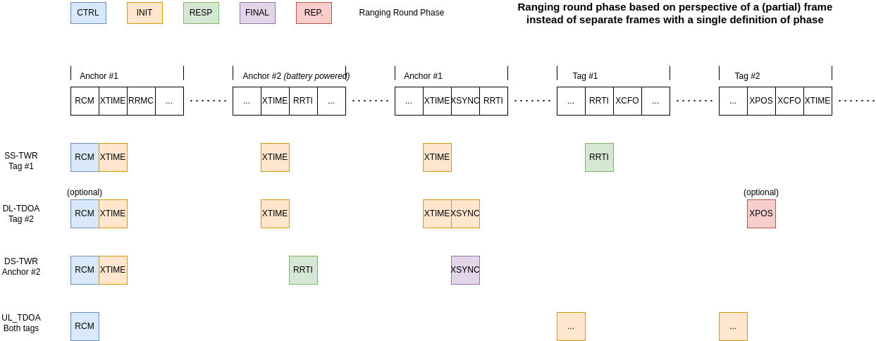

Figure 8-1: Different perspectives from different Ranging methods using same message sequence.