IEEE P802.15
Wireless Personal Area Networks

Project | IEEE P802.15 Working Group for Wireless Personal Area Networks (WPANs)
Title | Comment resolutions for r2-0308
Date Submitted | [October 2019]
Source | Aditya V. Padaki (Samsung Research America)
Re: | Re:
Abstract | Text for possible inclusion in IEEE 802.15.4z MAC
Purpose | Provision of the text to facilitate its incorporation into the draft text of the IEEE 802.15.4z standard currently under development in the 802.15 TG4z.
Notice | This document has been prepared to assist the IEEE P802.15. It is offered as a basis for discussion and is not binding on the contributing individual(s) or organization(s). The material in this document is subject to change in form and content after further study. The contributor(s) reserve(s) the right to add, amend or withdraw material contained herein.
Release
Patent Policy | The contributor is familiar with the IEEE-SA Patent Policy and Procedures:  <http://standards.ieee.org/guides/bylaws/sect6-7.html#6> and  <http://standards.ieee.org/guides/opman/sect6.html#6.3>.  Further information is located at <http://standards.ieee.org/board/pat/pat-material.html> and  <http://standards.ieee.org/board/pat>.

Goal of this submission:

The objective of this submission is to provide comment resolutions

This document addresses the following comments:

Comment resolutions for r2-0308

Change the following in Section 7.4.4.49 Ranging Multiple Message Receipt Confirmation IE

Change Figure 71 and Figure 72 on Page 100

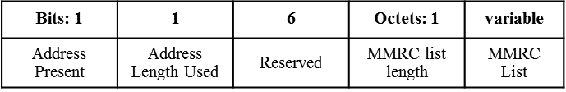
Figure 71. RMMRC IE Content field format

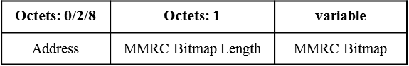
Figure 72. Each row of the RM Table of the RD IE

Add the following after Line 22 on page 100

Address Present bit is set to ‘1’ if address of the initiator is present in the MMRC List element, otherwise it is set to ‘0’.

Address Length Used bit is set to ‘0’ if 2-octet short address is used in MMRC List, otherwise it is set to ‘1’ to indicate 8-octet long address if used in MMRC List. If Address Present bit is ‘0’, this field is ignored.

Add the following after “The Address field” line 24 on page 100 to the following

“when present,”

